老板强烈要求各处和cadre或fundrise做的尽量一模一样

———————————————————————————————————————

下方各修改的新增接口已更新至eolinker：

https://www.eolinker.com/#/share/index?shareCode=JFvixX

browse页面

1 **每个**项目类型（如Commercial）的项目列表的下方，都有一个**相同**的增加链接和浮层

2 点击链接弹出浮层，详细效果见<https://cadre.com/browse>

链接名称和浮层中的内容文字可中英文配置，目前内容就配置成和cadre页面中的一模一样即可。



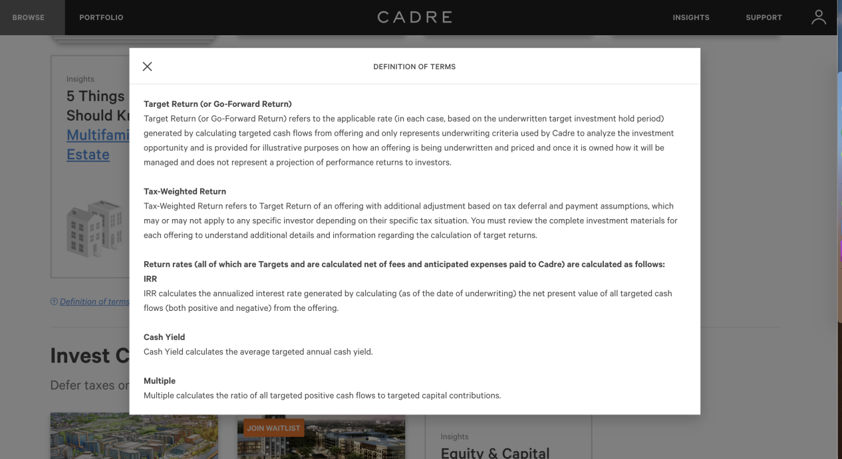

browse页面增加past offerings列表，详见<https://cadre.com/browse>：

1 增加ways to invest和past offerings两个大分割标题，需要中英文配置。

2 增加past offerings列表，即所有已结束项目的列表，

3 列表不需要按项目类型分类，

4 列表中显示卡片，

5 卡片背景图蒙成灰色，

6卡片不可点击。

Past offerings列表接口：/browse/cases_past

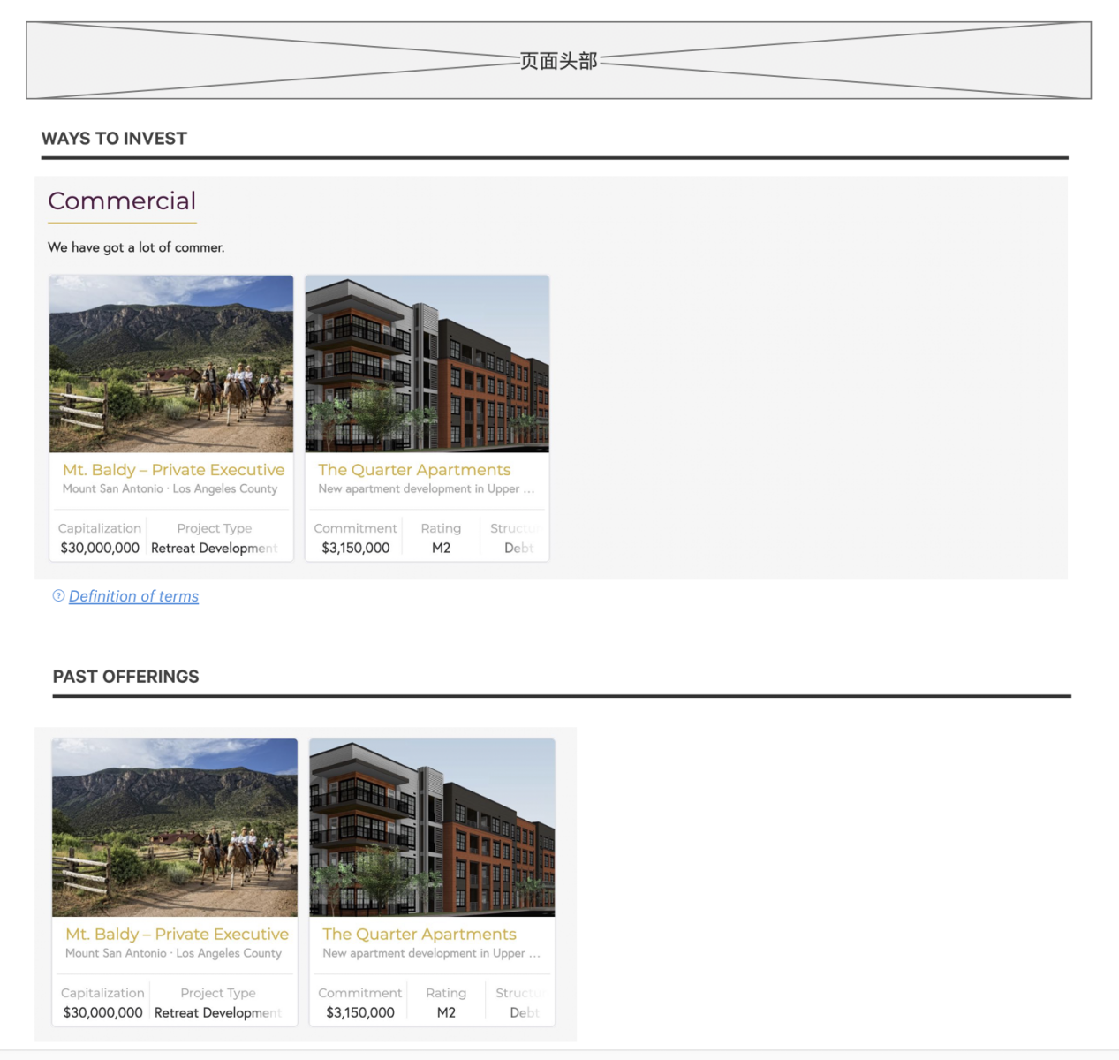

footer使用如下内容，和fundrise相似，字体大小12px

不需要中英文，代码内写即可，告诉我在哪里修改，怎么替换里面的链接。

Performance calculations are performed using the daily time-weighted rate of return (DTWR) calculation method, which is used to measure the performance of your account, portfolio, or security, unaffected by the timing and size of contributions, distributions, transfers, or liquidations. Performance returns for time periods longer than 365 days have been annualized.

The return calculation for a period includes dividends earned (whether paid or unpaid), plus realized and unrealized gains or losses as a result of any changes in the net asset value (NAV) of your shares, net of any advisory fees accrued or liquidation penalties charged.

Performance calculations are for informational purposes only and should not be relied on for any other purpose.

The estimated values for the real estate investments are based upon the current estimated net asset value per share, which may not accurately reflect the amount that might be paid for your shares in a market transaction, and thus are for informational purposes only and should not be relied upon for any other purpose.

Primior operates a website at [primior.com](http://primior.com) and certain mobile apps (the “Platform”). By using the Platform, you accept our [Terms of Service](https://fundrise.com/website-documents/Terms%20of%20Service) and [Privacy Policy](https://fundrise.com/website-documents/Privacy%20Policy). Past performance is no guarantee of future results. Any historical returns, expected returns, or probability projections may not reflect actual future performance. All securities involve risk and may result in partial or total loss. While the data we use from third parties is believed to be reliable, we cannot ensure the accuracy or completeness of data provided by investors or other third parties. Neither Primior nor any of its affiliates provide tax advice and do not represent in any manner that the outcomes described herein will result in any particular tax consequence. Prospective investors should confer with their personal tax advisors regarding the tax consequences based on their particular circumstances. Neither Primior nor any of its affiliates assume responsibility for the tax consequences for any investor of any investment.

The publicly filed offering circulars of the issuers sponsored by Primior, not all of which may be currently qualified by the Securities and Exchange Commission, may be found at [primior.com](http://primior.com) For investors and potential investors who are residents of the State of Washington, please send all correspondence, including any questions or comments, to [c](mailto:washingtonstate@fundrise.com)ontact@primior.com.

© 2019 Primior. All Rights Reserved. eREIT, eFund and eDirect are trademarks of Primior. Proudly designed and coded in Los Angeles, CA. 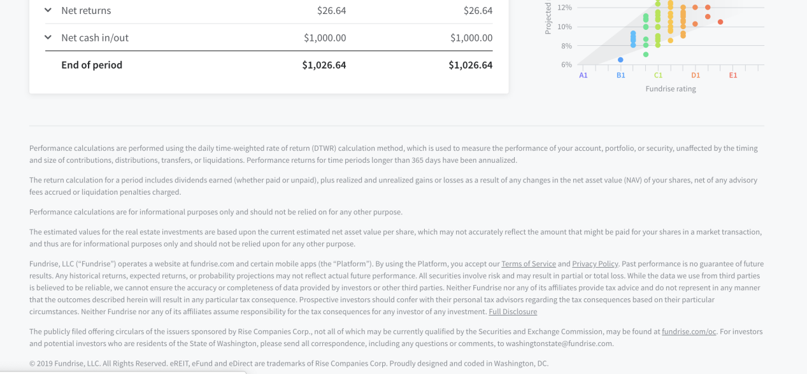

**portfolio页增加account value走势图和表格**

在My Projects上方增加1块栏目Account value图表。接口中没有的默认文字需要中英文翻译配置。

1 上方走势图：表单样式与首页走势图表格各设置相同（横纵坐标、hover交互等），颜色为浅色即可。接口：/performance/account_value_history

2 下方表格接口：接口：/performace/account_value_chart

3 走势图和表格内容如下，具体效果详见页面<https://fundrise.com/account/performance>中的最下一个表格：

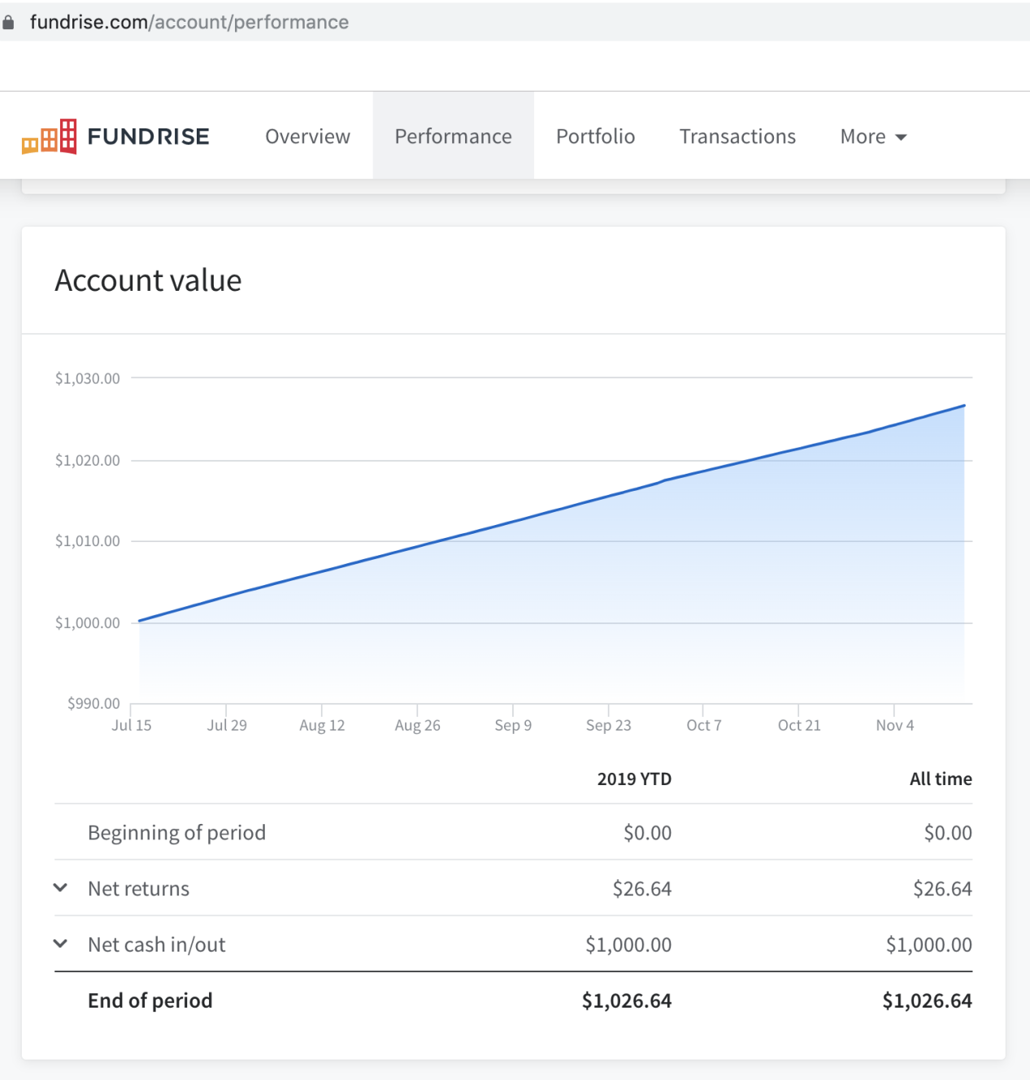

展开后的样式：

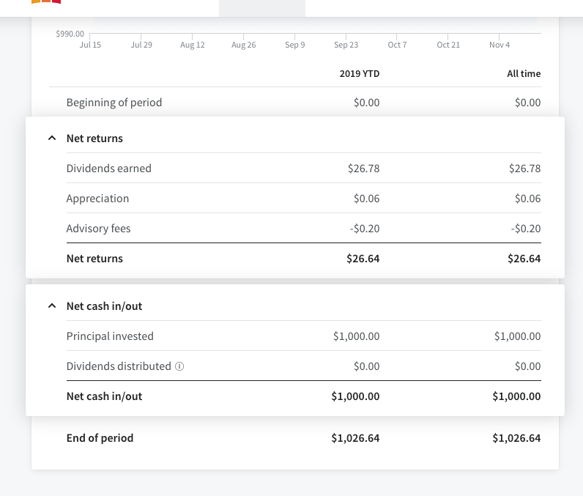

1将change password页改为edit profile页用户可以修改名字手机等信息，

2并在settings菜单上增加入口edit profile，

3 均需要中英文翻译配置

接口GET：/userinfo/edit

接口POST：/userinfo/edit

页面表单字段如下图，

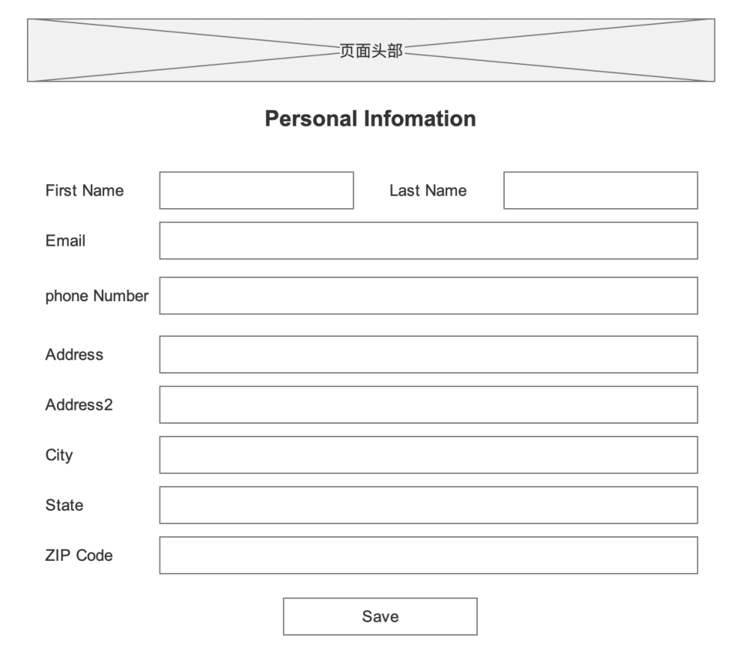

项目详情页，

底部增加DISCLAIMERS & CONFIDENTIALITY链接浮层，参见<https://cadre.com/deal/premier-place/overview>

链接名称和浮层内容中英文在翻译中配置，不用接口

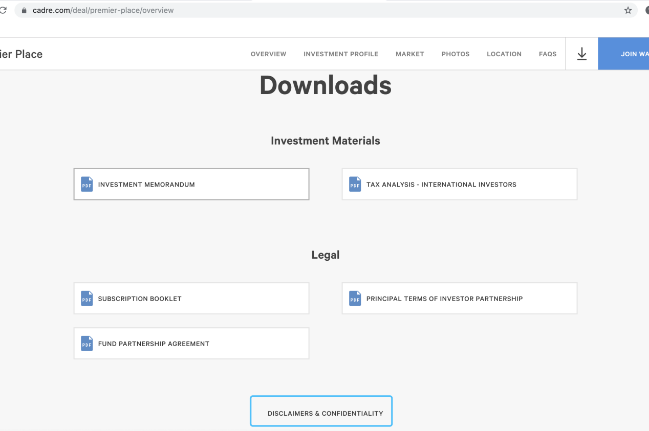

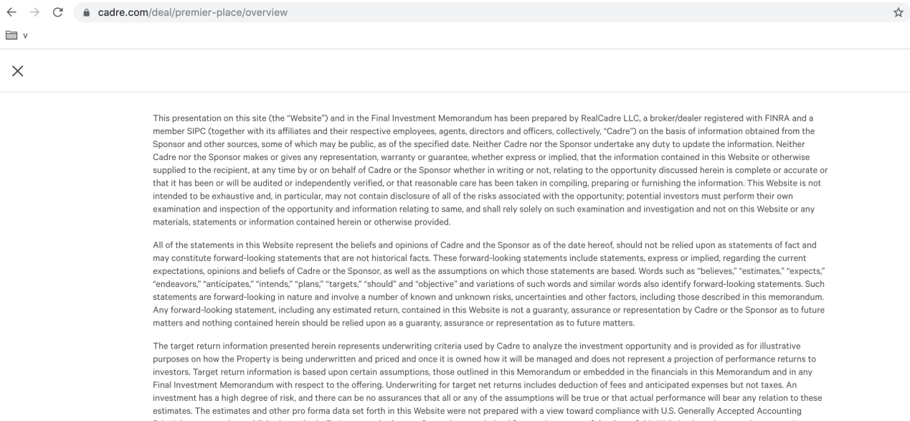

————————————————————————————————————

首页右侧图表中，

1缺少纵坐标说明纵向的文字 projected return

2纵坐标显示的最大值和最小值，根据所有点的最大值和最小值上下浮动部分，不要从0开始显示

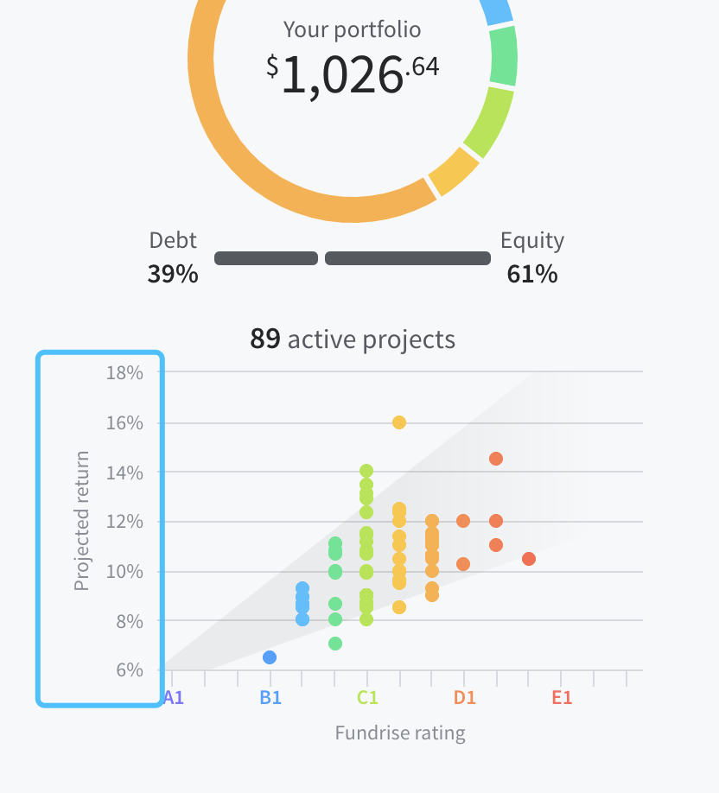

———————————————————————————————————————

Primior rating设置为链接，点击之后跳转到一个pdf，此pdf链接可配置。

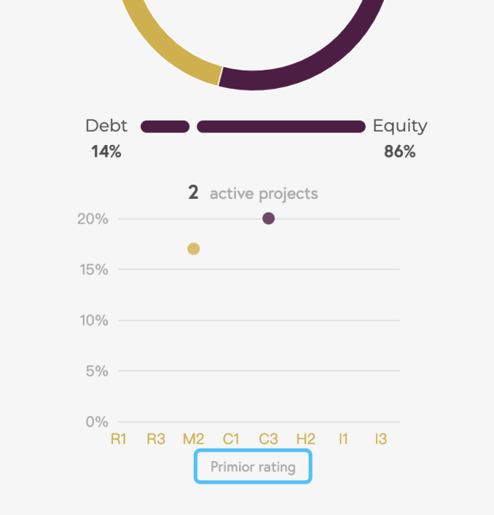

首页右侧图表中，红点hover时没有小浮层

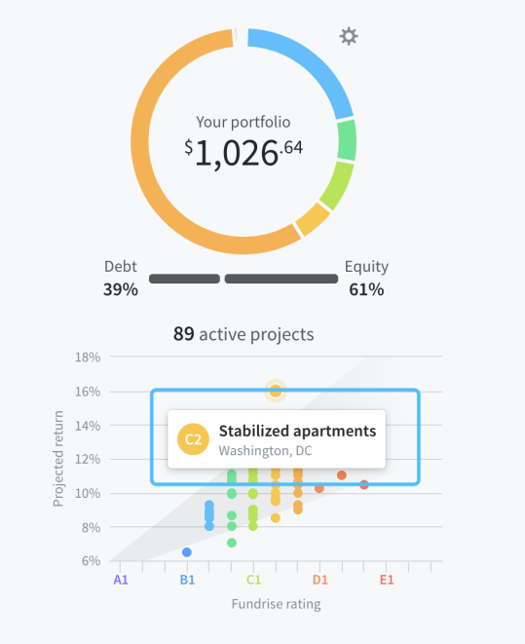

首页右侧图表中，点击红点浮层卡片中words内容没有显示

你用的哪个接口？



首页下方项目列表中，卡片words当内容超过时，右侧没有渐隐遮罩

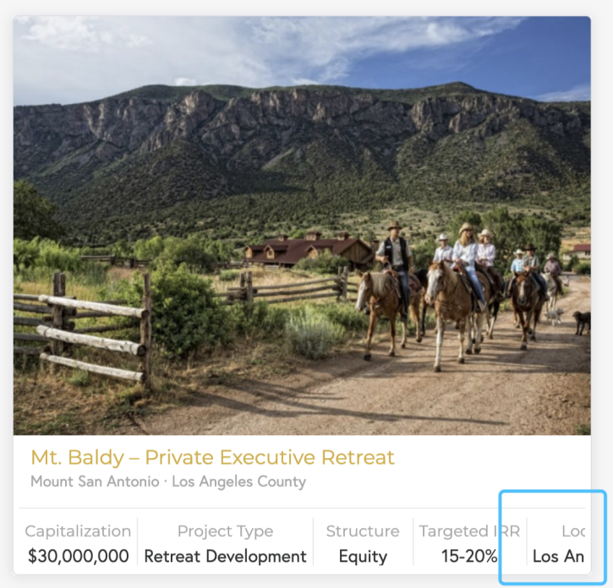

investment页面，此处联系方式在哪里修改或者配置，不需要中英文，或者告诉我在哪里代码改也可以。



Portfolio页面表格，既没有显示滚动条，右上角又被遮住不显示

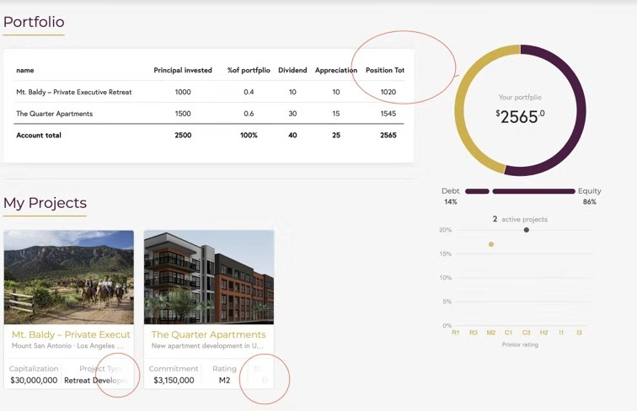

transactions页面右侧也需要有饼图图表，如fundrise

