Homework 01 - Image Processing

# Problem 1

1. Obtain the images “lena.bin” and “peppers.bin” from the dataset Each image has 256 × 256 pixels and each pixel has 8 bits.

(a) Read and display the images.

(b) Define a new 256 256 image J as follows: the left half of J, i.e., the first 128 columns, should be equal to the left half of the Lena image. The right half of

J, i.e., the 129th column through the 256th column, should be equal to the right half of the Peppers image.

(c) Define a new 256 × 256 image K by swapping the left and right halves of J.

(d) Be sure to turn in: A listing of your code and printouts of the original images, image J, and image K.

Python Solution:

import numpy as np

import matplotlib.pyplot as plt

rows, cols = 256, 256

# (a) Đọc ảnh từ file .bin

lena = np.fromfile("lenabin.sec", dtype=np.uint8).reshape((rows, cols))

peppers = np.fromfile("peppersbin.sec", dtype=np.uint8).reshape((rows, cols))

# (b) Tạo ảnh J

J = np.zeros((rows, cols), dtype=np.uint8)

J[:, :cols//2] = lena[:, :cols//2] # nửa trái Lena

J[:, cols//2:] = peppers[:, cols//2:] # nửa phải Peppers

# (c) Tạo ảnh K (swap)

K = np.zeros_like(J)

K[:, :cols//2] = J[:, cols//2:]

K[:, cols//2:] = J[:, :cols//2]

# (d) Hiển thị kết quả

plt.figure(figsize=(8,8))

plt.subplot(2,2,1), plt.imshow(lena, cmap="gray"), plt.title("Original Lena"), plt.axis("off")

plt.subplot(2,2,2), plt.imshow(peppers, cmap="gray"), plt.title("Original Peppers"), plt.axis("off")

plt.subplot(2,2,3), plt.imshow(J, cmap="gray"), plt.title("Image J"), plt.axis("off")

plt.subplot(2,2,4), plt.imshow(K, cmap="gray"), plt.title("Image K"), plt.axis("off")

plt.tight_layout()

plt.show()



# Problem 2

2. Use Python for this problem.

(a) Type help imread and help imwrite at the Python prompt to read the online help for these commands.

(b) Obtain the image “lenagray.jpg” from the dataset. It is the same image that you used in the first problem, but the file is in JPEG format this time.

(c) Use the imread function to read in the image. Let’s call this image J1.

(d) Make a new image J2 that is the photographic negative of J1. To do this, set J2 = 255 J1. Display the new image J2 and use the imwrite command to write it out as a JPEG file.

(e) Be sure to turn in: A listing of your code and printouts of the original and modified images.

Python Solution:

import cv2

import matplotlib.pyplot as plt

# Đọc ảnh grayscale

J1 = cv2.imread("lenagray.jpg", cv2.IMREAD_GRAYSCALE)

# Hiển thị ảnh gốc

plt.figure(figsize=(8,4))

plt.subplot(1,2,1)

plt.imshow(J1, cmap="gray")

plt.title("Original lenagray.jpg")

plt.axis("off")

# Tạo ảnh âm bản

J2 = 255 - J1

# Hiển thị ảnh âm bản

plt.subplot(1,2,2)

plt.imshow(J2, cmap="gray")

plt.title("Photographic Negative")

plt.axis("off")

plt.tight_layout()

plt.show()

# Lưu ảnh âm bản

cv2.imwrite("LenaNegative.jpg", J2)

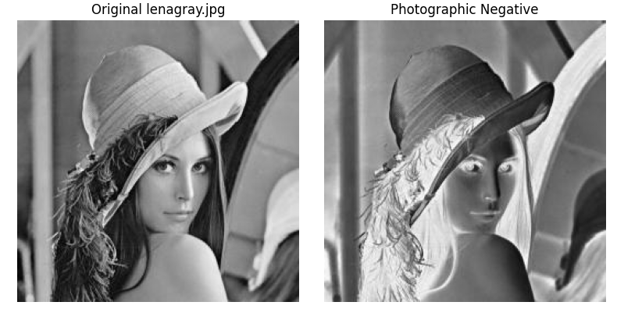

# Problem 3

3. Use Python for this problem.

(a) Obtain the color image “lena512color.jpg” from the dataset. It is the same image that you used in the first two problems, except this time it is in color (each pixel has 24 bits) and the size is 512 512 pixels. If you read the image into a Python array J1, then J1(:,:,1) is the Red band, J1(:,:,2) is the Green band, and J1(:,:,3) is the Blue band. In each band, each pixel has 8 bits, just like the image in the first problem.

(b) Use imread to read in the image and then display it. Let’s call this image J1.

(c) Make a new color image J2 by swapping the color bands of J1 as follows. First, just set J2 = J1 to initialize the new image with the right size. Then make the Red band of J2 equal to the Blue band of J1, make the Green band of J2 equal to the Red band of J1, and make the Blue band of J2 equal to the Green band of J1.

For example, to set the Red band of J2 equal to the Blue band of J1, you can type J2(:,:,1) = J1(:,:,3);.

(d) Display the new image and use imwrite to write it out to a JPEG file.

(e) Be sure to turn in: A listing of your code and printouts of the original and modified images.

Python Solution:

import cv2

import matplotlib.pyplot as plt

# (b) Đọc ảnh màu

J1 = cv2.imread("lena512color.jpg")

# OpenCV đọc theo BGR, cần đổi sang RGB để hiển thị đúng với matplotlib

J1 = cv2.cvtColor(J1, cv2.COLOR_BGR2RGB)

# Hiển thị ảnh gốc

plt.figure(figsize=(10,4))

plt.subplot(1,2,1)

plt.imshow(J1)

plt.title("Original lena512color.jpg")

plt.axis("off")

plt.savefig("P3J1.eps") # xuất EPS cho báo cáo

# (c) Tạo J2 bằng cách tráo kênh màu

J2 = J1.copy()

J2[:,:,0] = J1[:,:,2] # Red <- Blue

J2[:,:,1] = J1[:,:,0] # Green <- Red

J2[:,:,2] = J1[:,:,1] # Blue <- Green

# Hiển thị J2

plt.subplot(1,2,2)

plt.imshow(J2)

plt.title("Color Bands Switched")

plt.axis("off")

plt.savefig("P3J2.eps") # xuất EPS cho báo cáo

plt.show()

# Lưu J2 ra JPEG

J2_bgr = cv2.cvtColor(J2, cv2.COLOR_RGB2BGR) # đổi lại BGR cho OpenCV ghi file

cv2.imwrite("LenaColorSwitch.jpg", J2_bgr)

