Cao Phi Hung

S3372748

Assignment 1

The aim of this assignment is to emulate a monitor program and a set of simplified microcontrollers. The program is required to be implemented in the C++ programming language, and the emphasis is on using console I/O and basic OOP concepts.

COSC2131 – Programing Using C++

REPORT

1. Introduction

* This is a report for the first assignment of the COSC2131 – Programing using C++.

Title : MICROCONTROLLER EMULATION

Lecture Name: Pham Chi Thanh

Student Name : Cao Phi Hung

Student ID: s3372748

Due Date : 25/7/2014

1. How to build and install

* I have created the MAKEFILE so the user just need to run the makefile command then type ./main to run the program
* Clean function has been installed. Run the make clean command to remove the output file

1. Implementation

Model: Main class, Base class and 3 subclass for 3 types of microcontroller

* Main Class: main.cpp
* Base Class: Microcontroller. h , Microcontroller.cpp
* Extra Class: MicrocontrollerFactory.h, MicrocontrollerFactory.cpp
* Subclasses:
  + MorpsR500.h , MorpsR500.cpp
  + MacrochipPic32f42.h , MicrochipPic32f42.h
  + Rotamola34hc22.h , Rotamola34hc22.cpp

Data structure

* Three subclasses inheritance the base class.
* The Base will contain the common features, methods of each microcontroller. Three subclasses can override and modify the content of the methods to be specific with each microcontroller and have different behavior.
* All the data member must be private can be access through get and set methods.

Class Diagram

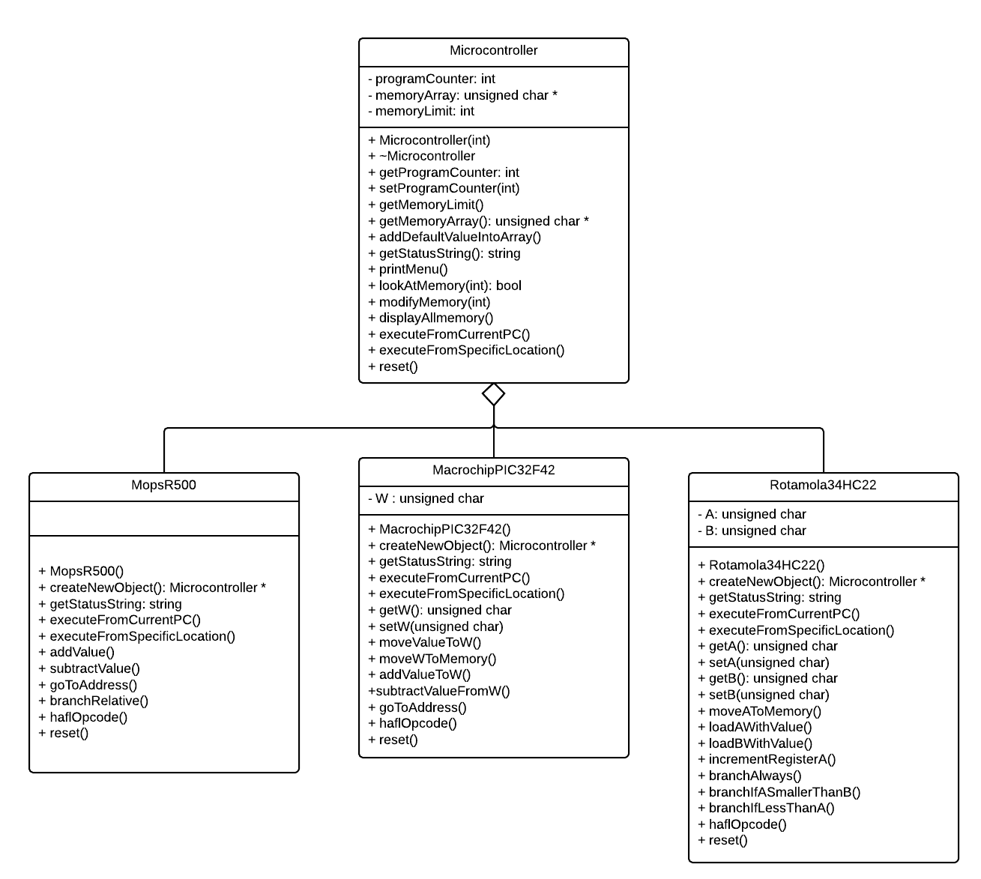

1. Extra Features

* I have implement the Microcontroller Factory for the extension of the Microcontroller program.
* When adding new microcontroller, the programmer just need to go to that class and adding the microcontroller.
* I have create 3 example test file which are : prog.r500 , prog.pic32f42 and prog.34hc22 to test the program.

1. Problem and Solution

* The problem is that I haven’t done programming for a chip. Therefore, many words, phase which I have no ideas about it. It take me a lot of time to research to understand.

1. References

* <http://stackoverflow.com/questions/3270307/how-do-i-get-the-lower-8-bits-of-int>
* [www.cplusplus.com](http://www.cplusplus.com)