Student Name: Phi Hung Cao

Student ID: 300279621

I confirm that my program is complete and working. I have implemented all required features

CSIS3540 Client SERVER SYStem

DBLab6: Product Queries

Source Code:

Main Form

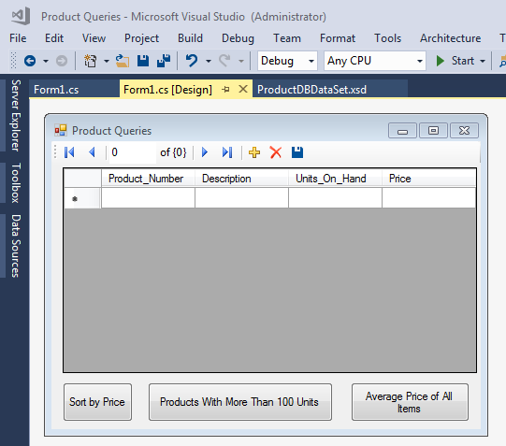

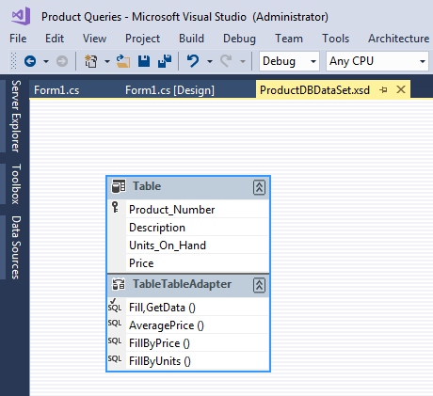

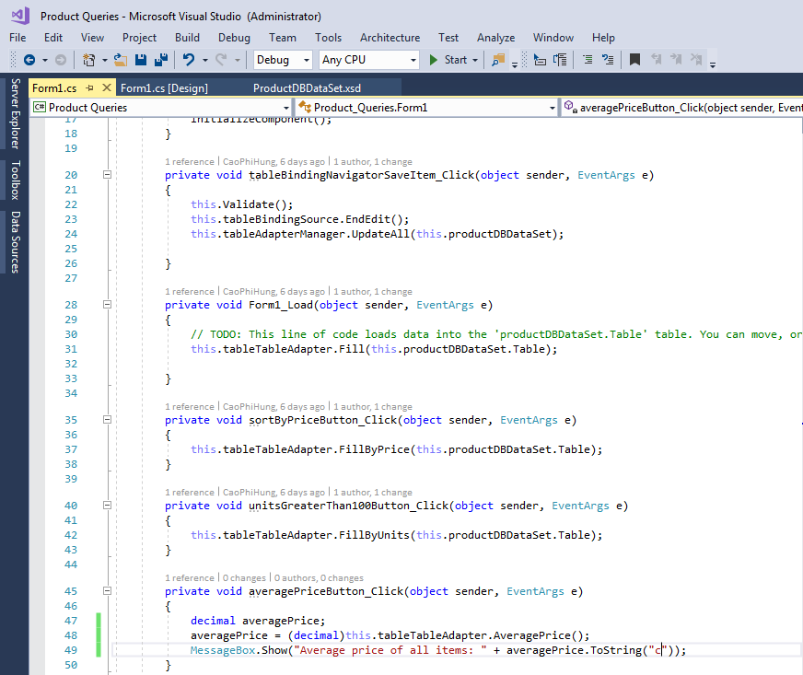

Output:

