Student Name: Phi Hung Cao

Student ID: 300279621

I confirm that my program is complete and working. I have implemented all required features

CSIS3540 Client SERVER SYStem

Extra Credit 5: Tic-Tac-Toe

Source Code:

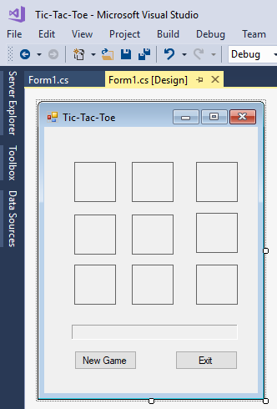

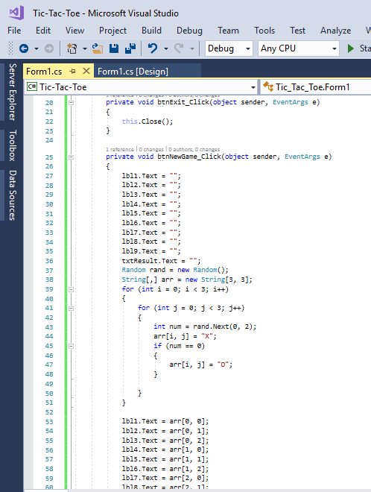

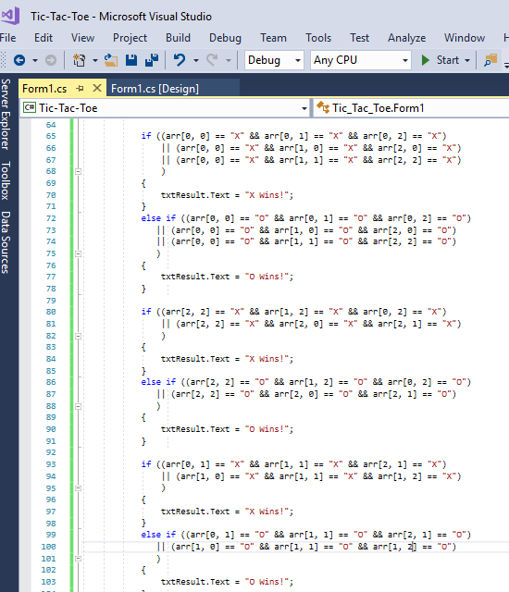

Output:

