Student Name: Phi Hung Cao

Student ID: 300279621

I confirm that my program is complete and working. I have implemented all required features

CSIS3540 Client SERVER SYStem

Lab5: InvoiceTest

Source Code:

Class Invoice

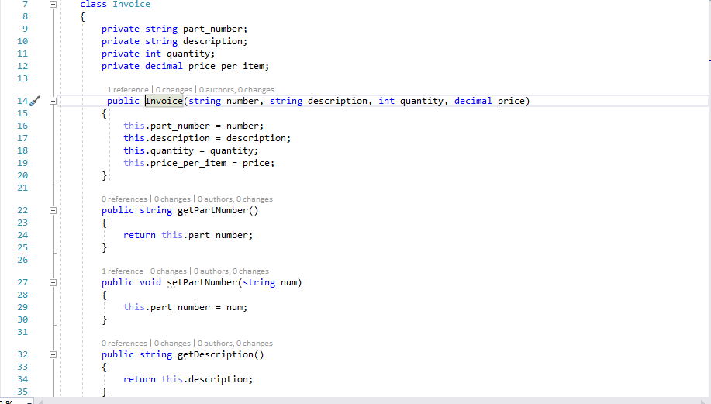

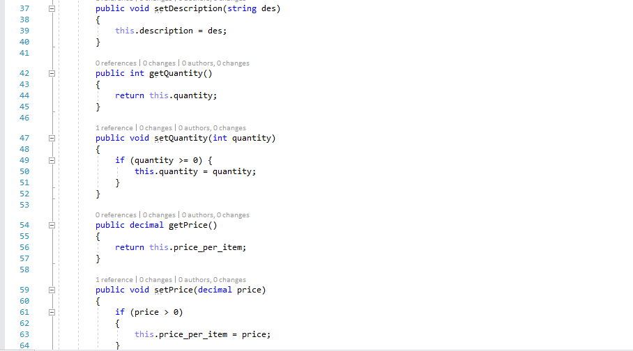

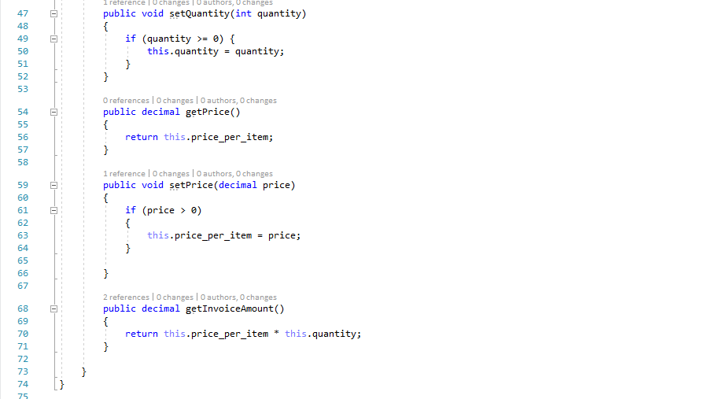

Invoice Test App

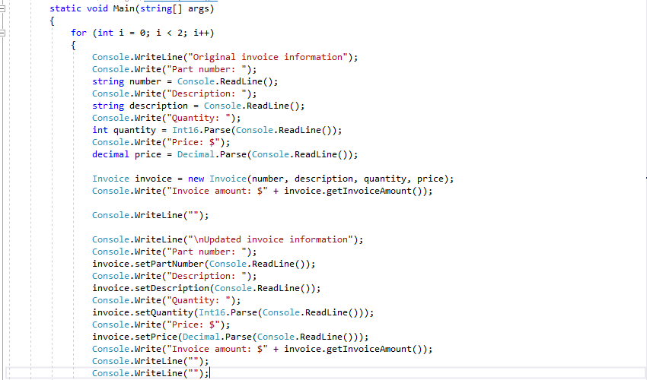

Output:

