Student Name: Phi Hung Cao

Student ID: 300279621

I confirm that my program is complete and working. I have implemented all required features

CSIS3540 Client SERVER SYStem

Lab6: Employee Test

Source Code:

Employee Class

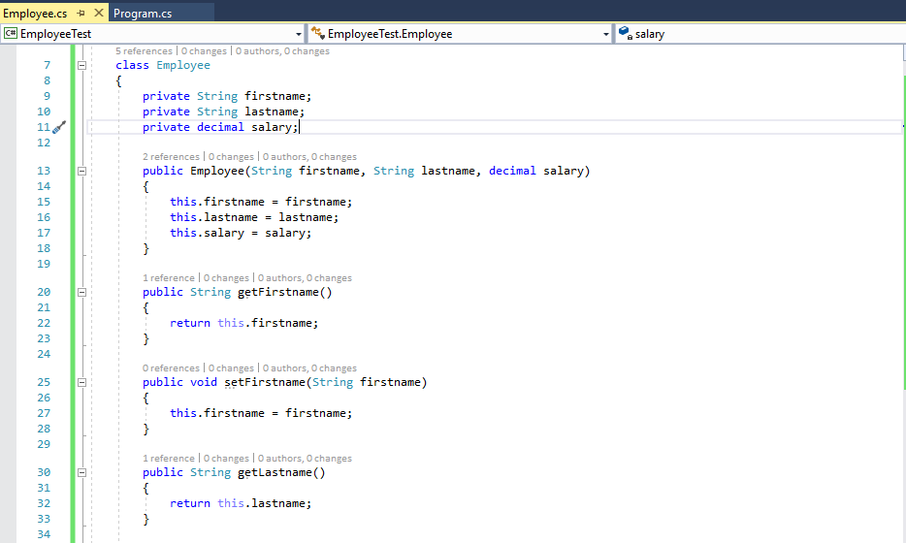

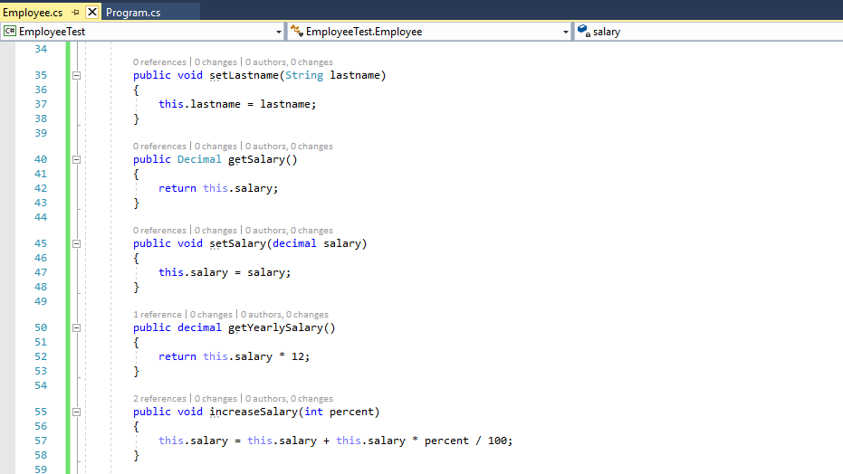

Employee Test

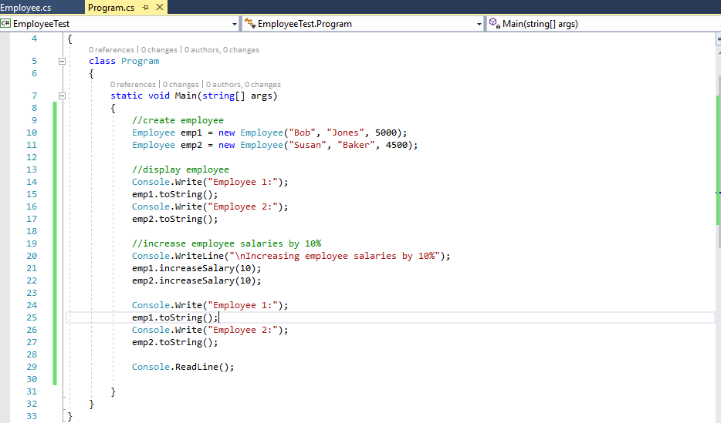

Output:

