Student Name: Phi Hung Cao

Student ID: 300279621

I confirm that my program is complete and working. I have implemented all required features

CSIS3540 Client SERVER SYStem

DBLab1: Phone Book

Source Code:

Step1: Create datatable

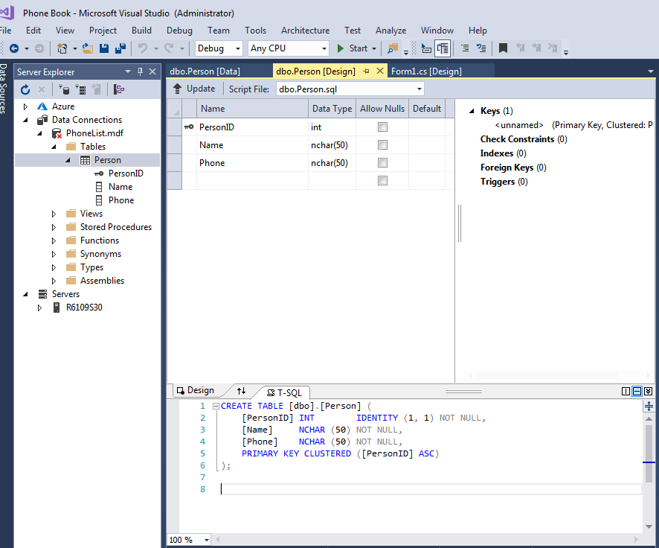

Step2: Add data

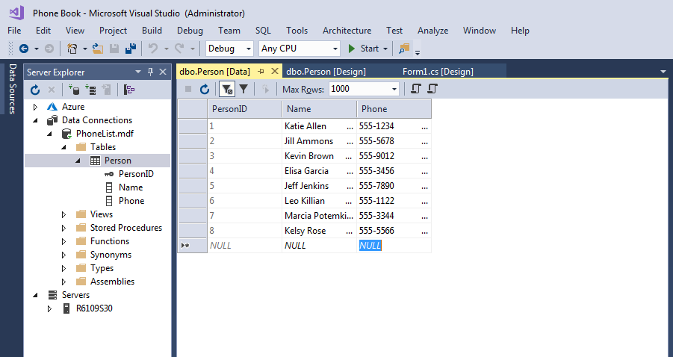

Step3: Create data grid view

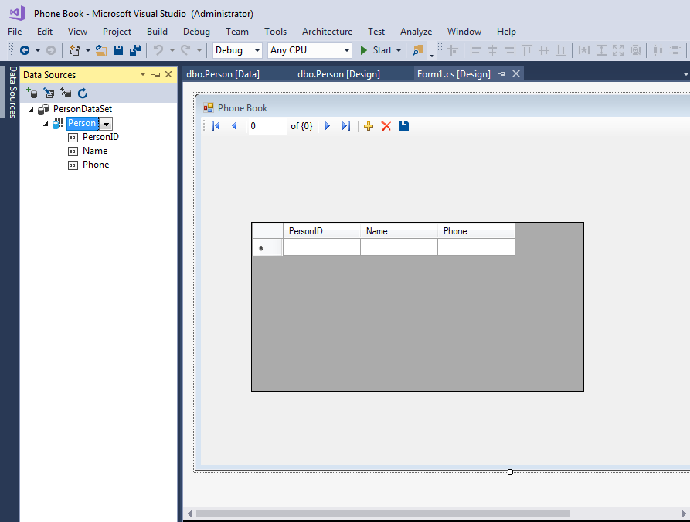

Output:

