Student Name: Phi Hung Cao

Student ID: 300279621

I confirm that my program is complete and working. I have implemented all required features

CSIS3540 Client SERVER SYStem

DBLab2: Products

Source Code:

Step1: Create datatable

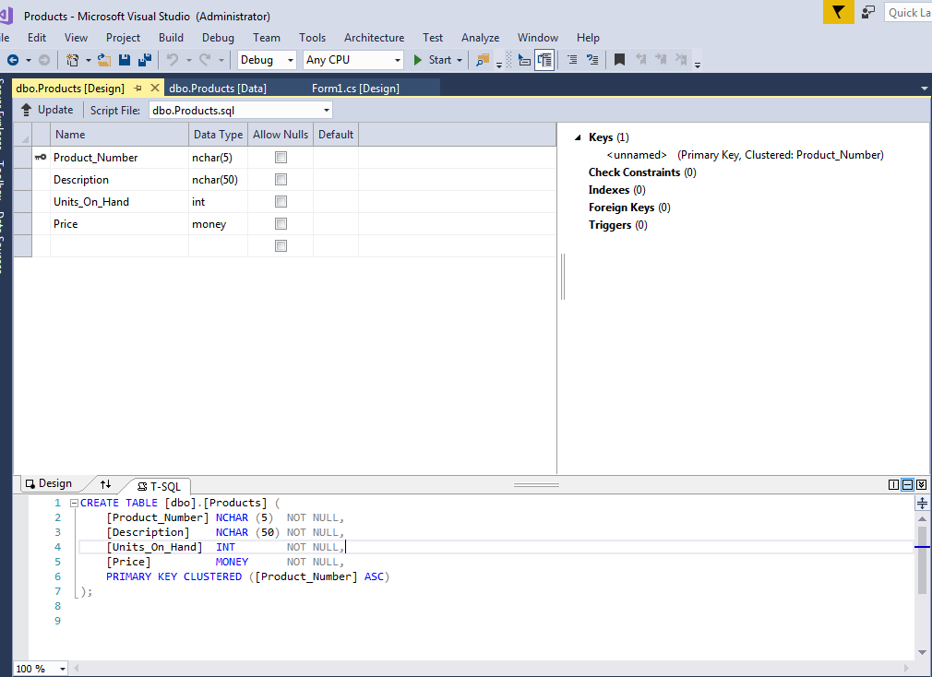

Step2: Add data

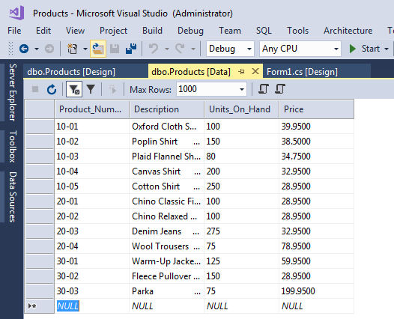

Step3: Create data detail view

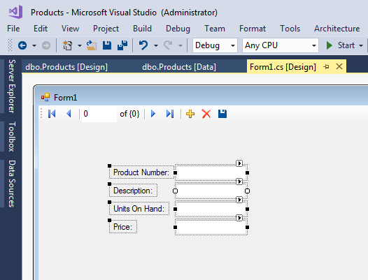

Output:

