1. Building your first app

<https://developer.android.com/training/basics/firstapp/index.html>

* 1. Run Android Studio and create a new project

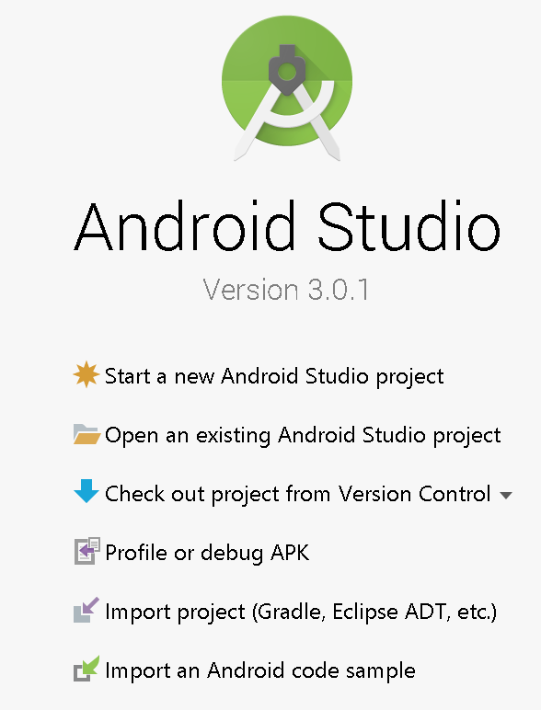

Create a new project

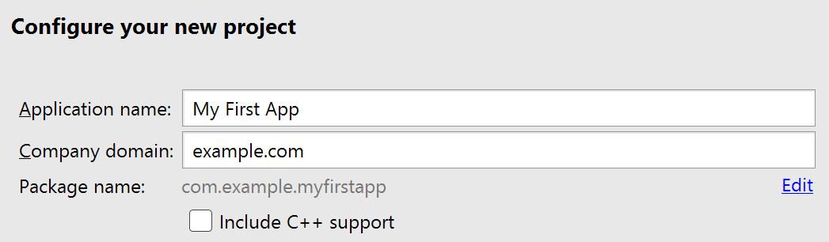

* Take note of the project location. You can change it.
* Click Next when done

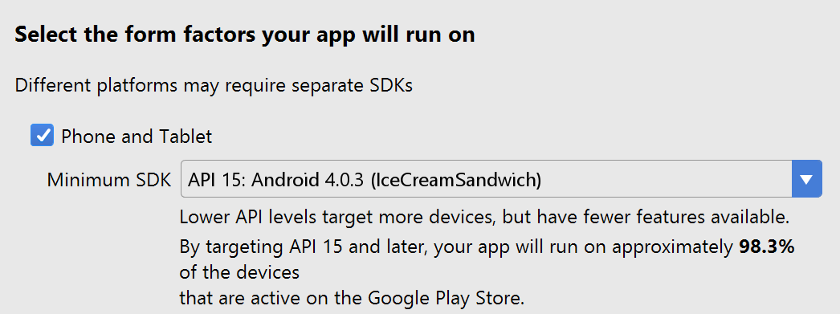

* Can keep the default value
* Click Next when done

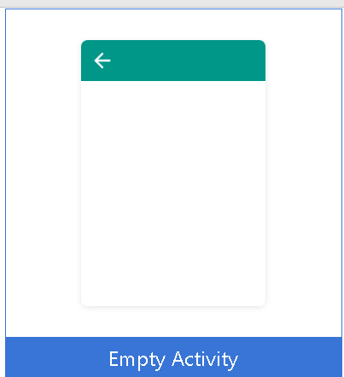

* Choose empty activity
* Click Next when done

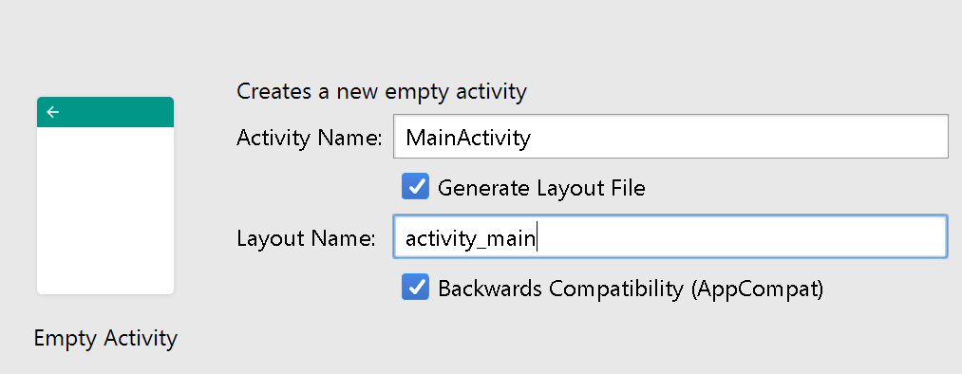

* Keep the default value
* Click Finish when done
  1. Run the application
  2. Understanding the environment and the files created

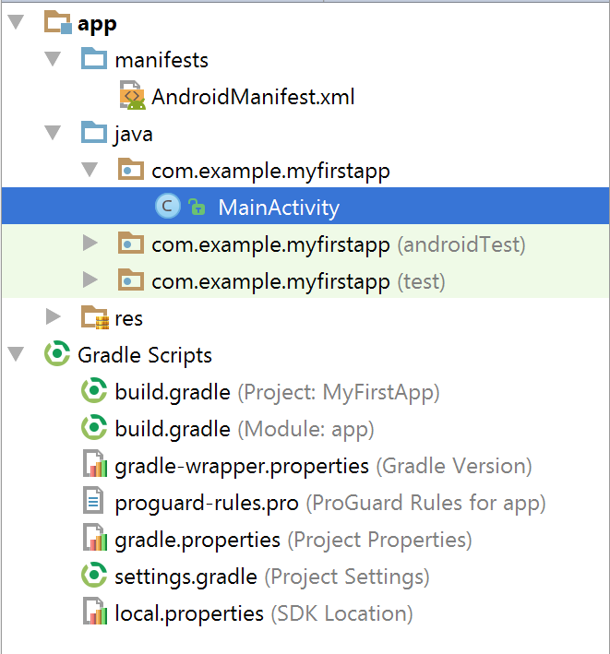

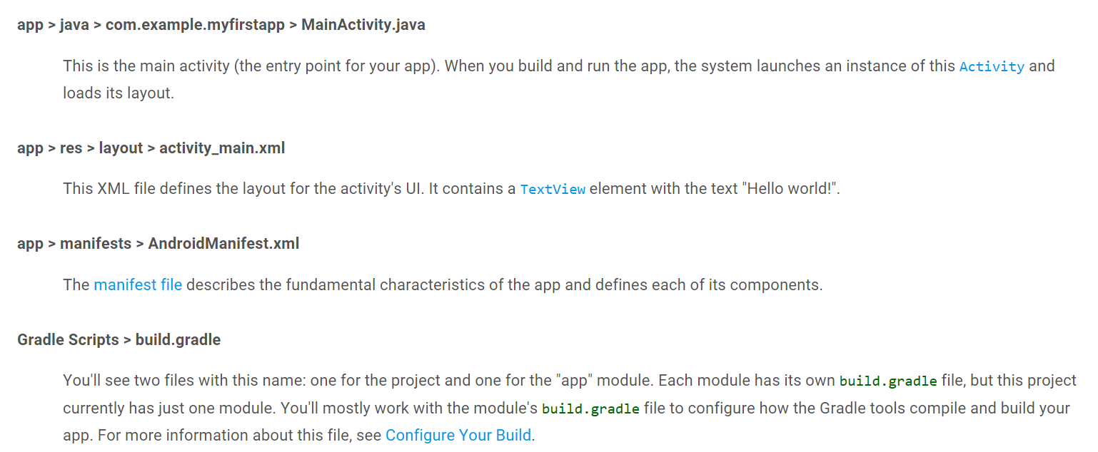

Notes

1. AndroidManifest.xml

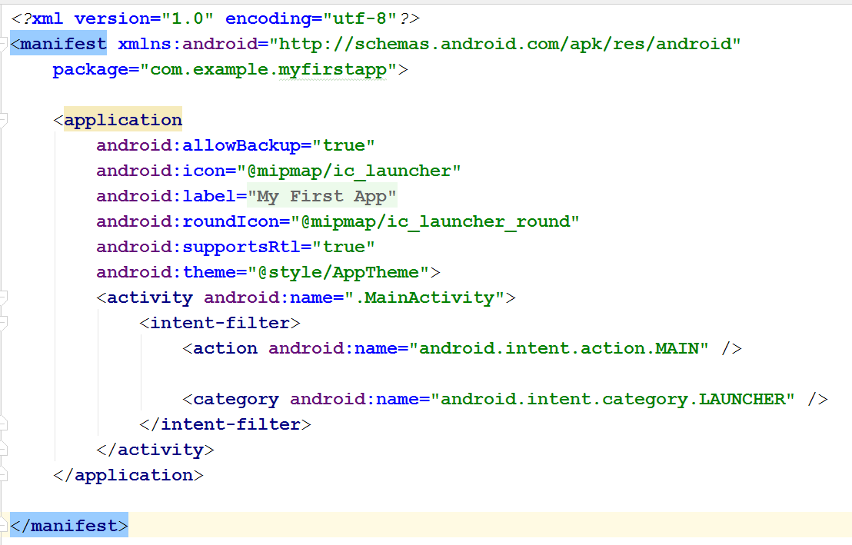

* Contains information about the package

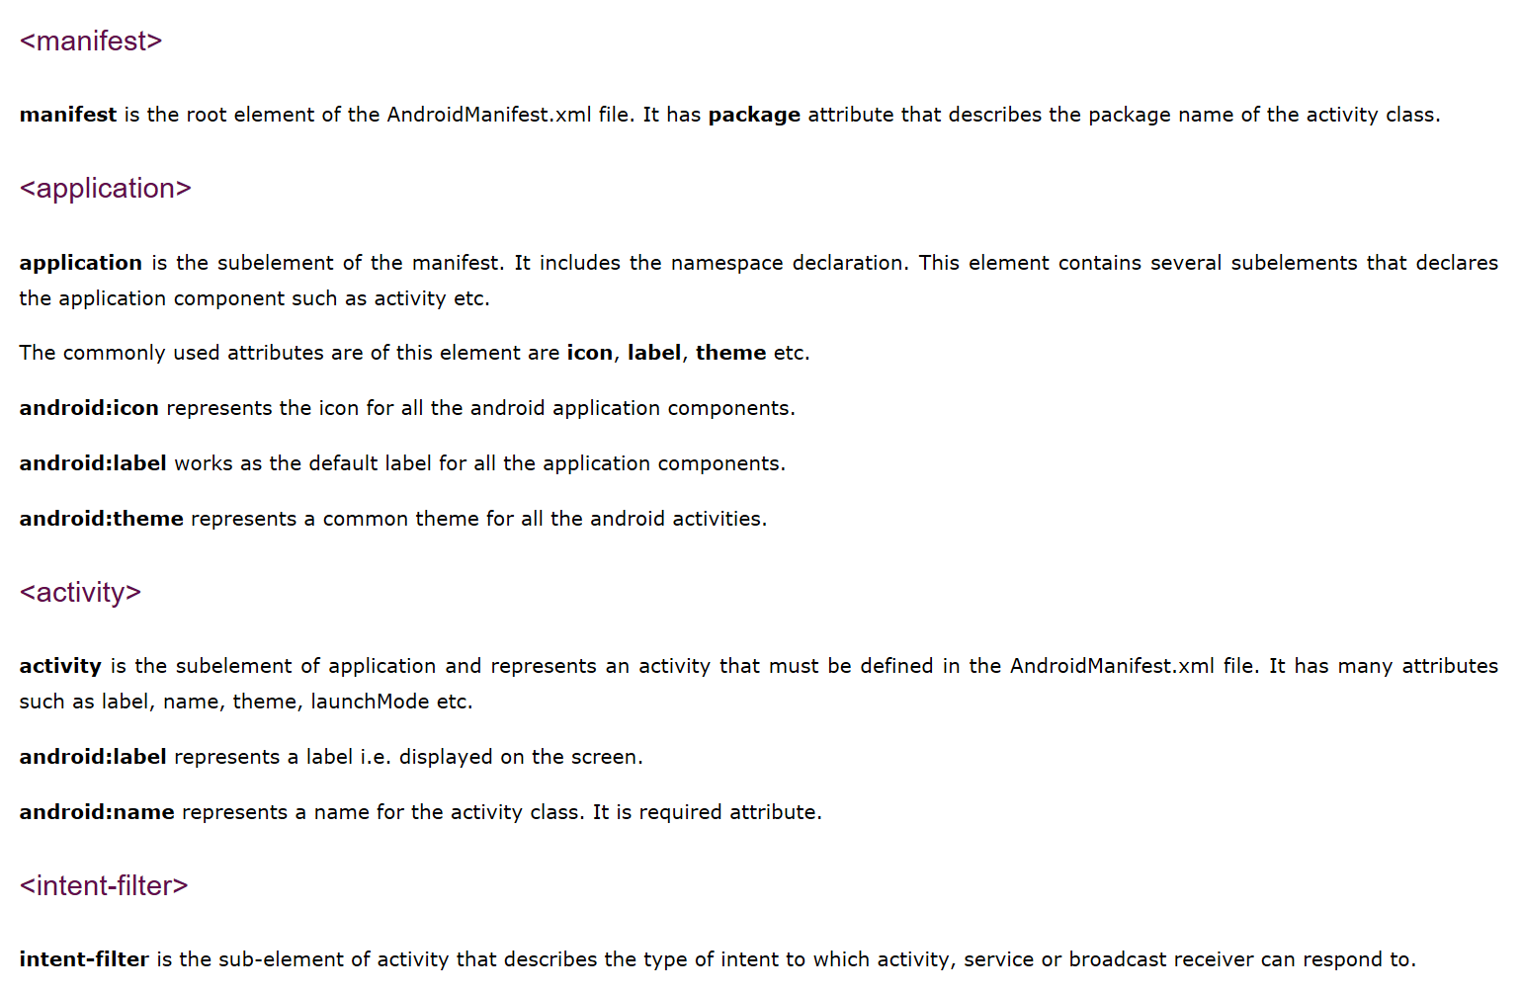

1. MainActivity.java

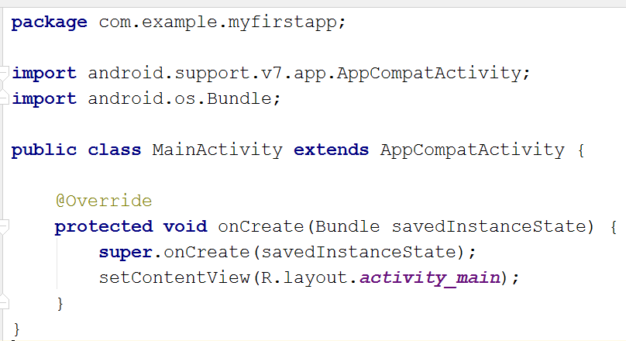

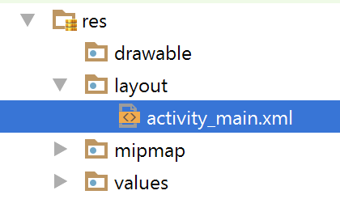

Activities

1. Understanding Activity Life Cycle [2 marks]

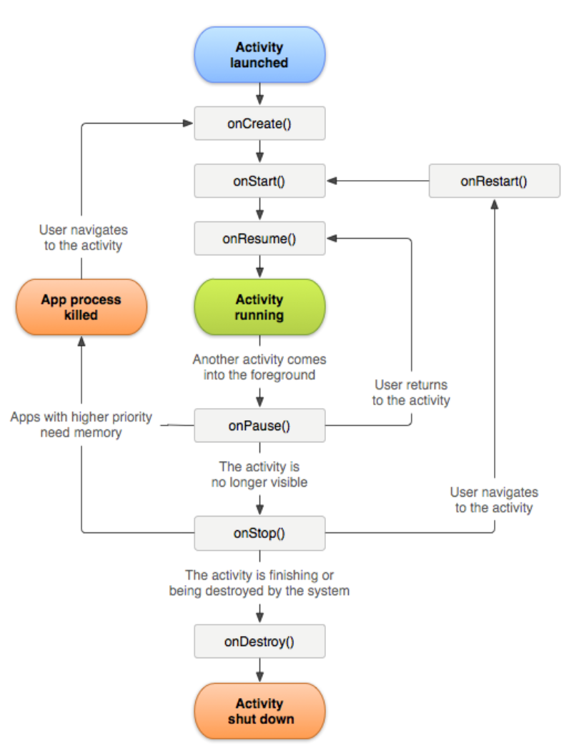

* Application Name : Problem1
* Company domain : yourLastName.com
* Choose : Empty Activity
* Activity Name : MActivity
* Open MActivity.java and type the following

**protected void** onCreate(Bundle savedInstanceState) {  
 **super**.onCreate(savedInstanceState);  
 setContentView(R.layout.***activity_m***);  
 Log.*d*(**"Event: "**, **"onCreate invoked"**);  
}  
  
**protected void** onStart() {  
 **super**.onStart();  
 Log.*d*(**"Event: "**, **"onStart called"**);  
}  
  
**protected void** onResume() {  
 **super**.onResume();  
 Log.*d*(**"Event: "**, **"onResume called"**);  
}  
  
**protected void** onPause() {  
 **super**.onPause();  
 Log.*d*(**"Event: "**, **"onPause called"**);  
}  
  
**protected void** onStop() {  
 **super**.onStop();  
 Log.*d*(**"Event: "**, **"onStop called"**);  
}  
  
**protected void** onRestart() {  
 **super**.onRestart();  
 Log.*d*(**"Event: "**, **"onRestart called"**);  
}  
  
**protected void** onDestroy() {  
 **super**.onDestroy();  
 Log.*d*(**"Event: "**, **"onDestroy called"**);  
}

* Run
* View the log display through Android Monitor



* Expected Results/Output

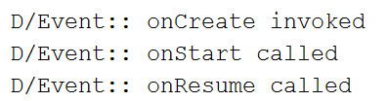

* Click “Back”



* Expected Results/Output after clicking “Back”

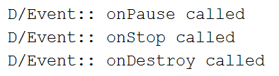

* Run the application again, then click “Home”
* Expected results/output after clicking “Home”

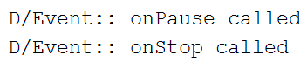

* Look and launch the application
* Expected results/output

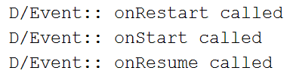

1. Working with TextView, Launcher icons, and ImageView [2 marks]
   1. On your own, try to create a similar application shown in AndroidHTP3_02 (ppt)
      1. Application name : Problem2
      2. Company name : yourLastName.com
      3. Project location : your choice
      4. Minimum SDK : your choice
      5. Layout : ConstraintLayout
      6. How launch Asset Studio

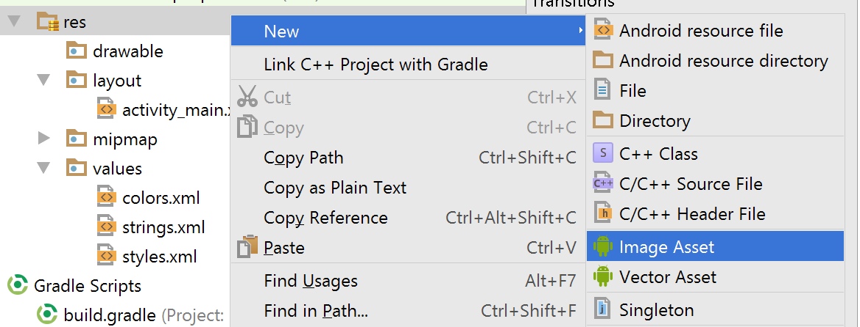

* Add the image for the launcher icon

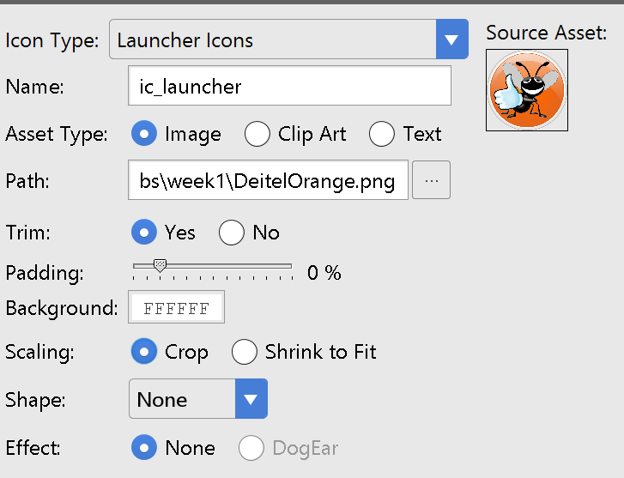

* Add the bug image. Copy and paste the image to the res/drawable. A dialogue box would appear

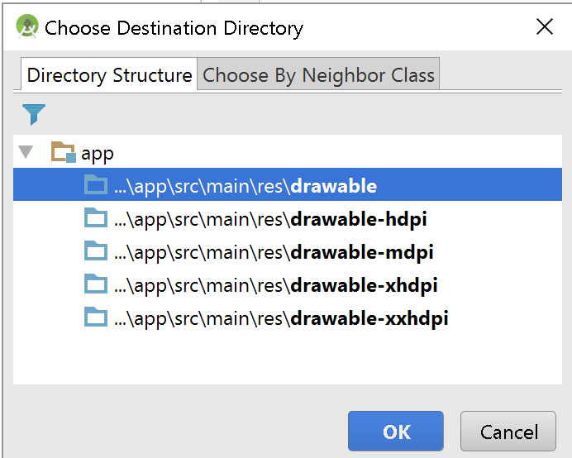

* + 1. Modifying the TextView’s properties
       1. text : Welcome to Android App Development
       2. textColor
       3. Gravity : Center
       4. textSize : 25sp
       5. background: any color you like
       6. layout_width and layout_height : resize as you wish
    2. Add an ImageView
    3. Sample Output

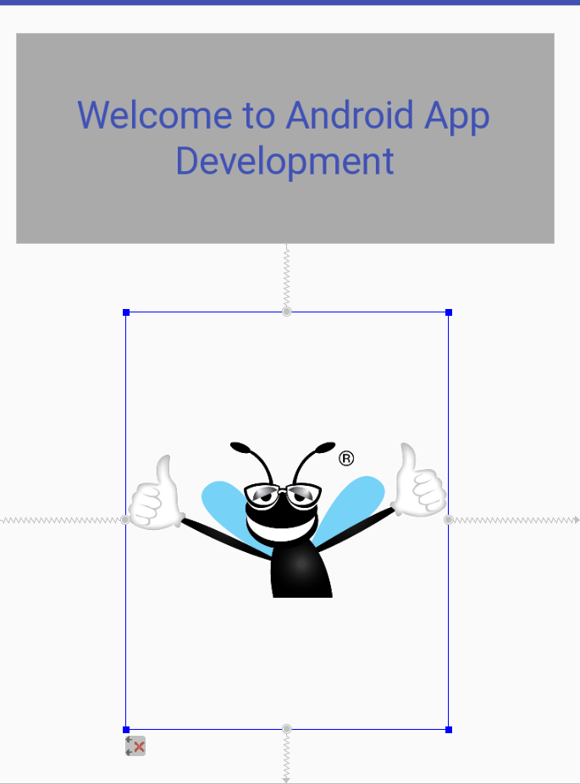

Other references

1. <https://www.javatpoint.com/AndroidManifest-xml-file-in-android>
2. Architecture: <https://developer.android.com/guide/platform/index.html>
3. Life cycle: <https://developer.android.com/guide/components/activities/activity-lifecycle.html>
4. Log: <https://developer.android.com/reference/android/util/Log.html>
5. Creating the first app:
   1. <https://www.tutorialspoint.com/android/android_hello_world_example.htm>