1. Calling another activity
   1. Create a new project

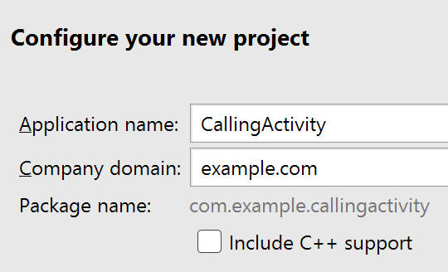

* 1. Use Empty Activity
  2. Use the default Activity and Layout Name
  3. Copy and paste Apple_pie.jpg to res/drawable
  4. Edit values/strings.xml

Change the app_name

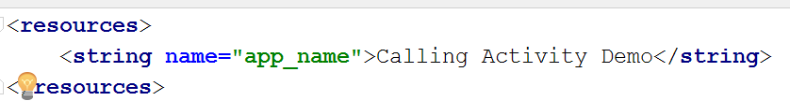

* 1. Edit activity_main.xml and create something similar

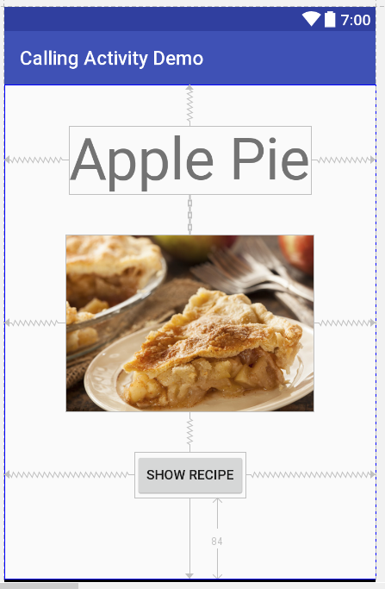







* 1. Create a new Activity.

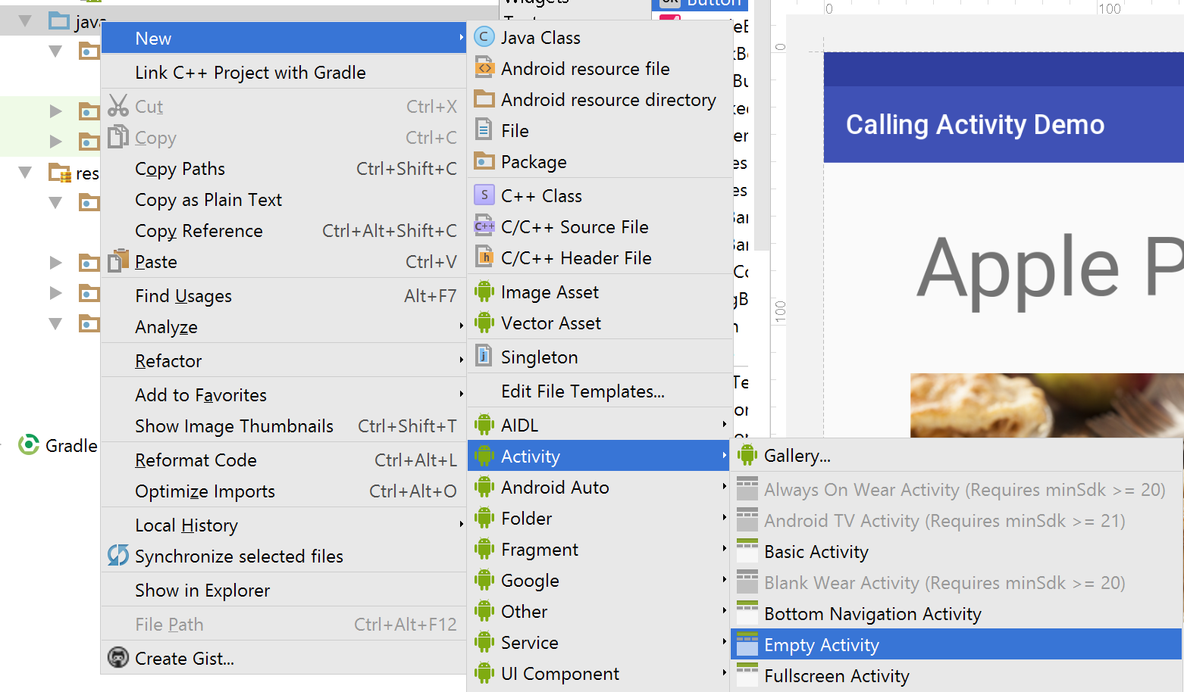

* 1. Set the Activity and Layout name

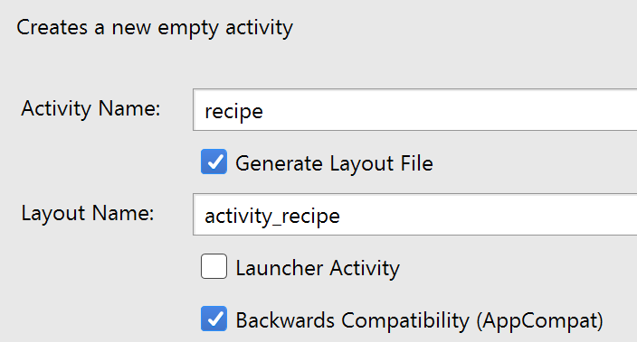

* 1. Open MainActivity.java and type the following

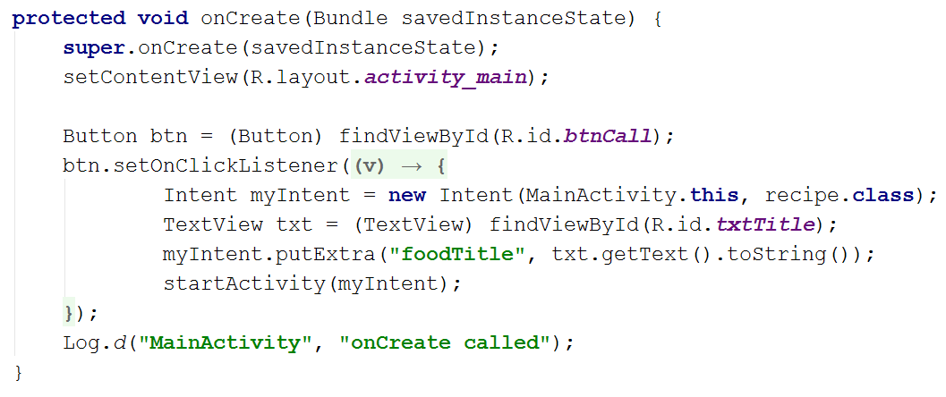

* 1. Edit activity_recipe.xml and create something similar

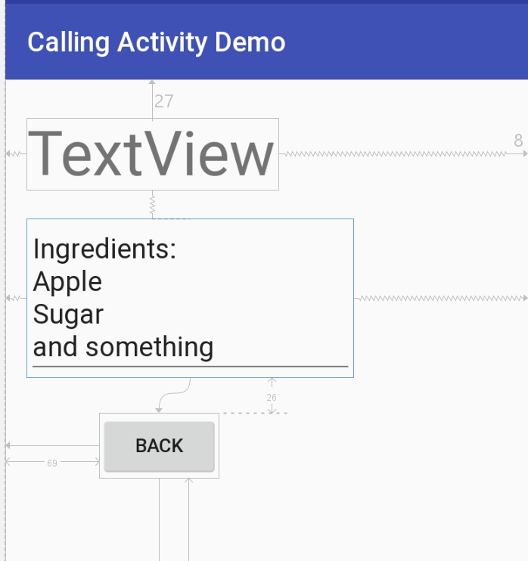

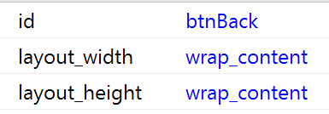

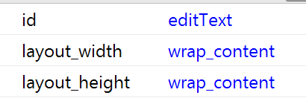

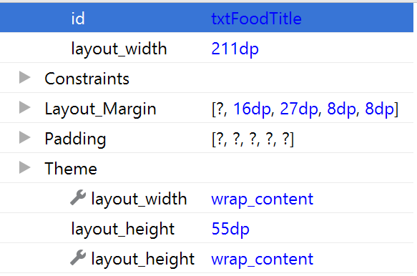

* 1. Open recipe.java and add the following code

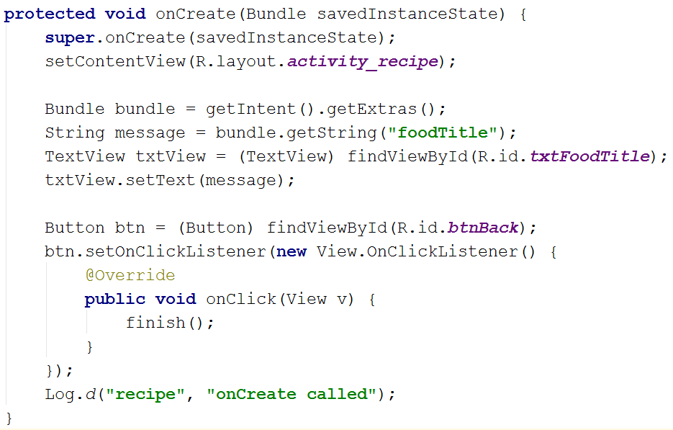

Activities

1. Create a recipe application for a salsa
   1. Image: salsa.png
   2. Additional button: Add a “Back” button on the second (recipe) page

|  |  |
| --- | --- |
|  |  |

1. Create an apartment rental application
   1. Image: apartment.png

|  |  |
| --- | --- |
|  |  |

1. Create an application that highlights a country
   1. Image: pick one image from North_America folder
   2. On the second activity, display the following information
      1. Name of the country/place
      2. Population
      3. Currency
      4. Official language
   3. Add a “Back” button