1. Doing calculation
   1. Create a new project

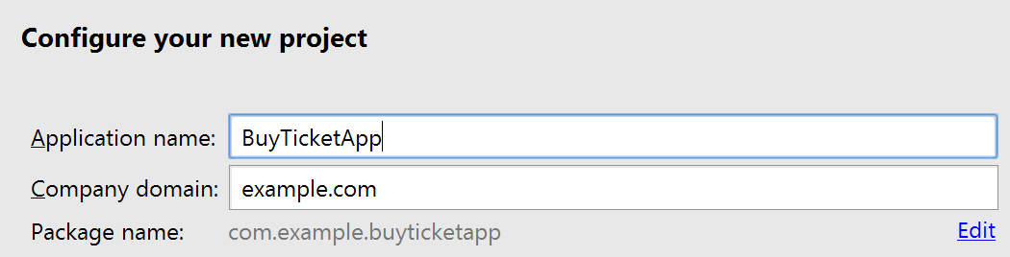

* 1. Use Empty Activity
  2. Use the default Activity and Layout Name
  3. Select strings.xml. Open the editor

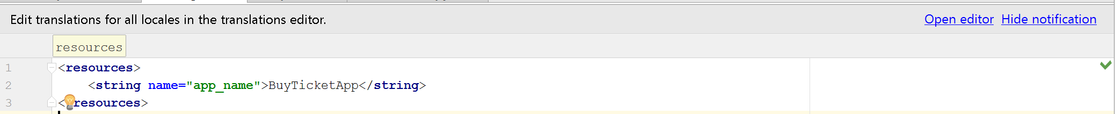

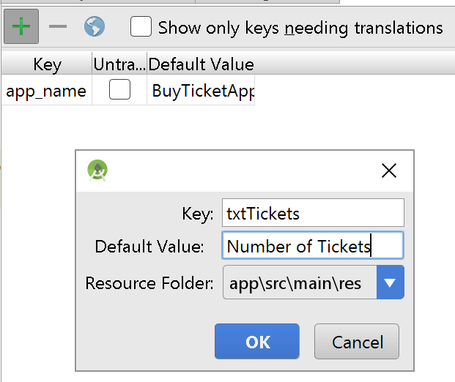

* 1. add the following <string-array>

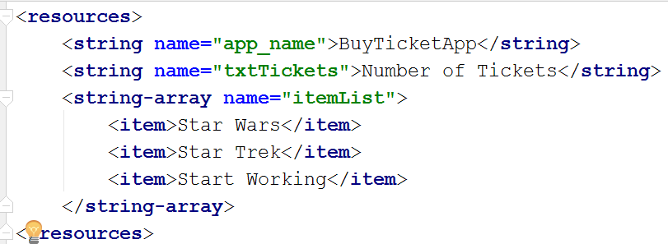

* 1. Open activity_main.xml and create something similar

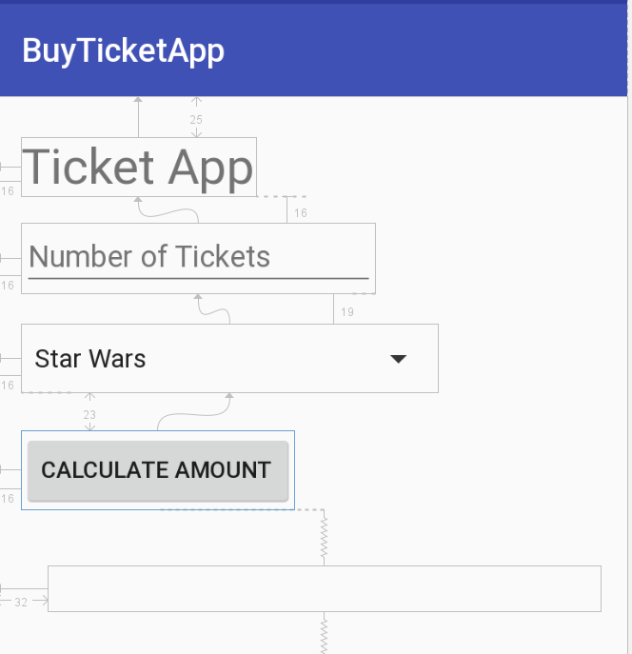

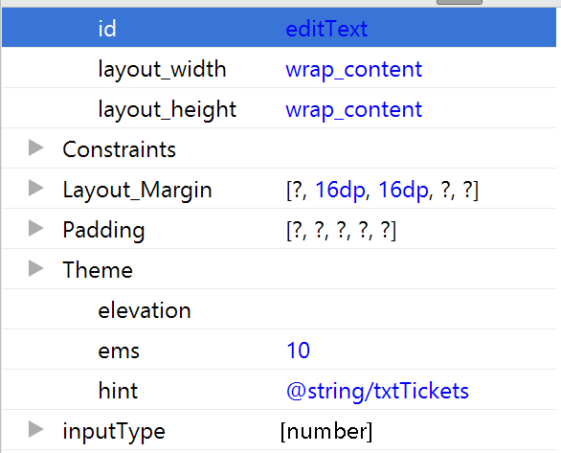

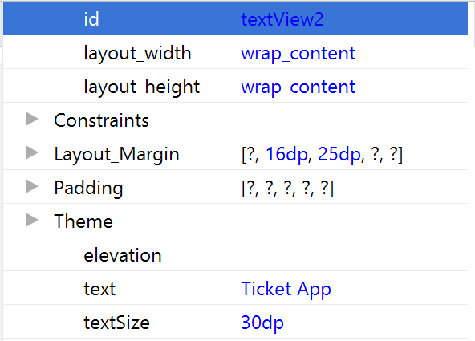

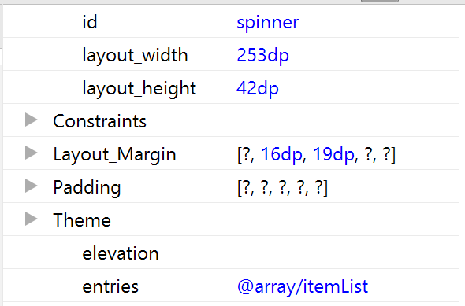

* 1. Open MainActivity.java and add the following code

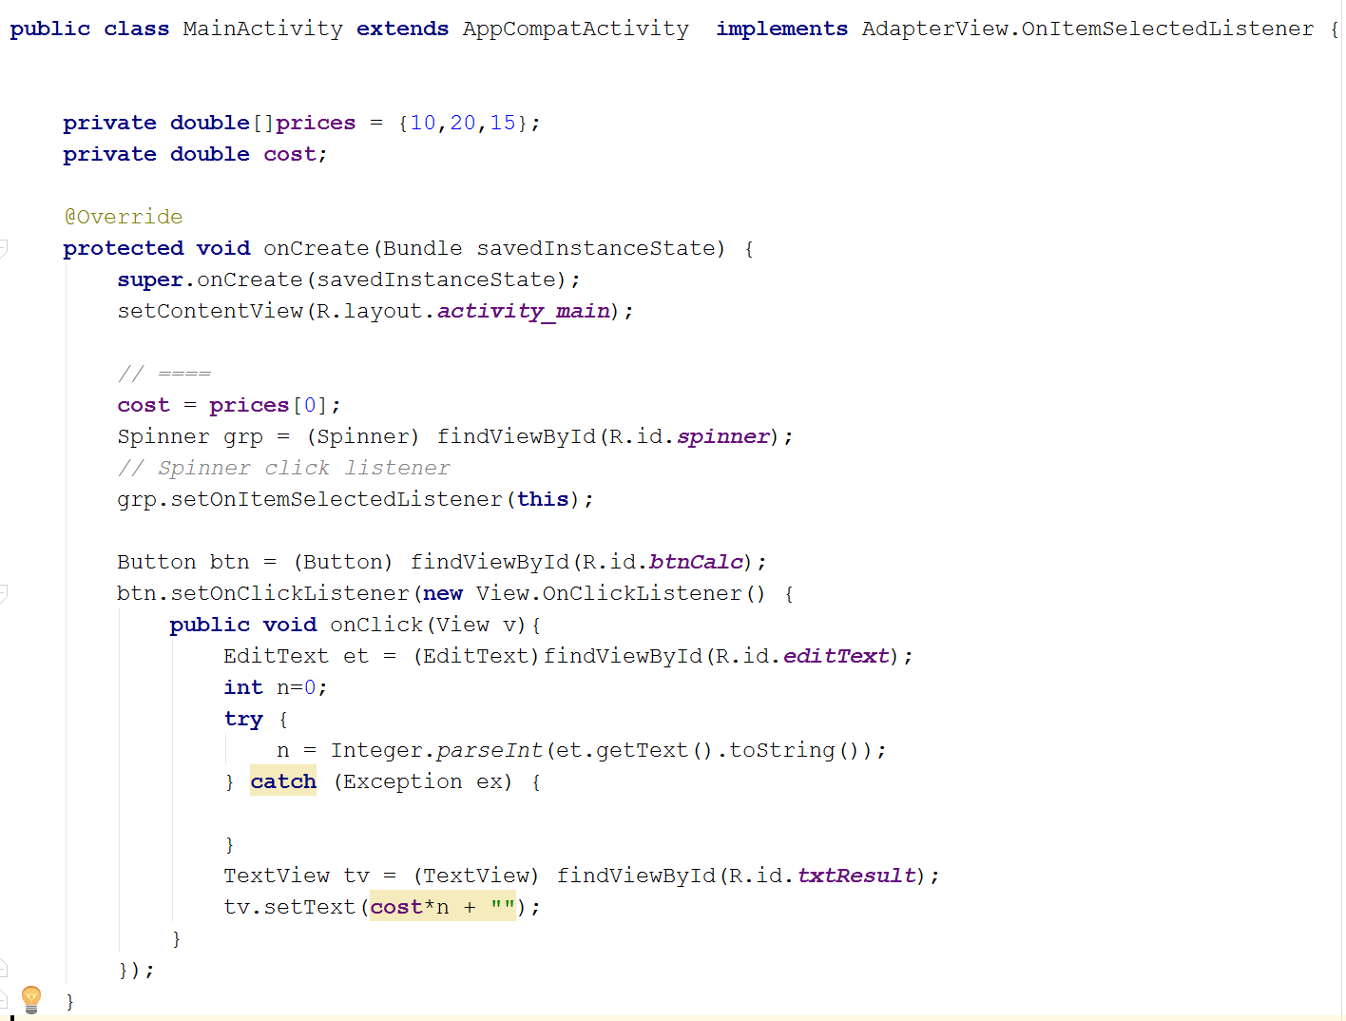

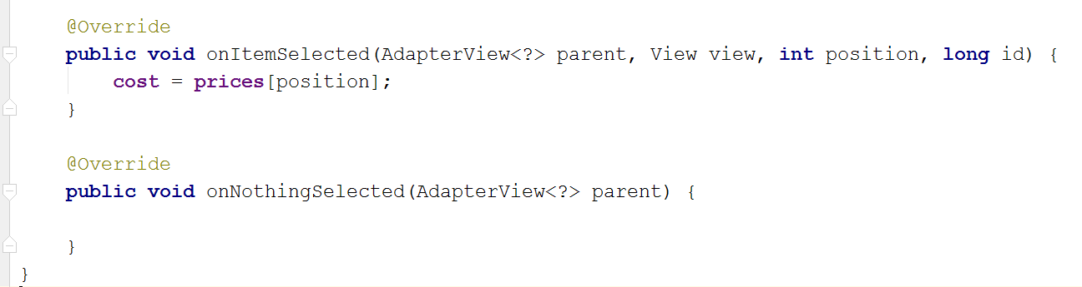

Activities

1. Case Project 3–2: Triathlon Registration App
2. Case Project 3–4: Chicago Cab Fare App