1. Playing App
   1. Create a new project

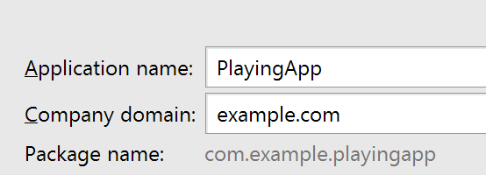

* 1. Use Empty Activity
  2. Use the default Activity and Layout Name
  3. Select strings.xml. Open the editor

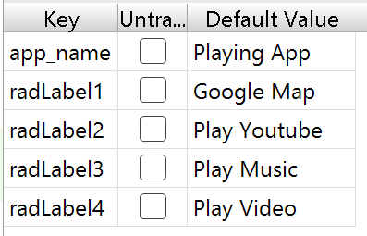

* 1. Select res folder and create a resource directory

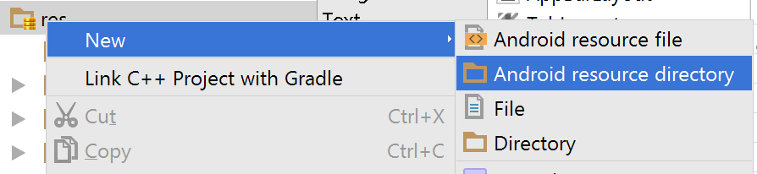

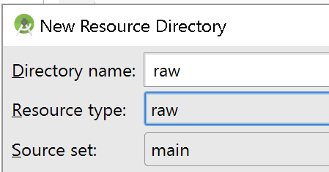

* Copy and paste the files to res/raw folder

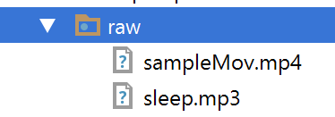

* 1. Open and edit activity_main.xml (Create something similar)

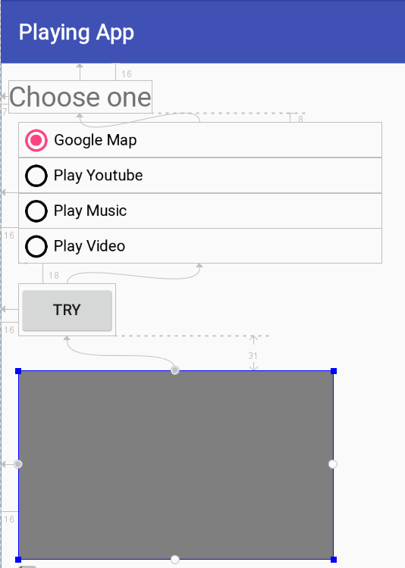

VideoView

|  |  |
| --- | --- |
|  |  |

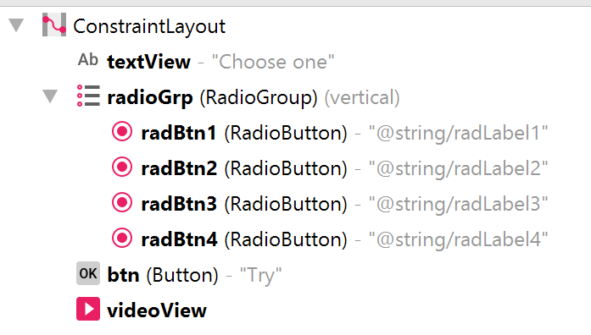

Note: You can use LinearLayout

* 1. open and edit MainActivity.java

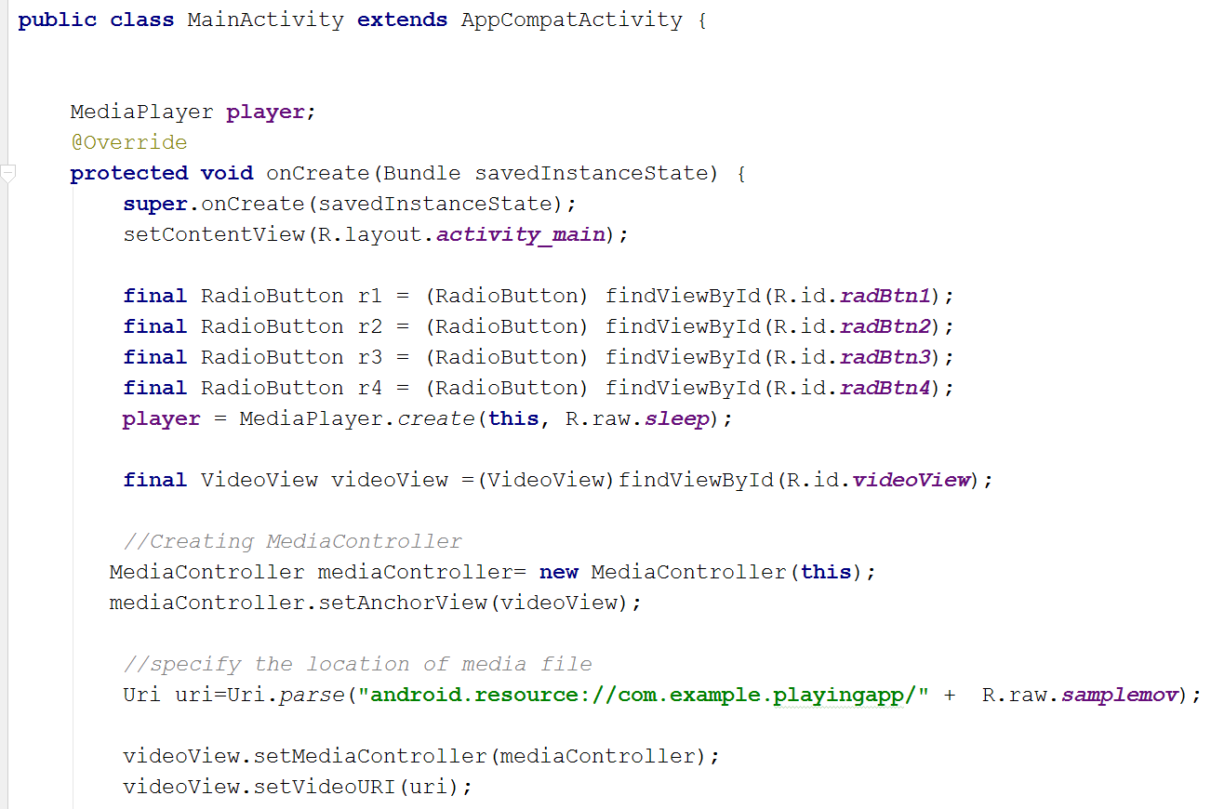

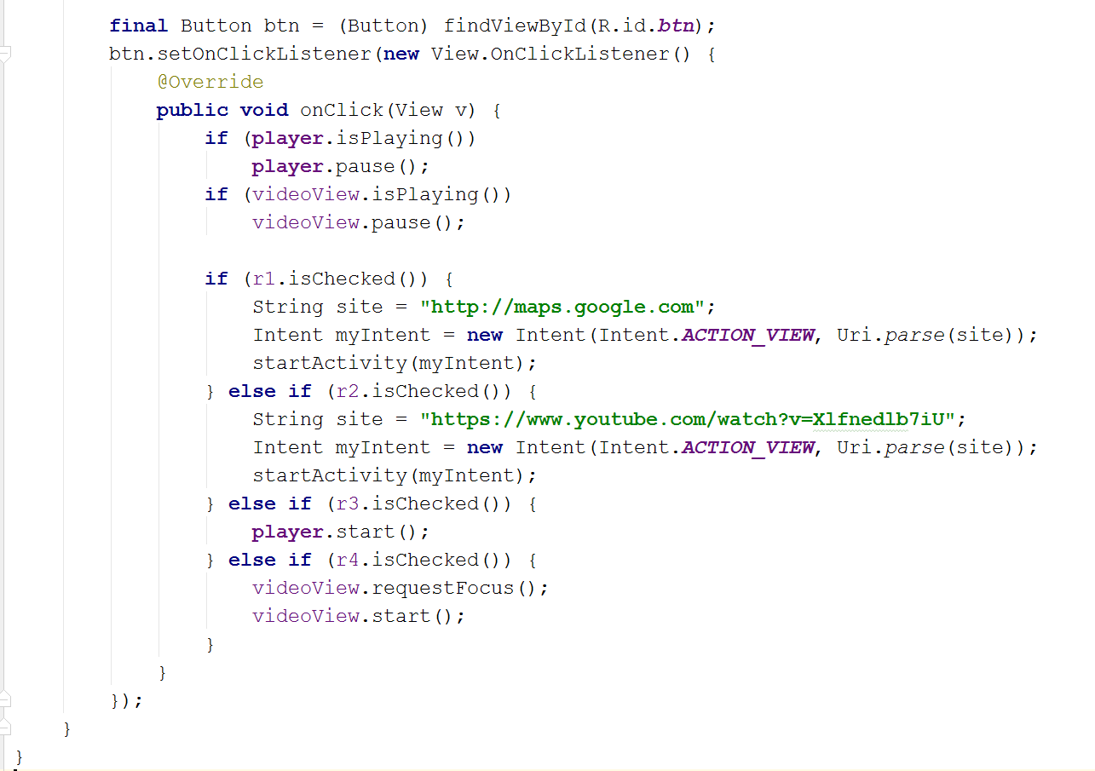

Activity

1. Case Project 6–1: Celtic Songs App

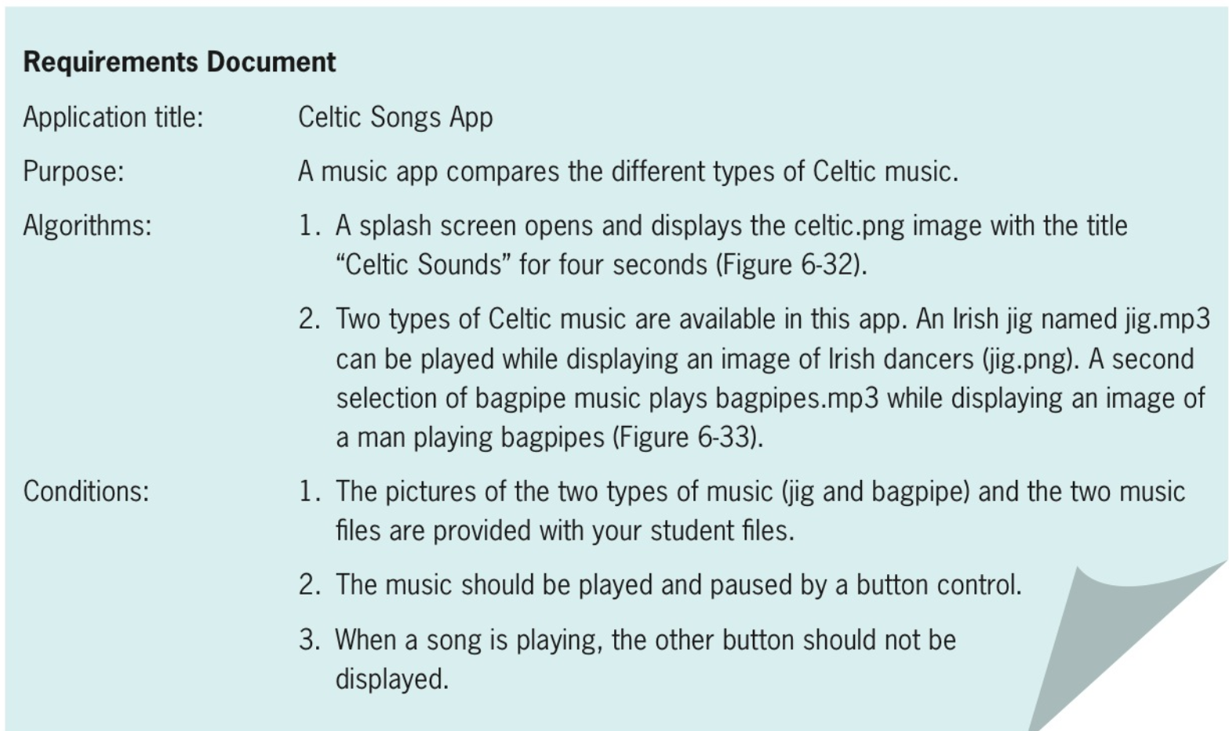

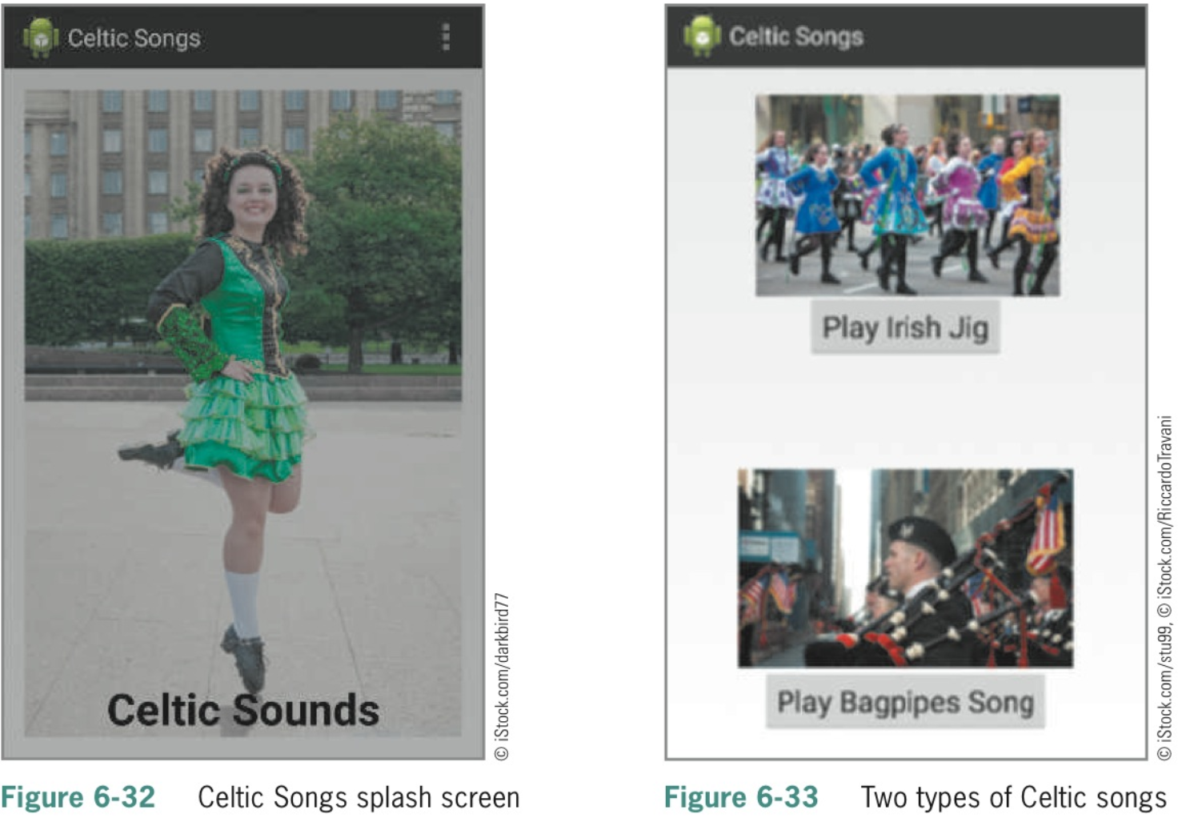

1. Case Project 6–2: Animal Voices Children’s App

