DOUGLAS COLLEGE
COMMERCE AND BUSINESS ADMINISTRATION
COURSE INFORMATION AND SCHEDULE
CSIS 3175 – Introduction to Mobile Develop

Instructor : Stephen Chiong
Office : N4335K
E-Mail : chiongs@douglascollege.ca
Section : 001 (Thu, 09:00 – 11:50)
002 (Wed, 09:00 – 11:50)

Office Hours: Wednesday/Thursday [12:30-15:30]
And by appointment

COURSE MATERIALS REQUIRED



CALENDAR COURSE DESCRIPTION

This course introduces students to mobile device development technology concepts used in business. Students will learn how to build applications and services to solve business problems. Topics covered include different mobile platforms, tools for development, user interface, and user experience design.

Learning Outcomes
The student will be able to:
- Install and use appropriate tools for mobile development;
- explain the mobile platform architecture;
- build user interfaces for mobile devices using Java;
- access and work with various mobile file systems;
- access and work with mobile database systems;
- create applications that make use of the mobile environment;
- use and work with built-in widgets and components on mobile devices.

Course Content
- Introduction to Layouts
- Views
- Intents on Android
- Menus
- Dialogs
- Introduction to Data Persistence
- SQLite and its applications
- Working in Background
- Location services and maps

EVALUATION

A final grade will be determined based on the following instruments and their corresponding weighted percentages:

Project(s)
- Mini project/lab 10%
- Main Project w/ defense 20%
Midterm 35%
Final Exam 35%
==================================
Total 100%

Note: You need to pass the project defense to get a mark on your project.

Course Objectives/Learning Outcomes:
http://www.douglascollege.ca/programs-courses/catalogue/courses

TRANSFERABILITY: See BC Transfer Guide at www.bccat.bc.ca for more details.

CLASSROOM CIVILITY AND SHARED RESPONSIBILITY

Cell phones are not allowed to be use in the classroom at all. Laptops and tablets may be used with the sole purpose of taking notes or reading the textbook. Generally, class time will include interactive lectures, class-participative case analysis and the occasional computer simulation or project workshop.
Class time is valuable to us all. Students are expected to attend, complete all assignments and tests and take part in problem-solving (cases, discussions…as fits the class). Students who miss a class are responsible for material covered in the missed class. Office hours are intended to assist students who have attended class and who wish additional help, not for the transmission of missed class content.
Late assignments: Assignments must be handed to me or submitted by the due date. Assignments handed in or submitted after the official due date will be marked but NOT GRADED, unless an extension has been arranged with the instructor PRIOR to the due date.

Missed quizzes: There will be more quizzes written than used for the final mark, therefore, missed quizzes will NOT be made up.

Missed Exams/Tests: Students MUST make every effort to write the tests/exam at the published time. Any exception to this must be arranged with the instructor BEFORE the time the exam should have been written.

Attendance and participation: Students are expected to prepare for, attend and actively participate in all class sessions and exercises, to sit the required tests and examinations, and to submit assignments as and when required. Students are responsible for all class announcements concerning course materials and/or assignment requirements, and/or schedule changed if they are in attendance. Any changes will be announced in class and may also be placed on Blackboard. Learners are expected to arrive to class on time and during class refrain from carrying on conversations with others during a lecture. Any students considered to be disrupting class will be given a warning which can lead to being asked to leave the class. All cell phones should be turned off during class.

Plagiarism and Cheating: Douglas College in common with other educational institutions condemns cheating or attempted cheating within its community. Reprimands and appeals will be exercised according to official college policy. DO NOT copy someone else’s work OR make it possible (intentionally or not) for someone else to copy your work. Do not use another person’s assignment effort as a template for your answer.

UN vs. F Grade: The grade of UN “Unofficial Withdrawal” shall be interpreted as being assigned to those students who have completed less than 70% of the total evaluation of the course.

Class Cancellation: If a class is cancelled due to instructor illness or other unforeseen circumstance, a notification will be made through Blackboard to every student enrolled in the course. It is the responsibility of every student to be proactive and to check their announcements and/or email before coming to class. Every effort will be made to ensure that the notification is made as soon as possible.

Grading

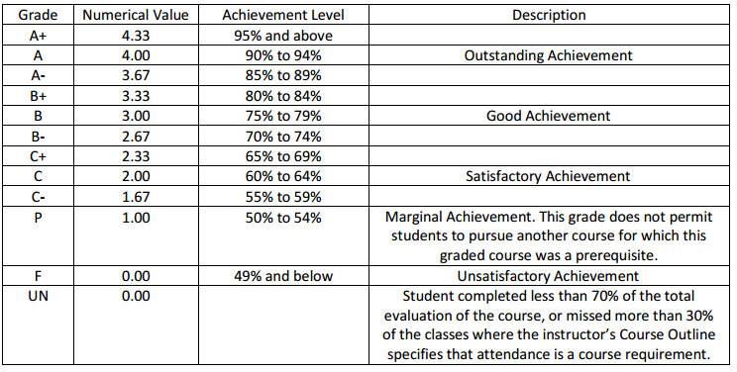

Avoid missing 30% or more of the classes.

