**Introduction**

I’m Andu Cao. I'm now attending Xi'an Jiaotong-Liverpool University to study child development and family education. My four years as an undergraduate have helped me become more self-assured and have taught me information and how to be a person. I have developed the trait of being positive and innovative while in school. I am excellent at communicating, value teamwork and am willing to learning new things and take on challenges.

I put a lot of effort into my studies, I have a keen interest in professional knowledge and am capable of critical thinking and analysis professional knowledge with confidence. I have received numerous awards at the university, including outstanding class leader. I have a strong foundation in English and the CET-6 Certificate. In terms of life and work, I formerly had a four-year term as a class monitor in college, and I take my job seriously and responsibly. Additionally, when acting as the monitor, I am able to fulfil the numerous duties given to me by the teacher on time and effectively, which not only develops my working skills but also my character and creates a down-to-earth work style. I have a strong interest in social work, and I'm particularly interested in working with young people. I've taught kindergarten in the past, so I have some knowledge in the field. I also have some managerial experience from my time working as an intern in various kindergartens. I operate under the tenet that everything is determined by attitude. I am confident that if I work tirelessly and with attention to detail, I will undoubtedly produce amazing outcomes.

**Target**

Special interest groups have drawn an increasing amount of attention from society as a result of the growth of times and the advancement of science. Children with ADHD have traditionally been marginalized as members of special populations. When it comes to the theory and practise of treating children with ADHD, medication therapy and conventional behavioural and educational interventions frequently receive more attention than study on and use of contemporary technology tools. Numerous experimental studies have demonstrated the effectiveness of using technology, including media, video, computers, and virtual reality, for the treatment of ADHD in young patients. Since games are inherently a part of childhood, the initial goal of this project's design was to figure out how to include educational games into the teaching and rehabilitation of children with ADHD using virtual reality.

Attention deficit hyperactivity disorder in children, or ADHD, is another name for the condition, which mostly affects school-age children and is classified as a neurological disease. The illness develops slowly and is challenging to treat. It is sometimes referred to as a chronic illness. With a frequency of 2.59%–7.25% and a male to female ratio of 4:1, with slightly more boys affected, ADHD is a prevalent condition in youngsters.Statistics show that there are around 16 million children with ADHD in China, and these children behave differently than their classmates, as seen by their hyperactivity, trouble focusing, anxiety, and other symptoms. They do worse than typical kids in the areas of emotional regulation, activity, executive function, learning, and social interaction.

Children with ADHD have trouble paying attention, which is one of their greatest traits. They frequently have a penchant for novelty or are too engrossed in their own world to desire to interact with others. Making children with ADHD fit into society is the ultimate objective of education and therapy. It is not advisable to use forceful and direct methods to attain this purpose.Children with ADHD may benefit from a virtual environment that allows for indirect social imitation. They can practise their social and learning skills while avoiding the anxiety and risk that come with coming into contact with actual people and things by engaging with virtual people or items. The virtual reality educational games used in this approach of teaching and rehabilitation for ADHD youngsters match the personalities of these kids.

Since children with ADHD are typically younger and have behavioural abilities that are impaired, games must be created to account for their age and weaknesses. It should be neither too difficult nor too simple, try to avoid their cognitive disorders, and It should be designed in a way that children can easily imitate or learn. This will help to ensure that kids will accept games positively.

**Project**

I finally made the decision to design the game space into three linear spaces of continuous forward movement, each of which has different training content designed for the various behavioural defects of ADHD children, after years of studying the weaknesses and defects of ADHD children in addition to the existing game modes. There will be a steady influx of different rings in these three linear movement spaces. Children with ADHD just need to push the handle button while simultaneously aiming their gaze towards the rings in order to collect them. Though it seems like a relatively straightforward game, it's not. This game's complexity stems from the fact that both the attributes of the numerous rings and the entire linear space vary. It's not easy to capture each ring in time. Next, I will make a brief introduction to the difficulty of each stage and the purpose of training.

First, a quick explanation of the game's overall mechanism is provided. A sight will be in front of the children's eyes when they first begin the game. The ring will be properly grabbed when the sight is pointed at it and the game pad button is pressed at the same moment. The game is played entirely in terms of accumulating points. The game score associated with each caught ring can be raised; if a ring is missed, the game score associated with that ring is reduced. The ring's score will increase in proportion to how complicated the motion state of the ring is. The aim with the eyes and grip with the controller is used because it helps children with ADHD develop hand-eye coordination.

The first stage of the game: a single ring, the whole linear space starts to move forward, and slowly moving rings constantly appear at the end of the space and fly towards the experiencer. All the rings maintain the same state, as shown in the figure below. This stage can be understood as the teaching stage, whose main function is to guide children to focus on the ring and get familiar with the operation. Capture it with the handle button.

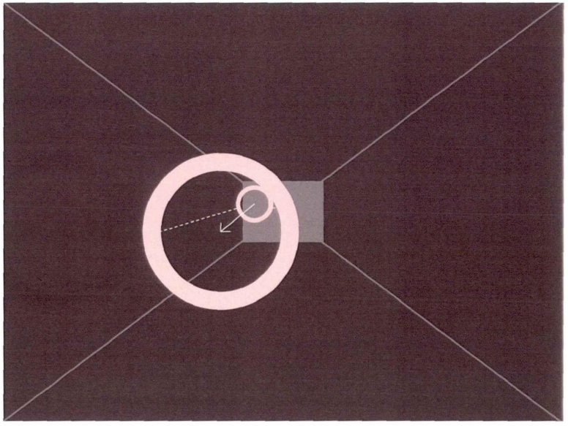

The second stage of the game: gravity ring, this stage introduces the influence factor of gravity of the ring itself, as shown in the figure below, also divided into slow ring and fast ring, the gravity attribute of the ring will constantly bounce in space, the height of the release ball is different, the generated elastic force and the frequency of jumping will also change, coupled with the influence of fast and slow speed on the ring. This requires children with ADHD to predict the elasticity and speed of the rings in advance in order to capture all the rings.

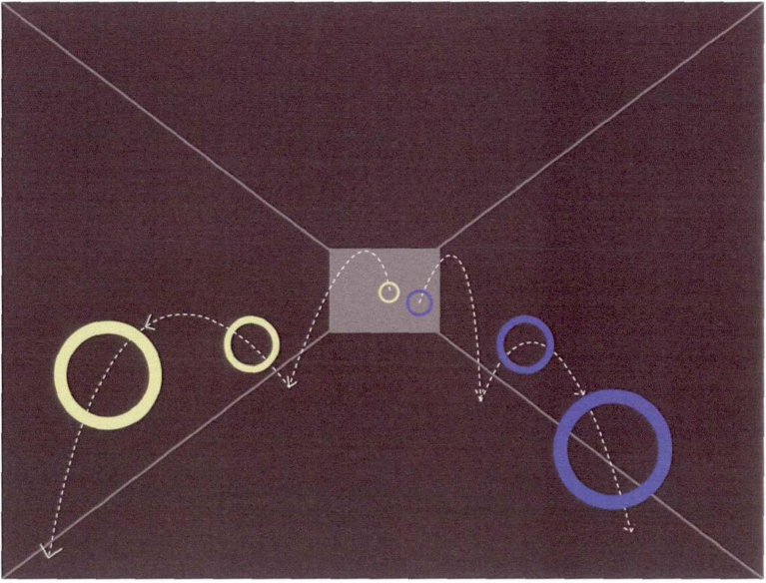

The third stage of the game: space obstacle. As shown below, four states (fast and slow loops and fast and slow loops of gravity) fly to the experiencer from the end of linear space. At the same time, the whole game space becomes complex and changeable, and the complexity of the space increases the difficulty of successfully capturing the players. This stage mainly cultivates the renewal ability of children with ADHD, that is, the ability to respond in a flexible and adaptive way, in order to keep up with the changes of the environment.

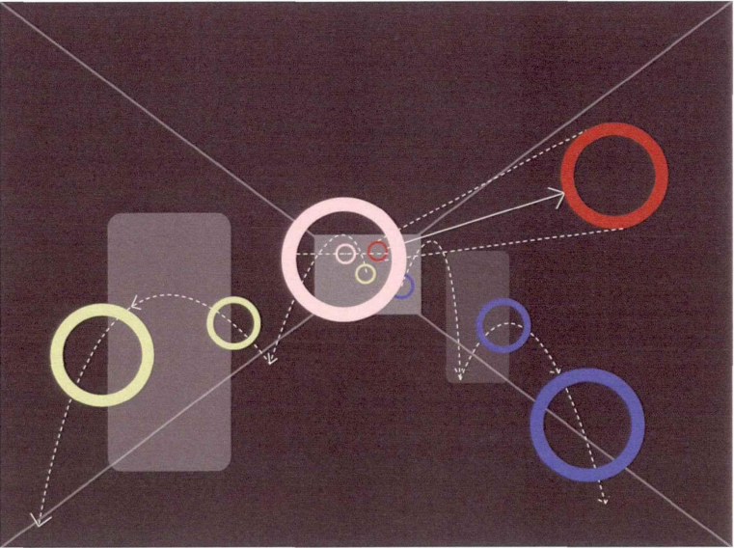

This programme offers physical and mental training for children's attention, learning capacity, memory, and sensory integration in order to aid in the rehabilitation of children with ADHD. This is done in accordance with the congenital flaws of children with ADHD. Unlike pharmacological therapy, which has negative effects, this programme is more like a game. As a result, parents and kids are more likely to embrace this method of recovery through entertainment and instruction.

Children with ADHD are now receiving the majority of their therapies independently. For instance, sensory integration training is mostly for children's physical quality whereas family education is primarily for children's psychological or intellectual development. The forms are rather straightforward, and there is no integration between the various rehabilitation techniques. This programme develops children's physical coordination in addition to their observation, memory, logical thinking, and learning abilities through the logical linkage of six levels. It is more engaging and imaginative than the standard rehabilitation approach. Children may contact and interact with their parents by following instructions and working together with them to finish the game.