**What’s web technologies?**

Web technology is the development of mechanism that allows two of more computer devices to communicate over a network. For instance, in a typical office setting, a number of computers plus additional devices such as printers may beinterconnected via network, allowing for quick and convenient transmission of information. The processes involved in web technology are complex and diverse, which is why major businesses employ whole departments to deal with the issue. web technology has revolutionized communication methods and has made operations far more efficient.

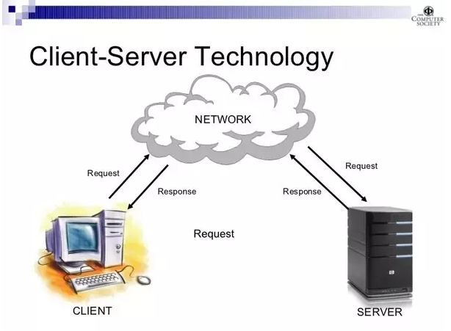

You probably know that computers don't communicate with each other the way that people do. Instead, computers require codes, or directions. These binary codes and commands allow computers to process needed information. Every second, billions upon billions of ones and zeros are processed in order to provide you with the information you need.

So what does that have to do with your ability to post your latest pictures online? Everything.

The methods by which computers communicate with each other through the use of markup languages and multimedia packages is known as **web technology**. In the past few decades, web technology has undergone a dramatic transition, from a few marked up web pages to the ability to do very specific work on a network without interruption. Let's look at some examples of web technology.

**The origin and history of web**

Tim Berners-Lee, a British scientist, invented the **World Wide Web** (WWW) in 1989, while working at CERN. The **Web was** originally conceived and developed to meet the demand for automated information-sharing between scientists in universities and institutes around the **world**.





Berners-Lee was born on 8 June 1955 in London, England,[[26]](https://en.wikipedia.org/wiki/Tim_Berners-Lee#cite_note-W3Bio-26) the eldest of the four children of [Mary Lee Woods](https://en.wikipedia.org/wiki/Mary_Lee_Woods) and [Conway Berners-Lee](https://en.wikipedia.org/wiki/Conway_Berners-Lee); his brother [Mike](https://en.wikipedia.org/wiki/Mike_Berners-Lee) is an expert on [greenhouse gases](https://en.wikipedia.org/wiki/Greenhouse_gas). His parents were computer scientists who worked on the first commercially built computer, the [Ferranti Mark 1](https://en.wikipedia.org/wiki/Ferranti_Mark_1). He attended Sheen Mount Primary School, and then went on to attend south west London's [Emanuel School](https://en.wikipedia.org/wiki/Emanuel_School) from 1969 to 1973, at the time a [direct grant grammar school](https://en.wikipedia.org/wiki/Direct_grant_grammar_school), which became an [independent school](https://en.wikipedia.org/wiki/Independent_school) in 1975.[[1]](https://en.wikipedia.org/wiki/Tim_Berners-Lee#cite_note-whoswho-1)[[18]](https://en.wikipedia.org/wiki/Tim_Berners-Lee#cite_note-tecb-18) A keen [trainspotter](https://en.wikipedia.org/wiki/Trainspotter) as a child, he learnt about electronics from tinkering with a model railway.[[27]](https://en.wikipedia.org/wiki/Tim_Berners-Lee#cite_note-27) He studied at [The Queen's College, Oxford](https://en.wikipedia.org/wiki/The_Queen%27s_College,_Oxford), from 1973 to 1976, where he received a [first-class](https://en.wikipedia.org/wiki/British_undergraduate_degree_classification#First-class_honours) [bachelor of arts](https://en.wikipedia.org/wiki/Bachelor_of_arts) degree in physics.[[1]](https://en.wikipedia.org/wiki/Tim_Berners-Lee#cite_note-whoswho-1)[[26]](https://en.wikipedia.org/wiki/Tim_Berners-Lee#cite_note-W3Bio-26) While at university, Berners-Lee made a computer out of an old [television set](https://en.wikipedia.org/wiki/Television_set), which he bought from a repair shop.[[28]](https://en.wikipedia.org/wiki/Tim_Berners-Lee#cite_note-auto1-28)

By October of 1990, Tim had written the three fundamental technologies that remain the foundation of today’s web (and which you may have seen appear on parts of your web browser):

* HTML: HyperText Markup Language. The markup (formatting) language for the web.
* URI: Uniform Resource Identifier. A kind of “address” that is unique and used to identify to each resource on the web. It is also commonly called a URL.
* HTTP: Hypertext Transfer Protocol. Allows for the retrieval of linked resources from across the web.
* History of web technology

<https://webfoundation.org/about/vision/history-of-the-web/>

3 - The development of web technologies.

**Web development** is the work involved in developing a [web site](https://en.wikipedia.org/wiki/Web_site) for the [Internet](https://en.wikipedia.org/wiki/Internet) ([World Wide Web](https://en.wikipedia.org/wiki/World_Wide_Web)) or an [intranet](https://en.wikipedia.org/wiki/Intranet) (a private network).[[1]](https://en.wikipedia.org/wiki/Web_development#cite_note-1) Web development can range from developing a simple single [static page](https://en.wikipedia.org/wiki/Static_web_page) of [plain text](https://en.wikipedia.org/wiki/Plain_text) to complex web-based [internet applications](https://en.wikipedia.org/wiki/Internet_application) (web apps), [electronic businesses](https://en.wikipedia.org/wiki/Electronic_business), and [social network services](https://en.wikipedia.org/wiki/Social_network_service). A more comprehensive list of tasks to which web development commonly refers, may include [web engineering](https://en.wikipedia.org/wiki/Web_engineering), [web design](https://en.wikipedia.org/wiki/Web_design), [web content development](https://en.wikipedia.org/wiki/Web_content_development), client liaison, [client-side](https://en.wikipedia.org/wiki/Client-side_scripting)/[server-side](https://en.wikipedia.org/wiki/Server-side_scripting) [scripting](https://en.wikipedia.org/wiki/Computer_programming), [web server](https://en.wikipedia.org/wiki/Web_server) and [network security](https://en.wikipedia.org/wiki/Network_security) configuration, and [e-commerce](https://en.wikipedia.org/wiki/E-commerce) development.

Since the [commercialization of the web](https://en.wikipedia.org/wiki/History_of_the_World_Wide_Web#1996%E2%80%931998:_Commercialization_of_the_WWW), web development has been a growing [industry](https://en.wikipedia.org/wiki/Industry). The growth of this industry is being driven by businesses wishing to use their website to advertise and sell products and services to customers.[[3]](https://en.wikipedia.org/wiki/Web_development#cite_note-3)

There are many [open source](https://en.wikipedia.org/wiki/Open_source) tools for web development such as [BerkeleyDB](https://en.wikipedia.org/wiki/Berkeley_DB), [GlassFish](https://en.wikipedia.org/wiki/GlassFish), [LAMP](https://en.wikipedia.org/wiki/LAMP_(software_bundle)) ([Linux](https://en.wikipedia.org/wiki/Linux), [Apache](https://en.wikipedia.org/wiki/Apache_HTTP_Server), [MySQL](https://en.wikipedia.org/wiki/MySQL), [PHP](https://en.wikipedia.org/wiki/PHP)) stack and [Perl/Plack](https://en.wikipedia.org/wiki/Plack_(software)). This has kept the cost of learning web development to a minimum. Another contributing factor to the growth of the industry has been the rise of easy-to-use [WYSIWYG](https://en.wikipedia.org/wiki/WYSIWYG) web-development software, such as [Adobe Dreamweaver](https://en.wikipedia.org/wiki/Adobe_Dreamweaver), [BlueGriffon](https://en.wikipedia.org/wiki/BlueGriffon) and [Microsoft Visual Studio](https://en.wikipedia.org/wiki/Microsoft_Visual_Studio). Knowledge of [HyperText Markup Language](https://en.wikipedia.org/wiki/HTML) (HTML) or of programming languages is still required to use such software, but the basics can be learned and implemented quickly.

An ever-growing set of tools and technologies have helped developers build more dynamic and interactive websites. Further, web developers now help to deliver applications as web services which were traditionally only available as applications on a desk-based computer. This has allowed for many opportunities to decentralize information and media distribution. Examples can be seen with the rise of [cloud](https://en.wikipedia.org/wiki/Cloud_computing) services such as [Adobe Creative Cloud](https://en.wikipedia.org/wiki/Adobe_Creative_Cloud), [Dropbox](https://en.wikipedia.org/wiki/Dropbox_(service)) and [Google Drive](https://en.wikipedia.org/wiki/Google_Drive). These web services allow users to interact with applications from many locations, instead of being tied to a specific workstation for their application environment.

Examples of dramatic transformation in communication and commerce led by web development include e-commerce. Online auction sites such as [eBay](https://en.wikipedia.org/wiki/EBay) have changed the way consumers find and purchase goods and services. Online retailers such as [Amazon.com](https://en.wikipedia.org/wiki/Amazon.com) and [Buy.com](https://en.wikipedia.org/wiki/Buy.com) (among many others) have transformed the shopping and bargain-hunting experience for many consumers. Another example of transformative communication led by web development is the [blog](https://en.wikipedia.org/wiki/Blog). Web applications such as [WordPress](https://en.wikipedia.org/wiki/WordPress) and [Movable Type](https://en.wikipedia.org/wiki/Movable_Type) have created blog-environments for individual websites. The increased usage of open-source [content management systems](https://en.wikipedia.org/wiki/Content_management_systems) and [enterprise content management](https://en.wikipedia.org/wiki/Enterprise_content_management) systems has extended web development's impact at online interaction and communication.

Web development has also impacted personal networking and marketing. Websites are no longer simply tools for work or for [commerce](https://en.wikipedia.org/wiki/Commerce), but serve more broadly for communication and [social networking](https://en.wikipedia.org/wiki/Social_networking). Web sites such as [Facebook](https://en.wikipedia.org/wiki/Facebook) and [Twitter](https://en.wikipedia.org/wiki/Twitter) provide users with a platform to communicate and organizations with a more personal and interactive way to engage the public.

Chronology

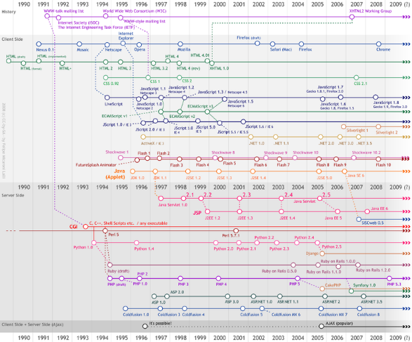

<https://home.cern/science/computing/birth-web/short-history-web>

4 - Present web technology

<https://yourstory.com/mystory/7-best-web-development-tools-and-resources>

5 - Languages used to design and execute the website

The page which you watching has to written by someone in some language. That part is called Front end and it will be written by HTML, CSS, JavaScript, JQuery are some of them. And the server part called as Back end it may be in PHP, C#, Java, Perl are few to mention. And all the data will present in the Database.

<https://tms-outsource.com/blog/posts/web-technologies/>



6 - Web technologies in future

<https://www.webnexs.com/blog/future-6-best-web-technologies-trends-2018/>