Industrial Programming CW2 – Report

Introduction
The purpose of this report is to outline the approach I took in the completion of CW2, data analysis of a document tracker.
There are several different levels of functionality required in this assignment, the application must be able to read in a JSON file. Once the file has been parsed the user should be able to select a specific function and the application will return a result to the user in either the form of a histogram or graph.
The python application should be able to return what countries/continents a specified document has been viewed in, what browsers are used to view the document, present profiles of the people who have read that document, provided the user with other documents that are related to the searched document and display a graph presenting the relationships between certain documents and certain readers.

Requirements Checklist
TASK | IMPLEMENTED
GUI | Implemented
CLI – Command line interface | Implemented
Histogram plotting | Implemented
Histogram of countries given a document id | Implemented
Histogram of continents given a document id | Implemented
Histogram of browsers used (full agent id) | Implemented
Histogram of browsers (browser name only) | Implemented
List of reader profiles | Implemented
Sorting List of reader profiles into top 10 | Implemented
Function that takes a doc id and returns all who have read that document | Implemented
Function that takes a user id and returns all documents that user has read | Implemented
Passing a sorting function to also likes | Implemented
Graphical representation of liked documents – using graphviz | Not implemented

Design Considerations
The GUI is a relatively small part of this application. The application can be interacted with entirely outside of the GUI, using the command line and passing in command line arguments. Nevertheless I tried my best to make the UI as simple and intuitive as possible.
The UI consists of three input boxes and seven buttons. Each button is labelled clearly and its functions are exactly what it says on the label. Rather than printing out most of the error messages in the terminal I kept most of the messages in the GUI, where possible (I will speak on this later). Therefore, whenever the user attempts to do something without the appropriate inputs message boxes warning them of this will appear.
There is one instance in which an error will only get printed in the terminal, this is when the JSON file cannot be found – a way around this would have been events however python does not currently support events.

User Guide

Developer Guide
Class Design:
Classes were created as a direct result of the requirements of the application. From the beginning it was obvious there was the necessity for a GUI class, I wanted my GUI to be separated from the rest of the code as much as possible.
The CLI code is also completely separated from the rest of the functionality of the application. The CLI class only interacts with the command line arguments and if none are passed in the class is not used at all. The main python file that runs the application checks to see if command line arguments have been passed in and if they have not the GUI is used, as shown below. 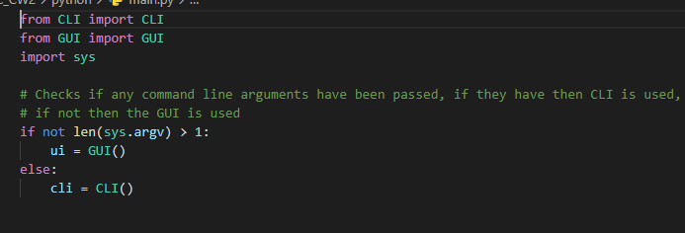
I realised that with the requirement that the application would have to work both with a GUI and a CLI I realised that I would need a class to manage each of the actions the application was to make. The action manager class came about to invoke functionality in other classes from either the GUI or CLI.

The action manager is responsible for issuing commands to the rest of the application, depending on what action it receives from the GUI or CLI a specific function will be called:
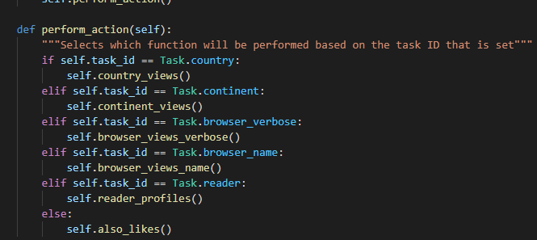
This function checks what the Task ID is, Task ID passed through when the action manager is initialised, and depending on that value one of 6 functions will get called.

Data Structures:
There are two data structurers used in my application, lists and dictionaries.
I chose to use dictionaries anywhere that required key – value pairs. This was essentially only in the DataAnalysis class. This class required I keep track of a certain value from the JSON data set and usually required a count of how many times that specific value appears (when it has be read).
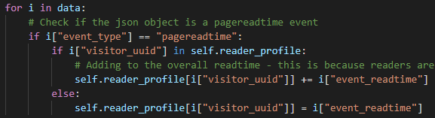
A good example of this is illustrated above.

Reflections on programming language
Python is rather easy to work with, especially when it comes to OOP, something I was quite surprised by.
Programming in OOP was rather like programming in OOP in any other object-oriented language, before the undertaking of this project I had a preconceived idea that python was only a scripting language and had no support for OOP.
There are some strengths where python is concerned. The syntax is much more simplified than any of the C-Style languages I am more familiar with. This is not necessarily a good or bad thing; it is simply something that I had to get used to.
As previously mentioned, events were something I felt would have been lead to an improvement in the project I also believe that switch statements would have also provided a much cleaner implementation of some functionality, a good example is here:
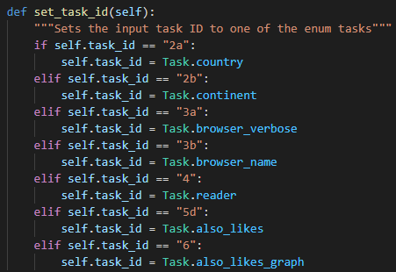
Python does support switches in later versions, however 3.9, the version installed on the Linux machines, does not.

What did I learn from CW1?
Looking back on my CW1 I found that the main issue was separation of functionality. My UI and my browser logic were heavily intertwined, the code that ran the UI was also running most of the browser code.
There was separation of browser functionality, the favourites/history classes were separated from the UI code, but all of the methods contained within those classes were being accessed and called from the UI code directly.
This time around I have been very careful to separate functionality, trying to only keep necessary functionality in the necessary places.
I found that it was also very easy to make your UI unintuitive, there was an issue in CW1 where it was not clear at all that the home button could be right clicked to gain access to the button’s secondary functionality. This time around, while the UI is much simpler, I tried to make sure that it was intuitive, and all functionality was presented straight away.

Conclusions
The major missing element in this project is the lack of graphical representation of the liked documents. This is purely down to a mismanagement of time.
There are other issues with the project, however these lie in the repetition of code in the DataAnalysis class. Most of the functions here are quite similar and had the project been started sooner it would have been a case of simplifying most of these down to one function that loops through the data and adds values to a provided dictionary. This code repetition is the one major failure of the work that was completed.
I do believe that overall application has appropriate separation of functionality.

References
All internet resources used in the completion of the project are included in the source files as well as here.
- https://stackoverflow.com/questions/11604653/how-to-add-command-line-arguments-with-flags-in-python3
- https://stackoverflow.com/questions/34667710/pattern-matching-tkinter-child-widgets-winfo-children-to-determine-type
- http://www.macs.hw.ac.uk/~hwloidl/Courses/F21SC/Samples/simple_histo.py

