1. SELECT COUNT(CustomerName)

FROM Customers

WHERE Country='Germany';

Result – 11

1. SELECT \* FROM Customers

WHERE CustomerName LIKE '%e';

Result – 14

1. INSERT INTO Customers

VALUES ('92', 'Anna Guseva', 'Anna Guseva', 'Russkaya St. 23', 'Novosibirsk', '630058', 'Russia');

SELECT \* FROM Customers

WHERE CustomerName LIKE 'Anna Guseva';

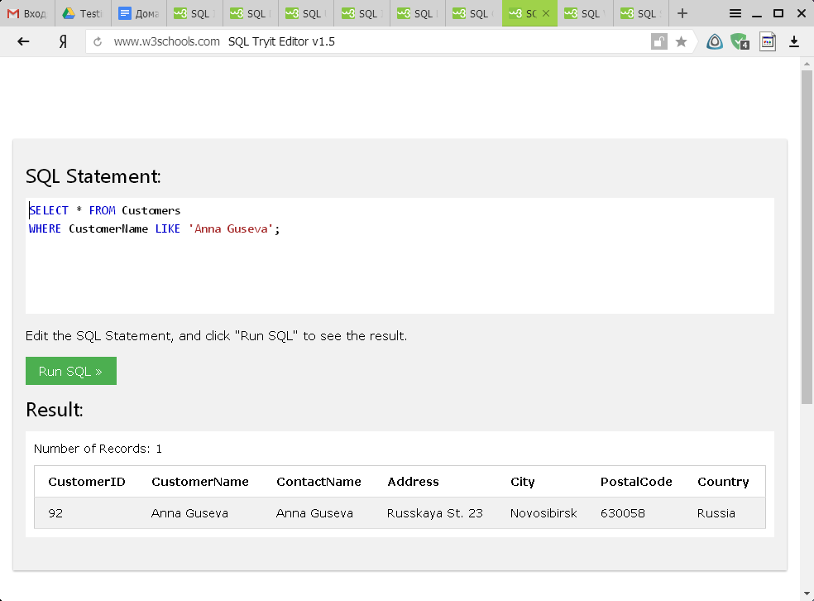

1. UPDATE Customers

SET CustomerName='Anastasiya Guseva', ContactName='Anastasiya Guseva'

WHERE CustomerID=92;

SELECT \* FROM Customers

WHERE CustomerName LIKE 'Anastasiya Guseva';

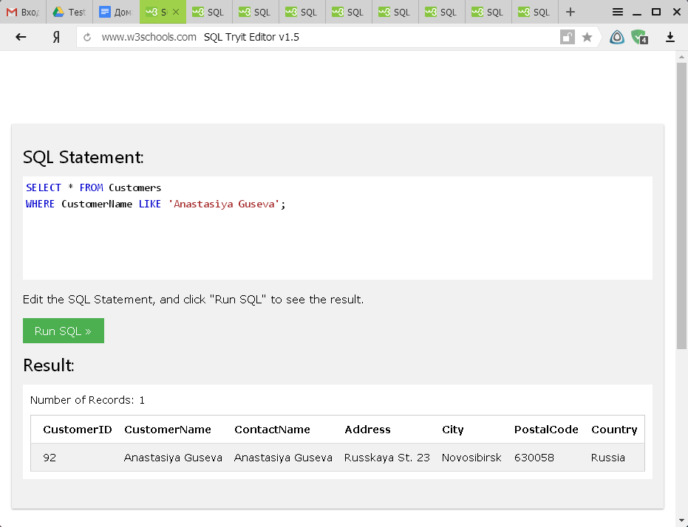

1. DELETE FROM Customers

WHERE City='Nantes';

Result – 2 (deleted)

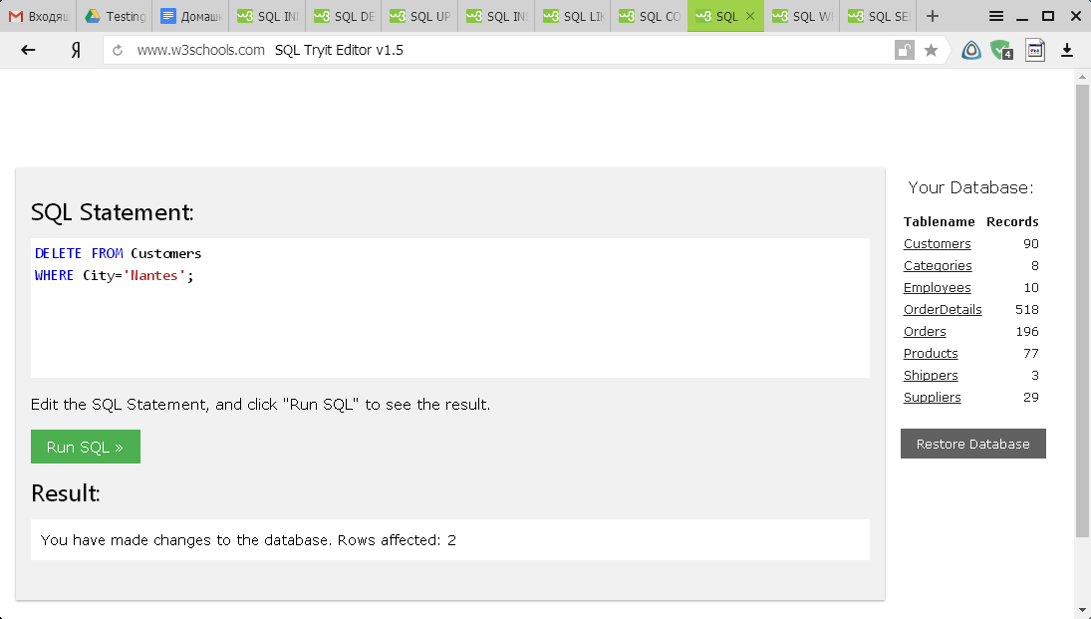

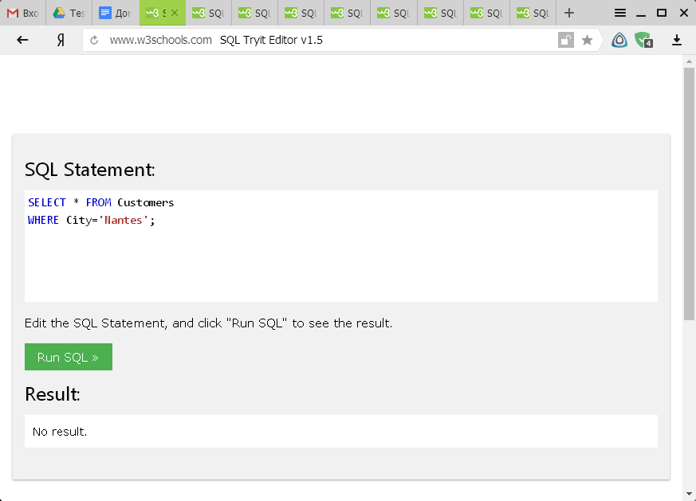

1. SELECT Orders.OrderID, Employees.FirstName

FROM Orders

INNER JOIN Employees ON Orders.EmployeeID = Employees.EmployeeID WHERE FirstName LIKE 'Steven';

