Control your software application
with C³

C³ is a Java library providing component abstraction, as its main feature. Component has to be used to structure your software. Before, defining your software's component frame, you have to define : what and how your application's user can do. C³ provides to define that, an Application class, which is described inside this article.

An application can be seen as a black box, it is created by coder and used by user. Their needs are different, the coder wants to write the simplest program with the requested functions. Users wants to be able to configure it easily with a correct documentation. A very simple sample is used for this article. It is a “HelloWorld” application which is able to salute. Let's see together what C³ provides for it.
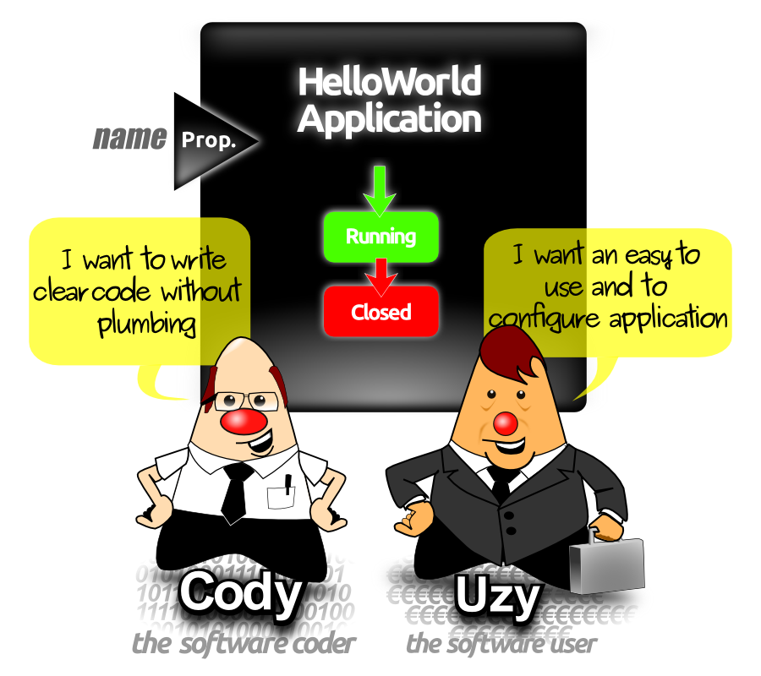
Application class provides the following features :
- application state-machine : Coder can benefit from the simple C³ application state machine. Let's start with only two important states “Running” and “Closed”. By sub-classing the abstract Application class, the compiler will force you to implement the events. At run-time, your events will be called before each state
- application property : application shall be configurable by the software user with java properties (other configuration type might be added in next version). The annotation called @AppProperty handles simply this functionality in a declarative manner and C³ does the plumbing for you.
- generic help with auto-documented mechanism : No plumbing code shall be added for displaying the application name, the about informations and the properties. C³ discovers automatically all the application features and display them, when the software user adds the “-help” parameter to launch its software.

Application annotation

@AppInformation (version="1.0", about="This a Hello world application with C³")
public class HelloWorldApplication extends Application {
….
}

C³ provides an application annotation in which the version can be set and also an about text. This information will be able to be read by the software user.

Application state machine
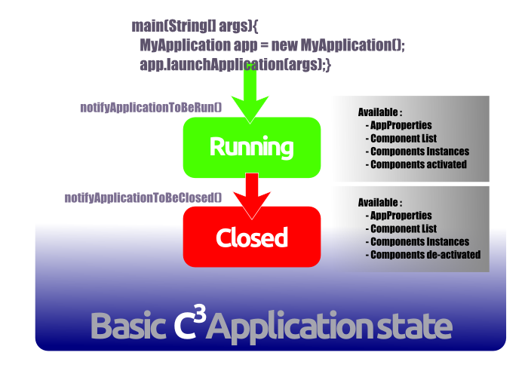

For simple software, C³ provides an application state-machine, with only two states “Running” and “Closed”. Just before reaching each of the two states, C³ will notify you with the two events notifyApplicationToBeRun, and notifyApplicationToBeClosed.
The first one is called when all AppProperties are ready, and when components are created. A future article will talk about components. Basically, this event has to be used to configure and to start your application.
The second one is called when the application is stopped. C³ detects, for you, that your application is closing and notify it. This Event can be used to cleanly close resource such as a socket, a database, or a file etc..

@AppInformation (version="1.0", about="This a Hello world application with C³")
public class HelloWorldApplication extends Application {
@Override
public void notifyApplicationToBeRun(String applicationDescrition, String componentsDescription) {
System.out.println("Application started");
}

@Override
public void notifyApplicationToBeClosed() {
System.out.println("bye bye, application closed");
}
}

AppProperty annotation

Java language provides system property which can be set either on java command line with “-D” prefix or by loading a property file. Property is a key/value pair, and value are get from its key.
C³ provides annotations in order to automatically link a property to your class Application member. The principle is basic, by being declarative. This way the code is more functional and less technical. What you have to do is to add, as class member, the needed configuration with the Application. For instance, let's say that an application needs to be configured with a name to salute. All you have to do is to add, inside your own Application's sub class, a member like :
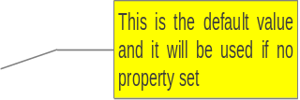
@AppProperty
String name = "World";

The above piece of code can be read as this is a property called name and its default value is “world”. Automatically the “name” system property is available for configuring your application.

Min and max value can be added for some numerical properties

@AppProperty(comment = "primitive value", min = 3, max = 7)
int intValue1 = 5;

Application member type supported so far are listed in the below table :
Type | comment
int | min and max values can be defined
java.lang.Integer | min and max values can be defined
double | min and max values can be defined
java.lang.Double | min and max values can be defined
java.lang.String
java.awt.Color | color value in hexadecimal
java.nio.filePath | Check if the file exist and raise and error an system.error if not.

Extra types can be easily added by implementing the generic interface ObjectFactoryFromStringValue which shall return the defined generic type from a string. When the factory is written just add it with the following method at your application creation.

public void addNewObjectFactory(Class<?> objectFactoryType, ObjectFactoryFromStringValue<?> factory)


Application command line
C³ provides default command parameters such with the keyword “-help”, “-h”, “--help” or “--h”. When called with one of this parameters, C³ put on the system output the name of the application, some about information, the version of the application and the list of properties, with its type.

Either use your own code typed from the samples or download the ready to use classes

At http://c3.capcaval.org/download.html download :
- C3.jar
- HelloWorldApplication.zip

Unzip the file, and go inside the root directory. You need to run with a Java7 jre. After launch the following command line and result :

java -cp .:./c3.jar c3sample.HelloWorldApplication

with the following result
Application first state

Application started
Salute with the default value
Hello World!
bye bye, application closed
Application last state

In order to know the available application properties used the -help parameter as below :

java -cp .:./c3.jar c3sample.HelloWorldApplication -help

the result shall be :
Application name
**************************************************************************
Application Name : HelloWorldApplication
Application Version
Version : 1.0
About : This a Hello world application with C³
-----------------------------------------------------------------------
The available properties are :
Application information
name
comment : Application which salute anyone.
This application got only one
Property named name
type : String
**************************************************************************

Configure your application
Of course the default value in our case “world” can be changed for the “name” property. Just write the above command line:

java -cp .:./c3.jar -Dname="Uzy" c3sample.HelloWorldApplication

Use « -D » property followed by the
Property name

The application result shall be :

Application started
« world » default value is not used anymore
Replace by the configured one
Hello Uzy!
bye bye, application closed

Mik Arber
founder of C³ : c3.capcaval.org
Jug Leader : finistjug.fr
blog : miksblog.capcaval.org

