1/28/26 – 1/29/26
Summary: Looked at compressed air options and compatibility. Explored a mutable and modular schematic for valve control and decided to reduce project scope to accommodate lower engineering complexities. Created designed pressure control circuit to cut out the microcontroller in favor of just the pi.
Compressed air Research:
https://www.vevor.com/diving-snorkeling-c_13730/vevor-mini-scuba-tank-0-5l-portable-diving-tank-for-underwater-breathing-reusable-lung-diving-cylinder-up-to-10-minutes-dive-time-emergency-rescue-pony-bottle-with-bag-and-lanyard-for-snorkeling-p_010590332402?adp=gmc&utm_source=google&utm_medium=cpc&utm_id=12662136951&ad_group=120277860237&ad_id=511500383956&utm_term=&gad_source=1&gad_campaignid=12662136951&gclid=Cj0KCQiAp-zLBhDkARIsABcYc6vXG_DnRlvuOhXstf7fGZJfOssDfsqbHhyuEEk9fGXHofH9Ofu4awkaAhT7EALw_wcB

https://www.homedepot.com/p/VEVOR-PCP-Hand-Pump-4-Stage-30Mpa-4500-PSI-High-Pressure-PCP-Air-Rifile-Filling-Stirrup-Pump-for-Airguns-Scuba-Tank-SDQQCQB4000PSVH1RV0/329398485?source=shoppingads&locale=en-US&fp=ggl

Circuit stuff:
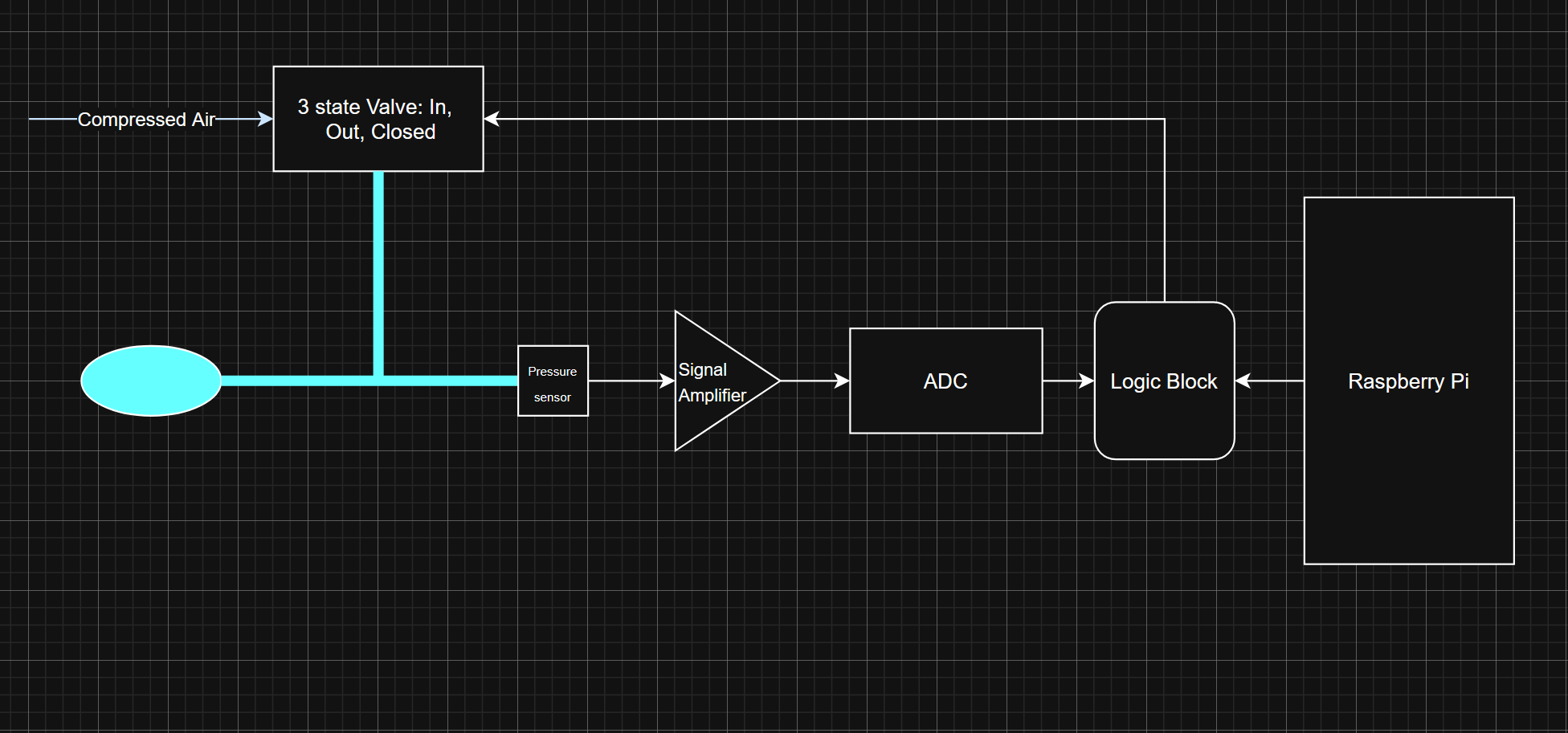
Handwritten notes and scratch:

