Assignment 1

For this assignment I’ve taken the following datasets:

1. Microsoft inc. (MSFT) daily stock prices from Yahoo finance.
2. Electronic Arts (EA) daily stock prices from Google finance.
3. Crude Oil Prices: Brent - Europe (DCOILBRENTEU) daily price index from Federal Reserve. (PCU31141131141117)
4. S&P (^GSPC) daily index from Yahoo finance.

All of the datasets are filtered to be from 2010-01-01 to 2017-01-01.

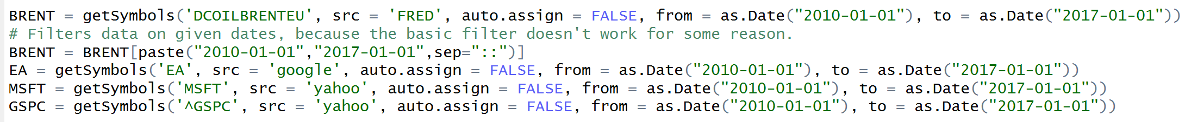

1. Except Brent Oil process, the chosen datasets have no “NA” values, which can be seen on the following picture:

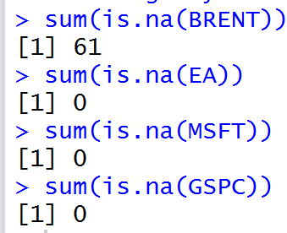

Brent has 61 “voids” in throughout the whole period, which is seen on the following graph on the FRED website:

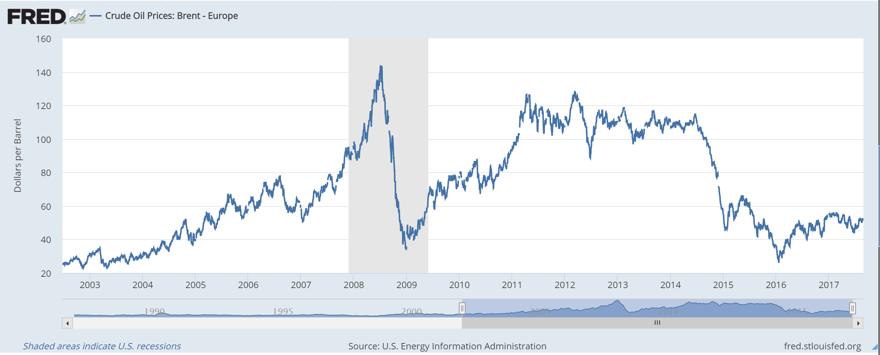

It is easily avoided by the na.omit function in R.

1. In the code.
2. The required statistics can be obtained by using the basicStats command from the fbasics package. The result on all of the examined stocks can be seen on the following picture:

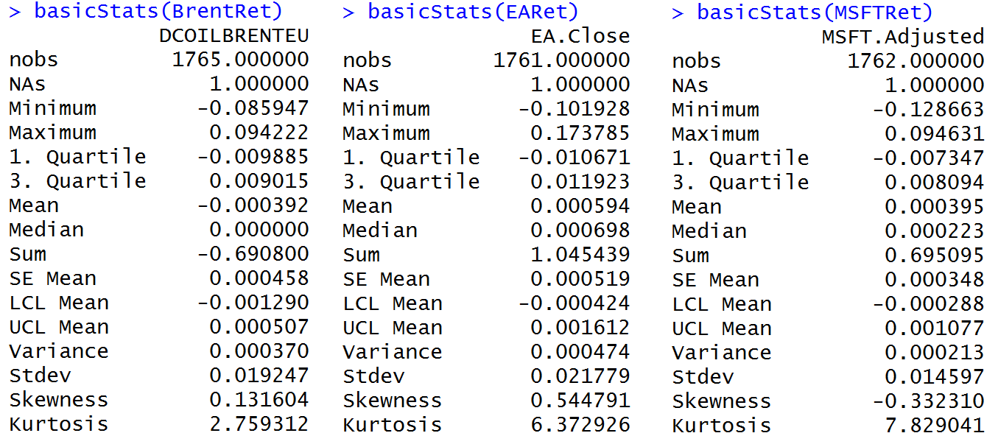

1. The graphs on the stock returns density and theoretical normal distributed densities are shown below. On the first glance all the data seems to be normally distributed as they represent the typical form of “bell”.

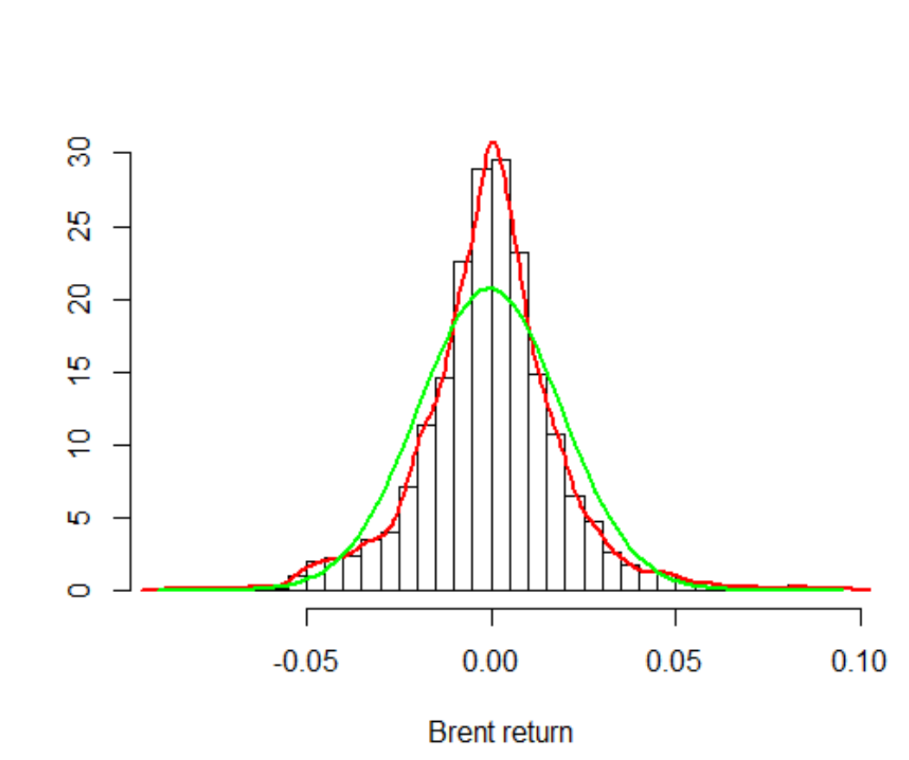 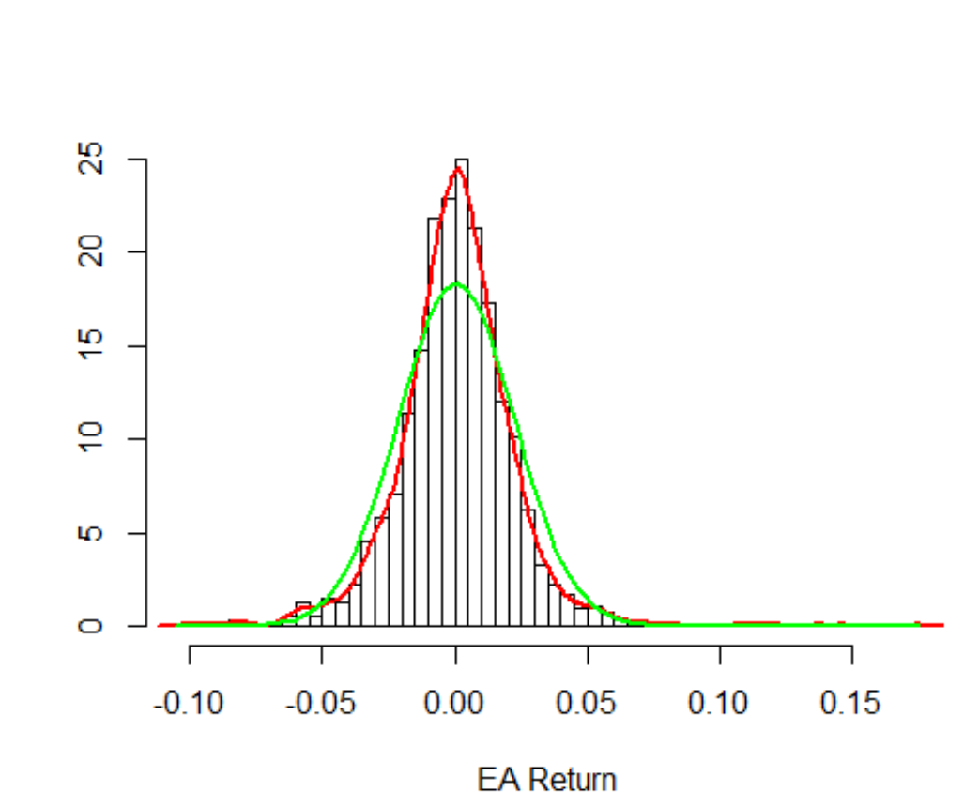 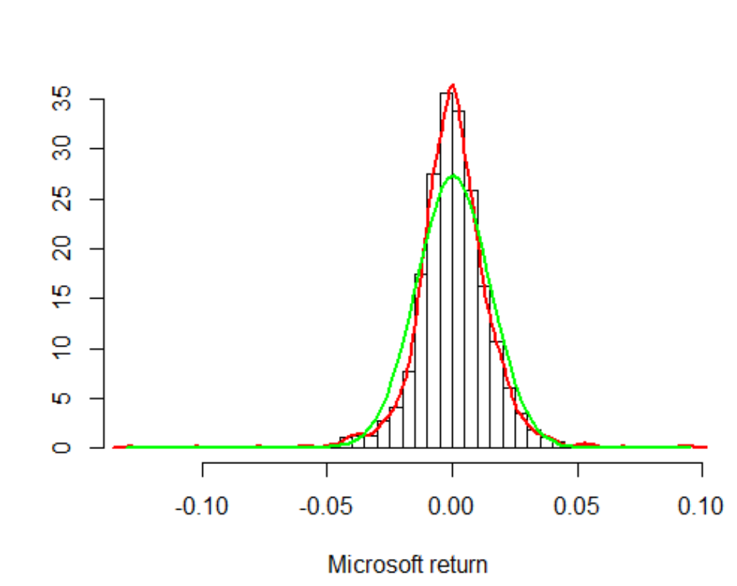

1. The following pictures show QQ plots for the stocks return. In these graphs we see that the data doesn’t lay in the normal distribution area. Therefore all of the datasets aren’t normally distributed because they don’t fit into 95% confidence interval required for normal distribution.

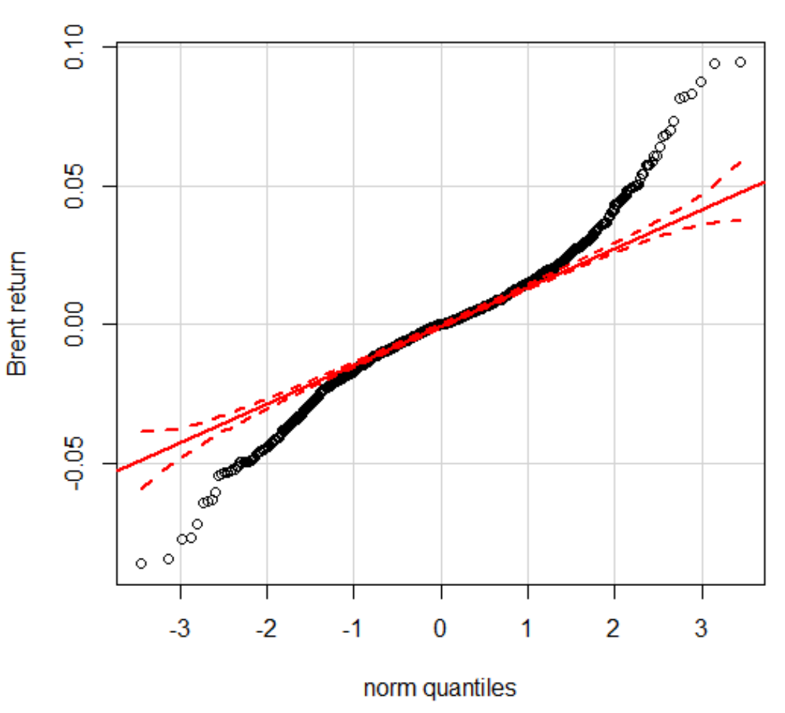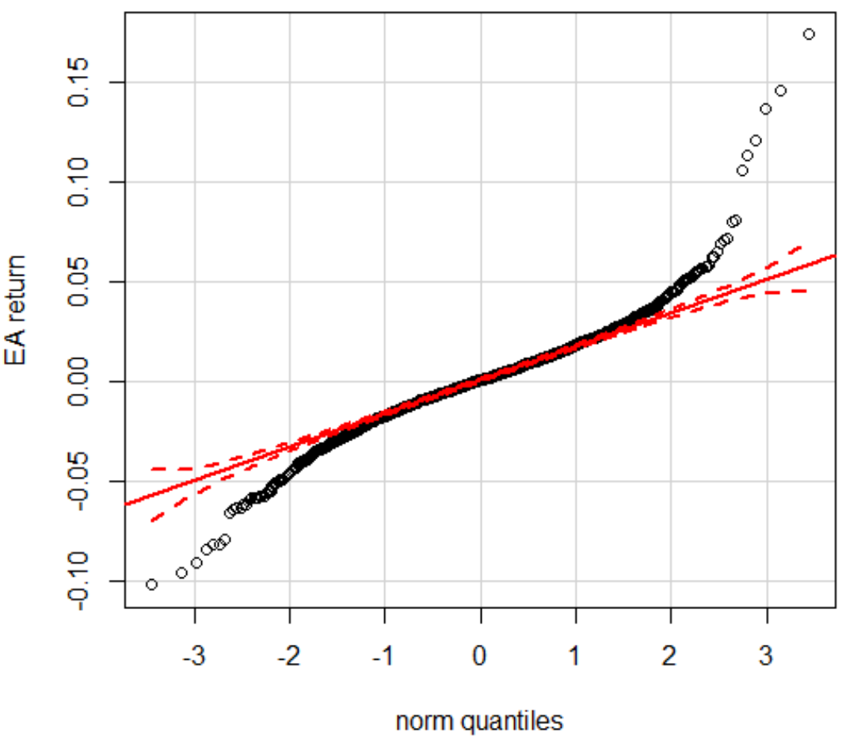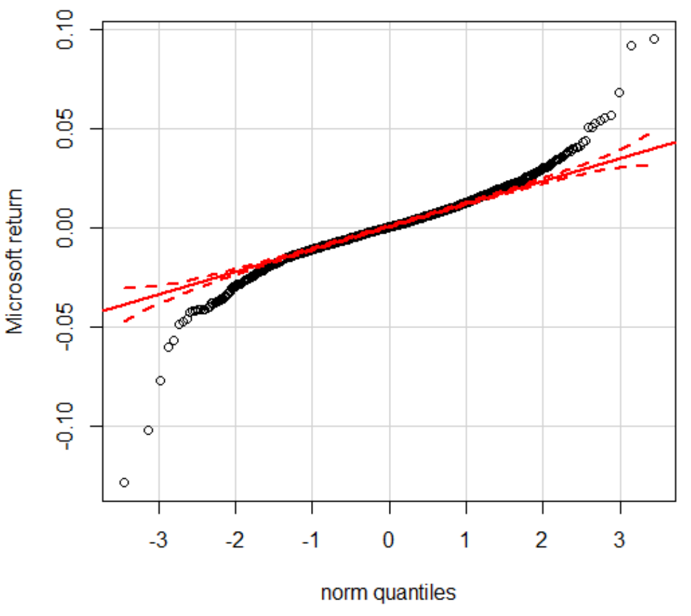

1. I have used the package tseries and its function jarque.bera.test(dataset) to perform the Jarque-Bera test. In all of the cases, the null hypothesis of the datasets being normally distributed is not accepted.

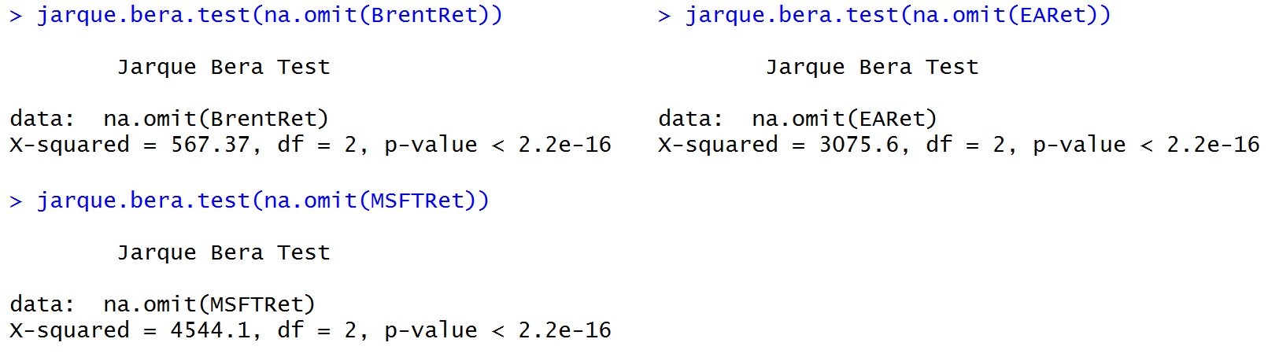

1. Sdf
2. Sdf