Input Layer:

1. Input Layer Source Code:

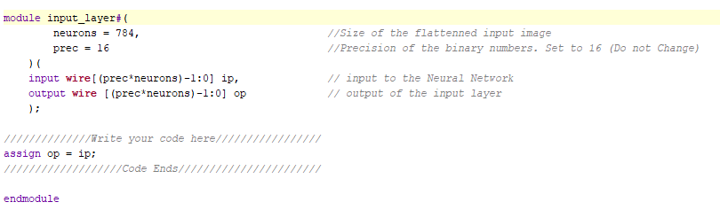

1. Input Layer Results (from TCL Console):

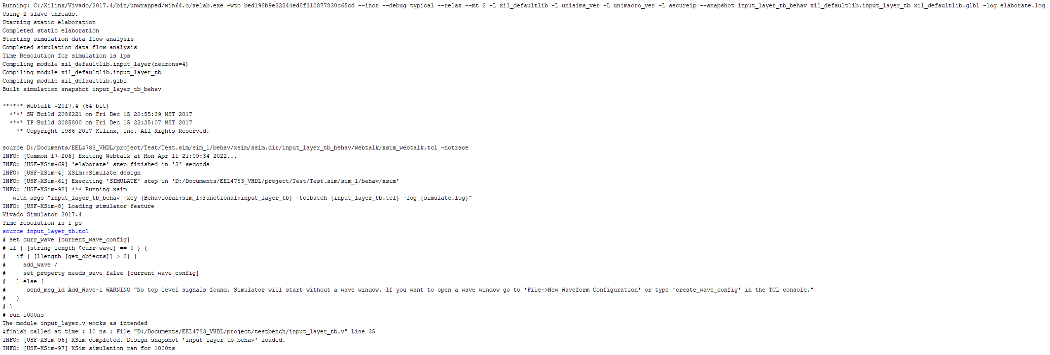

* This shows that the input layer module is working as intended.

1. Input Layer Waveform:

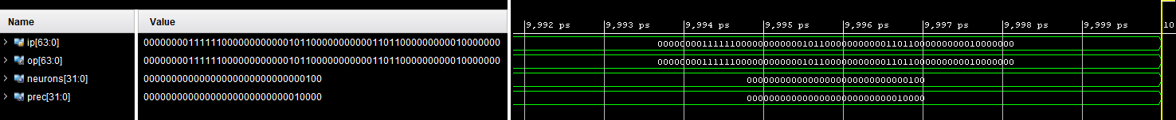

* You can see that the input is the same as the output, which is what is expected.

Neuron:

1. Neuron Source Code:

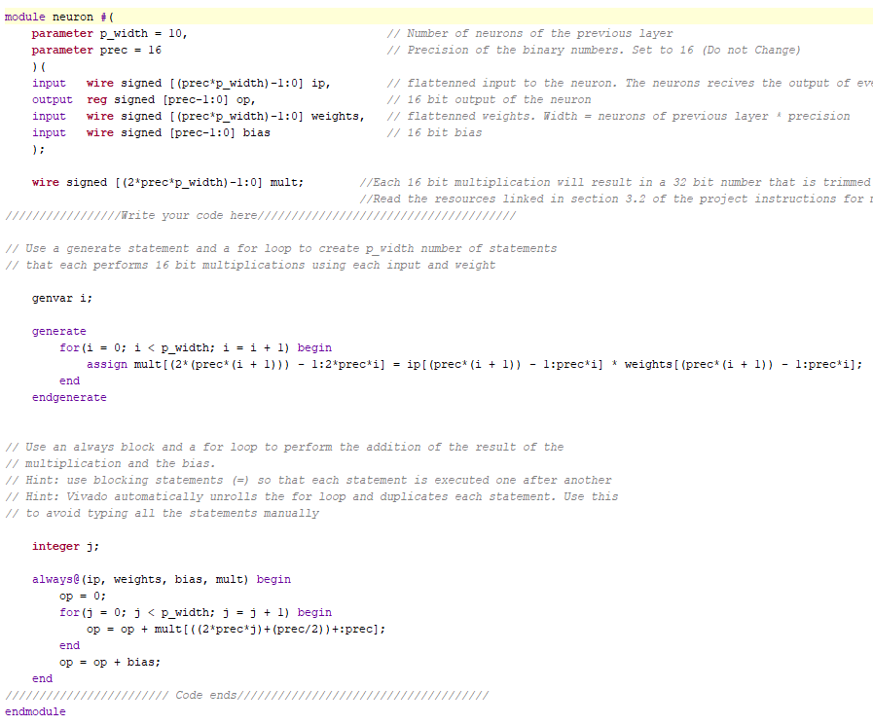

1. Neuron Results (from TCL Console):

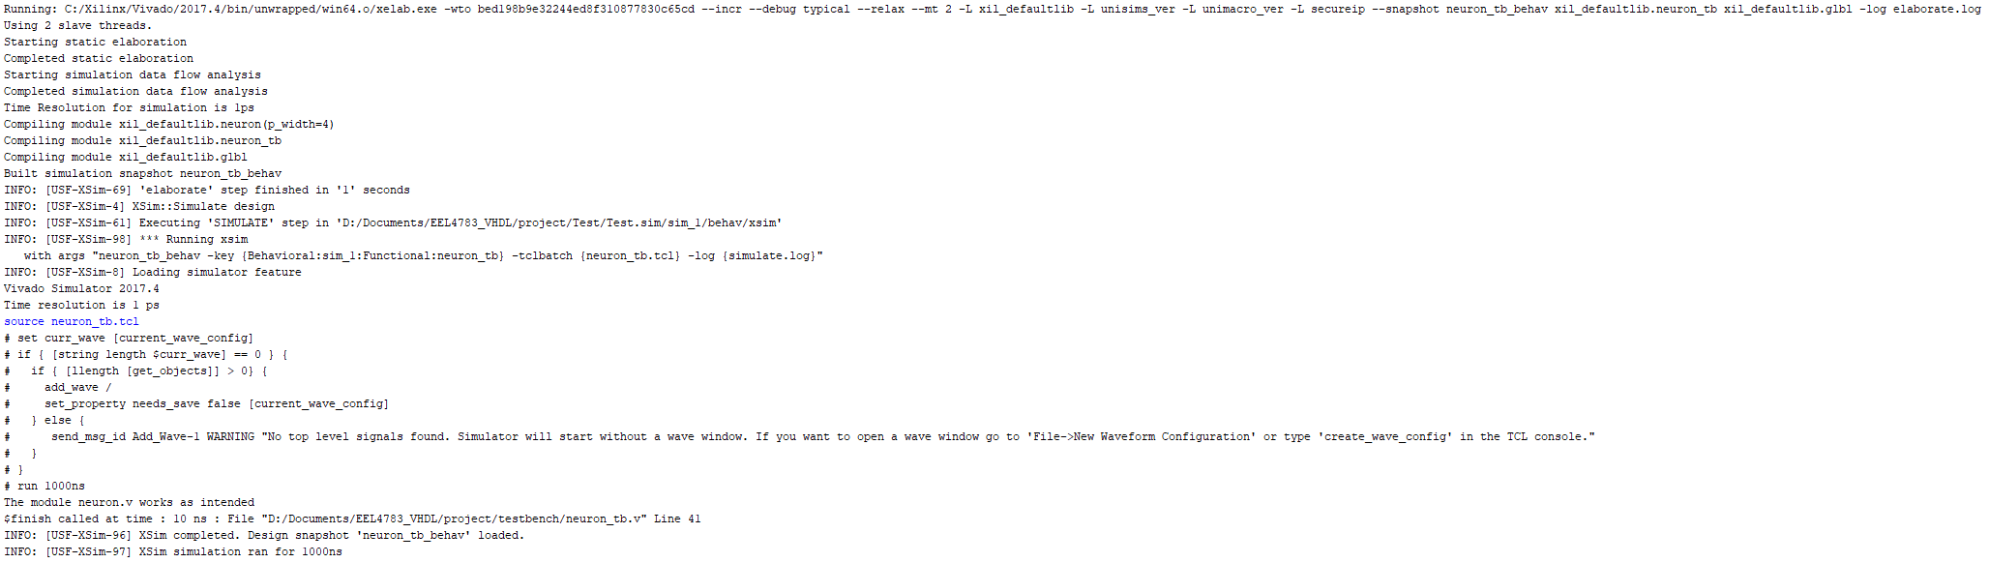

* This shows that the Neuron module is working as intended.

1. Neuron Waveform:

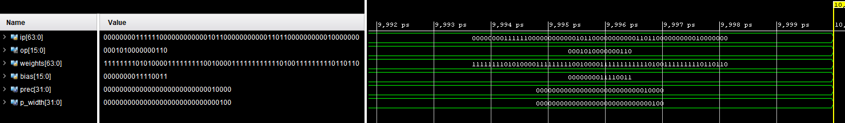

1. Neuron Test Bench Condition:

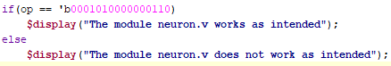

* Looking at the waveform, you can see that the output matches what is expected.

Hidden Layer:

1. Hidden Layer Source Code:

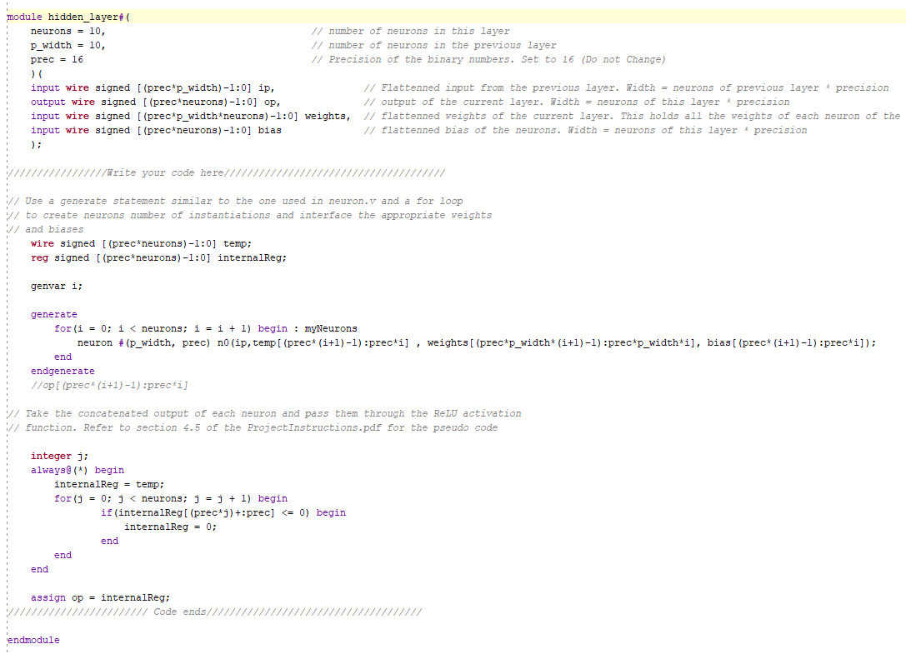

1. Hidden Layer Results (from TCL Console):

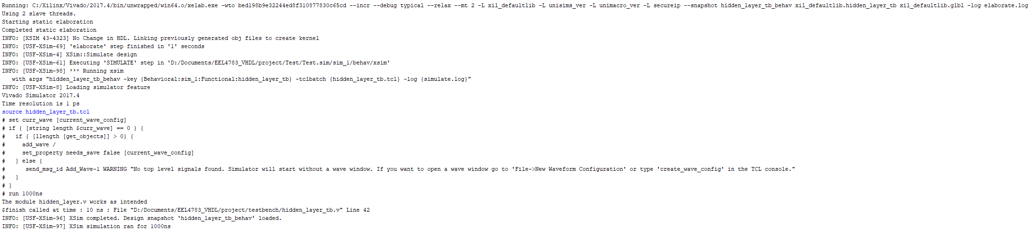

* This shows that the Hidden Layer module is working as intended.

1. Hidden Layer Waveform:

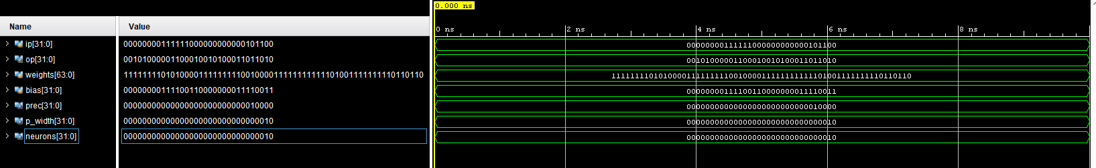

1. Hidden Layer Test Bench Condition:

* Looking at the waveform, you can see that the output matches what is expected.