Image 0 Output (Using segment of accuracy test bench to show results):

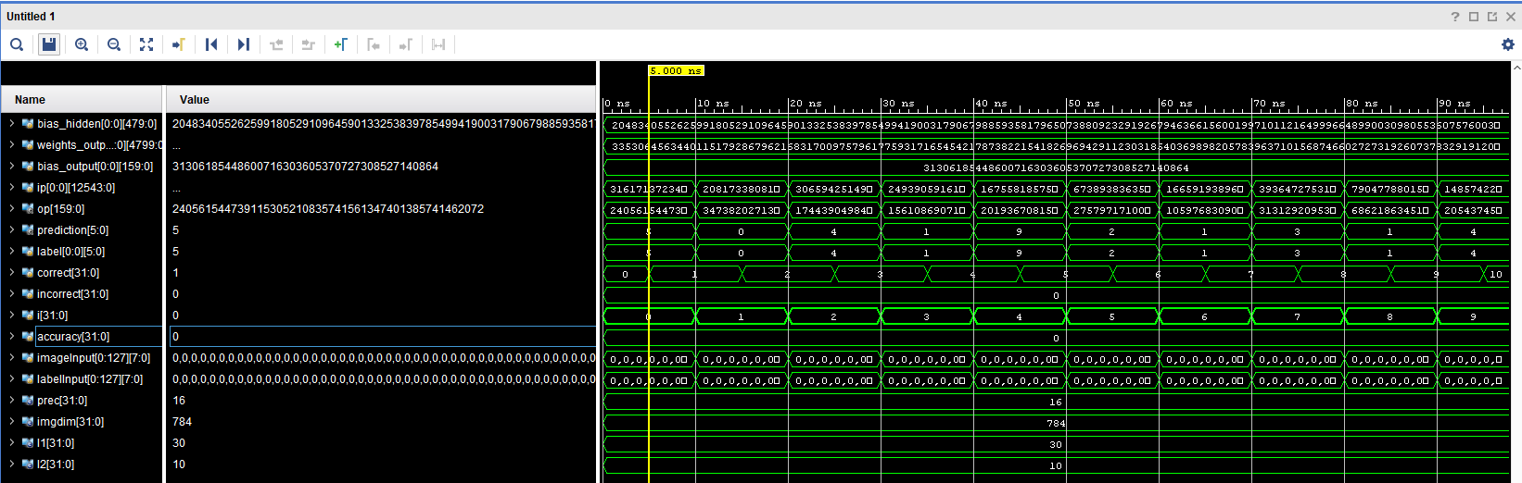

Image 0 Waveform:



* You can see that both the label and the prediction have the same value as well as the correct register incremented by 1 when this prediction was made. The matching values were 5 for prediction and 5 for label.

Image 1 Output:

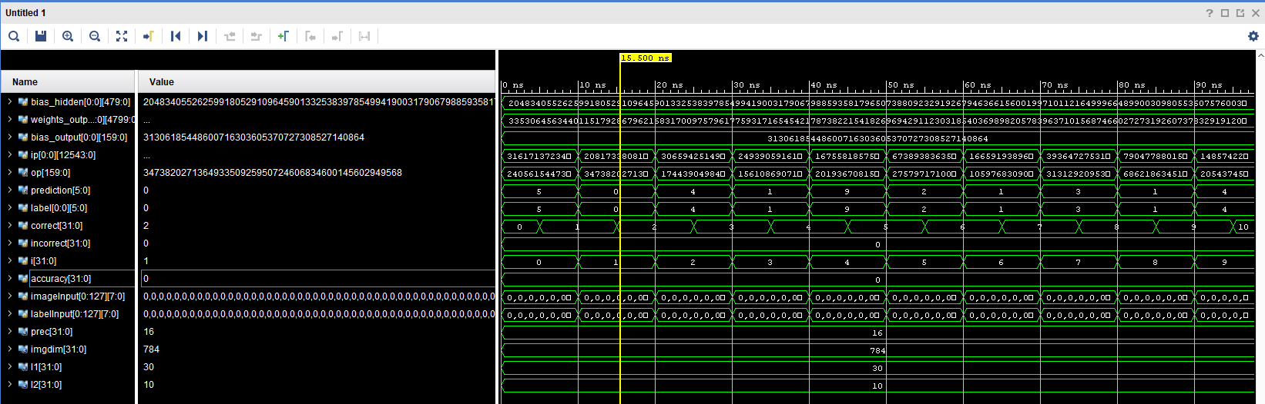

Image 1 Waveform:



* You can see that for the label and prediction registers here as well, they match and increment the correct register. The matching values are 0 for prediction and 0 for label.

Image 2 Output:

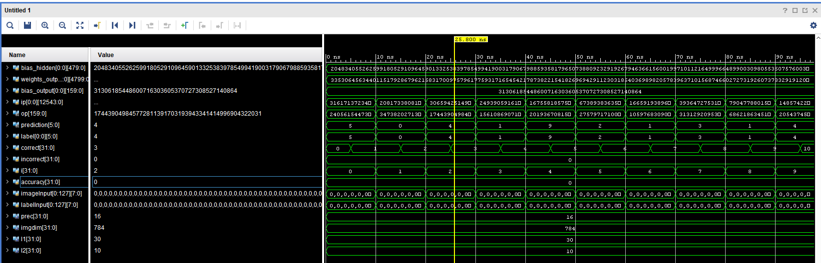

Image 2 Waveform:



* Image 2 also has a matching prediction value compared to the label value when ran through the neural network. Correct register gets incremented as well. The matching values are 4 for prediction and 4 for label.

Accuracy Test Bench full waveform:

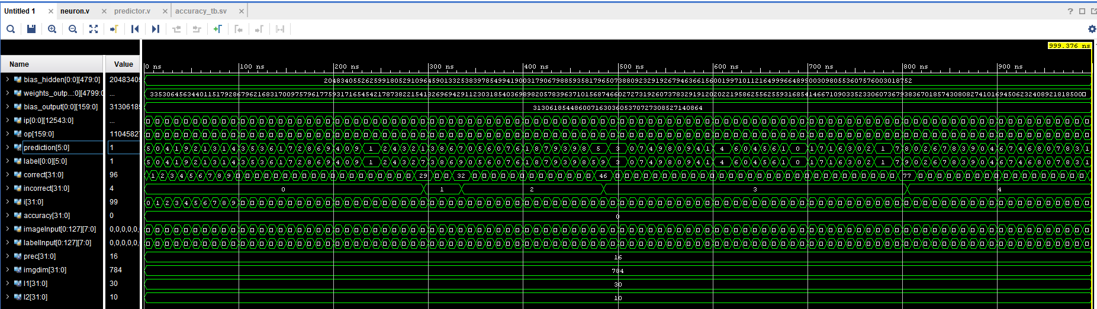

Accuracy Results:

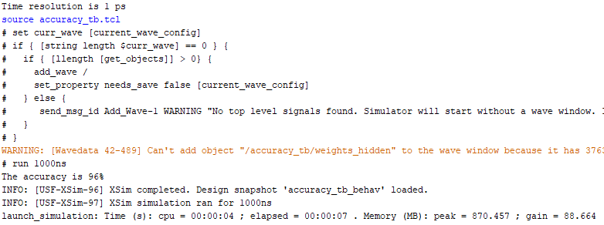

* As you can see, the accuracy simulation produces as result of 96%

Challenges and Implementation:

* There were lots of challenges when making this neural network. The first challenge was understanding how to modify certain wires based on a for loop.
* One big thing as well was understanding the two types of for loops we used in this project. One was a generate for loop using a genvar variable allowing us to identify wires the normal way. The other was a for loop within an always statement which required an integer variable as well as a different format in identifying specific wires.
* Understanding the layout of the network was also very important in successfully getting the result required.
* Another new challenge was the special way of overwriting parameters when instantiating modules.
* Lastly, I did have to do a different implementation in the accuracy test bench. We were instructed to use $sformatf to modify the file path strings, but my software wouldn’t recognize it as a function. Because of this I used $sformat and had to store the string in an array of 8 wire static logic variables and then put those in the $readmemb function. I left the requested $sformatf option commented out to show how it would be implemented the normal way.