**Máy chính**

1. Download oracle instanctclient

link:

<https://www.oracle.com/database/technologies/instant-client/winx64-64-downloads.html>

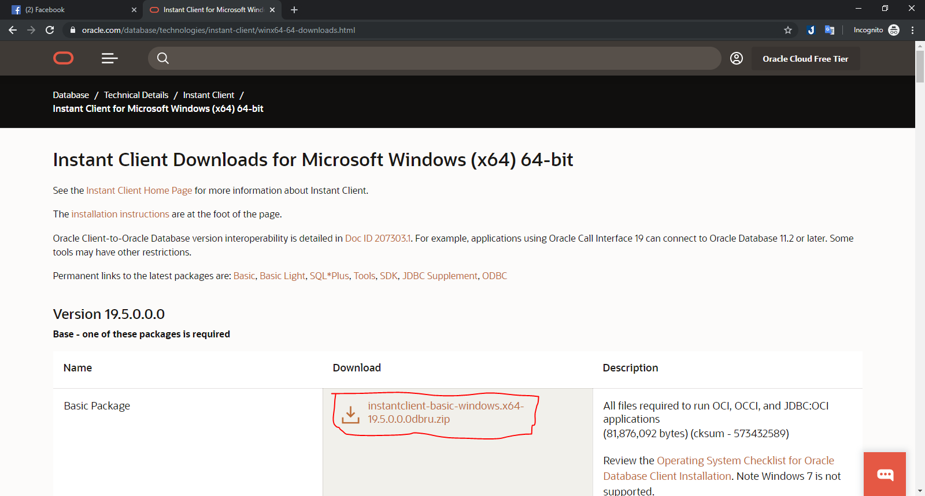

- Extract to C:\oracle

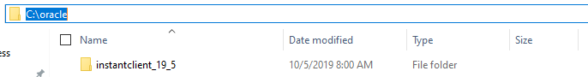

- Edit environment variables:

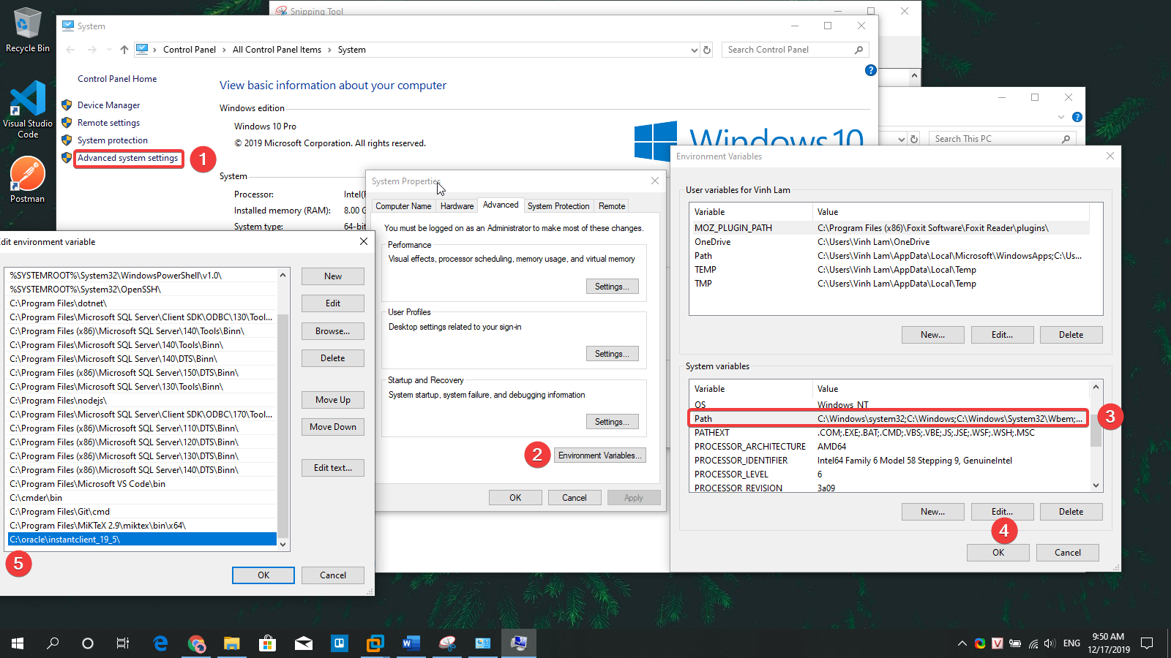

**Máy Oracle**

2. Sửa 2 file: listener.ora, tnsnames.ora

path: C:\Oracle19c\network\admin

- File listener.ora: đổi *localhost* 🡪 *hostname*

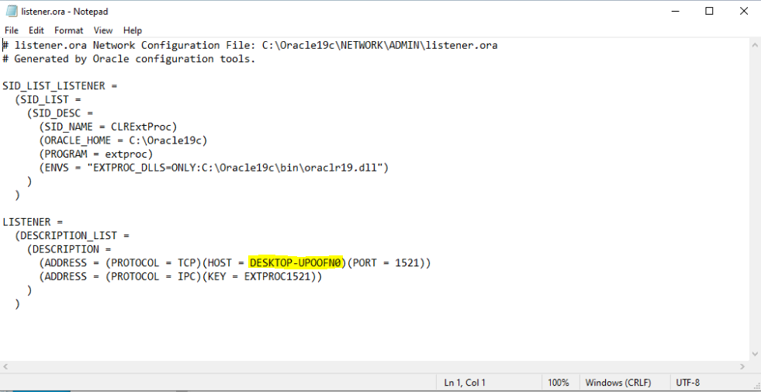

- File tnsnames.ora: đổi *localhost* 🡪 *hostname*

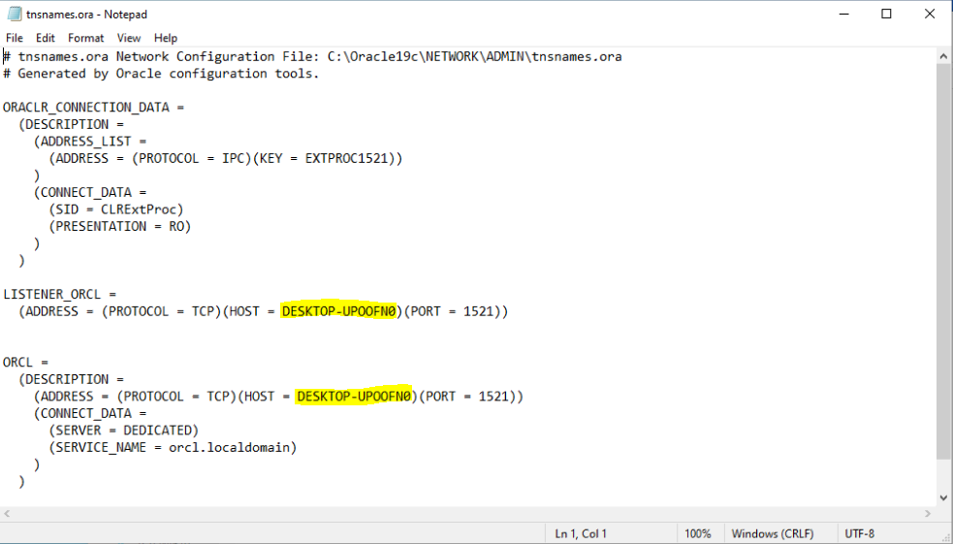

3. Vào service 🡪 restart OracleOraDB19Home1TNSListener

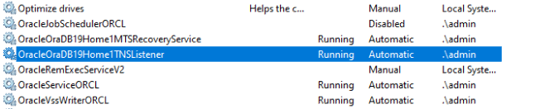

4. Sửa file host

path: C:\Windows\System32\drivers\etc

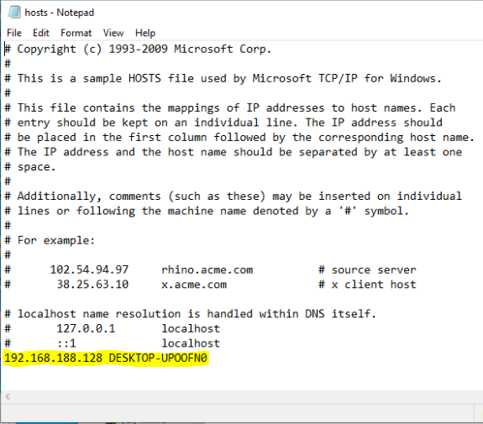

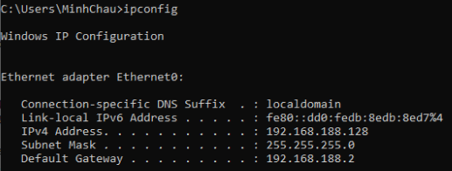

5. Tắt Firewall

6. Test

