Four Pixel TPE Authentication
  - Professor-facing implementation audit and reproducibility report · v3
Professor, this revision verifies the existing four-pixel experiment without changing its result values. The six 512×512 RGB source arrays are recoverable and their pixel hashes match the run manifest. The saved bundles recorded exact image and five-bit payload recovery, and the tamper cases recorded four-block localization. However, the original random keys were not retained, so those specific bundles cannot now be independently decrypted. The NIST schedule-stream reports are exploratory and contain substantial failures; the full predeclared v2 protocol was not run.
Branch: audit/tpe-fourpixel-auth-v2 · starting commit: 32e6c4922c1fc624a0f3878294663ff97d6b35ef · audited 26 October 2026

Audit outcome
Area | Verified finding
Image inputs | Six 512×512 RGB pixel arrays verified against the repository reference hashes. Couple and Girl source PNG bytes are missing; their arrays match.
Clean recovery | Historical run records 6/6 exact image recovery and 6/6 exact five-bit payload recovery. This audit cannot rerun bundle recovery because the original keys are absent.
Thumbnail | All six 16×16×3 block-mean outputs match exactly. Each cell is the per-channel mean of one 32×32 RGB image block.
Tamper tests | One-pixel and cross-image 32×32 block edits were rejected. The detector reports one four-block group per affected channel, not a unique changed pixel/block.
NIST | Two exploratory schedule-stream reports were recomputed. Both contain large failure counts; neither is the predeclared full v2 protocol.
Security claim | This is a reproducible implementation demonstration, not a security proof or faithful reproduction of the paper’s chaotic key schedule.

What was implemented
The selected paper defines a reversible four-pixel sum-preserving transform driven by a chaotic key. The repository applies that transform to four-pixel sets inside 32×32 image blocks. The adapter converts this repository’s 2D-CSM output into the paper’s stated key-value domain. That schedule adaptation is not the paper’s own key schedule and is not an exact reproduction.
The authentication system is repository-added. It includes block permutation, histogram-shifting reversible data hiding (RDH), HMAC-SHA256 tags, a reversible-complement-mapping (RCM) carrier and a sidecar protected with AEAD. The red-channel RDH stream carries the demonstrated five user bits alongside repository-generated authentication material. The sidecar carries encrypted layout and reversible correction metadata. These stages are not defined by the four-pixel paper.

Why this paper was selected
Candidate | Implementation and block structure | Payload and authentication fit | Reason for selection
Four-pixel SPE paper | Four-pixel sum-preserving operation; repository adapts it to 32×32 blocks. | Paper transform itself provides no authentication-tag container. Repository RDH and external group tags must be added. Four-block localization is supplied by our adaptation. | Professor directed the newest paper and one implementation under the deadline. Its explicit reversible four-pixel core was the narrowest selected TPE stage to integrate and compare.
Dual-mode chaotic TPE + RDH | Chaotic permutation, RDH, then substitution; native RDH sits inside an existing multi-stage flow. | Native payload mechanism could be studied for tag insertion, but fitting per-group authentication and localizable tags still requires design and capacity tests. | Promising next comparison; extra integration surface and separate RDH capacity behavior were not needed to satisfy the directed one-paper prototype.
PR3 visual privacy + data hiding | Region division, vacated-area hiding, thumbnail preservation and sub-block permutation; a different architecture. | Existing hiding stages are central to recovery and usability. Tag capacity and local group verification would require redesign and benchmarking. | Different region-based design would make a larger adaptation and comparison task under the same time limit.

This is an engineering-selection rationale, not a claim that the selected paper is superior. The project did not measure comparative tag capacity or runtime across the three papers. References: four-pixel SPE, DOI 10.1038/s41598-026-47090-9; dual-mode scheme, DOI 10.1007/s44443-026-00479-y; PR3, DOI 10.1109/TBDATA.2024.3375155.

Visual result and thumbnail
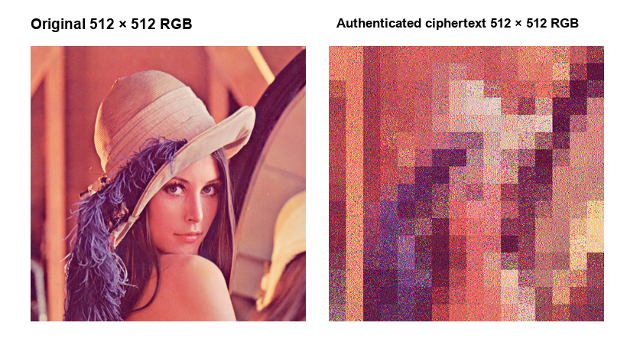
Figure 1. Lena source and authenticated ciphertext. Both image arrays are 512×512 RGB and are shown side by side at the same display scale; the figure panel uses a 360×360 display copy for page fit. It does not imply native-size display. The separately retained PNGs preserve all 512×512 pixels.
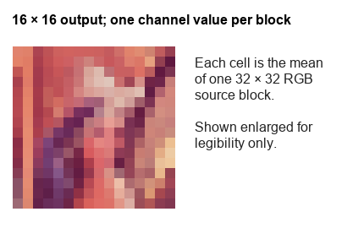
Figure 2. Exact 16×16×3 thumbnail output. Each value is the arithmetic mean of one non-overlapping 32×32 block, computed separately for R, G and B. The thumbnail is enlarged with nearest-neighbor display only for legibility; the data output remains 16×16.

Recomputed image measurements
Full-image PSNR is computed on the original versus saved authenticated ciphertext PNG, over all 512×512×3 uint8 samples: MSE = mean((I − C)²); PSNR = 10 log10(255²/MSE). Thumbnail MSE is calculated separately on two 16×16×3 arrays of per-channel 32×32 block means. A zero thumbnail MSE means exact equality; its PSNR is infinite. Bundle size is encrypted PNG bytes plus sidecar bytes.
Image | Full PSNR dB | 16×16 thumb MSE | Cipher PNG B | Sidecar B | Bundle B
Airplane | 12.37 | 0.0 | 767,040 | 1,198,659 | 1,965,699
Baboon | 11.28 | 0.0 | 783,185 | 1,200,453 | 1,983,638
Couple | 16.76 | 0.0 | 690,787 | 1,150,828 | 1,841,615
Girl | 14.55 | 0.0 | 747,299 | 1,169,771 | 1,917,070
Lena | 12.29 | 0.0 | 779,302 | 1,199,320 | 1,978,622
Peppers | 11.99 | 0.0 | 776,416 | 1,188,975 | 1,965,391

Across six images: average per-image PSNR 13.21 dB; all six thumbnail MSE values are 0. Mean combined bundle 1.942 MB (decimal), or 1.852 MiB. This equals 2.47× the 786,432-byte raw RGB array and 4.31× the source PNG size. These are reconstructed from saved files and prior metrics; exact recovery is not independently replayed without keys.
The prior 9.3–10.0 second timing mixed encrypt, disk export, recovery and fresh-process file operations. It is not reported as encryption runtime. No isolated stage timing was retained.

Tamper rejection and group localization
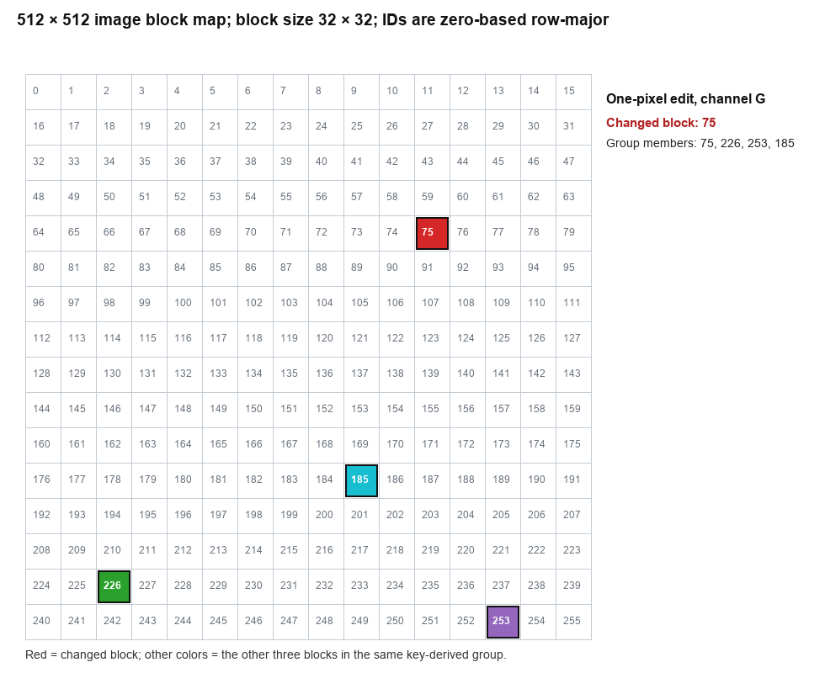
Figure 3. One changed green-channel pixel at Lena (y=135, x=361) lies in 32×32 block 75. The key-derived authentication group is [75, 226, 253, 185]. The detector rejected recovery and named this group. The three other group members are spatially separate blocks; the result does not identify the exact changed pixel by itself.
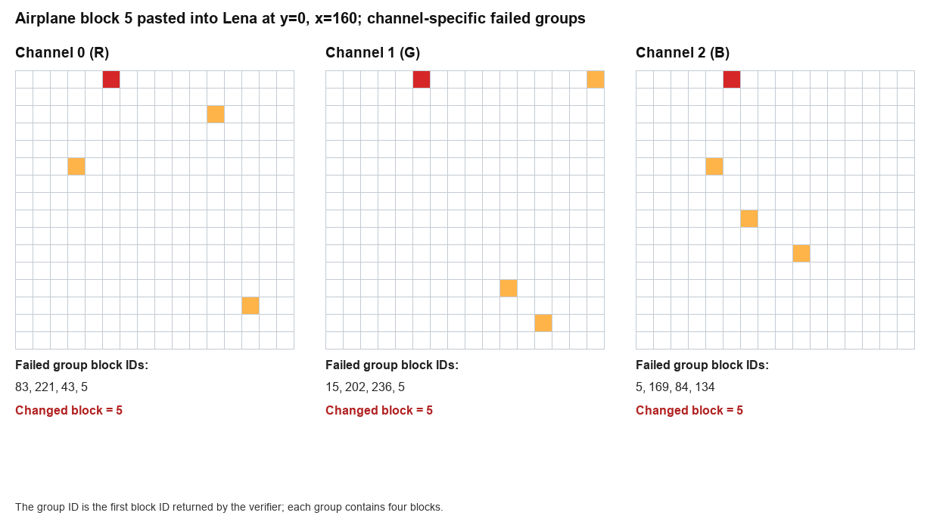
Figure 4. Airplane ciphertext block 5 (y=0, x=160, 32×32) replaced Lena block 5. Rejection and localization are channel-specific: R group [83, 221, 43, 5]; G group [15, 202, 236, 5]; B group [5, 169, 84, 134]. A group identifies four candidate blocks. A group ID is the first block ID in that channel’s key-derived group ordering.

Inputs, provenance and keys
All six run arrays are available from the tracked visual-gallery originals. All are 512×512 RGB; the run consumes the RGB arrays without crop or resize. The saved input manifest lists per-file historical hash, recovered reference-file hash, and pixel-array hash. Four file hashes match exactly. Couple and Girl do not: their original run PNG bytes cannot be recovered, but the matching 512×512 RGB arrays are available from the repository references. The repository does not include an upstream source/license record for these gallery copies; the report does not assert independent redistribution rights.
Run image | SHA-256 of RGB pixels | Run file bytes recovered?
000_uct_airplane.png | a7405a85dc79ba2207… | Yes
001_uct_baboon.png | a511e253857a0bfd85… | Yes
002_uct_couple.png | 7ac5f99ce6e090aed2… | No; pixels match
003_uct_girl.png | 47ffc14019e003443c… | No; pixels match
004_uct_lena.png | c878c0dc0b46bd7a13… | Yes
005_uct_peppers.png | 5350521bbe3522935e… | Yes

To restore expected filenames, run `python3 authenticated_tpe_nist_v2/scripts/prepare_four_pixel_inputs.py`; it re-encodes PNGs, does not resize/crop, and verifies pixels against the manifest. The resulting Couple/Girl PNG file hashes will differ from the historical run file hashes. Use pixel hashes to verify input equivalence.
The run used two fresh random 32-byte keys from environment variables. Neither key nor key hashes were retained. The original bundles cannot now be independently decrypted unless the exact keys are recovered from a private external store. A new run with new keys creates different valid artifacts and does not validate old bundles. Keep key values outside Git and inject them with an OS secrets facility. The reusable four-pixel parameters now default to no key and reject omission; deterministic test keys remain confined to tests.

NIST SP 800-22 evidence
The full predeclared v2 protocol was not run. The two included reports are exploratory tests of separate schedule streams, not results for the complete four-pixel authentication method. The raw ASCII stream files and STS 2.1.2 assessment logs were available locally and inspected. Reports, manifests and assessment logs are included; the large ASCII stream inputs are not bundled, but their file sizes and SHA-256 values are recorded. Exact generator source, complete stream-generation seed/parameter records, and a full invocation script are missing, so independent stream regeneration is not possible from the committed artifacts.
Stream | Rows | p < .01 | p < .0001 | Fail either STS check | Report * rows
substitution_r | 188 | 150 | 148 | 153 | 153
upsilon_p | 162 | 147 | 144 | 148 | 148

The p < .01 column answers the requested threshold recount; it is not the NIST p-value uniformity cutoff. STS uses p < .0001 for uniformity. The other STS criterion uses the report’s pass-proportion cutoff of 0.96 for 100 sequences. The union of those failures equals the report asterisk count: substitution_r 153/188; upsilon_p 148/162. The earlier claim of 142 substitution_r rows with p < .01 is not reproduced; this independent parse finds 150. The earlier 147 upsilon_p count is reproduced. The earlier 146/150 failure totals are also not reproduced: independent counts are 153 and 148, and match the actual report asterisks. This corrects the prior report’s inaccurate 162-row substitution count and its other failure recounts. Failures are not hidden or used to tune parameters.
Both logs show all 15 standard test families selected: Frequency, Block Frequency, Cumulative Sums, Runs, Longest Run, Rank, FFT, Non-overlapping Template, Overlapping Template, Universal, Approximate Entropy, Random Excursions, Random Excursions Variant, Serial and Linear Complexity. Random Excursions rows occur only where cycle requirements are met. These statistical outcomes are not a security proof.

Regression verification and limitations
The repository includes regression coverage for exact image and payload recovery, block-sum preservation, wrong TPE/authentication keys, wrong ImageID, malformed sidecars, one-pixel edits, cross-image block replacement and exact key-derived group localization. A new check verifies that the four-pixel pipeline rejects an omitted key. The four-pixel regression module passed 13 tests in 27.27 seconds, including exact image/payload recovery, block sums, wrong keys/ID, one-pixel and cross-image edits, group localization, and the new omitted-key rejection check. The authenticated TPE suite passed 102 tests in 80.64 seconds (14 third-party deprecation warnings); the repository’s broader authenticated_tpe_nist_v2 suite was also started and its final outcome is recorded in the audit note and test log.
The six historical clean-run recovery flags remain reported as historical observations, not newly replayed facts. The missing original keys prevent that replay. This prototype’s RDH tag carrier and authentication scheme are repository adaptations and have not received formal cryptographic analysis.

References and accompanying evidence
Four-pixel paper: https://doi.org/10.1038/s41598-026-47090-9
Dual-mode chaotic TPE + RDH paper: https://doi.org/10.1007/s44443-026-00479-y
PR3 paper: https://doi.org/10.1109/TBDATA.2024.3375155
The adjacent v3 audit folder contains the six source references and ciphertexts, tamper-localization figures, input manifest, recomputed metrics, NIST reports/logs/manifests, supporting audit notes and SHA256SUMS. No secret key is included.

