Visual encrypted-image examples
Each right-hand image is the final encrypted image after authentication information has been embedded. It is generated using the same image, key, ImageID and final ciphertext verified in the corrected PSNR evaluation. Images are shown at native 512 × 512 RGB pixels (scaled only to fit this page).

Airplane — input vs. final marked ciphertext
Input-to-final PSNR: 17.5464 dB | SSIM: 0.3087 | Mode: group | Authentication accepted; exact recovery verified.
Original input | Final encrypted + authentication data
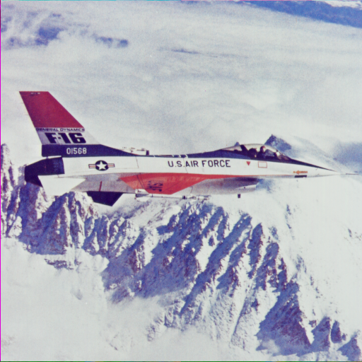 | 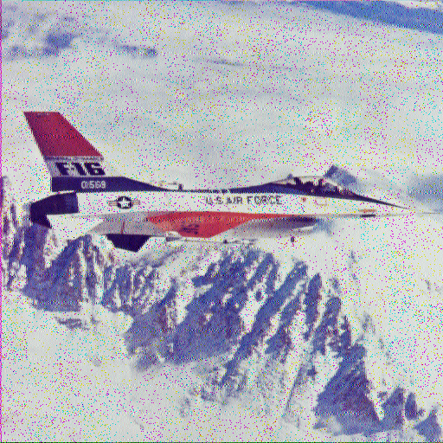

Baboon — input vs. final marked ciphertext
Input-to-final PSNR: 17.2877 dB | SSIM: 0.4941 | Mode: group | Authentication accepted; exact recovery verified.
Original input | Final encrypted + authentication data
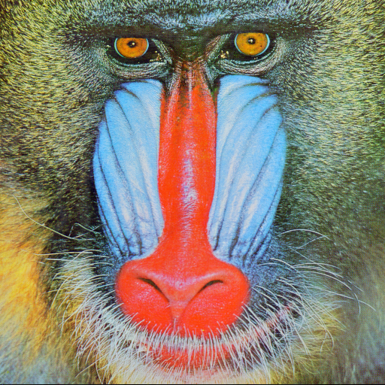 | 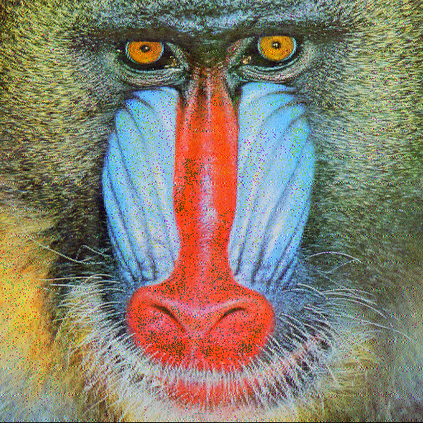

Couple — input vs. final marked ciphertext
Input-to-final PSNR: 25.4119 dB | SSIM: 0.6784 | Mode: group | Authentication accepted; exact recovery verified.
Original input | Final encrypted + authentication data
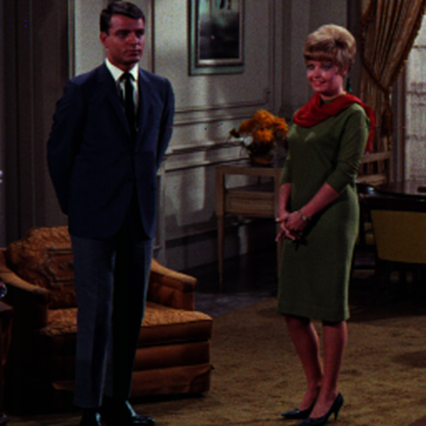 | 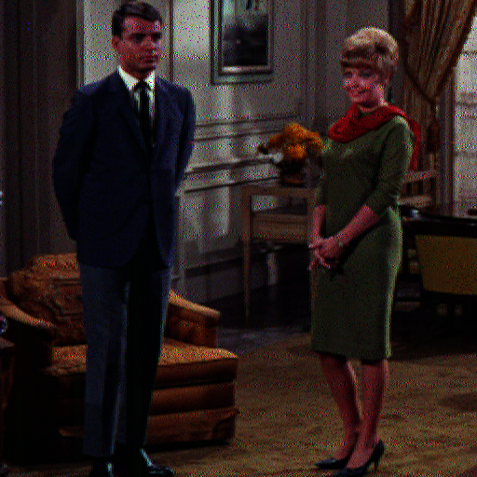

Girl — input vs. final marked ciphertext
Input-to-final PSNR: 22.5926 dB | SSIM: 0.5000 | Mode: group | Authentication accepted; exact recovery verified.
Original input | Final encrypted + authentication data
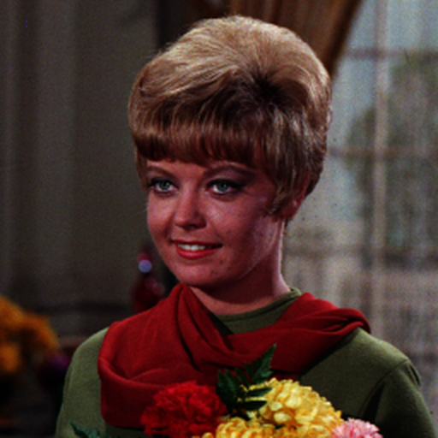 | 

Lena — input vs. final marked ciphertext
Input-to-final PSNR: 18.1882 dB | SSIM: 0.3126 | Mode: group | Authentication accepted; exact recovery verified.
Original input | Final encrypted + authentication data
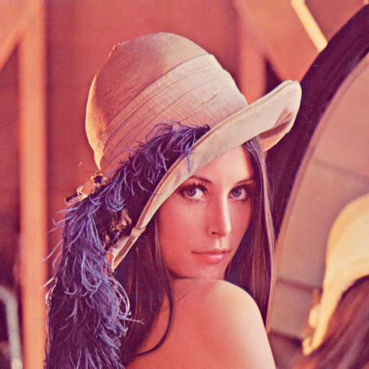 | 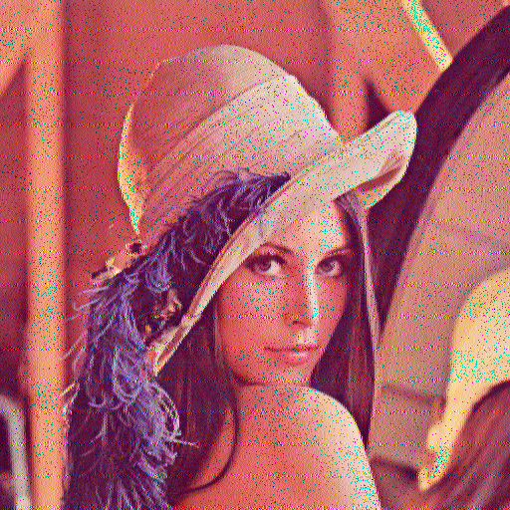

Peppers — input vs. final marked ciphertext
Input-to-final PSNR: 19.5001 dB | SSIM: 0.3800 | Mode: group | Authentication accepted; exact recovery verified.
Original input | Final encrypted + authentication data
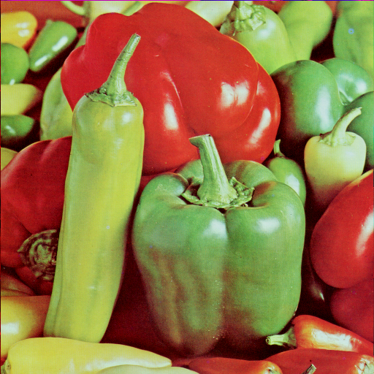 | 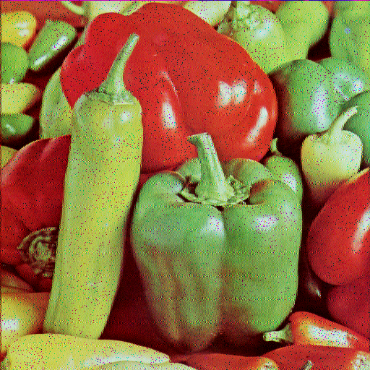
Measurement note: PSNR/SSIM compare the original input to the final authentication-marked ciphertext. The previously reported ~27.77 dB Baboon quantity compared the marked output to the Step-2 image before tag embedding and therefore measured marking-only distortion, not original-to-encrypted visual fidelity.

