Four Pixel TPE Authentication Evaluation
  - Revised v2 research report | Six 512 × 512 RGB images | 25 October 2026
The six saved image/sidecar pairs recovered exact source pixels and the five-bit payload when tested with the matching keys. Their 32 × 32 block-mean thumbnails were exactly preserved. This is a repository integration experiment: it is not a faithful reproduction of the published four-pixel method, a security proof, or a result from the full predeclared NIST protocol.
Results overview
Measure | Observed result
Exact image and payload recovery | 6/6 after lossless file reload and fresh-process recovery
32 × 32 block thumbnail | MSE 0; PSNR +∞ dB (exact equality)
Full-image PSNR | Mean 13.21 dB; range 11.28–16.76 dB
Runtime | Mean 9.513 s/image; end-to-end local run, not a hardware-normalized benchmark
Sidecar size | Mean 1.185 MB; range 1.151–1.200 MB
Total bundle overhead | PNG + sidecar exceeds original PNG by 1.491 MB/image on average (330.8% aggregate increase); bundle is 4.31× input PNG
Metric definitions
Exact recovery compares all decoded RGB samples after decrypting the saved lossless PNG and sidecar. Payload recovery checks the embedded bit string [0, 1, 1, 0, 1]. Both require the matching TPE and authentication keys.
Thumbnail MSE/PSNR uses the per-channel arithmetic mean of each non-overlapping 32 × 32 pixel block, giving a 16 × 16 × 3 thumbnail array. MSE is averaged over that array. Zero MSE is exact equality and gives mathematically infinite PSNR.
Full-image PSNR compares source RGB samples to the final authenticated ciphertext: 10 log10(255²/MSE), with MSE averaged over all pixels and channels. The reported mean is the arithmetic mean of six per-image PSNRs; it is distinct from the thumbnail PSNR.
Runtime is the runner’s measured interval from encryption start through image/sidecar writes, saved-file recovery, and a fresh-interpreter recovery check. It includes process and filesystem costs; it is not a controlled algorithm-only benchmark.
Bundle overhead is (lossless encrypted PNG bytes + sidecar bytes) minus the corresponding original input PNG bytes; percentage overhead divides this difference by original PNG bytes. Reported MB uses 10^6 bytes. Original and encrypted PNGs are both 512 × 512 RGB, but their compression ratios differ.
No results or p-values were changed in this revision. The changes are reporting, definitions, visuals, data provenance, and reproducibility guidance.

Why the four-pixel paper was selected
The selection followed the professor’s instruction to implement one paper quickly, then combine the selected method with the proposed authentication function. Selection was based on scope and fit for that experiment, not a claim that this method is better than the other candidates.
Candidate | Relevant method feature | Reason for this experiment
Four-pixel sum-preserving encryption (Kao et al., 2026) | Directly tests the four-pixel sum-preserving transform and its compatibility with the existing 32 × 32 block workflow. Selected as the focused transform to integrate and evaluate. | Chosen for the four-pixel research question and the professor’s time-bounded direction. The paper does not supply the repository authentication system.
Dual-mode chaotic TPE with RDH (An et al., 2026) | Combines chaotic permutation/substitution and histogram-shifting RDH for reversible embedding of non-visual data. It is a close alternative and may offer a more native embedding path. | Not selected because it would require implementing and evaluating a distinct full TPE/RDH architecture, broadening the immediate four-pixel authentication experiment.
PR3 (Zhao et al., 2025) | A reversible thumbnail-preserving/data-hiding design using sum-preserving embedding, overflow handling, and additional-data capacity. | A distinct embedding-centric design rather than the requested four-pixel transform. It remains a relevant future comparison; this work does not establish that it is inferior.
The four-pixel article was selected as the primary transform to integrate, while the other two papers remain meaningful alternatives. In particular, both include data-hiding mechanisms relevant to authentication. A controlled head-to-head implementation was not performed, so the selection is a scope decision, not an empirical ranking.
Separate the paper method from repository additions
Layer | What this experiment adds or uses
Published four-pixel SPE | Sequential four-sample, piecewise sum-preserving substitution; paper uses its own chaotic key/permutation setup.
Repository TPE wrapper | Existing 32 × 32 block permutation, selected 2D-CSM-derived key schedule, and adapter mapping into the paper quantizer.
Repository native RDH | Histogram-shifting stage inserts one 256-bit HMAC-SHA256 tag per color channel and the five-bit user payload in the red-channel stream.
Repository localization | Four-block groups are derived by keyed HMAC_DRBG; reversible contrast mapping (RCM) embeds another 256-bit group tag for each channel.
Repository sidecar | Versioned ChaCha20-Poly1305 sidecar carries encrypted layout, schedule identifier, and reversible block-sum correction map. This compensates for changes introduced by authentication.
Thus, “native RDH” here means the repository’s existing TPE/RDH carrier stage. The four-pixel paper itself does not define the HMAC tags, the five-bit payload, RCM group localization, or the AEAD sidecar.
Source-to-code deviations
The adapter converts its 2D-CSM value x ∈ [−1, 1] to u = (x + 1)/2 before applying r = floor(255u) + 1. The generator and overall schedule differ from the paper. Code follows the Supplementary Note’s explicit S < 255 first-case boundary; the article prose differs at S = 255. A directed test found the printed Case 2 inverse sign inconsistent with the forward equation and uses the algebraically derived minus-r inverse. These are documented deviations, not a faithful reproduction.

Original and encrypted images at full input dimensions
Each panel uses the complete 512 × 512 RGB input and corresponding authenticated ciphertext image. Images are scaled only to fit the page; none is replaced by a thumbnail. Pair order matches the metrics table. The original and ciphertext files are supplied in the v2 and tracked visual-gallery outputs.
Image | Original 512 × 512 | Authenticated ciphertext 512 × 512
Airplane | 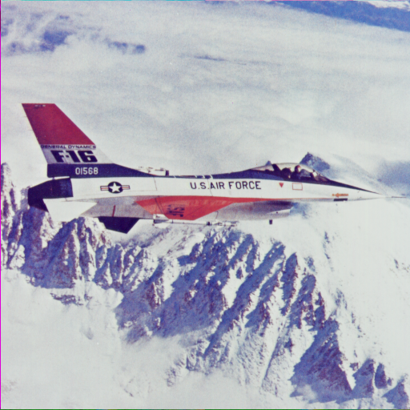 | 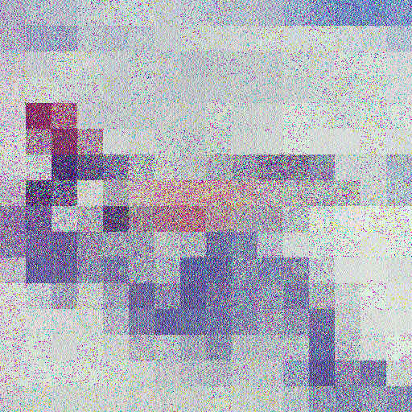
Baboon | 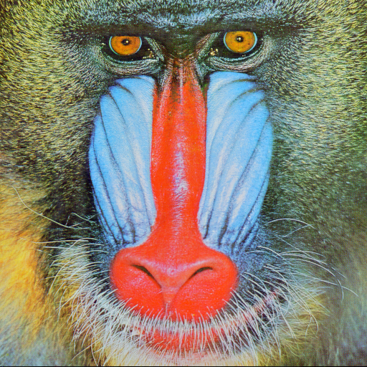 | 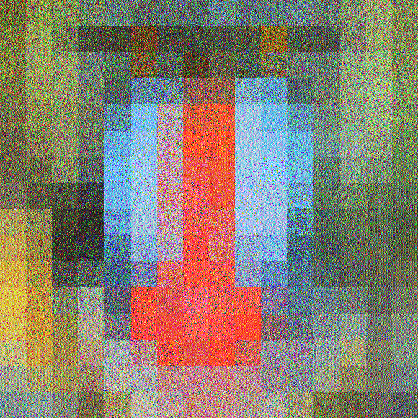
Couple | 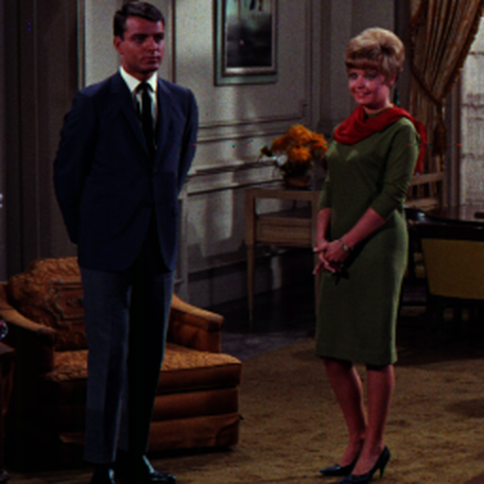 | 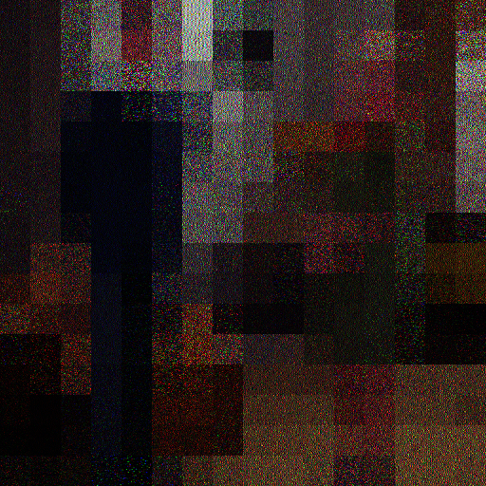
Figure 1. The source originals are from the tracked visual gallery; the ciphertext panels are the six v2 outputs. All source arrays and encrypted arrays have 512 × 512 × 3 samples. Image files are lossless PNG.

Original and encrypted images continued
The remaining full-dimension 512 × 512 RGB pairs are shown below at the same display scale.
Image | Original 512 × 512 | Authenticated ciphertext 512 × 512
Girl |  | 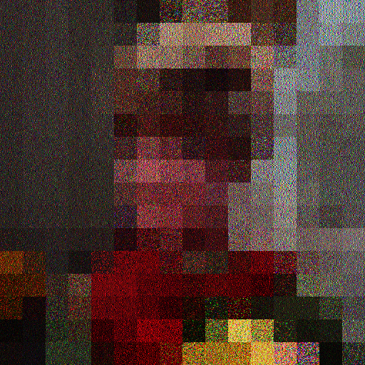
Lena | 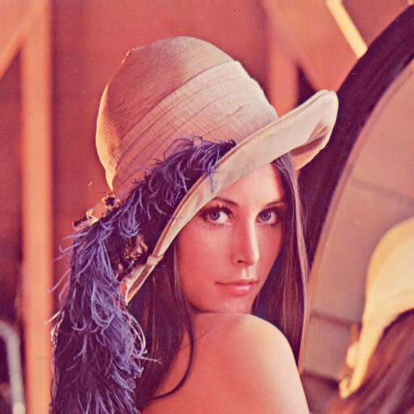 | 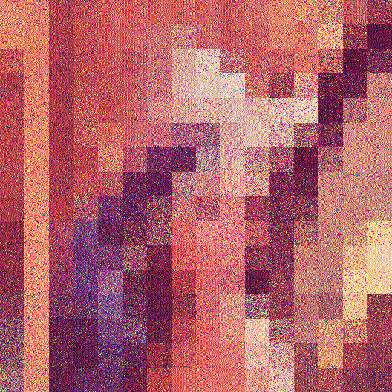
Peppers | 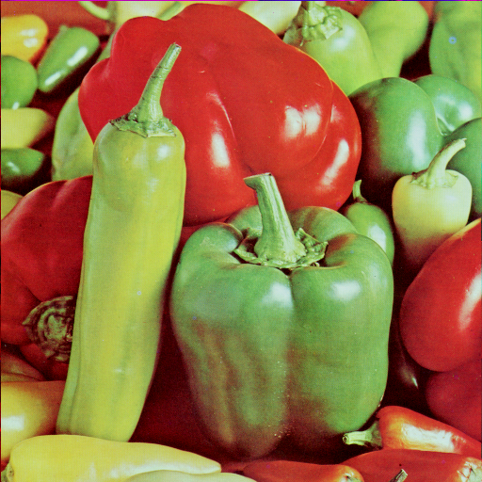 | 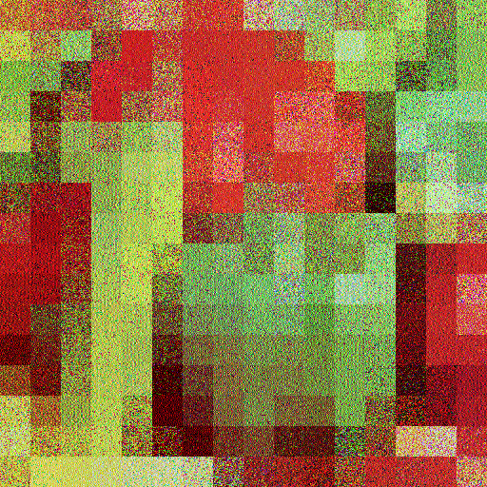

Tamper edits and localized authentication groups
The red, cyan, and yellow boxes show the four block positions in keyed localization groups. These group members are non-contiguous. The outlined pixel or block is the tampered region; a reported group means the four-block authentication check failed. The decryptor withheld the reconstructed image in both cases.
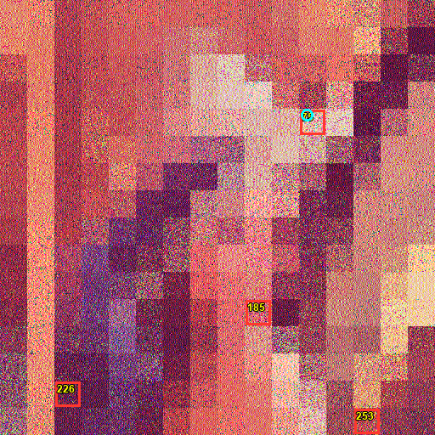  One-pixel edit: Lena ciphertext, green channel, coordinate (y=135, x=361). A single modified sample failed group 75, whose block IDs are 75, 226, 253, and 185. The image shown contains the marked one-pixel edit. | 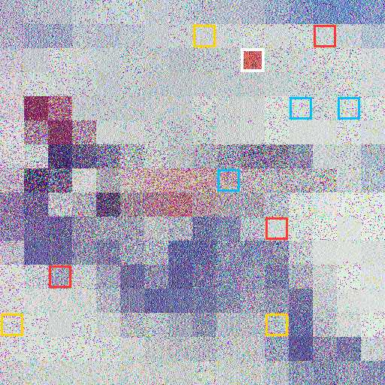  Cross-image splice: a Lena ciphertext 32 × 32 block (block 42, region y=64–95 and x=320–351) replaces the same Airplane ciphertext block. One failed group is reported in each channel (group labels 29, 78, 208); image recovery is withheld.
Additional checks: one-pixel modifications in all three channels and widely separated blocks localized one group each; two modified blocks in one group flagged that group, while edits across two groups reported both. Opposite-direction Airplane/Lena block replacements were also rejected and localized three channel groups each. Wrong keys, mismatched ImageID, altered/truncated sidecars, and a replaced sidecar failed closed. Invalid sidecar metadata provides no trusted map for fine localization.
These finite tests demonstrate observed behavior for the named cases only. They do not estimate attack success probability or prove authentication security for all modifications.

Per-image quality, runtime, and bundle size
Image | Exact recovery | Thumb MSE / PSNR | Full PSNR dB | Time s | Sidecar MB | Bundle MB | Overhead vs PNG
Airplane | Yes; payload yes | 0; +∞ | 12.37 | 9.965 | 1.199 | 1.966 | +1.541 (362%)
Baboon | Yes; payload yes | 0; +∞ | 11.28 | 9.476 | 1.200 | 1.984 | +1.358 (217%)
Couple | Yes; payload yes | 0; +∞ | 16.76 | 9.417 | 1.151 | 1.842 | +1.528 (488%)
Girl | Yes; payload yes | 0; +∞ | 14.55 | 9.434 | 1.170 | 1.917 | +1.557 (433%)
Lena | Yes; payload yes | 0; +∞ | 12.29 | 9.341 | 1.199 | 1.979 | +1.504 (317%)
Peppers | Yes; payload yes | 0; +∞ | 11.99 | 9.442 | 1.189 | 1.965 | +1.459 (288%)
Bundle total is the encrypted PNG plus its AEAD sidecar. Overhead is bundle total minus the original input PNG bytes; percentage is relative to the original PNG. Across all six images, input PNGs total 2,704,932 bytes, bundles total 11,652,035 bytes, and added overhead is 8,947,103 bytes (330.8%). The large sidecar dominates storage expansion.
Input image provenance
The exact run input PNGs were omitted from the earlier commit because `authenticated_tpe_nist_v2/input/images_512/*.png` is Git-ignored. Matching 512 × 512 RGB arrays are available in the tracked `authenticated_tpe_nist_v2/output/metrics/visual_gallery/` originals. A helper now copies those into the ignored runner input folder and verifies decoded RGB hashes. The tracked source TIFFs contain 512 × 512 Airplane, Baboon, Lena, and Peppers, but Couple and Girl are 256 × 256; those two must use the tracked 512 × 512 gallery originals to match this experiment. The original PNG byte hashes in the earlier metrics identify the omitted ignored inputs; input sizes above are the sizes recorded during that run. Re-encoded PNG bytes can differ while decoded source pixels match.
Run from the repository root: `python3 authenticated_tpe_nist_v2/scripts/prepare_four_pixel_inputs.py`. Then use the pinned requirements file and provide both keys through a trusted secrets manager or restricted local environment before running `python3 authenticated_tpe_nist_v2/scripts/run_four_pixel_auth_demo.py`.
Keys needed to verify saved bundles
Every saved PNG/sidecar pair requires both the matching 32-byte TPE key and matching 32-byte authentication key to verify, recover pixels, and extract the RDH payload. The original experimental keys are not in the repository or output files. Therefore, an outside recipient cannot verify these particular saved bundles unless the original keys are obtained securely from the original operator. A rerun with new random keys creates new bundles; those new keys must be retained securely to recover that rerun.
Safe reproducibility: generate two independent random keys in an approved secrets manager, inject them only into the run process, do not place them in source, shell history, logs, DOCX, or Git, and store them separately from the bundles under access control. If sharing an existing bundle, transmit its exact two keys through a separate approved secure channel. No key values or key hashes are published with this report.

NIST SP 800-22 scope and observed schedule-stream failures
The full predeclared NIST SP 800-22 protocol was not run for v2. Its stream definitions and tag message bind to the earlier method. V2 changes the substitution schedule and authenticated carrier, so those previous outcomes are not v2 results. We have not reused, retuned, or re-labelled the older NIST results.
Two separate schedule-stream final reports are included as diagnostics. Their report-row flags are transcribed below. A flagged row can reflect failed p-value uniformity, a passing-sequence proportion below the STS criterion, or both; these counts are not counts of v2 authentication failures.
Included report | Summary | Largest flagged categories | Reported p-value span
upsilon_p | 162 test rows; 148 flagged | NonOverlappingTemplate: 136; CumulativeSums: 2; Serial: 2 | 0.000000–0.991468
substitution_r | 188 test rows; 153 flagged | NonOverlappingTemplate: 133; RandomExcursions: 8; CumulativeSums: 2 | 0.000000–0.964295
Both reports used 100 sequences of 1,000,000 bits in the available local run. Upsilon/p: 148 of 162 reported test rows were flagged, including 136 NonOverlappingTemplate rows. Substitution/r: 153 of 188 rows were flagged, including 133 NonOverlappingTemplate rows and 8 RandomExcursions rows. Both show conspicuous failures; they must not be described as passing randomness evidence. Full report files and manifests are included in this revision support directory.
Evidence limits and missing configuration
The repository includes the two text reports and JSON manifests containing stream numbers and SHA-256 hashes for keys, ImageIDs, and stream bytes. It does not include the two 100 MB ASCII stream files in the committed evidence, the stream-generation source, actual key/seed values, complete chaotic parameters, sequence formatting instructions, or a complete STS command/configuration record. The available local STS source tree and report files do not fill those gaps. Hashes support integrity checking only; they cannot reconstruct missing inputs or secret values.
These schedule-stream diagnostics are separate from the full predeclared protocol and cannot establish that the v2 image cipher or authentication layer is secure. NIST statistical testing is not a cryptographic security proof. No p-value improvement is claimed or pursued; the observed failures remain disclosed.
Limitations and references
The experiment covers six 512 × 512 images and finite scripted attacks. It does not establish chosen-plaintext security, resistance to key compromise, robustness to lossy image processing, or suitability as a standard image cipher. The 2D-CSM schedule adaptation, RDH, HMAC, RCM, correction map, and sidecar are repository integration choices. The four-pixel paper’s equations and its stated method are not reproduced end to end.
Kao, C.-H., Chen, G.-Z., Hou, Y.-Y., and Liao, T.-L. “Four-pixel sum-preserving encryption using the chaotic map for high thumbnail-preserving image security.” Scientific Reports 16, 21218 (2026). DOI: 10.1038/s41598-026-47090-9.
An, D., Pu, X., Lu, J., et al. “A dual-mode thumbnail-preserving encryption scheme based on chaotic system and reversible data hiding.” Journal of King Saud University Computer and Information Sciences 38, 96 (2026). DOI: 10.1007/s44443-026-00479-y.
Zhao, R., Zhang, Y., Wen, W., et al. “PR3: Reversible and Usability-Enhanced Visual Privacy Protection via Thumbnail Preservation and Data Hiding.” IEEE Transactions on Big Data 11(1), 59–73 (2025). DOI: 10.1109/TBDATA.2024.3375155.
Supporting files: `REPRODUCIBILITY_AND_EVIDENCE.md`, `revised_results_metrics.csv`, two schedule-stream reports and manifests, and two tamper-localization figures in `authenticated_tpe_nist_v2/output/four_pixel_authentication_demo_v2_revised/`.

