Authentication Tamper Demonstration
Full-size images · both Airplane/Lena splice directions · one-pixel tamper
How it works. For each channel, an HMAC-SHA256 tag authenticates each DRBG-selected four-block group. Verification extracts the embedded tag, recomputes it from the received group and image identifier, rejects a mismatch, and withholds recovery.
Lena block → Airplane — full 512×512 encrypted images
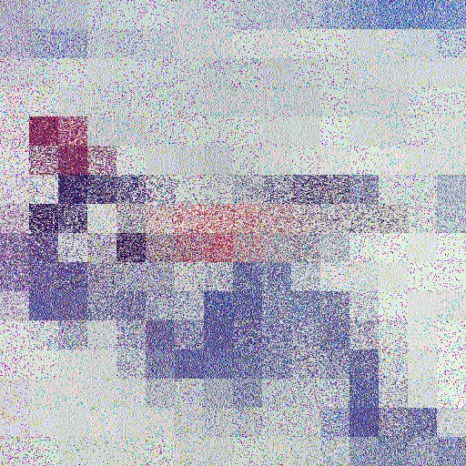 | 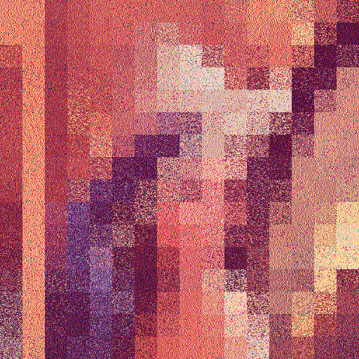 | 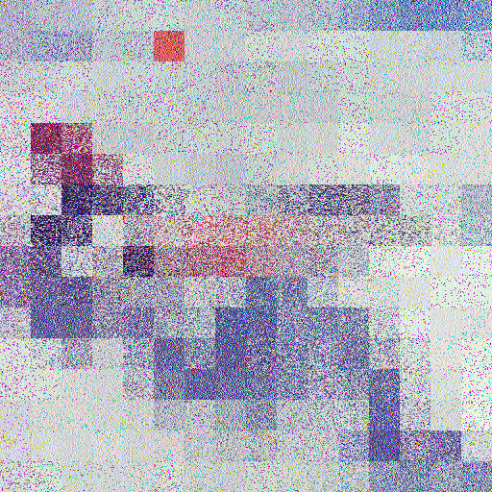
Airplane clean authenticated image | Lena donor authenticated image | Airplane after 32×32 block splice
Result: replaced block row 1, column 5; rejected; exact affected groups: channel 0: group 185; channel 1: group 98; channel 2: group 189. Recovery withheld.
Airplane block → Lena — full 512×512 encrypted images
 |  | 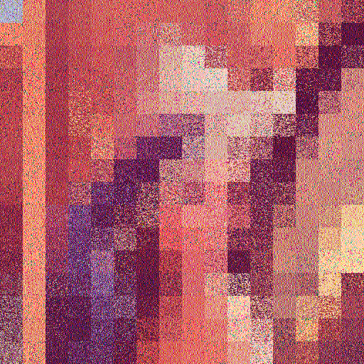
Lena clean authenticated image | Airplane donor authenticated image | Lena after 32×32 block splice
Result: replaced block row 0, column 0; rejected; exact affected groups: channel 0: group 204; channel 1: group 128; channel 2: group 186. Recovery withheld.

Close-ups and one-pixel test
Airplane recipient / Lena donor block detail
 | 
Recipient block before | Donor block | Recipient block after splice
Lena recipient / Airplane donor block detail
 | 
Recipient block before | Donor block | Recipient block after splice
Single-pixel change: authenticated Couple image
 |  | 
Clean authenticated Couple | Same image after 1-pixel edit | 16× enlarged pixel neighborhood
Result: one pixel at (y=160, x=64), channel 1, was flipped. Verification rejected the image and localized the failure to group 42; recovery withheld.
Test | Verification | Localization
Lena block → Airplane | Rejected; recovery withheld | 3 exact channel groups
Airplane block → Lena | Rejected; recovery withheld | 3 exact channel groups
One-pixel edit | Rejected; recovery withheld | 1 exact four-block group
Controls: clean Airplane, clean Lena, and clean Couple outputs verified before modifications. Tests use the saved research outputs and reproducibility fixture key; this is a demonstration, not a security certification.

