Exact-Order Authenticated 32×32 Block-TPE Results
Professor flowchart order, localized four-block HMAC tags, and corrected thumbnail-fidelity measurements
Six real color images · 32×32 blocks · 11 October 2026

Result at a glance
- All six images followed the flowchart’s processing order: legacy block TPE/RDH → reversible Step-1/Step-2 processing → HMAC_DRBG four-block group selection → per-group HMAC-SHA256 → RCM tag embedding.
- All 864 expected per-channel/four-block tags were embedded and verified; every group had at least 1,150 net RCM bits for its 256-bit tag. No whole-image fallback was used.
- All six images and embedded RDH payloads recovered exactly. A selected one-pixel tamper was rejected and localized to its selected four-block group.
- After reversible block-sum compensation, the final authenticated image preserves each pre-authentication 32×32 per-channel block sum exactly. Final original-to-ciphertext block-thumbnail PSNR is 49.82–54.84 dB.

Implementation sequence and necessary additions
Flowchart stage | What this run does
1. Block TPE/RDH | Existing b=32 TPE pipeline creates the encrypted block image and embeds the reversible payload.
2. Reversible pair transforms | Authentication Step-1 and Step-2 run on the TPE ciphertext after it is produced.
3. HMAC_DRBG grouping | The keyed DRBG determines the four-block membership/order independently for each color channel.
4. Group authentication | HMAC-SHA256 is calculated over each post-Step-2 four-block group and its logical pairing map.
5. RCM marking | A 256-bit group HMAC is inserted using reversible contrast mapping. Groups are capacity-preflighted; failure is closed, not silently downgraded.
6. Reversible fidelity wrapper | A protected sidecar stores the data-dependent within-block pairing map and per-pixel sum-correction vector. The correction restores the pre-auth block sum exactly; verification reverses it before extracting the RCM tags.
Important format limitation: The RGB image is not self-contained. A companion ChaCha20-Poly1305-protected sidecar is required; it is about 1.20 MB for 512×512 inputs and 0.29 MB for 256×256 inputs. This is a research prototype, not a compact deployment format.

Measured fidelity, capacity, and recovery
Image | Group tags | Min. net capacity (bits) | Full RGB PSNR dB | 32×32 thumbnail PSNR dB | Thumbnail SSIM | Max block-sum delta | Auth + exact recovery
Airplane | 192 | 1496 | 12.13 | 54.02 | 0.999879 | 0 | Yes
Baboon | 192 | 1552 | 10.92 | 52.20 | 0.999952 | 0 | Yes
Couple | 48 | 1150 | 15.83 | 54.43 | 0.999812 | 0 | Yes
Girl | 48 | 1292 | 13.31 | 54.84 | 0.999922 | 0 | Yes
Lena | 192 | 1462 | 11.78 | 51.16 | 0.999893 | 0 | Yes
Peppers | 192 | 1482 | 11.70 | 49.82 | 0.999928 | 0 | Yes
PSNR definitions. Full RGB PSNR compares the original full-resolution pixels with the final authenticated ciphertext; low values are expected for an encrypted image. Thumbnail PSNR compares rounded RGB means for every corresponding 32×32 block in the original and final ciphertext—the task-relevant thumbnail metric. The authenticated image’s thumbnail equals its pre-authentication TPE thumbnail because each block sum is exactly restored. All six full-resolution inputs are included; no test image was dropped.

Before / after the exact-order correction
Measure | Previous hybrid (preserved, not overwritten) | Exact-order compensated run
Ordering | RCM authentication was inserted before the legacy substitution, which was then wrapped around it. | Authentication Step-1/Step-2 and HMAC/RCM run after the complete legacy TPE ciphertext, in flowchart order.
Localization | The prior six outputs used one whole-image fallback tag; no four-block localization. | All 864 expected four-block tags pass capacity and verify; one-pixel tamper test localizes to the affected group.
Thumbnail PSNR | Prior final range: 36.46–51.47 dB; marking changed block sums. | Final range: 49.82–54.84 dB; final authenticated per-block sums match pre-auth TPE exactly.
Recovery | Exact image and payload recovery passed. | Exact image and payload recovery still pass; no whole-image fallback.
Scope note. This experiment validates the exact-order image pipeline and its reversibility. It does not re-run NIST STS 2.1.2. Previously reported NIST tests cover the defined cryptographic-component streams; they are not image-fidelity scores, and they are not newly claimed as a validation of this layout/compensation wrapper.

Airplane — original, b=32 TPE, and authenticated output
Full RGB PSNR (original→final): 12.13 dB | 32×32 thumbnail PSNR: 54.02 dB | thumbnail SSIM: 0.999879 | four-block tags: 192 | min capacity: 1496 bits | exact recovery: True
Original input | Block TPE before authentication | Final authenticated TPE
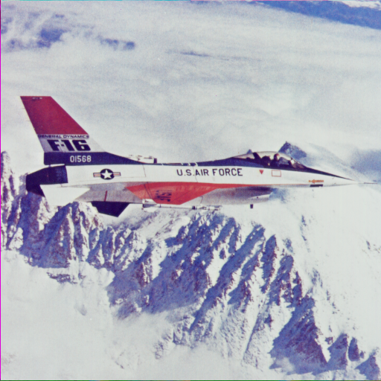 |  | 

Baboon — original, b=32 TPE, and authenticated output
Full RGB PSNR (original→final): 10.92 dB | 32×32 thumbnail PSNR: 52.20 dB | thumbnail SSIM: 0.999952 | four-block tags: 192 | min capacity: 1552 bits | exact recovery: True
Original input | Block TPE before authentication | Final authenticated TPE
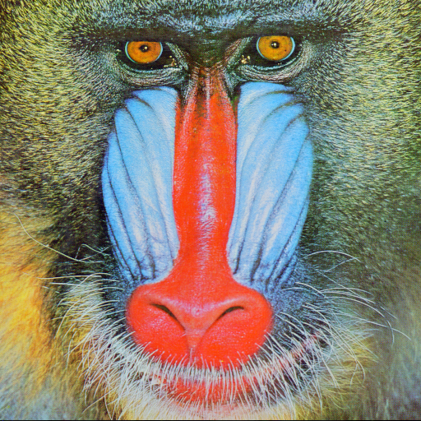 | 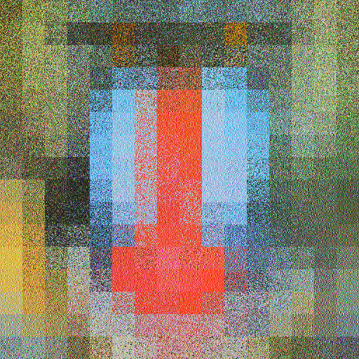 | 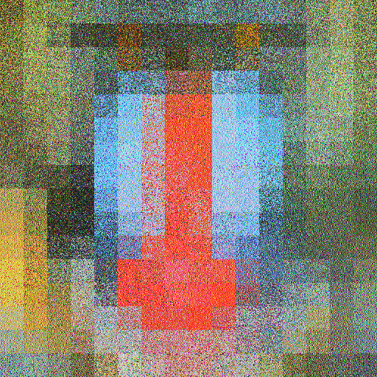

Couple — original, b=32 TPE, and authenticated output
Full RGB PSNR (original→final): 15.83 dB | 32×32 thumbnail PSNR: 54.43 dB | thumbnail SSIM: 0.999812 | four-block tags: 48 | min capacity: 1150 bits | exact recovery: True
Original input | Block TPE before authentication | Final authenticated TPE
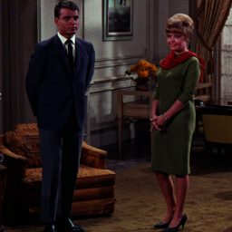 |  | 

Girl — original, b=32 TPE, and authenticated output
Full RGB PSNR (original→final): 13.31 dB | 32×32 thumbnail PSNR: 54.84 dB | thumbnail SSIM: 0.999922 | four-block tags: 48 | min capacity: 1292 bits | exact recovery: True
Original input | Block TPE before authentication | Final authenticated TPE
 | 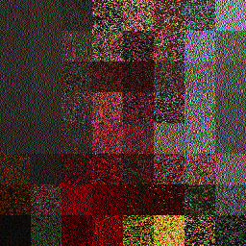 | 

Lena — original, b=32 TPE, and authenticated output
Full RGB PSNR (original→final): 11.78 dB | 32×32 thumbnail PSNR: 51.16 dB | thumbnail SSIM: 0.999893 | four-block tags: 192 | min capacity: 1462 bits | exact recovery: True
Original input | Block TPE before authentication | Final authenticated TPE
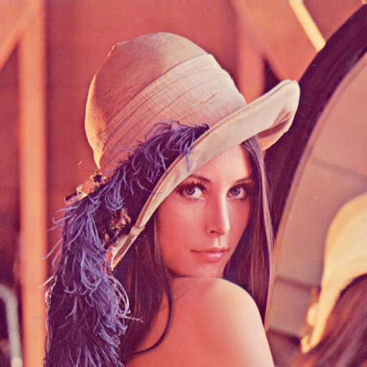 |  | 

Peppers — original, b=32 TPE, and authenticated output
Full RGB PSNR (original→final): 11.70 dB | 32×32 thumbnail PSNR: 49.82 dB | thumbnail SSIM: 0.999928 | four-block tags: 192 | min capacity: 1482 bits | exact recovery: True
Original input | Block TPE before authentication | Final authenticated TPE
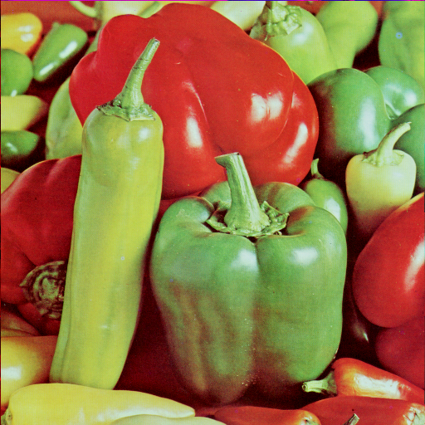 | 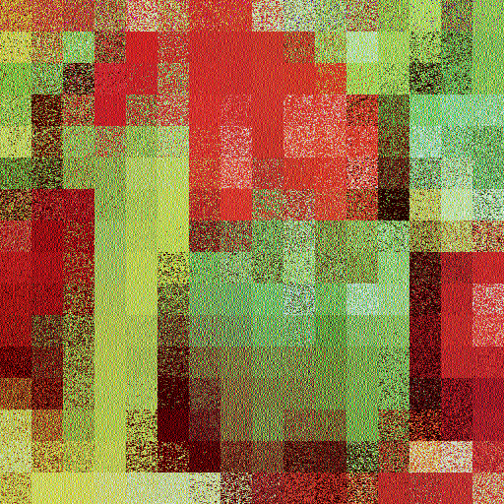 | 