Four-Pixel TPE with Block-Group Authentication
Initial implementation and verification | 25 October 2026
I implemented the four-pixel sum-preserving transform as a new TPE option and connected it to the existing 32×32 block-group HMAC-SHA256 authentication. The six tracked 512×512 images all passed exact recovery, exact payload recovery, and block-thumbnail checks.

Results
Measure | Result
Full-image PSNR, original vs. final authenticated ciphertext | Mean 13.2528 dB; range 11.3101–16.8958 dB (arithmetic mean of six per-image dB values).
32×32 thumbnail PSNR | All six thumbnails are exactly equal (zero MSE); PSNR is ∞ / not a finite value, not a finite 27 dB figure.
Recovery | 6/6 exact RGB image recovery and 6/6 exact payload recovery.
Authentication layout | 192 HMAC tags per 512×512 image: 4-block groups across 3 channels.
Tamper checks | A one-pixel edit was localized to one group. One 32×32 RGB block splice in either direction was detected and localized to the corresponding group in each affected channel.

Full-image PSNR by image
Image | Full-image PSNR | 32×32 thumbnail
Airplane | 12.3784 dB | Exact
Baboon | 11.3101 dB | Exact
Couple | 16.8958 dB | Exact
Girl | 14.6262 dB | Exact
Lena | 12.2918 dB | Exact
Peppers | 12.0147 dB | Exact

Visual example
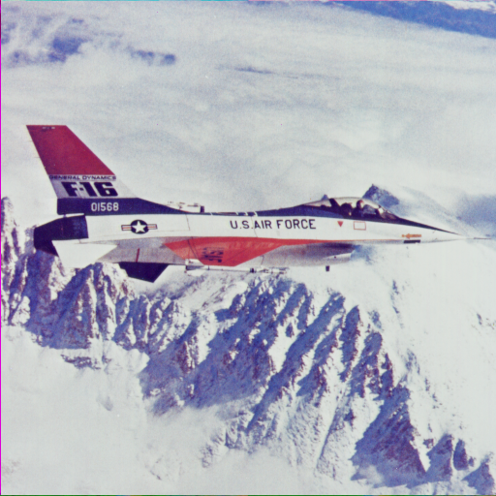  Original Airplane | 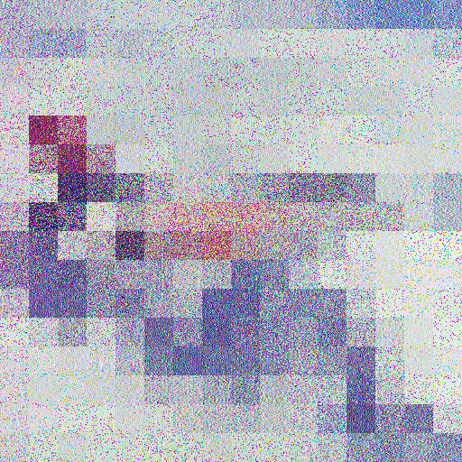  Authenticated encrypted output
Both source files are 512×512 pixels. They are displayed at the same width here; the PNG files themselves were not resized.

Tamper localization
Test | Observed localization
One-pixel edit in Lena | One changed channel sample at (y=263, x=137); group blocks [132, 44, 159, 120] in channel 1 failed.
Airplane → Lena | Replaced Lena block 5 (32×32 RGB); detected; 3 groups reported, one per color channel.
Lena → Airplane | Replaced Airplane block 42 (32×32 RGB); detected; 3 groups reported, one per color channel.
Each authentication group contains four 32×32 blocks within one color channel. A full RGB splice changes all three channels, so the expected localization is three channel-specific groups at that spatial block. The verifier withholds the recovered image whenever a group fails.

Implementation notes
The four-pixel paper does not define an auxiliary-payload container. For this integration, payload bits are carried inside the existing ChaCha20-Poly1305-protected sidecar; they are not embedded in the RGB ciphertext. The sidecar also carries the reversible layout/correction data and is approximately 1.13–1.20 MB per 512×512 image.
The four-pixel equations are used, but the schedule is adapted to the repository’s existing 2D-CSM stream instead of reproducing the paper’s own chaotic schedule exactly. The appendix’s Case 2 inverse for c has a sign inconsistent with its forward equation; the code uses the algebraic inverse and regression-tests the round trip. This is an integration prototype, not a bit-for-bit replication of the paper.
The 71 targeted existing/new regression tests passed. The full historical suite could not be completed because its external UCID image cache and predefined NIST stream files are absent in this restored sandbox. The corrected 700-stream NIST campaign belongs to the earlier method; it has not been rerun for this four-pixel variant, so no NIST pass claim is made here.
Reference: “Four-pixel sum-preserving encryption using the chaotic map for high thumbnail-preserving image security,” Scientific Reports (2026), https://doi.org/10.1038/s41598-026-47090-9.

