32×32 Block-Encrypted Image Examples
Each right-hand panel is a newly generated encrypted output using the previous TPE/RDH pipeline with block size b=32. The images are shown at native input dimensions, scaled only to fit this page. All six runs verified exact recovery, payload recovery, and preservation of each 32×32 per-channel block sum.

Airplane — original vs. b=32 encrypted image
Block size: 32×32 | Exact recovery: True | Payload recovered: True | Block sums preserved: True
Original input | 32×32 block-encrypted output
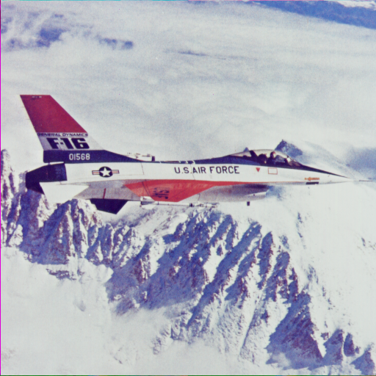 | 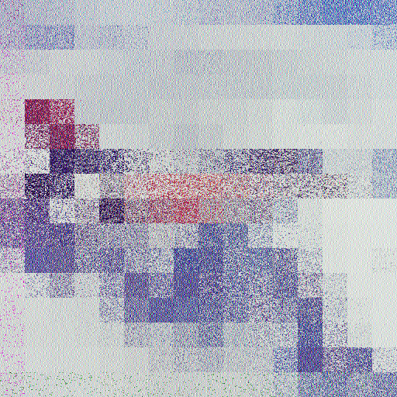

Baboon — original vs. b=32 encrypted image
Block size: 32×32 | Exact recovery: True | Payload recovered: True | Block sums preserved: True
Original input | 32×32 block-encrypted output
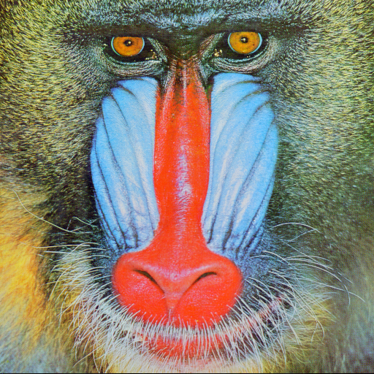 | 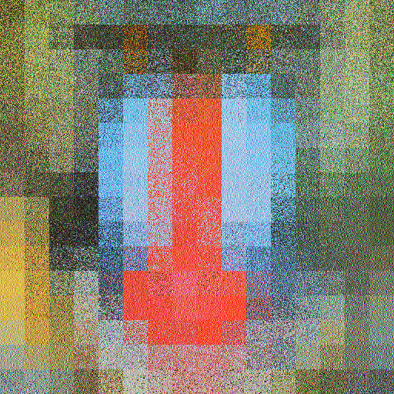

Couple — original vs. b=32 encrypted image
Block size: 32×32 | Exact recovery: True | Payload recovered: True | Block sums preserved: True
Original input | 32×32 block-encrypted output
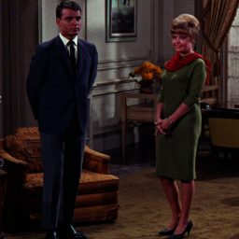 | 

Girl — original vs. b=32 encrypted image
Block size: 32×32 | Exact recovery: True | Payload recovered: True | Block sums preserved: True
Original input | 32×32 block-encrypted output
 | 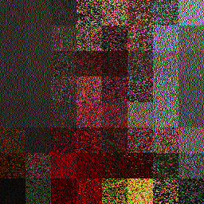

Lena — original vs. b=32 encrypted image
Block size: 32×32 | Exact recovery: True | Payload recovered: True | Block sums preserved: True
Original input | 32×32 block-encrypted output
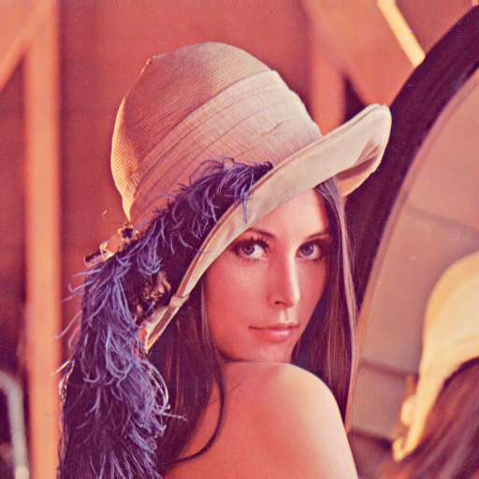 | 

Peppers — original vs. b=32 encrypted image
Block size: 32×32 | Exact recovery: True | Payload recovered: True | Block sums preserved: True
Original input | 32×32 block-encrypted output
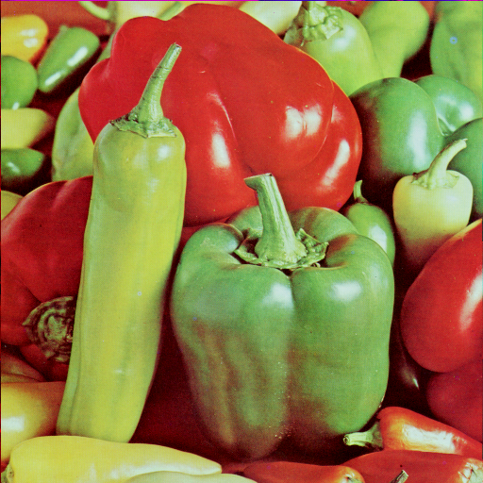 | 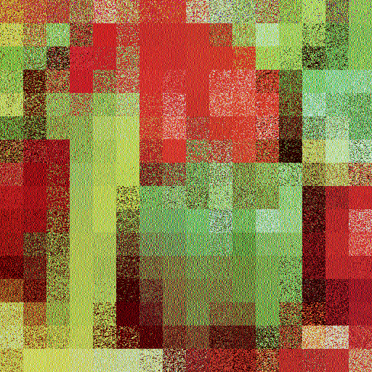
Method note: These images are from the separate chaotic TPE/RDH implementation, not the authenticated block-group prototype. The authenticated method processes 32×32 blocks but does not spatially permute block positions; it is therefore not expected to show this same block-wise appearance. No visual overlay or post-processing has been applied.

Flowchart-combined authenticated TPE results
Following the professor’s flowchart, this supplement preserves the original 32×32 block-TPE stage and adds HMAC-SHA256 authentication with HMAC_DRBG grouping and reversible RCM marking. The final image remains an encrypted block-TPE output. The legacy pair-sum-preserving substitution is applied after RCM as an outer reversible step; verification first reverses that step, then authenticates, before plaintext recovery. This ordering adjustment is disclosed below and in the implementation notes.

PSNR and thumbnail-fidelity results
Full RGB PSNR compares original pixels with the encrypted image and is not the thumbnail-preservation score. “Block-thumbnail PSNR” compares rounded RGB means for corresponding 32×32 blocks in the original and encrypted images. That is the relevant block-thumbnail fidelity measure. Authentication marking changes some block means, so both pre-authentication and final authenticated values are shown.
Image | Full RGB PSNR dB  TPE → Auth | 32×32 thumbnail PSNR dB  TPE → Auth | 32×32 thumbnail SSIM  TPE → Auth | Auth mode
Airplane | 13.2544 → 12.7848 | 54.0178 → 36.4636 | 0.999879 → 0.993927 | whole-image
Baboon | 11.3812 → 11.2735 | 52.1988 → 39.5298 | 0.999952 → 0.997915 | whole-image
Couple | 16.4928 → 16.4355 | 54.4317 → 51.4699 | 0.999812 → 0.999591 | whole-image
Girl | 13.8179 → 13.7931 | 54.8360 → 51.4699 | 0.999922 → 0.999767 | whole-image
Lena | 12.4657 → 12.2437 | 51.1638 → 36.8573 | 0.999893 → 0.997616 | whole-image
Peppers | 12.2221 → 12.1111 | 49.8244 → 43.5740 | 0.999928 → 0.999202 | whole-image
Six-image mean: full RGB PSNR 13.2724 → 13.1069 dB; block-thumbnail PSNR 52.7454 → 43.2274 dB.

Measured RCM capacity and fallback
A 256-bit group tag needs at least 256 net eligible pair slots (T + O − N) within that group. HMAC_DRBG still defines the deterministic group ordering; the source method falls back atomically to one whole-image tag if any group cannot carry its tag. The table reports every group’s capacity outcome count, not a selected subset.
Image | Post-auth-Step-2 whole net bits | 4-block groups with ≥256 bits | Legacy post-substitution net bits
Airplane | 250706 | 191/192 | -132962
Baboon | 203012 | 188/192 | -133026
Couple | 8272 | 22/48 | -35216
Girl | 36222 | 42/48 | -34448
Lena | 254036 | 189/192 | -132040
Peppers | 206736 | 183/192 | -128360
All six outputs authenticated and recovered the original image and payload exactly in the test. All six selected whole-image authentication fallback because at least one four-block group was short of 256 net RCM slots (e.g., Couple: only 22 of 48 groups fit; remaining 26 do not). After the legacy substitution, RCM net capacity is negative for every image (for example, Baboon: −133,026 bits), so embedding RCM after that legacy stage is impossible under this code. The hybrid therefore places authentication before that outer reversible substitution and inverts it before verifying. Authentication works, but group-level tamper localization is not achieved for these six images. No tag or failure was hidden.

Authenticated output examples

Airplane — original, block TPE, and authenticated output
Full RGB PSNR: 12.7848 dB | 32×32 thumbnail PSNR: 36.4636 dB | Thumbnail SSIM: 0.993927 | Auth: whole-image | Exact recovery and payload: verified
Original | Block TPE (before authentication) | Final authenticated TPE
 |  | 

Baboon — original, block TPE, and authenticated output
Full RGB PSNR: 11.2735 dB | 32×32 thumbnail PSNR: 39.5298 dB | Thumbnail SSIM: 0.997915 | Auth: whole-image | Exact recovery and payload: verified
Original | Block TPE (before authentication) | Final authenticated TPE
 |  | 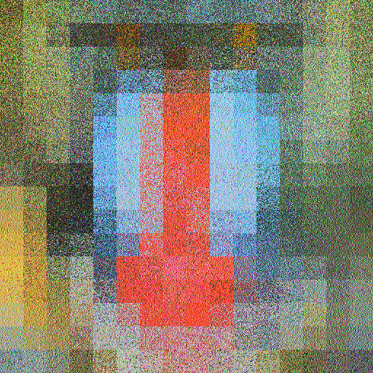

Couple — original, block TPE, and authenticated output
Full RGB PSNR: 16.4355 dB | 32×32 thumbnail PSNR: 51.4699 dB | Thumbnail SSIM: 0.999591 | Auth: whole-image | Exact recovery and payload: verified
Original | Block TPE (before authentication) | Final authenticated TPE
 |  | 

Girl — original, block TPE, and authenticated output
Full RGB PSNR: 13.7931 dB | 32×32 thumbnail PSNR: 51.4699 dB | Thumbnail SSIM: 0.999767 | Auth: whole-image | Exact recovery and payload: verified
Original | Block TPE (before authentication) | Final authenticated TPE
 |  | 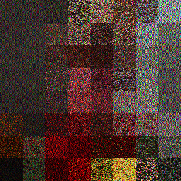

Lena — original, block TPE, and authenticated output
Full RGB PSNR: 12.2437 dB | 32×32 thumbnail PSNR: 36.8573 dB | Thumbnail SSIM: 0.997616 | Auth: whole-image | Exact recovery and payload: verified
Original | Block TPE (before authentication) | Final authenticated TPE
 |  | 

Peppers — original, block TPE, and authenticated output
Full RGB PSNR: 12.1111 dB | 32×32 thumbnail PSNR: 43.5740 dB | Thumbnail SSIM: 0.999202 | Auth: whole-image | Exact recovery and payload: verified
Original | Block TPE (before authentication) | Final authenticated TPE
 |  | 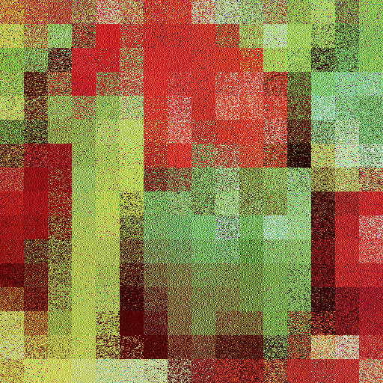
Limitation and next step: This is a reproducible research prototype following the flowchart’s component order at a reversible boundary. It demonstrates authenticated recovery while retaining visible block effects, but does not obtain four-block localization on this image set because RCM capacity is inadequate. To require per-group localization, the RCM carrier/capacity scheme must be redesigned and then revalidated; changing the key, block membership, or reporting convention to make this run look successful would not be scientifically appropriate.

