32×32 Block-Encrypted Image Examples
Each right-hand panel is a newly generated encrypted output using the previous TPE/RDH pipeline with block size b=32. The images are shown at native input dimensions, scaled only to fit this page. All six runs verified exact recovery, payload recovery, and preservation of each 32×32 per-channel block sum.

Airplane — original vs. b=32 encrypted image
Block size: 32×32 | Exact recovery: True | Payload recovered: True | Block sums preserved: True
Original input | 32×32 block-encrypted output
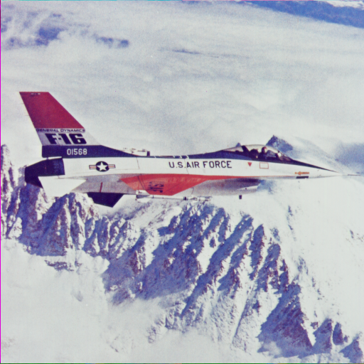 | 

Baboon — original vs. b=32 encrypted image
Block size: 32×32 | Exact recovery: True | Payload recovered: True | Block sums preserved: True
Original input | 32×32 block-encrypted output
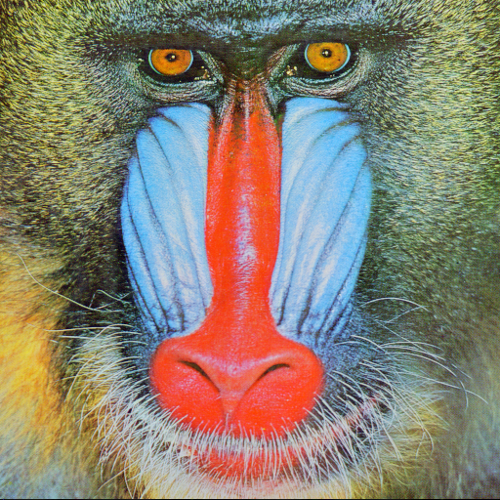 | 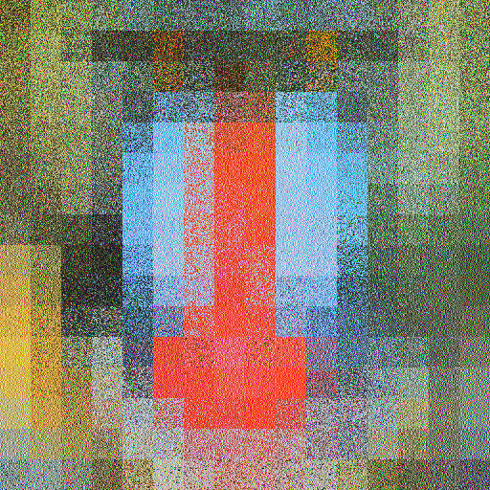

Couple — original vs. b=32 encrypted image
Block size: 32×32 | Exact recovery: True | Payload recovered: True | Block sums preserved: True
Original input | 32×32 block-encrypted output
 | 

Girl — original vs. b=32 encrypted image
Block size: 32×32 | Exact recovery: True | Payload recovered: True | Block sums preserved: True
Original input | 32×32 block-encrypted output
 | 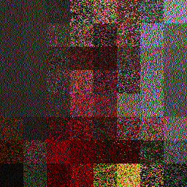

Lena — original vs. b=32 encrypted image
Block size: 32×32 | Exact recovery: True | Payload recovered: True | Block sums preserved: True
Original input | 32×32 block-encrypted output
 | 

Peppers — original vs. b=32 encrypted image
Block size: 32×32 | Exact recovery: True | Payload recovered: True | Block sums preserved: True
Original input | 32×32 block-encrypted output
 | 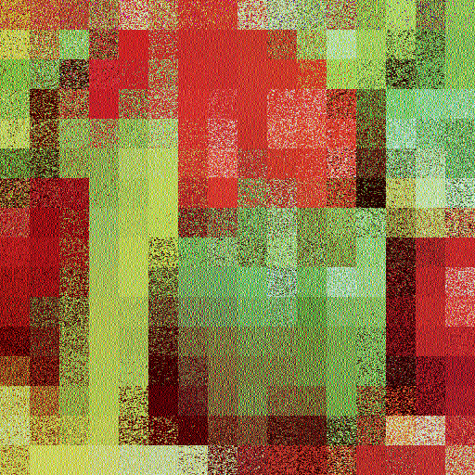
Method note: These images are from the separate chaotic TPE/RDH implementation, not the authenticated block-group prototype. The authenticated method processes 32×32 blocks but does not spatially permute block positions; it is therefore not expected to show this same block-wise appearance. No visual overlay or post-processing has been applied.

