Aparente, Clyde E.

BSCPE - 3A

## Laboratory Activity 6:

1. Create a 1NF table:

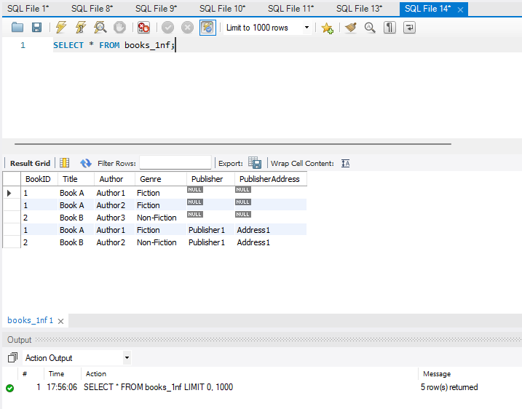

1. Insert sample data:

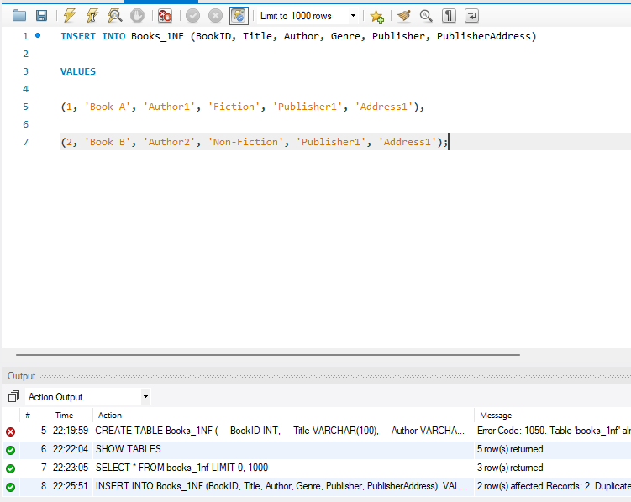

1. Create two separate tables to remove partial dependency:

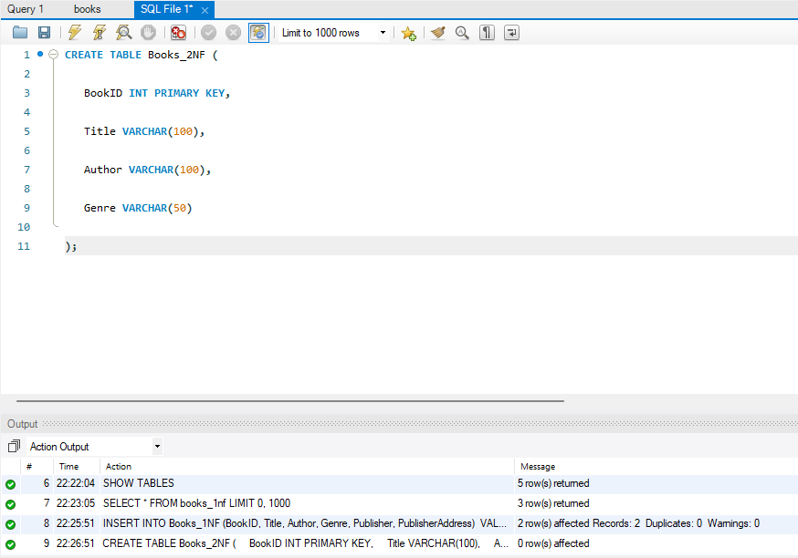

**Additional Questions/Discussions:**

* What is a partial dependency, and how does 2NF eliminate it?

- A partial dependency occurs when a non-key attribute depends on only part of a composite primary key instead of the entire key. In 2NF, partial dependencies are removed by ensuring that every non-key attribute depends on the whole primary key. This is done by splitting the table into separate tables where each attribute has a full functional dependency on the primary key.

* How do foreign keys help maintain data integrity?

- Foreign keys establish a relationship between tables by linking a column in one table to the primary key in another. This ensures that referenced data remains consistent and prevents orphan records. If a referenced record in the primary table is deleted, database constraints can prevent accidental loss of important related data.

**Conclusions:**

**-** In this activity, we transformed a 1NF table into 2NF by eliminating partial dependencies. This was achieved by creating separate tables for books and publishers, ensuring that non-key attributes fully depend on the primary key. The use of foreign keys maintains relationships between tables, improving data organization and reducing redundancy.