Aparente, Clyde E.

BSCPE - 3A

## **Laboratory Activity 7:**

1. Start with a 2NF table:

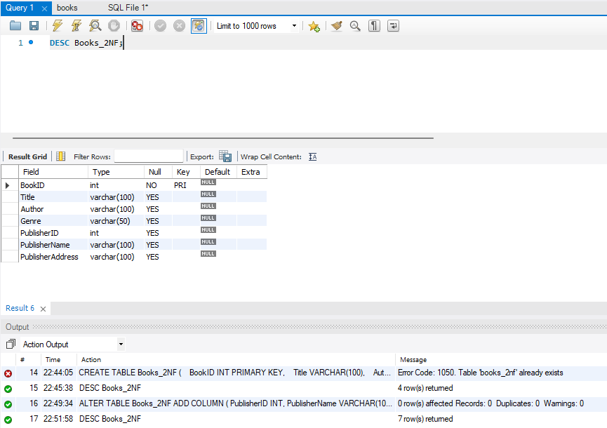

1. Insert data:

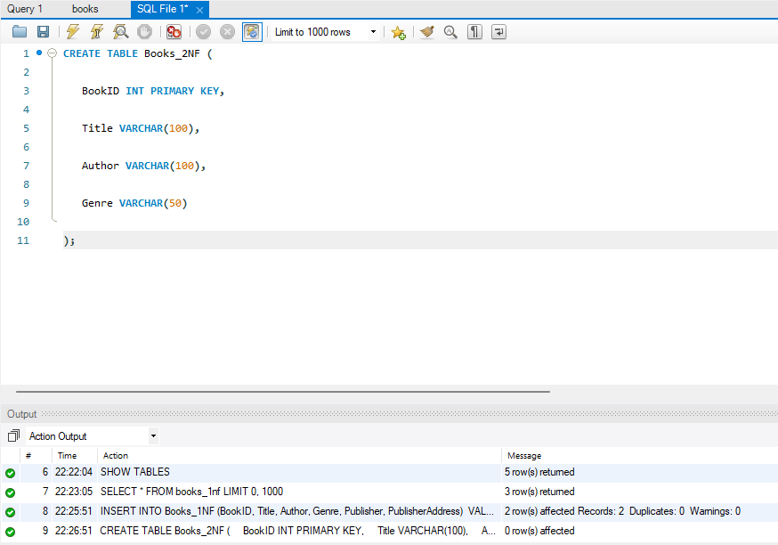

1. Separate publisher details into a new table and link with PublisherID:

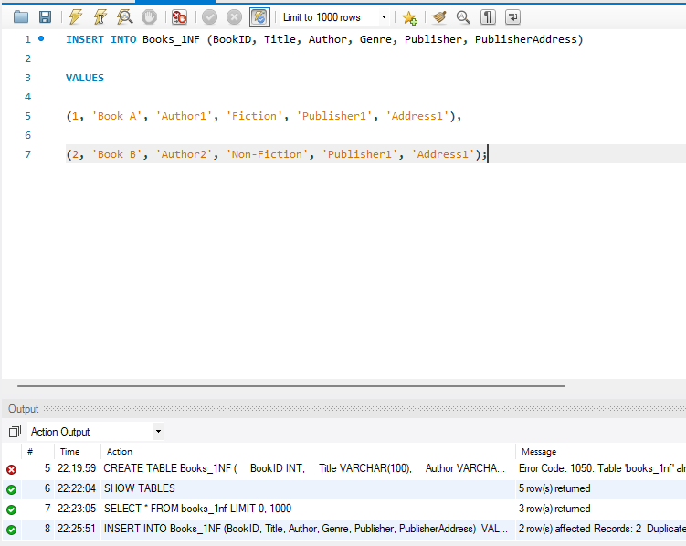

1. ****Remove PublisherName and PublisherAddress from Books_2NF and adjust the table to use only PublisherID.

**Additional Questions/Discussions:**

* What are transitive dependencies, and why should they be eliminated?

- A transitive dependency happens when a non-key attribute depends on another non-key attribute instead of the primary key. Removing them ensures each table stores only relevant data, reducing redundancy and improving efficiency.

* How does 3NF improve data integrity?

- 3NF removes unnecessary dependencies, preventing duplicate data and inconsistencies. It keeps related data in separate tables, making updates easier and maintaining accuracy.

**Conclusions:**

By moving publisher details to a separate table, we eliminated transitive dependencies and achieved 3NF. This improves data organization, reduces redundancy, and ensures consistency.