Aparente, Clyde E.

BSCPE - 3A

## **Laboratory Activity 5:**

1. Start by creating a sample non-normalized table:

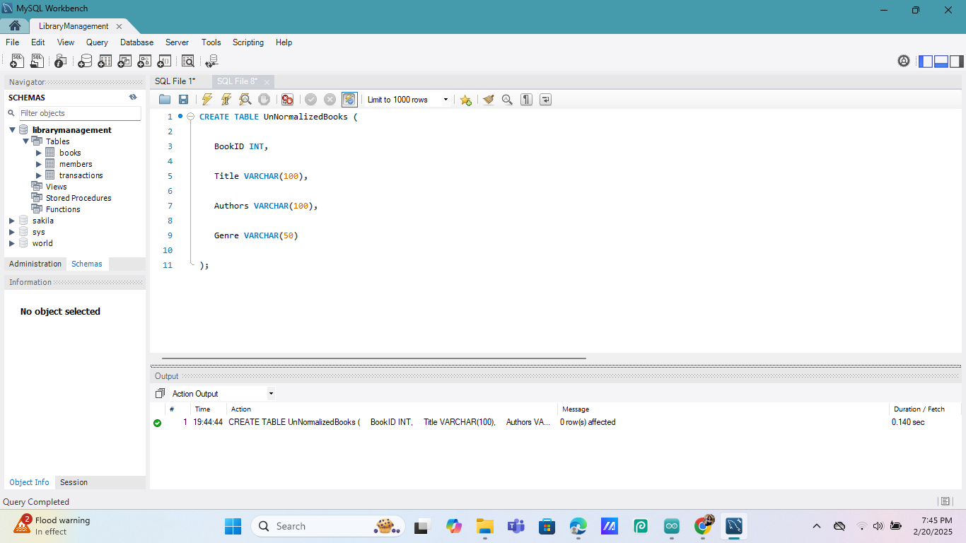

1. Insert data into the table:

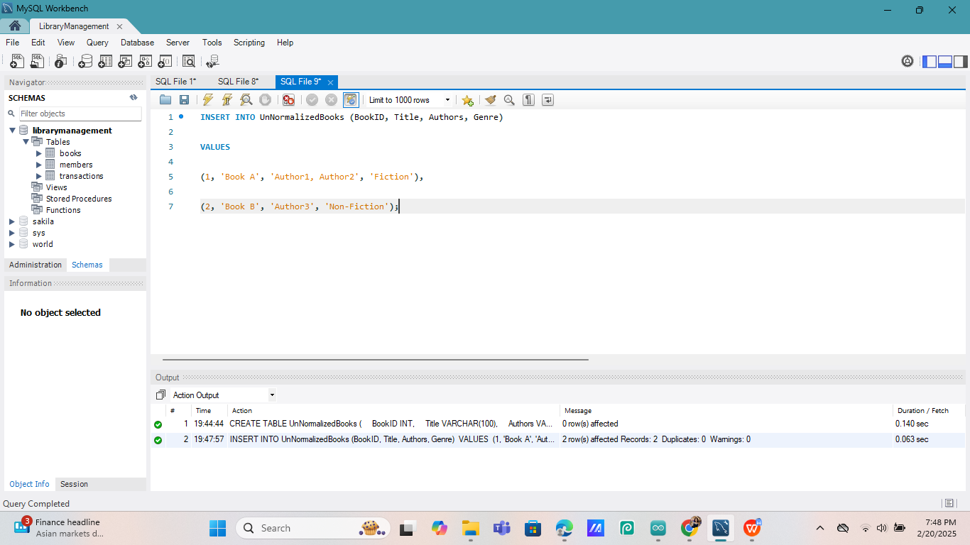

1. Convert to 1NF by creating separate rows for multiple authors:

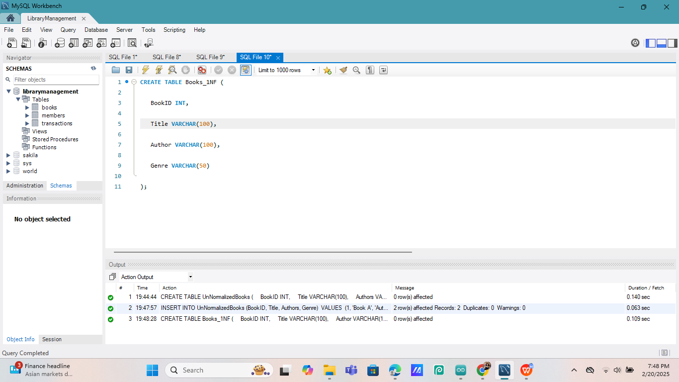

1. Insert normalized data:

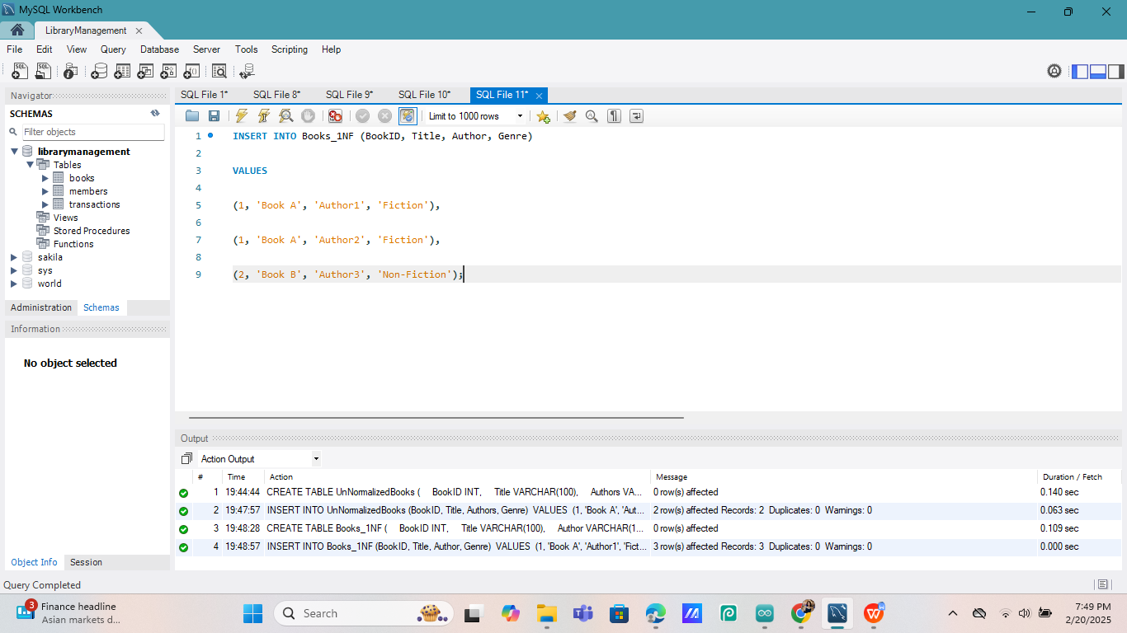

**Additional Questions/Discussions:**

* How does 1NF improve data integrity?

- **1NF improves data integrity** by ensuring each column has a single value, reducing redundancy, and preventing inconsistencies. It also makes data easier to update, search, and maintain.

* What are atomic values, and why are they important?

- **Atomic values** mean each field contains only one piece of data, not multiple. This makes the database more organized, prevents errors, and improves efficiency.

**Conclusions:**

By applying **First Normal Form (1NF),** we eliminated multi-valued fields, ensuring each column holds atomic values. This improved data integrity, reduced redundancy, and made the database easier to manage and query.