THE 1140A CORPORATION
a Massachusetts non-profit presenting company
FOUNDING PARTNER
Sole Sponsorship Invitation
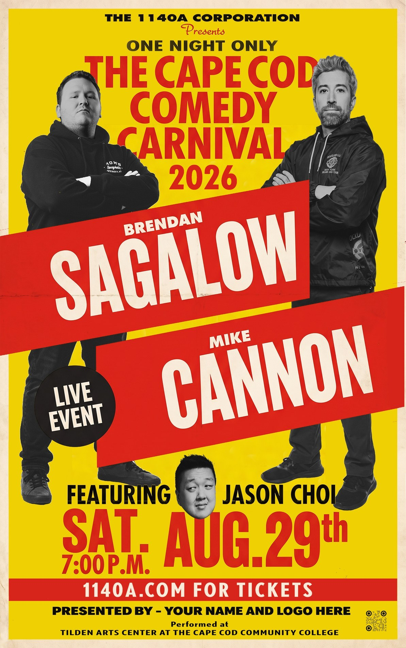
THE CAPE COD COMEDY CARNIVAL
The Invitation
On Saturday, 29 August, two nationally-touring Comedy Cellar headliners - Brendan Sagalow and Mike Cannon, with Jason Choi opening - play the Tilden Arts Center on Cape Cod. Two full headline sets in one night is a rarity on the Cape. Video of their comedy has drawn over 25 million documented views, their combined following runs past 640,000, and they are regular guests in the biggest rooms in comedy. These are not amateurs.
There is a reason it is happening here. Through the 1980s and ’90s, a Cape teenager could see A-list stand-ups in real, well-staged yet intimate, venues like the Tony Kent Arena and the Cape Cod Coliseum, at a price they could afford. Then the rooms went away. One even became a warehouse and nothing comparable rose to take their place. The 1140A Corporation exists to bring that back: professional comedy on the Cape, priced for Cape Codders, and built to recur - this the first of a planned series.
We invite a single organisation to become the sole Founding Partner of it - not for one night’s advertising, but to plant your name at the root of something built to last. What Ralph Lauren is to the polo at the Hamptons, a Founding Partner is to this.

What We’re Asking
$9,750
sole Founding Partner · twelve guests · one price
One figure, one decision - no tiered menu, no second sponsor. For it, the Founding Partner receives:
▪ Sole sponsor status. You are the only sponsoring organisation - your name and logo on event materials as the sole partner, in the position shown on the poster in this document. No competing brand shares the event’s public presence.
▪ A private meet-and-greet with the headliners. Twelve guests, on a bucolic private Cape Cod property, before the show - a relaxed gathering with the comedians in their warm off-stage personas.
▪ Twelve premium reserved (Orchestra) seats. Your guests are seated together in the Orchestra - the reserved VIP section up-close-and-personal - for the show.
▪ A founding association that recurs. First right to continue as Founding Partner of future events in the series - the same name carried forward, year after year.
A note on timing, with our apologies for the short window. We have reserved twelve of the very best seats in the house for our Founding Partner. In fairness to the public, we can hold them only until roughly two weeks before the event, when the remaining reserved seats are released for general sale. That is the honest reason for the timeline - not pressure, simply the reality of holding the best seats for you for as long as we responsibly can. And in candour, this invitation goes simultaneously to a small number of local supporters of the arts; the sole slot goes to the first to commit. We will follow up once, about a week after this reaches you.

Why This Matters
A civic gift, not an ad campaign. As of 29 July, tickets are already on sale and the campaign is already in motion. A Founding Partner is not buying this single event’s advertising - they are joining a recurring Cape Cod institution at its founding, and being known as the organisation that made affordable, professional comedy possible on the Cape. That association compounds every year it continues.
The long game. The corporation intends to present comedy - and, in time, other arts and culture programming - on the Cape on an ongoing basis. A Founding Partner is positioned to grow with it: the same name, event after event, year after year, tied to a body of work the community comes to rely on. The partnership is the point; the single event is merely where it begins.
Advertising presence (included, but not the point). Sole-sponsor visibility is real and it is yours alone - your name and logo on event materials as the single sponsoring organisation, with no competing brand present. We are candid that the campaign is already live, so this is a founding association rather than a launch-window media buy. The value is the partnership; the visibility comes with it.

The Talent
Two nationally-touring headliners - both regulars at the world-famous Comedy Cellar - and a rising opening act.
BRENDAN SAGALOW “Thin Lips”
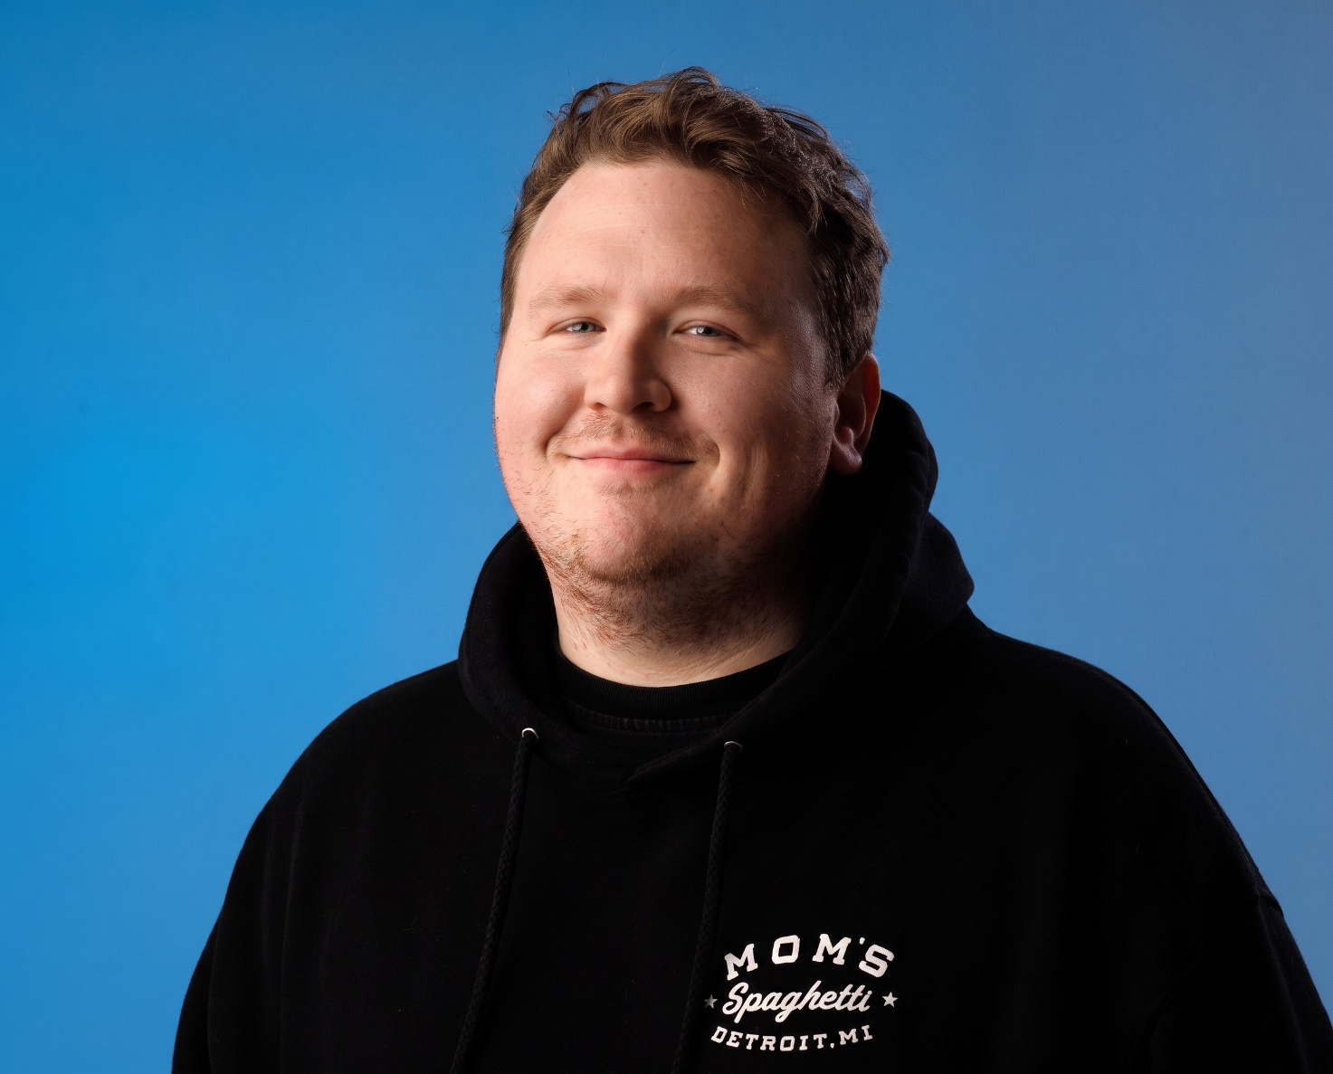
Brendan Sagalow is a New York-based stand-up comedian and a regular at the world-famous Comedy Cellar. Known for a fearless, high-energy, self-deprecating style, he tours nationally and released his latest hour-long special, Thin Lips (2024), independently to a large and fast-growing online audience. His clips travel widely across YouTube, TikTok, and Instagram, and his fanbase follows him from city to city - the mark of a comedian who converts attention into filled rooms. He is a regular presence on the podcasts that drive the modern comedy scene — among them Legion of Skanks, The Bonfire, and Robert Kelly’s You Know What Dude!

MIKE CANNON “Traumatized Animal”
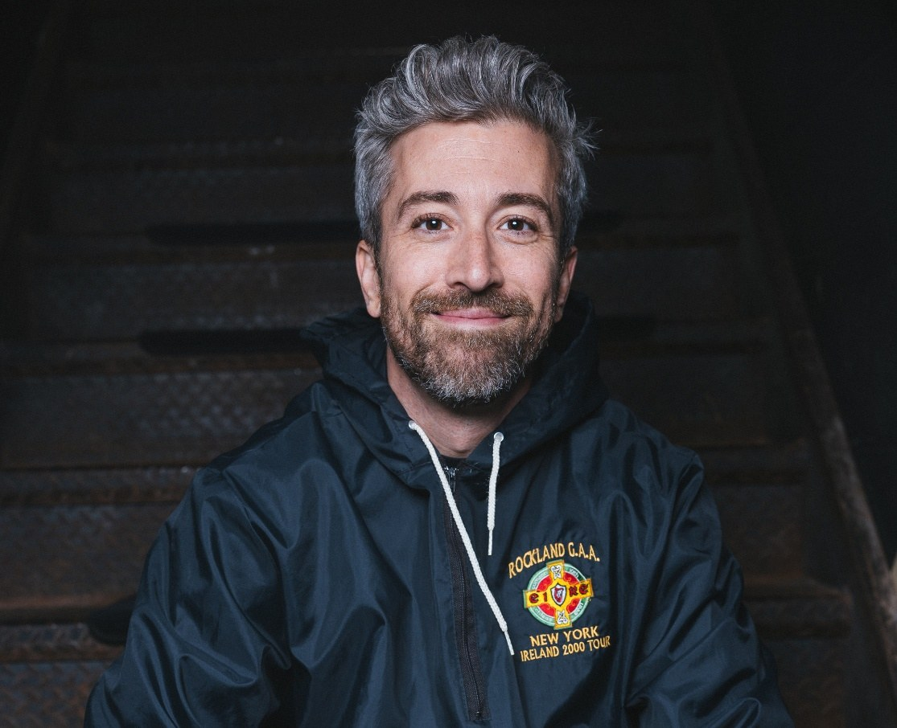
Mike Cannon is a New York-based comedian and Comedy Cellar regular whose sharp, self-aware writing and effortless crowd work have made him one of the most reliable headliners on the circuit. His most recent special, Traumatized Animal (2024), was released independently and has drawn a devoted following. Cannon has built his audience the modern way - through material that spreads far beyond his own channels - and brings a room fully under his control from the first minute. He is a fixture on the scene’s defining podcasts — Legion of Skanks, The Bonfire, and Robert Kelly’s You Know What Dude! among them.

JASON CHOI opening the night
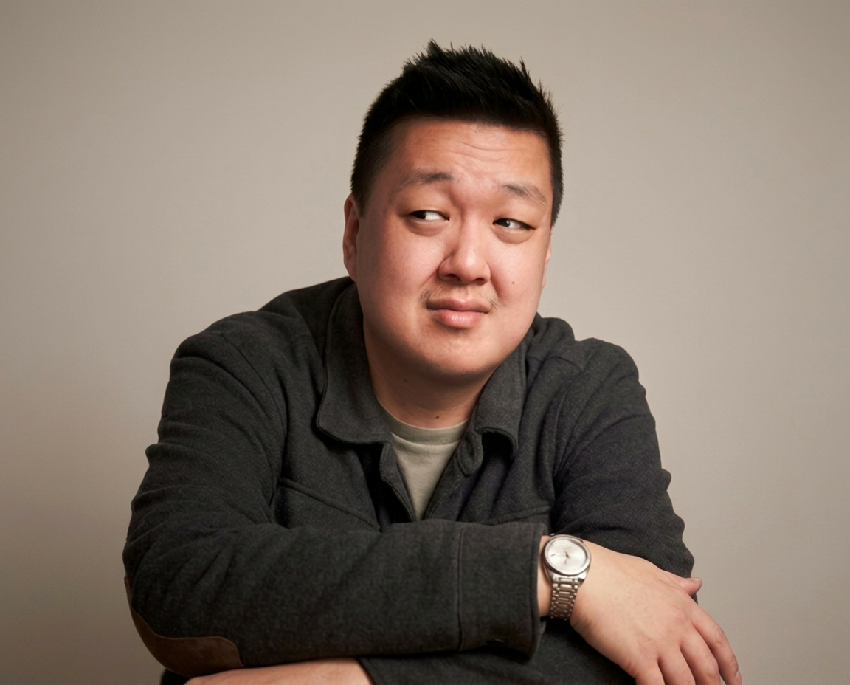
Jason Choi is a New York-based comedian, writer and actor, and opens the evening. He was named New York’s Funniest at the 2025 New York Comedy Festival, was a finalist at the Boston Comedy Festival and the New York Comedy Club Fall Invitational, and made his network television debut in 2026 on CBS’s Comic’s Unleashed. He has opened for Ronny Chieng, Mike Cannon, Mike Vecchione, and Gary Gulman.

The Meet-and-Greet
The Founding Partner’s guests are hosted on a private 32-acre Conservation Cape Cod property - open lawns, weathered cottages, Captain Howes’s 1700 home, a barn, and picnic tables under the summer sky. It is unhurried, pleasant, and quintessentially Cape Cod: the kind of place a party feels like an afternoon, not an appointment.
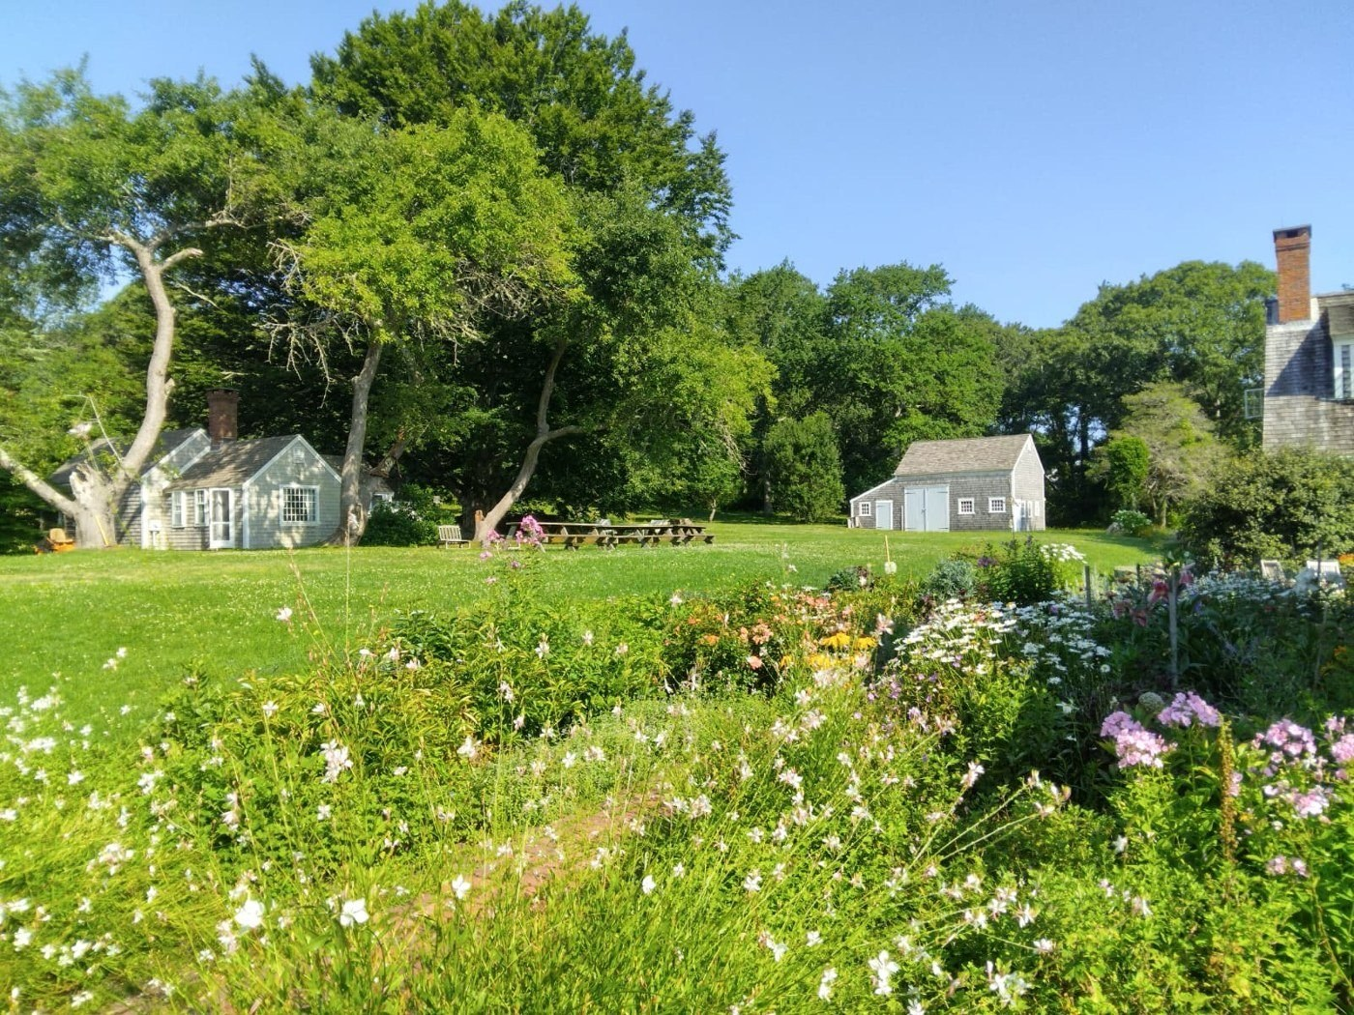
The private property - July 2026.
Here, before the show, your twelve guests meet the headliners over a selection of foods and beverages - a proper spread, and a full bar offering both alcoholic and non-alcoholic choices. It is a warm, informal get-together that turns a night out into an experience your guests remember and attribute to you.

The Venue
The event is presented at the Tilden Arts Center at Cape Cod Community College in West Barnstable - a professional, purpose-built Cape performing-arts venue, and a fitting home for a company that means to be part of the Cape’s cultural life for years to come.
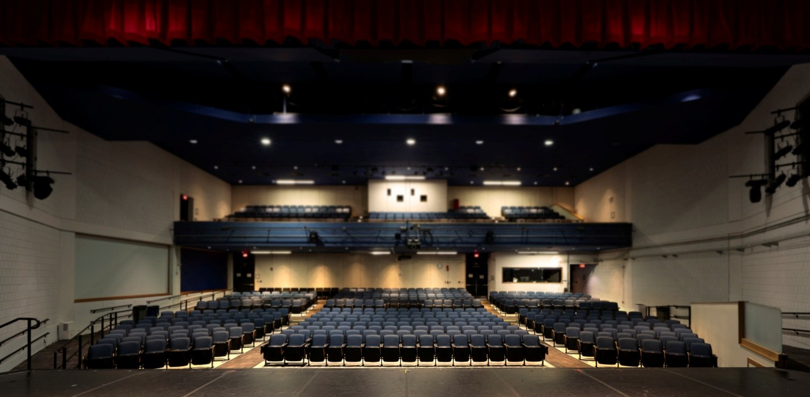
The Tilden Arts Center, Cape Cod Community College.
The seating. The house is fully reserved and assigned - every guest has a specific seat, chosen and held in advance rather than scrambled for at the door. Your twelve guests are seated together in the Orchestra, the premium reserved section closest to the stage.
The 1140A Corporation
The 1140A Corporation is a Massachusetts non-profit presenting company, founded to bring professional performing arts to Cape Cod at prices the community can afford. The Cape Cod Comedy Carnival is its inaugural production - the first of a planned, recurring series of comedy and cultural events. It owns and produces its own events; a Founding Partner is not sponsoring a one-off, but joining an organisation at the beginning of what it intends to become.
Become the Founding Partner.
The sole slot, the twelve best seats, and a name at the root of something built to last - offered for the next two weeks.
Max Makowski · The 1140A Corporation
116 New Boston Road, Dennis, MA 02638 · info@1140a.com

