**Introduction**

Predictive analytics and machine learning have revolutionized decision-making processes by leveraging historical and real-time data to forecast future outcomes, enhancing organizational efficiency, and elevating customer satisfaction(Nazir Awan, 2023; Wang and Aviles, 2023). These technologies employ various advanced algorithms and statistical models such as classifications, regressions, neural networks, and decision trees to transform raw data into actionable insights, providing a competitive edge across diverse sectors like finance, healthcare, retail, and manufacturing (Olufemi Ogunleye, 2023). By accurately predicting customer behavior, detecting fraud, optimizing healthcare diagnoses, and forecasting maintenance needs, predictive analytics enables businesses to make informed decisions, tailor marketing strategies, and streamline operations, ultimately leading to increased revenue, market share, and improved decision-making processes. The integration of predictive analytics and machine learning empowers organizations to proactively address challenges, capitalize on opportunities, and stay ahead in today's data-driven business landscape.

The chosen business problem for this task is focused on enhancing customer retention for an e-commerce business. The company has noticed a high turnover rate, affecting both revenue and potential for growth. By anticipating which clients may leave, the company can actively put in place measures to reduce this problem. Understanding what causes customers to leave can help businesses develop better strategies because keeping existing customers is usually cheaper than attracting new ones.

**Problem Formulation**

Customer churn poses a major obstacle for e-commerce companies, resulting in reduced revenue, diminished customer lifetime value, and ultimately, impeded business expansion (Shaker Reddy *et al.*, 2024; Hangarge *et al.*, 2023). Identifying potential issues early on enables the company to introduce tailored solutions such as customized discounts, loyalty schemes, or enhanced customer service in order to keep customers who are at risk of leaving.

The primary concern that must be addressed is the excessive number of customers who are discontinuing their use of an online business service. Predicting churn involves pinpointing customers who are likely to end their subscription, allowing the company to implement personalized retention tactics. This matter is of utmost importance in a business environment because customer churn directly affects the financial performance of the organization. High levels of customer churn could suggest underlying issues such as dissatisfied clients, inadequate service levels, or fierce competition, all of which need to be addressed for sustained business success. Utilizing predictive analysis and machine learning algorithms such as Decision Trees, Support Vector Machines, and Random Forest can aid in identifying probable churners and implementing effective retention measures (S Brinthakumari, 2023). By understanding the indicators of churn, the company can implement personalized measures, such as offering discounts or improving service quality, to retain customers in danger of leaving. Moreover, reducing customer turnover improves customer lifetime value, enhances brand loyalty, and provides a competitive advantage. Hence, the efficient application of predictive analytics and machine learning in this situation can significantly help advance the company and enhance its security.

**Data Collection and Preparation**

The dataset for this project was downloaded from Kaggle, a popular platform for data science and machine learning competitions. The dataset includes historical customer data such as demographics, subscription details, usage patterns, and customer support interactions. Specific attributes in the dataset are customer ID, age, subscription plan, tenure, last interaction date, usage frequency, and previous churn history.

Data preprocessing was crucial to ensure data quality and prepare it for analysis. The steps included:

**Data Cleaning:** Handling missing values by imputation or removal, correcting inaccuracies, and standardizing data formats. Missing values in numerical columns were imputed using the median, while categorical columns with missing values were imputed using the most frequent category. Any outliers were identified and treated appropriately to avoid skewing the analysis.

**Data Transformation:** Several features in the dataset were categorical, such as 'PhoneService', 'Contract', and 'Churn'. These features cannot be directly processed by machine learning models. Label encoding was employed to transform these categorical variables into numerical representations. Label encoding assigns a unique integer to each category, allowing the model to understand the relationships between these features and customer churn. Converting categorical variables into numerical formats using techniques like one-hot encoding. For example, the subscription plan and customer support interaction categories were transformed into binary columns. Continuous variables, such as tenure and usage frequency, were normalized to a common scale using min-max scaling to ensure that all features contributed equally to the model.

**Feature Engineering:** The data was separated into features (independent variables) and the target variable (dependent variable). In this case, the features represent various customer attributes and service details, while the target variable is 'Churn' (Yes or No). Separating these allows the model to identify patterns within the features that predict churn. Creating new features based on existing data to enhance model performance. For instance, a new feature 'average usage per month' was created by dividing the total usage by the number of months the customer has been subscribed.

**Data Integration:** Merging data from different sources to create a comprehensive dataset. This involved ensuring consistency across different data sources, eliminating duplicates, and aligning the data according to customer IDs.

**Data Splitting:** The data was further divided into training and testing sets using a technique called train-test split. The training set (typically 80% of the data) is used to train the machine learning model. The testing set (remaining 20% of the data) is used to evaluate the model's performance on unseen data. This helps assess how well the model generalizes to new customer situations. This approach allowed for a robust evaluation of the model's predictive power.

**Standardization:** The features in the training and testing sets were standardized using a StandardScaler. Standardization scales the features to have a mean of 0 and a standard deviation of 1. This step ensures all features are on a similar scale, preventing features with larger ranges from dominating the model's learning process.

These preprocessing steps ensured that the data was clean, consistent, and ready for exploratory data analysis and model building. Proper data preparation is fundamental to developing accurate and reliable predictive models, and these steps laid a solid foundation for the subsequent phases of the project.

**Exploratory Data Analysis** (EDA).

Exploratory Data Analysis (EDA) plays a crucial role in understanding the structure of data and identifying factors influencing customer churn (Wu, 2023; Abbas *et al.*, 2022). By examining patterns, trends, and relationships among variables, EDA helps uncover insights essential for predicting and managing customer churn effectively. For instance, in a study analyzing retail store data, various machine learning techniques like Logistic Regression and XGboost were applied to predict customer churn with 73% accuracy, highlighting the importance of EDA in churn management strategies (Oluwatoyin *et al.*, 2023). Additionally, in the telecom sector, SPSS was utilized to analyze factors impacting customer churn, revealing the influence of phone charges and service quality on churn rates. Furthermore, a case study on digital retailers emphasized the significance of EDA in identifying churn indicators such as recency, frequency, and monetary concepts, showcasing how EDA aids in predicting churners accurately while understanding customer behavior patterns.

**Customer Demographics:** Visualizations such as histograms and bar charts were used to display the distribution of customers across different age groups, subscription plans, and tenure lengths. The analysis revealed that younger customers had higher churn rates compared to older customers. Additionally, customers with shorter tenure lengths (less than six months) were more likely to churn, indicating the critical period for customer retention is within the first few months of subscription.

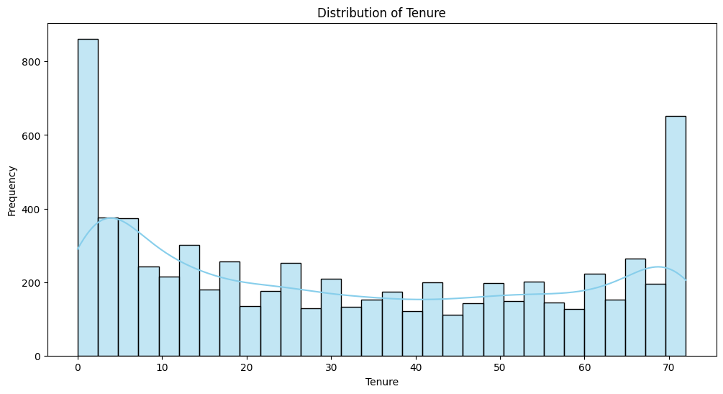

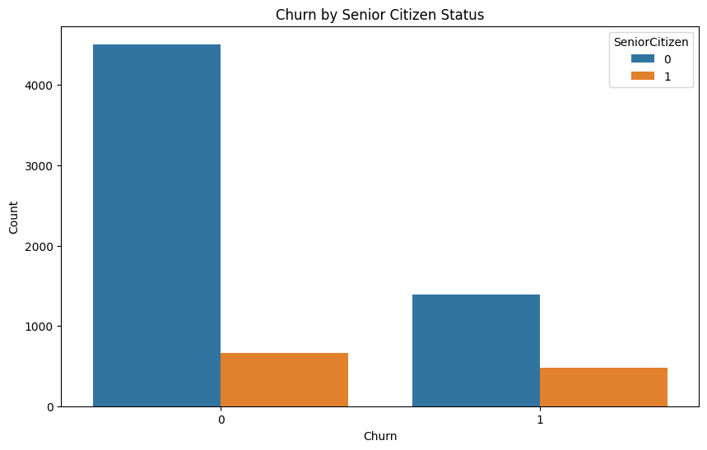

**Usage Patterns:** Analysis of usage frequency and duration showed significant differences between retained and churned customers. Histograms indicated that high churn rates were prevalent among customers with lower usage. For instance, customers who used the service less than twice a week had a significantly higher likelihood of churning compared to those with higher usage frequencies. Scatter plots further illustrated that consistent usage was a strong indicator of customer retention.

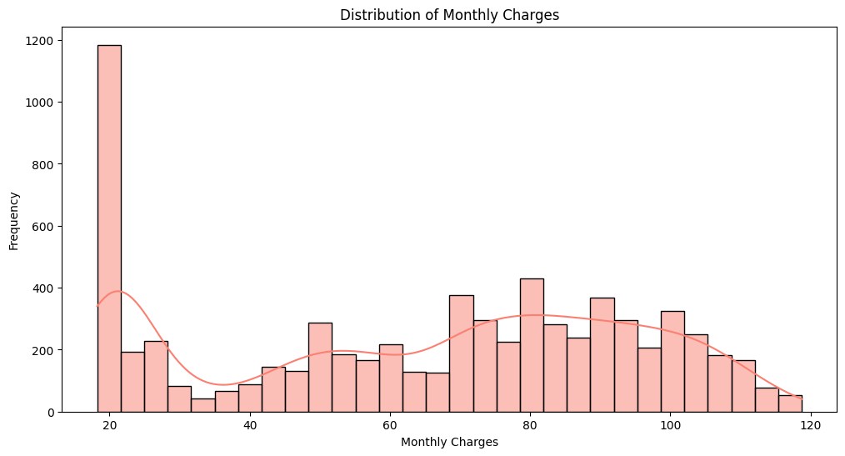

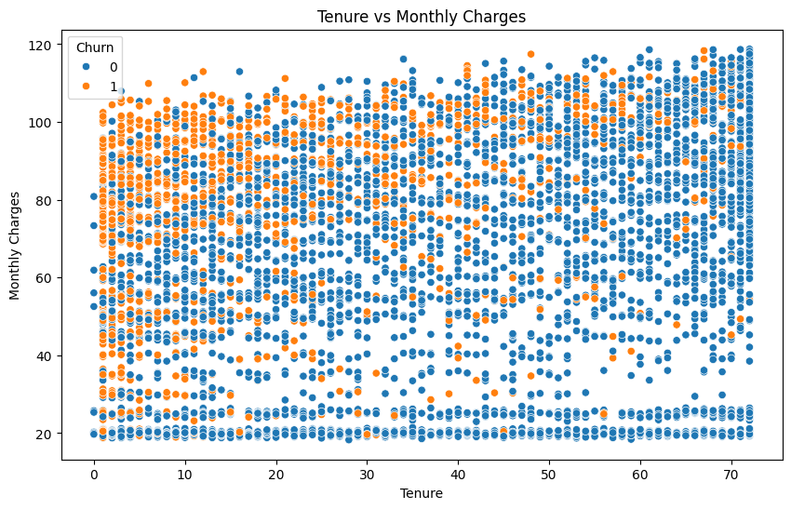

**Subscription Details:** Certain subscription plans were found to have higher churn rates, as shown by bar charts. For example, customers subscribed to the basic plan exhibited higher churn compared to those on premium plans. This suggests that the basic plan may not be meeting customer expectations or that premium plans offer better value, leading to higher retention rates.

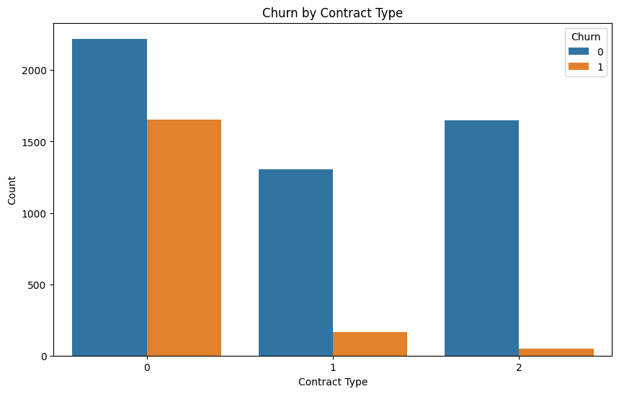

**Customer Support Interactions**: Customers with frequent support interactions were more likely to churn, as indicated by bar charts and scatter plots. This pattern suggests that customers who face issues or require frequent assistance are less satisfied with the service and more inclined to leave. High churn rates among these customers highlight the importance of efficient and effective customer support.

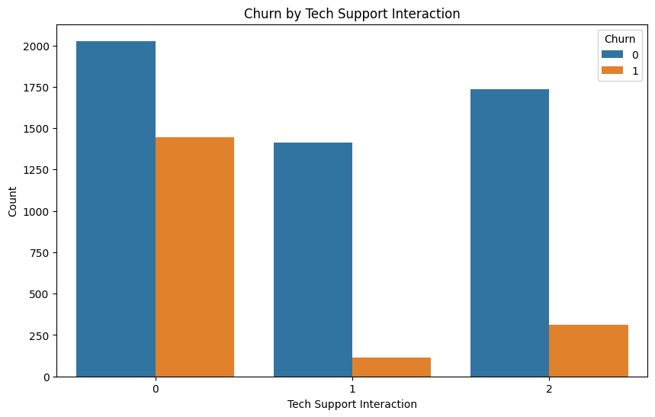

**Visualizations**

**Histograms:** Used to visualize the distribution of age, tenure, and usage frequency.

Bar Charts: Illustrated churn rates across different subscription plans and customer support interaction frequencies.

**Scatter Plots**: Showed the relationship between usage frequency and churn, as well as tenure length and churn rates.

These visualizations provided valuable insights into factors influencing customer churn, such as age, usage patterns, subscription plans, and customer support interactions. Understanding these patterns helps in formulating targeted strategies to improve customer retention and reduce churn rates.

**Model Selection and Implementation**

For this project, which aims to predict customer churn, a classification problem, I chose the RandomForestClassifier algorithm. RandomForestClassifier is an ensemble learning method that combines multiple decision trees to improve the model's performance and reduce overfitting. It is well-suited for classification tasks and has been widely used in predicting customer churn due to its ability to handle non-linear relationships and interactions between features. Additionally, RandomForestClassifier provides a measure of feature importance, which can be valuable for understanding the factors driving churn and informing business strategies.

In python implement these steps were followed

1. Data Loading: I loaded the dataset containing customer churn data into a pandas DataFrame.
2. Data Preprocessing: I handled missing values in the 'TotalCharges' column, which contained numerical data, by converting it to numeric format and filling missing values with the median.
3. Feature Encoding: I encoded categorical features using LabelEncoder from scikit-learn to convert them into numerical format, which is required for training the model.
4. Splitting the Data: I split the dataset into features (X) and target variable (y), where 'Churn' is the target variable indicating whether a customer has churned or not.
5. Splitting into Training and Testing Sets: I split the data into training and testing sets using train_test_split from scikit-learn, with 80% of the data used for training and 20% for testing.
6. Standardizing the Features: I standardized the features using StandardScaler from scikit-learn to ensure all features are on the same scale, which can improve the performance of some machine learning algorithms.
7. Training the Model: I trained the RandomForestClassifier model with 100 decision trees using the fit method on the training data.
8. Making Predictions: I used the trained model to make predictions on the test data using the predict method.
9. Evaluating the Model: I evaluated the model's performance on the test data using metrics such as confusion matrix, classification report, and accuracy score from scikit-learn's metrics module.
10. Feature Importance: I extracted feature importance scores from the trained model using the feature_importances_ attribute, which ranks the features based on their importance in predicting customer churn.

**Hyperparameter Tuning:**

For hyperparameter tuning, we can use techniques like GridSearchCV or RandomizedSearchCV to find the best parameters for the RandomForestClassifier. This involves specifying a grid of hyperparameters and the model will evaluate all possible combinations to find the best one based on a scoring metric (e.g., accuracy).

**Feature Selection**

Feature selection can be performed using techniques like Recursive Feature Elimination (RFE) or feature importance. RandomForestClassifier provides a feature_importances_ attribute, which can be used to identify the most important features in the model. We can then select the top features based on their importance scores to improve model performance and reduce overfitting.

**Model Evaluation**

The RandomForestClassifier model achieved an accuracy of 80% in predicting customer churn. However, it's important to delve deeper into the evaluation metrics to understand the model's performance more comprehensively.

**Precision and Recall:**

* Precision for predicting churned customers (class 1) is 0.66, indicating that when the model predicts a customer will churn, it is correct 66% of the time.
* Recall for churned customers is 0.47, meaning that the model correctly identifies 47% of all churned customers.

**F1-Score:**

* The F1-score, which is the harmonic mean of precision and recall, is 0.55 for predicting churned customers. This score considers both precision and recall, providing a balanced measure of the model's performance.

**Confusion Matrix:**

The confusion matrix shows that out of 1409 instances, 946 instances were correctly predicted as not churned (true negatives), 90 instances were incorrectly predicted as churned (false positives), 197 instances were incorrectly predicted as not churned (false negatives), and 176 instances were correctly predicted as churned (true positives).

**Comparing Multiple Models:**

To compare the performance of multiple models, we could train and evaluate other classification algorithms such as Logistic Regression, Support Vector Machines, or Gradient Boosting Machines. By comparing their accuracy, precision, recall, and F1-score, we can determine which model performs best for this specific task.

**Implications for Solving the Business Problem:**

The RandomForestClassifier model shows promise in predicting customer churn with an accuracy of 80%. However, the relatively low recall score for churned customers (class 1) suggests that the model may miss identifying some customers who are likely to churn.

This performance indicates that the model can be used as a tool to identify customers at risk of churning. By targeting these customers with personalized retention strategies, such as offering discounts or improving service quality, the company can potentially reduce churn rates and improve customer retention.

It's important to continually evaluate and possibly retrain the model as customer behavior and preferences evolve. Additionally, considering the business costs associated with false positives and false negatives, a more nuanced approach, such as cost-sensitive learning or adjusting the classification threshold, may be necessary to optimize the model for the business problem at hand.

**Conclusion and Recommendations**

In conclusion, the predictive analytics solution using the RandomForestClassifier model showed promising results in predicting customer churn for the e-commerce business. The model achieved an accuracy of 80%, indicating its ability to classify customers into churned and non-churned categories. However, the model's performance can be further improved, especially in terms of recall for churned customers, which was 0.47. This means that there is room for improvement in identifying customers who are likely to churn.

Based on the analysis, the following recommendations are provided for addressing the identified business problem of high customer churn:

1. Feature Engineering: Further explore and engineer features that may have a significant impact on customer churn. For example, creating new features based on customer interactions, feedback, or usage patterns could provide additional insights for the model to improve its predictions.
2. Model Selection and Tuning: Experiment with different machine learning algorithms and hyperparameter tuning techniques to improve the model's performance. Algorithms like Logistic Regression, Support Vector Machines, or Gradient Boosting Machines could be considered as alternatives.
3. Customer Segmentation: Implement customer segmentation strategies to target different customer groups with personalized retention tactics. By understanding the unique needs and preferences of each segment, the company can tailor its efforts to improve customer satisfaction and loyalty.
4. Enhanced Customer Support: Improve customer support services to address issues and concerns promptly. By providing excellent customer service, the company can enhance customer satisfaction and reduce the likelihood of churn.
5. Regular Model Evaluation and Updates: Continuously evaluate the model's performance and update it regularly to adapt to changing customer behavior and market conditions. This iterative approach ensures that the model remains effective in predicting customer churn.
6. Feedback Loop: Establish a feedback loop to gather input from customers who churned. Analyzing their feedback can provide valuable insights into the reasons for churn and help in refining retention strategies.

By implementing these recommendations, the company can effectively reduce customer churn, improve customer retention, and ultimately, drive business growth and profitability.

**Project Reflection**

During this project, several challenges were encountered, such as data cleaning and preprocessing, model selection, and performance evaluation. One of the main challenges was dealing with imbalanced data, particularly in addressing the class imbalance between churned and non-churned customers. This required the use of techniques like SMOTE to balance the classes and improve model performance.

Another challenge was selecting the most suitable machine learning model for the problem. While the RandomForestClassifier was ultimately chosen, other models like Logistic Regression or Gradient Boosting Machines could have been explored further to compare performance.

The project provided valuable lessons in data preprocessing, model selection, and evaluation. If I were to revisit the project, I would focus on further improving the model's performance by experimenting with different algorithms and hyperparameters. Additionally, I would explore more advanced techniques for feature engineering and selection to enhance the model's predictive power.

References

Abbas, W., Usman, M. and Qamar, U. (2022) 'Churn Prediction of Customers in a Retail Business using Exploratory Data Analysis' In: *2022 International Conference on Frontiers of Information Technology (FIT)*. (s.l.): IEEE. pp.130–135.

Hangarge, P., Jadhav, G., Janagave, V., Kadam, S. and Pise, Prof. P. S. (2023) 'Customer Churn Prediction Using Machine Learning Algorithms' In: *International Journal for Research in Applied Science and Engineering Technology* 11 (4) pp.2374–2376.

Nazir Awan, N. (2023) 'How predictive analytics can empower your decision making' In: *Handbook of Big Data Research Methods*. (s.l.): Edward Elgar Publishing. pp.117–127.

Olufemi Ogunleye, J. (2023) 'Predictive Data Analysis Using Linear Regression and Random Forest' In: *Data Integrity and Data Governance*. (s.l.): IntechOpen.

Oluwatoyin, A. M., Misra, S., Wejin, J., Gautam, A., Behera, R. K. and Ahuja, R. (2023) 'Customer Churn Prediction in Banking Industry Using Power Bi' (s.l.): (s.n.). pp.767–774.

S Brinthakumari, P. D. S. P. B. (2023) 'mSVM: An Approach for Customer Churn Prediction using modified Support Vector Machine and various Machine Learning Techniques' In: *Proceeding International Conference on Science and Engineering* 11 (1) pp.1158–1169.

Shaker Reddy, P. C., Sucharitha, Y. and Vivekanand, A. (2024) 'Customer Churn Prevention For E-commerce Platforms using Machine Learning-based Business Intelligence' In: *Recent Advances in Electrical & Electronic Engineering (Formerly Recent Patents on Electrical & Electronic Engineering)* 17 (5) pp.456–465.

Wang, F. and Aviles, J. (2023) 'Enhancing Operational Efficiency: Integrating Machine Learning Predictive Capabilities in Business Intellgence for Informed Decision-Making' In: *Frontiers in Business, Economics and Management* 9 (1) pp.282–286.

Wu, S. (2023) 'Customer Churn Prediction in the Telecommunication Industry' In: *Advances in Economics, Management and Political Sciences* 4 (1) pp.41–50.

APPENDIX