**DAR ES SALAAM INSTITUTE OF TECHNOLOGY**



**INDUSTRIAL PRACTICAL TRAINING TECHNICAL REPORT**

**STUDENT'S NAME:** **CAPHACE ETHANI.**

**ADMISSION NO: 160630720011.**

**CLASS: BENG 17 ETE.**

**DEPARTMENT:** ELECTRONICS AND TELECOMMUNICATION.

**PROGRAMME:** ELECTRONICS AND TELECOMMUNICATION.

**ACADEMIC YEAR: 2017/2018**

**NAME OF INDUSTRY/ MINISTRY/COMPANY/ ORGANIZATION**

WEB TECHNOLOGIES.

**I. GENERAL PART**

# Organization structure and management.

* Historical Background.

**Web Technologies Tanzania Limited** is Information Technology Company that specializes in the provision of cost effective Information management systems. We focus on delivering high-impact solutions that incorporate customized functionality specific to the project requirements. The combination of thorough process, comprehensive experience and expansive creative vision enables us to create solutions that are innovative, usable and reliable.

Web Technologies Tanzania Limited was established in response to the growing market demand for high quality Innovative solutions at affordable prices. Our commitment to refining the development process and creating a superior infrastructure has allowed us to introduce a range of packages and customized solutions that enable businesses to implement high value systems.

With industry experience and an ongoing relationship with well-established companies, our IT consultants, web designers, and developers have worked with industry leading companies to acquire an in depth understanding of the latest technologies and processes.

* Organization Structure.

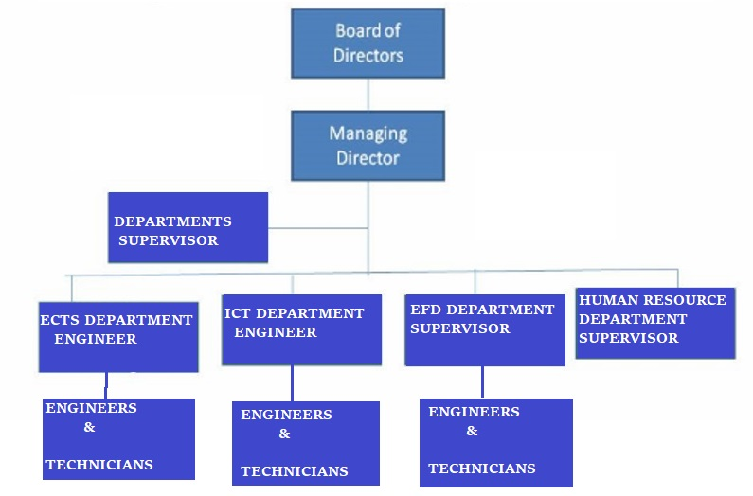

* Activities Undertaken.

The following are the Activities undertaken at Web Technologies.

* Web Solutions;
* Website designing, Redesigning, Maintenance, Hosting and Domain registration.
* Electronic Fiscal Devices (EFD) and Business Solutions;
* Hardware and Software Maintenance of EFD and Point Of Sale (POS) devices,
* Communication Systems and Advanced Security systems.
* Vehicle Tracking and Fleet Management.
* Software Development and Maintenance,
* Information and Communication Technology Solutions,
* Operating System (OS), Backup and Recovery,
* Tracking Technologies and Internet Services.
* Networking.
* Voice and Data Networking,
* CISCO Networking,
* Fiber Optics Networking and
* CCTV Networking.

**II. TECHNICAL PART.**

# **INSTALLATION OF GPS TRACKING DEVICE IN A**

# **MOTORCYCLE.**

1. INTRODUCTION.

**Global Position System (GPS)** is a worldwide radio-navigation system formed from the constellation of 24 satellites and their ground stations.

**Global Position System tracking** is a method of working out exactly where something is. GPS works by providing real time information’s on exact location, movement and routes of vehicles or any other GPS installed device.

Therefore, this system or device can be placed in a vehicle, on a cell phones, or on special GPS devices, which can either be fixed or portable unit.

*GPS tracking device/unit* is a navigation device, normally installed in a moving vehicle as stated above, that uses *GPS* to track the vehicle’s movements and determine its location and routes. The *recorded location Data* can either be **stored** within the tracking unit or **transmitted** to an Internet-connected device using the Cellular (GPRS or SMS).

This allows the location to be displayed against a map backdrop either in real time or when analyzing the tracker later, using **GPS tracking software.**

## Summary of GPS Vehicle Tracker.

Working of this Device is based on *Existing GSM/GPRS* network and GPS satellites. This product (device) can locate and monitor any remote targets by **SMS** or **Internet**.

**OVERVIEW OF DEVICE CHARACTERISTICS**:

* GPS position.
* GSM 850/900/1800/1900MHz.
* With Shock sensor.
* Power-Cut alarm (Optional, need battery inside).
* Auto set APN.
* Working Voltage 6-78V.
* Oil-Cut function (Optional).
* ACC alarm (Optional).
* Shock alarm.
* GEO-fence.

**DEVICE SPECIFICATIONS**:

* GSM 850/900/1800/1900MHz.
* GPRS: Class12, TCP/IP.
* Working voltage: 6-78V.
* Working current: ≈ 22 mA (12V).
* Working current: ≈ 12 mA (24V)
* GPS locating time: Cold start ≈ 38s (Open sky)

Warm start ≈32s

Hot start ≈2s (Open sky)

* GPS Precision: 10m (2D RM).
* Working Temperature: -20°C ~ 70°C.
* Working humidity: 20% ~ 80%RH.
* Measurement: 78(L) × 26(W) × 15(H) mm.

1. MATERIALS, EQUIPMENT AND INSTRUMENTS REQUIRED.

The following are Materials, Equipment and Instruments required during Installation of GPS Tracking device in a Motorcycle.

* Motorcycle,
* Mobile phone,
* GPS Tracker or Device,
* SIM card,
* Sellotape,
* Electric Cables / Wires,
* Screw Drivers,
* Spanners,
* Relay,
* Cutter-pliers.

1. PROCEDURES FOR INSTALLATION OF GPS TRACKER IN A MOTORCYCLE.

The following are the procedures for GPS Tracker installation in a Motorcycle;

### Connecting and Testing the GPS Tracker before Installation in a Motorcycle.

(Preparation before Installation).

* The Device’s packing box is opened to check the GPS device and included accessories.
* Installing SIM Card: The back cover is opened and the Micro – SIM card is inserted as shown below;

**NOTE:**

(The installed SIM card must have access to both GPRS and SMS service)

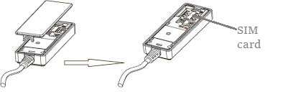

Figure 01.

* Powering the **Device**: The 12V adapter is connected to the AC Power source, and then it is connected to the device.

After the power connection is done, the device is **switched ON.**

**(**The Power Switch is at the back after removing the back cover**).**

* Device’s LED Indicators: After the Device is switched ON, The following are the LED Indicators the Device shows:

Blue LED (GPS)

|  |  |
| --- | --- |
| Status | Meaning |
| 1.Flash quickly | Searching (GPS) signal |
| 2.Solid red | Position succeed |

Green LED (GSM)

|  |  |
| --- | --- |
| Status | Meaning |
| 1.Quick flashing | GSM initializing/ Online |
| 2.Slow flashing | Normal Network signal |

When the device is Switched ON, Device’s LEDs shows the status number 1,

After some minutes, The LEDs indicated the status number 2.

* Basic Settings and Functions: The following are the basic settings and functions that are set to the device;
* SOS phone numbers. The SOS number is added using the following command format: SOS,A, phone number1, phone number2#

After **adding** these two numbers, The Device replied the following message:

“OK! SOS1: phone number1 SOS2: phone number2” set successfully.

Note: SOS numbers are the numbers which Device’s location data are sent.

* Setting the Center number: The center number is set, through which an SMS command can be sent telling the Device to Switch ON / OFF the Motorcycle.

Therefore, the center number is set using the following command:

CENTER,A, phone number#

After sending this SMS command to the Device, an “OK” reply messages from the devices is sent, indicating the Center number is successfully ***added***.

### Installation of GPS device in Motorcycle.

### 

* **Connecting the GPS Device as shown in the Wiring diagrams below**: The Device, Relay, battery, Ignition wire and fuse are connected as shown in the Wiring Diagram below;
* From the Motorcycle Battery, using two electric cables / wires the Device is connected to the battery (Powered). Red and Black cables from the Device are connected to Positive and Negative terminal of battery respectively.
* Using the electric wires, the Relay is connected to the Device and to the power as shown in the wiring diagram.
* Using Screw Drivers and Spanners the Ignition key is opened, and using Multimeter, The Ignition wire is found.

Ignition wire is the one which, when the *Motorcycle is OFF*, has **0V** potential. And when the *Motorcycle starts*, the potential increases to around **10V**.

Therefore is found simply using Multimeter at the ignition key.

* Using Cutter-pliers, The Ignition wire is **cut,** one end is connected to the Relay through **85** **pin** and the other through **87a pin.**
* All cut and joined wires are insulated using **sellotape**.
* Ignition Switch is then closed, using the instruments used during opening it.

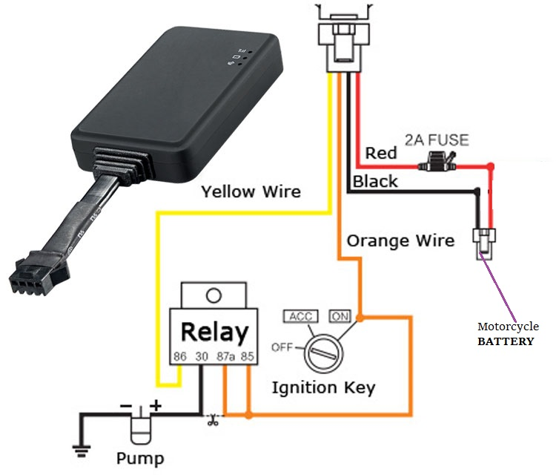

Figure 02.

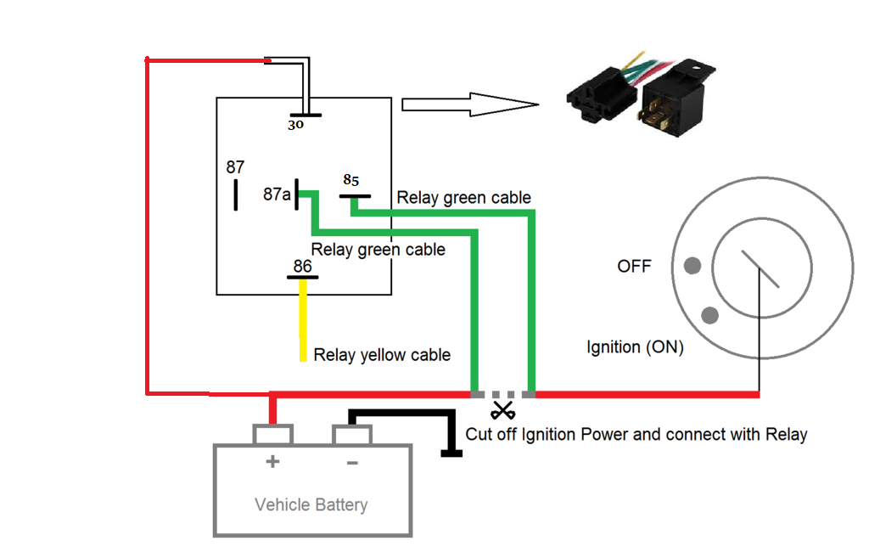

Figure 03.

* The whole system is placed under the back seat as shown below.

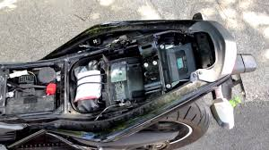

Figure 04.

### TESTING THE INSTALLATION.

After the Installation of the GPS device is complete, the ON / OFF functions of the device are tested.

* ON -SMS command is sent to the device, and When the Motorcycle is switched ON;
* Motorcycle **switches ON.**
* Another OFF –SMS command is sent to the device, and When the Motorcycle is switched ON;
* Motorcycle **doesn’t** switch ON.

**Therefore;**

**The ON / OFF functions of the device are functioning properly.**

* The **Real-time data** of Motorcycle’s position is sent to the SOS phone numbers.