**FEASIBILITY STUDY OF STOP AND GO**

**SYSTEM FOR ID SCHOOL ENTRANCE CONTROL**

**IN ORIENTAL MINDORO**

A Feasibility Study

Presented to

**Mr. GENER M. CUPO, MBA, MSIT**

**MINDORO STATE UNIVERSITY**

**(MinSU) – Calapan City Campus**

**BACHELOR OF SCIENCE IN INFORMATION TECHNOLOGY DEPARTMENT**

Masipit, Calapan City

In Partial Fulfillment

of the Requirements for the Subject of

**ITE 322 - TECHNOPRENUERSHIP**

By

**JUN MARK MORENO**

**LOURENCE QUINIO**

**DEXTHER DELMONTE**

**ALLAN CAPIO**

**ROSTUM LIQUIGAN**

July 2024

**INTRODUCTION**

**Methodology**

The feasibility study will employ a multifaceted methodology combining quantitative and qualitative research methods. Surveys, focus group discussions, interviews, and data analysis will be utilized to collect primary data from MinSu stakeholders, including students, faculty, and administrators. Secondary research from industry reports, academic publications, and market studies will supplement primary data, providing a comprehensive understanding of the market feasibility of the Stop&Go Tech cashless payment system at Mindoro State University.

**Definition of Terms**

A detailed glossary of key terms will be provided to ensure clarity and consistency throughout the feasibility study. Definitions will cover essential concepts such as cashless payment system, RFID/NFC technology, return on investment (ROI), regulatory compliance, user experience (UX), and user interface (UI), among others.

**II. MARKET STUDY**

**Description of the Target Market**

The target market for Stop&Go Tech consists of MinSu's diverse student population, comprising undergraduate and graduate students from various academic disciplines and socio-economic backgrounds. Detailed demographic analysis, including factors such as age, gender, income level, and residential status, will be conducted to understand the unique needs and preferences of different student segments. Additionally, psychographic insights related to lifestyle preferences, technology adoption behavior, and campus engagement will be explored to develop a comprehensive profile of the target market.

**Name of the Product Stop&Go Tech**

Stop&Go Tech represents a groundbreaking advancement in campus payment solutions, providing MinSu students with a seamless, secure, and user-friendly payment experience. By integrating state-of-the-art RFID/NFC technology into student ID cards, Stop&Go Tech enables quick and convenient transactions for a wide range of campus services, including dining hall purchases, library fines, transportation fees, and event tickets. With its intuitive interface, robust security features, and real-time transaction tracking capabilities, Stop&Go Tech sets a new standard for cashless payment systems in the higher education sector.

**Demand & Supply Analysis**

The feasibility study will conduct a comprehensive analysis of the demand for cashless payment solutions among MinSu students. Through surveys, focus groups, and transaction data analysis, the study will assess student preferences, usage patterns, and willingness to adopt new payment technologies. Market trends, competitive landscape, and regulatory considerations will also be examined to understand the supply side dynamics and identify potential opportunities and challenges for Stop&Go Tech in the marketplace.

**Marketing Strategy**

A holistic marketing strategy will be developed to effectively promote Stop&Go Tech and drive adoption among MinSu students. The strategy will encompass a mix of digital and traditional marketing channels, including targeted online advertising, social media campaigns, campus events, and promotional partnerships. In addition, strategic collaborations with campus organizations, faculty endorsements, and student ambassadors will be leveraged to enhance brand credibility and increase user engagement. Furthermore, innovative tactics such as gamification, loyalty programs, and exclusive offers will be implemented to incentivize adoption and foster a sense of community among Stop&Go Tech users.

**Plant Location**

The strategic placement of Stop&Go Tech terminals within the MinSu campus will be determined through careful analysis of student traffic patterns, campus infrastructure, and transactional data. Priority will be given to high-traffic areas such as student centers, dining facilities, academic buildings, and transportation hubs to maximize user accessibility and convenience. Collaboration with campus facilities management and IT departments will ensure seamless integration of Stop&Go Tech infrastructure with existing campus facilities and services.

**Utilities**

A detailed assessment of utility requirements, including power supply, network connectivity, and physical infrastructure, will be conducted to support the implementation of Stop&Go Tech. Close coordination with campus utilities providers, IT departments, and facilities management will be essential to address infrastructure needs and ensure the reliable operation of Stop&Go Tech. Additionally, measures will be taken to optimize energy efficiency, minimize environmental impact, and promote sustainability in the deployment of Stop&Go Tech infrastructure.

**Chapter III**

**TECHNICAL STUDY**

**3.1 Product Design and Features**

Stop&Go Tech introduces a sophisticated cashless payment system that integrates RFID/NFC technology into student ID cards, revolutionizing the payment experience at Mindoro State University (MinSu). This innovative system offers a range of features tailored to meet the diverse needs of students, including:

- Seamless Transactions: With RFID/NFC technology embedded in student ID cards, users can conduct quick and contactless transactions across various campus services such as dining, library services, transportation, and events.

- User-Friendly Interface: Stop&Go Tech boasts an intuitive interface designed to ensure ease of use for students of all technological proficiencies, enhancing overall user experience.

- Real-time Transaction Monitoring: Users have access to real-time transaction tracking capabilities, allowing them to monitor their spending and account balances conveniently.

- Enhanced Security Measures: The system implements robust encryption protocols and authentication mechanisms to safeguard user data and prevent fraudulent activities, ensuring the security of transactions.

- Customization Options: Stop&Go Tech offers customizable payment options, enabling users to link their preferred payment methods for added flexibility and convenience.

- Scalability and Adaptability: Designed to be scalable and adaptable, Stop&Go Tech can accommodate future expansions and enhancements to meet evolving campus needs and technological advancements.

**3.2 Manufacturing Process**

The manufacturing process of Stop&Go Tech involves several key stages, ensuring the seamless integration of RFID/NFC technology into student ID cards:

1. RFID/NFC Chip Embedding: High-precision machinery is utilized to embed RFID/NFC chips seamlessly within student ID cards, ensuring optimal performance and durability.

2. Software Integration: Specialized software is developed and integrated into the university's existing systems to facilitate communication between RFID/NFC-enabled ID cards and campus payment terminals.

3. Quality Assurance Testing: Rigorous quality assurance testing is conducted to validate the functionality, security, and reliability of each RFID/NFC-enabled ID card before distribution to students.

4. Deployment and Training: Upon successful manufacturing, RFID/NFC-enabled ID cards are deployed to students, accompanied by comprehensive training sessions to familiarize them with the Stop&Go Tech payment system.

**3.3 Machinery and Equipment**

The manufacturing process of Stop&Go Tech requires advanced machinery and equipment tailored to RFID/NFC chip embedding, software integration, and quality assurance testing:

- RFID/NFC Chip Embedding Machine: Specialized machinery embeds RFID/NFC chips seamlessly within student ID cards with precision and accuracy.

- Software Development Tools: State-of-the-art software development tools facilitate the design, development, and integration of necessary software components for seamless communication between ID cards and campus payment terminals.

- Quality Assurance Testing Equipment: High-tech testing equipment validates the functionality, security, and reliability of each RFID/NFC-enabled ID card before distribution.

- Training Facilities: Dedicated training facilities equipped with multimedia resources conduct comprehensive training sessions for students and administrative staff on the usage and management of the Stop&Go Tech payment system.

**3.4 Plant Integration and Infrastructure**

The production scale for Stop&Go RFID IDs is determined by market demand, available resources, and production capabilities.

**Production Schedule:**

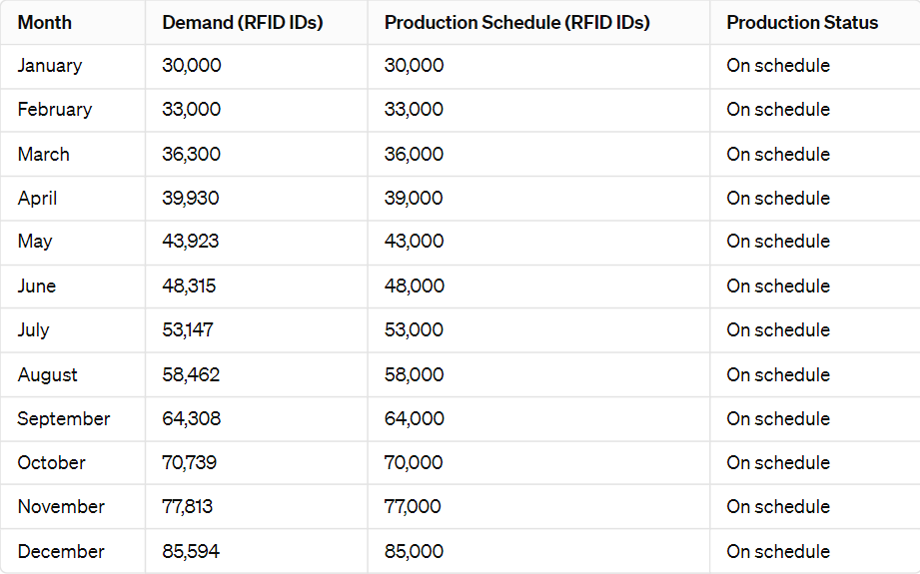

**3.5 Maintenance and Support**

|  |  |  |  |  |
| --- | --- | --- | --- | --- |
| Machinery and Equipment | Description | Cost Per Unit | Quantity | Estimated Cost |
| RFID/NFC Chip Embedding Machine | Specialized machinery designed to seamlessly embed RFID/NFC chips within student ID cards with precision and accuracy. This equipment ensures the efficient integration of essential components for the Stop&Go Tech payment system, enhancing its functionality and security. | **₱**200,000 | 1 | **₱**200,000 |
| Software Development Tools | State-of-the-art software development tools facilitate the design, development, and integration of necessary software components for the Stop&Go Tech payment system. These tools enable seamless communication between ID cards and campus payment terminals, ensuring a smooth and reliable transaction process for users. | **₱**100,000 | 1 | **₱**100,000 |
| Quality Assurance Testing Equipment | High-tech testing equipment dedicated to validating the functionality, security, and reliability of each RFID/NFC-enabled ID card before distribution. This equipment plays a crucial role in ensuring the quality and performance of the Stop&Go Tech payment system, instilling confidence in users and minimizing potential issues during card usage. | **₱**50,000 | 1 | **₱**50,000 |
| Training Facilities | Dedicated training facilities equipped with multimedia resources conduct comprehensive training sessions for students and administrative staff on the usage and management of the Stop&Go Tech payment system. These facilities play a vital role in ensuring that users understand the system's features and functionalities, promoting efficient and effective utilization of the payment system across campus. | **₱**75,000 | 1 | **₱**75,000 |

**3.6 Plant Location**

The strategic placement of Stop&Go Tech terminals within the MinSu campus will be determined through careful analysis of student traffic patterns, campus infrastructure, and transactional data. Priority will be given to high-traffic areas such as student centers, dining facilities, academic buildings, and transportation hubs to maximize user accessibility and convenience. Collaboration with campus facilities management and IT departments will ensure seamless integration of Stop&Go Tech infrastructure with existing campus facilities and services.

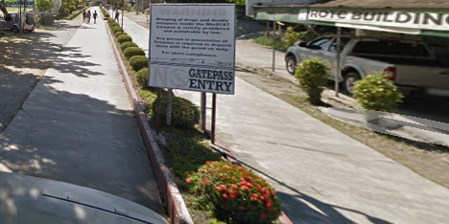

**Figure 1. Plant Location**

**3.7 Plant Layout**

The plant layout for Stop&Go Tech implementation will be designed to optimize operational efficiency and user experience. Clear signage and intuitive navigation will guide users to the nearest terminals, while designated queuing areas will facilitate smooth and orderly transactions during peak hours. Ergonomic considerations will be incorporated into terminal placement and design to ensure ease of use for users of all abilities.

**Figure 2. Plant Layout**

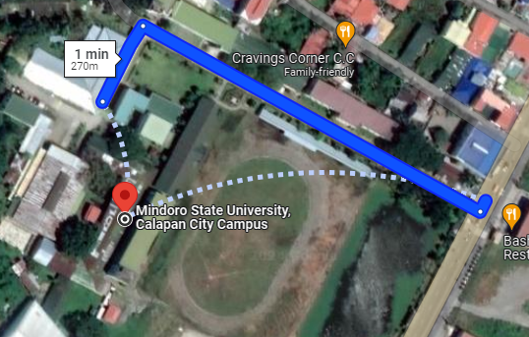

**3.8 Building and Facilities**

The implementation of Stop&Go Tech will require designated spaces for equipment storage, maintenance, and administrative tasks. These facilities will be equipped with the necessary infrastructure to support manufacturing processes, software integration, quality assurance testing, and staff training. Additionally, provisions will be made for utilities such as power supply, network connectivity, and environmental controls to ensure optimal performance and safety.

**3.9 Raw Materials and Suppliers**

The raw materials required for manufacturing RFID/NFC-enabled ID cards will be sourced from reputable suppliers with a proven track record of quality and reliability. Close partnerships will be established with suppliers to ensure timely delivery, competitive pricing, and ongoing support. Quality control measures will be implemented to verify the integrity and authenticity of raw materials, maintaining the high standards required for Stop&Go Tech production.

**3.10 Utilities**

|  |  |  |
| --- | --- | --- |
| **Utilities** | **Description** | **Estimated monthly**  **cost** |
| RFID Cards | RFID cards are essential components of the Stop&Go system, providing users with secure identification and access. Each card is equipped with an embedded RFID chip for contactless transactions. | **₱2 per card** |
| **RFID Readers** | RFID readers are installed at entry points or checkpoints where users need to authenticate their RFID IDs. These readers communicate wirelessly with the RFID cards to verify user identity. | **₱500 (per reader)** |
| Total Cost |  | Varies depending on the number of cards and readers deployed. |

**3.11 Waste Disposal**

Proper waste disposal protocols will be established to manage any by-products or materials generated during the manufacturing process of Stop&Go Tech. Recycling initiatives will be prioritized to minimize waste and reduce environmental impact, with designated collection points and procedures implemented to segregate recyclable materials. Collaboration with campus sustainability programs and local waste management authorities will ensure compliance with regulations and best practices for responsible waste disposal.

**3.12 Labor Requirements**

The implementation of Stop&Go Tech will require a skilled workforce comprising manufacturing technicians, software developers, quality assurance specialists, and support staff. Training programs will be provided to equip employees with the necessary knowledge and skills to perform their roles effectively. Recruitment efforts will prioritize local talent to support economic development and community engagement initiatives. Ongoing professional development opportunities will be available to employees to enhance job satisfaction and retention.