CAPITAL INFOTECH Inc.

Project Name:
KAMDHIN
(Electronic - Corporate Operations Automate Tool)
Business Requirements Document
(Phase-1)

Prepared by: Capital Infotech Inc
Prepared for: Capital Infotech Inc
Date Submitted: 5/8/2017

Project Sponsor: Capital Infotech Inc
Client Acceptor:
Project Manager:

Document Number: 2015-01-KAMDHIN-CIT /BRD
Security Classification: High
Version: 1.0

Last Updated: 5/8/2020
Creation Date: 12/1/2016

Table of Contents
Table of Contents 2
1. Introduction 3
1.1. Document Purpose 3
1.2. Intended Audience 3
1.3. Project Background 3
1.4. Stakeholders 3
2.0 Requirements Scope 4
1.5. In Scope 4
1.6. Out of Scope 4
3.0 E-KAMDHIN Functional Requirements 4
3.1 Functional Requirements 4
3.1 Essential Use Case Diagrams 7
3.2 Essential Use Case Specifications 7
4. Data Requirements 9
4.1. Data Architecture 9
5.0 Business Glossary 11
Revision Log 12
Appendices 12
Approval 13

Introduction

Document Purpose

The purpose of this document is to describe business requirements for Electronic - Corporate Operations Automate Tool (E-KAMDHIN) completely, accurately and unambiguously in a Technology-independent manner. All attempts have been made in using mostly business terminology and business language while describing the requirements in this document. Very minimal and commonly understood technical terminology is used. Use case approach is used in modeling the business requirements in this document. The whole system is de-composed into several modules and each module’s functionality will be documented in use cases, flow charts and user interface screen shots/html mock up screens.

Intended Audience

The main intended audience for this document are the business owners of the proposed system. This document should be readable by business owners of the proposed system. They must be able to verify that their business requirements have been documented here completely, accurately, and unambiguously.

Data Architects, Application Architects, and Technical Architects would also find the information in this document useful when they need to design a solution that will address these business requirements.

Since the requirements are documented here in a Technology-independent manner, the end-users of the system should be able to comprehend the requirements fairly easily from this document.

Project Background

Kamdhin, Electronic Corporate Operations Automation and Tracking System allows corporates to handle day to day activities related to vendor management, Employee management invoices, employee management, time sheets and status reports in single application.
This System serves the companies and corporates to manage their employee information such as their time sheet entries, status reports and periodic appraisal entries at one place and provide reporting capabilities for management as well as the employees to trach their submissions.
It also provides the companies, the ability to manage their vendors, customers and the assignments and provide interface with timesheet entries and generate invoices and reports against the data.
The system allow the companies to electronically store and organize the Public Access files as well as the Private Access Files for their employees and serves as a storage and retrieval point for employee information.

The core functions that were identified for E-KAMDHIN (Kamdhin) are:

- Document Management
- Employee Management
- Vendor Management
- Project Management
- Reports

Stakeholders

Stakeholders are the individuals or groups who have a vested interest in this project and whose interests need to be considered throughout the project.

Srinivasarao Vempati | President  Capital Infotech Inc.
Anil Sadineni | Solutions Architect  Optlin Inc.
Venu Guntupalli | Solutions Architect  Optlin Inc.

Requirements Scope

In Scope
Every use case that was documented in this requirement document is in scope. For the Phase-1 of this application the following modules are In Scope.
1). Document management
2). Employee management
3). Reports

Out of Scope
The following modules are Out of Scope in Phase-1 and will be included in future versions.
1.Vendor Management
2.Project Management

3.0 E-KAMDHIN Functional Requirements

This section describes the E-KAMDHIN Business Requirements. In Use case approach, the Functional Requirements are comprised of Actor Profile Specification, Essential Use case diagram and Essential Use case specification in narrative text form.

Actors Identified for the system.
1).ADMIN : Administrator for the entire system
2).MANAGER: Employer Manager for creating Customers, Vendors, Employees for Company.
3).EMPLOYEE: Employee for creating updating timesheets, status reports and appraisals.

Functional Requirements

3.1.1 Login Module-SignUp:
The KAMDHIN system must provide a login page to allow authorized users to access the authorized pages based on their role. The system must provide registration page for the interested users to sign up. This will be evaluated/verified by CIT_ADMIN and grant the privileges as well as access to the system.

3.1.2 Login Module-Sign In
The KAMDHIN System must provide the users to enter their credentials and upon submission verify their validity and roles and navigate them to the main page with user specific functionality.
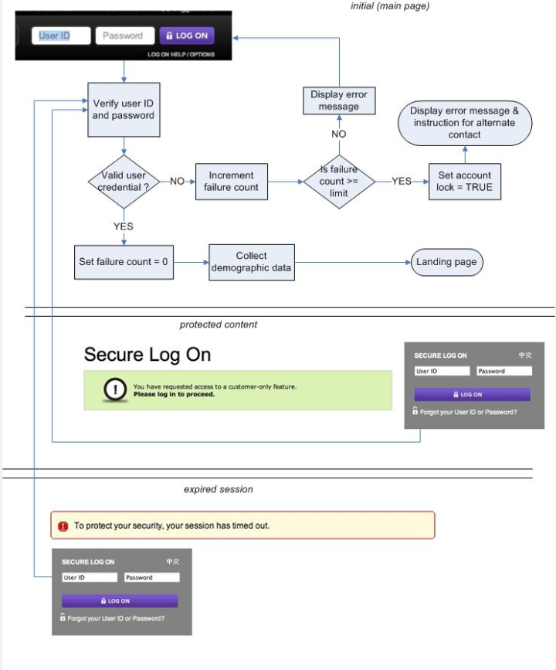

3.1.3 Employee Management
Employee management module must cover all the functionality pertaining to an employee such as create project, create customer and assign the same to newly created employee based on logged in user role. Also creating and updating weekly timesheets, status reports appraisals etc.

3.1.4 Document Management
Document management module must provide users to store and retrieve the documents based on the roles assigned to them. Managers and Admins to store Public access files for their company and employees to store their appraisals, personnel documents such as I-9/W4,LCAs etc etc. Print, search and reporting capabilities are needed against the stored documents.

3.1.5 Reports
KAMDHIN system must provide well defined report interface based on roles. Management reports and employee specific reports need to be designed and developed with filtering capabilities.

3.1.6 Administration
Administration module must provide a way to configure to view the audit logs, creating lookup data adding and delete the accounts via a well-defined user interface.

Essential Use Case Diagrams

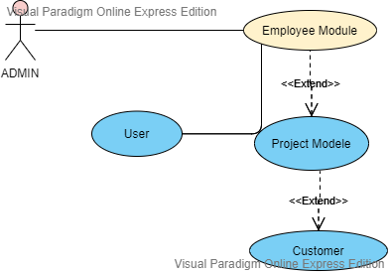

Essential Use Case Specifications

This section is applicable only to Use case approach. This section describes each Essential Use case in narrative text form. A use case typically has one basic course of action and one or more alternate courses of actions. The basic course of action is the main start-to-finish path that the use case will follow, whereas the alternate courses represent the infrequently used paths and exceptions, error conditions etc. The complete business logic of a use case such as basic course of action, alternate course of action, pre-condition, post-condition, etc. is not depicted in the Use case diagram. Rather they are documented in narrative style in use case specifications.

Use Case Id: E-KAMDHIN-SIGN-IN-001
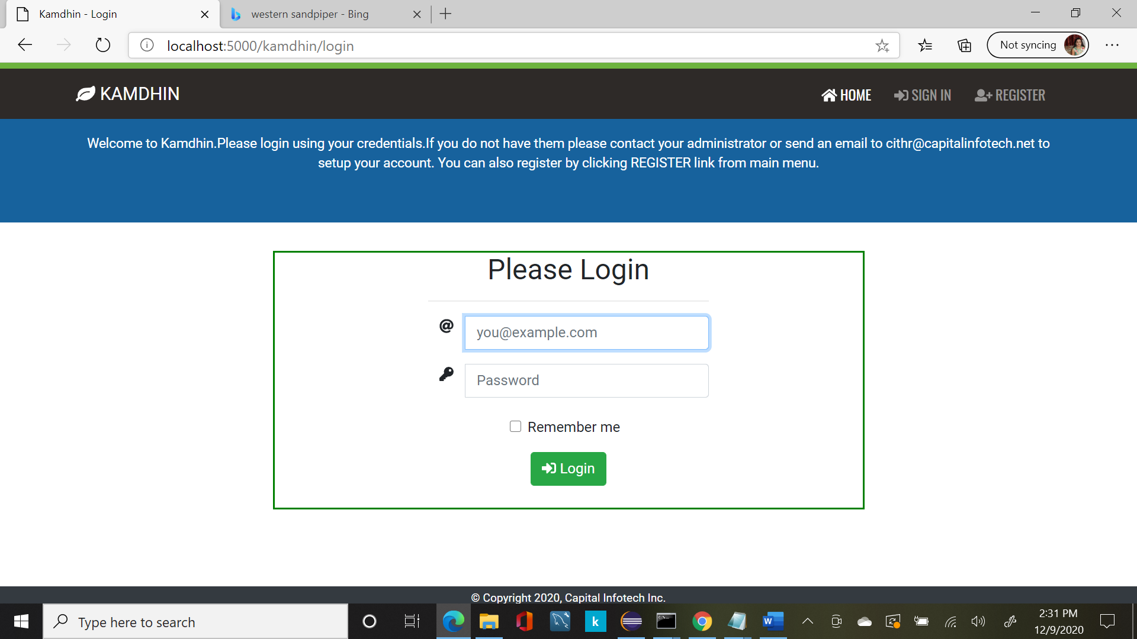

Use Case Name | E-KAMDHIN-SIGN-IN-001
Description | The use case explains how the authorized actors can login to the KAMDHIN System.
Actors | ADMIN, MANAGER, EMPLOYEE
Business Rules | None.
Basic Flow | Alternate Flows
1).User enters his username/emailid in the username input text box and password in password input box and clicks Login button.  System verify the user entered credentials and if they are correct allow him to navigate to his home page with “My Profile” link active.  . | 1).User did not enter username information and hits the Login button.  2).System responds with “Please fill out this field” message and auto focus in Username field.  2)User didn’t enter password and hit Login Button.  3)System respond with “Please fill out this field” message and auto focus in Password field.  4). User Entered incorrect username or password.  5).System respond with a message saying Invalid username and password.
Non-Functional Requirements | None
Pre-Conditions: | User types the url http://kamdhin.us-east-1.elasticbeanstalk.com/kamdhin/login and land on the index page of the application.
Post-Conditions. | User successfully navigate to his home page.
Validation of the fields
1).Username –Varchar(32) | Category should contain minimum a character and max of 50 alpha numeric characters. Cannot be null.  If null show message “Please fill out this field”.
2).Passsword–Varchar(16) | Value should contain minimum one character and max of 50 alpha numeric characters. Cannot be null.  If null show message “Please fill out this field”.

Use Case Id: E-KAMDHIN-REGISTER-002

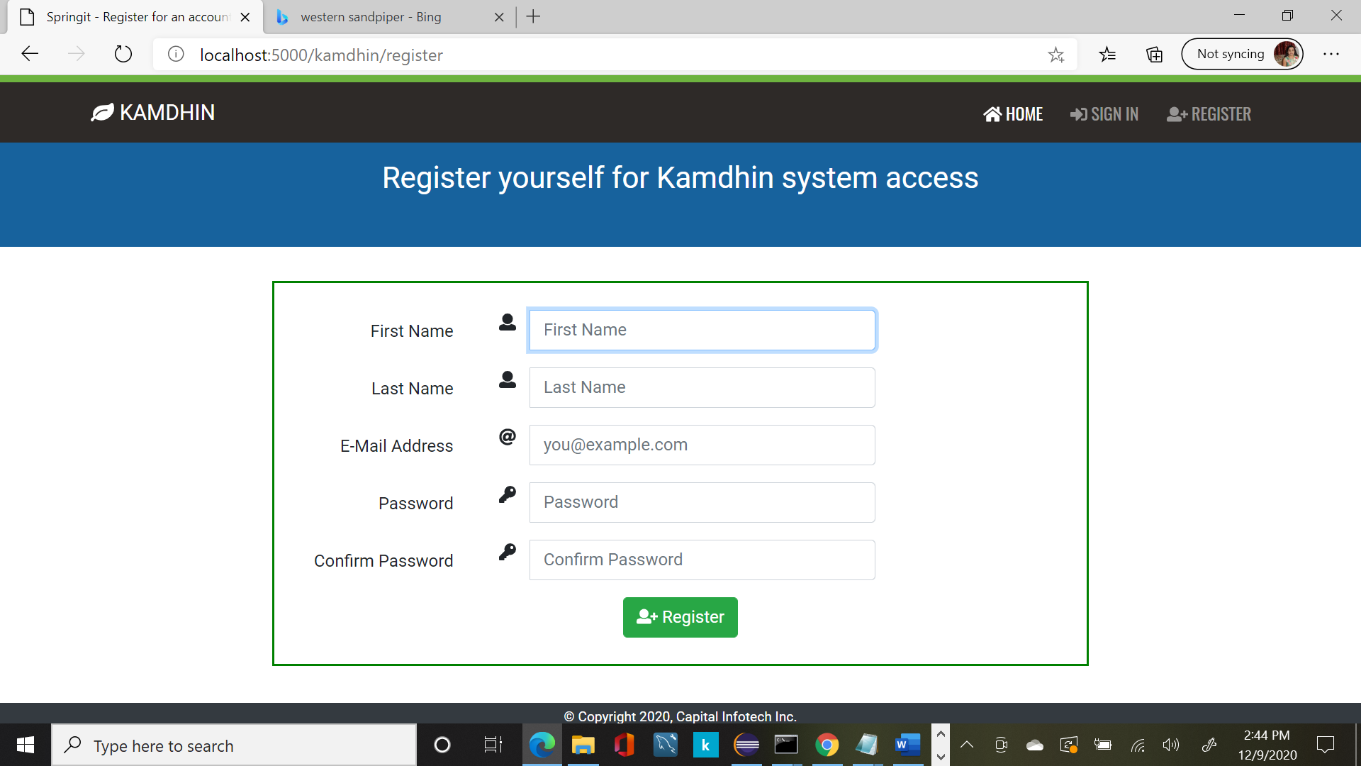

Use Case Name | E-KAMDHIN-REGISTER-002
Description | The use case explains how the authorized actors can Register for requesting access to the KAMDHIN System.
Actors | ANY USER
Business Rules | None.
Basic Flow | Alternate Flows
.

Non-Functional Requirements | None
Pre-Conditions: | User types the url http://kamdhin.us-east-1.elasticbeanstalk.com/kamdhin/login and clicks the REGISTER link from main menu.
Post-Conditions.
Validation of the fields
1).First Name –Varchar(32)
2).Last Name–Varchar(32)
3).Emai Addres
4).Password
5).Confirm Password

Data Requirements

This section describes the Data requirements part of the Business Requirements.

Data Architecture

SQL scripts:
=============================
create database db_Kamdhin

USE db_Kamdhin;
CREATE TABLE `tbl_corporate` (
`corporate_id` bigint(20) NOT NULL AUTO_INCREMENT,
`corporate_name` varchar(250) NOT NULL,
`created_by` varchar(150) DEFAULT NULL,
`created_on` datetime DEFAULT current_timestamp(),
`updated_by` varchar(150) DEFAULT NULL,
`updated_on` datetime DEFAULT NULL ON UPDATE current_timestamp(),
`is_active` int(1) DEFAULT 1,
PRIMARY KEY (`corporate_id`)
) ENGINE=InnoDB DEFAULT CHARSET=latin1;

USE db_Kamdhin;

CREATE TABLE `tbl_corporate_address` (
`corpr_corporate_id` bigint(20) NOT NULL AUTO_INCREMENT,
`corporate_id` bigint(20) NOT NULL DEFAULT 0,
`address_1` varchar(250) DEFAULT '0',
`address_2` varchar(250) DEFAULT '0',
`city` varchar(100) DEFAULT '0',
`state` varchar(100) DEFAULT '0',
`zip` varchar(15) DEFAULT '0',
`county` varchar(150) DEFAULT '0',
`country` varchar(150) DEFAULT '0',
`phone` varchar(15) DEFAULT '0',
`fax` varchar(15) DEFAULT '0',
`website` varchar(150) DEFAULT '0',
`created_by` varchar(150) DEFAULT '0',
`created_on` datetime DEFAULT current_timestamp(),
`updated_by` varchar(150) DEFAULT NULL,
`updated_on` datetime DEFAULT NULL ON UPDATE current_timestamp(),
`is_active` int(1) DEFAULT 1,
PRIMARY KEY (`corpr_corporate_id`),
KEY `fk_corpr_corporate` (`corporate_id`),
CONSTRAINT `fk_corpr_corporate` FOREIGN KEY (`corporate_id`) REFERENCES `tbl_corporate` (`corporate_id`) ON UPDATE CASCADE
) ENGINE=InnoDB DEFAULT CHARSET=latin1 COMMENT='address details of corporates';

USE db_Kamdhin;

CREATE TABLE `tbl_client` (
`client_id` bigint(20) NOT NULL AUTO_INCREMENT,
`corporate_id` bigint(20) NOT NULL,
`client_name` varchar(150) NOT NULL,
`active` int(1) NOT NULL DEFAULT 1,
`created_by` varchar(150) DEFAULT NULL,
`created_on` datetime DEFAULT current_timestamp(),
`updated_by` varchar(150) DEFAULT NULL,
`updated_on` datetime DEFAULT NULL ON UPDATE current_timestamp(),
`is_active` int(1) DEFAULT 1,
PRIMARY KEY (`client_id`),
KEY `fk_client_corporate` (`corporate_id`),
CONSTRAINT `fk_client_corporate` FOREIGN KEY (`corporate_id`) REFERENCES `tbl_corporate` (`corporate_id`) ON UPDATE CASCADE
) ENGINE=InnoDB DEFAULT CHARSET=latin1;

USE db_Kamdhin;

CREATE TABLE `tbl_client_address` (
`client_address_id` bigint(20) NOT NULL AUTO_INCREMENT,
`client_id` bigint(20) NOT NULL DEFAULT 0,
`address_1` varchar(250) DEFAULT '0',
`address_2` varchar(250) DEFAULT '0',
`city` varchar(100) DEFAULT '0',
`state` varchar(100) DEFAULT '0',
`zip` varchar(15) DEFAULT '0',
`county` varchar(150) DEFAULT '0',
`country` varchar(150) DEFAULT '0',
`phone` varchar(15) DEFAULT '0',
`fax` varchar(15) DEFAULT '0',
`website` varchar(150) DEFAULT '0',
`created_by` varchar(150) DEFAULT '0',
`created_on` datetime DEFAULT current_timestamp(),
`updated_by` varchar(150) DEFAULT NULL,
`updated_on` datetime DEFAULT NULL ON UPDATE current_timestamp(),
`is_active` int(1) DEFAULT 1,
PRIMARY KEY (`client_address_id`),
KEY `fk_client_address_client` (`client_id`),
CONSTRAINT `fk_client_address_client` FOREIGN KEY (`client_id`) REFERENCES `tbl_client` (`client_id`) ON UPDATE CASCADE
) ENGINE=InnoDB DEFAULT CHARSET=latin1 COMMENT='address details of client';

USE db_Kamdhin;

CREATE TABLE `tbl_project` (
`project_id` bigint(20) NOT NULL AUTO_INCREMENT,
`project_name` varchar(50) NOT NULL,
`project_description` varchar(250) NOT NULL,
`client_id` bigint(20) DEFAULT NULL,
`corporate_id` bigint(20) NOT NULL,
`active` int(1) NOT NULL DEFAULT 1,
`created_by` varchar(150) DEFAULT NULL,
`created_on` datetime DEFAULT current_timestamp(),
`updated_by` varchar(150) DEFAULT NULL,
`updated_on` datetime DEFAULT NULL ON UPDATE current_timestamp(),
`is_active` int(1) DEFAULT 1,
PRIMARY KEY (`project_id`),
KEY `fk_project_corporate` (`corporate_id`),
KEY `fk_project_client` (`client_id`),
CONSTRAINT `fk_project_client` FOREIGN KEY (`client_id`) REFERENCES `tbl_client` (`client_id`) ON UPDATE CASCADE,
CONSTRAINT `fk_project_corporate` FOREIGN KEY (`corporate_id`) REFERENCES `tbl_corporate` (`corporate_id`) ON UPDATE CASCADE
) ENGINE=InnoDB DEFAULT CHARSET=latin1;

USE db_Kamdhin;

CREATE TABLE `tbl_employee` (
`employee_id` bigint(20) NOT NULL AUTO_INCREMENT,
`corporate_id` bigint(20) NOT NULL DEFAULT 0,
`first_name` varchar(150) DEFAULT '0',
`last_name` varchar(150) DEFAULT '0',
`email_address` varchar(150) DEFAULT '0',
`supervisor_id` bigint(20) NOT NULL,
`created_by` varchar(150) DEFAULT '0',
`created_on` datetime DEFAULT current_timestamp(),
`updated_by` varchar(150) DEFAULT NULL,
`updated_on` datetime DEFAULT NULL ON UPDATE current_timestamp(),
`is_active` int(1) DEFAULT 1,
PRIMARY KEY (`employee_id`),
KEY `fk_employee_corporate` (`corporate_id`),
KEY `fk_employee_supervisor` (`supervisor_id`),
CONSTRAINT `fk_employee_corporate` FOREIGN KEY (`corporate_id`) REFERENCES `tbl_corporate` (`corporate_id`) ON UPDATE CASCADE,
CONSTRAINT `fk_employee_supervisor` FOREIGN KEY (`supervisor_id`) REFERENCES `tbl_employee` (`employee_id`) ON UPDATE CASCADE
) ENGINE=InnoDB DEFAULT CHARSET=latin1 COMMENT='address details of corporates';

USE db_Kamdhin;

CREATE TABLE `tbl_employee_contact_details` (
`employee_contact_id` bigint(20) NOT NULL AUTO_INCREMENT,
`employee_id` bigint(20) NOT NULL DEFAULT 0,
`address_1` varchar(250) DEFAULT '0',
`address_2` varchar(250) DEFAULT '0',
`city` varchar(100) DEFAULT '0',
`state` varchar(100) DEFAULT '0',
`zip` varchar(15) DEFAULT '0',
`county` varchar(150) DEFAULT '0',
`country` varchar(150) DEFAULT '0',
`phone` varchar(15) DEFAULT '0',
`fax` varchar(15) DEFAULT '0',
`created_by` varchar(150) DEFAULT '0',
`created_on` datetime DEFAULT current_timestamp(),
`updated_by` varchar(150) DEFAULT NULL,
`updated_on` datetime DEFAULT NULL ON UPDATE current_timestamp(),
`is_active` int(1) DEFAULT 1,
PRIMARY KEY (`employee_contact_id`),
KEY `fk_employee_contact_employee` (`employee_id`),
CONSTRAINT `fk_employee_contact_employee` FOREIGN KEY (`employee_id`) REFERENCES `tbl_employee` (`employee_id`) ON UPDATE CASCADE
) ENGINE=InnoDB DEFAULT CHARSET=latin1 COMMENT='address details of employees';

USE db_Kamdhin;

CREATE TABLE `tbl_role` (
`role_id` bigint(20) NOT NULL AUTO_INCREMENT,
`role_name` varchar(50) NOT NULL,
`role_description` varchar(250) NOT NULL,
PRIMARY KEY (`role_id`)
) ENGINE=InnoDB DEFAULT CHARSET=latin1;

USE db_Kamdhin;

CREATE TABLE `tbl_user` (
`user_id` varchar(250) NOT NULL,
`employee_id` bigint(20) NOT NULL DEFAULT 0,
`corporate_id` bigint(20) NOT NULL DEFAULT 0,
`password` varchar(250) DEFAULT '0',
`retries` int(11) DEFAULT 0,
`effective_date` datetime DEFAULT current_timestamp(),
`expiration_date` datetime DEFAULT current_timestamp(),
`active` int(1) DEFAULT 1,
`locked` int(1) DEFAULT 1,
`created_by` varchar(150) DEFAULT '0',
`created_on` datetime DEFAULT current_timestamp(),
`updated_by` varchar(150) DEFAULT NULL,
`updated_on` datetime DEFAULT NULL ON UPDATE current_timestamp(),
`is_active` int(1) DEFAULT 1,
PRIMARY KEY (`user_id`),
KEY `fk_user_corporate` (`corporate_id`),
KEY `fk_user_employee` (`employee_id`),
CONSTRAINT `fk_user_corporate` FOREIGN KEY (`corporate_id`) REFERENCES `tbl_corporate` (`corporate_id`) ON UPDATE CASCADE,
CONSTRAINT `fk_user_employee` FOREIGN KEY (`employee_id`) REFERENCES `tbl_employee` (`employee_id`) ON UPDATE CASCADE
) ENGINE=InnoDB DEFAULT CHARSET=latin1 COMMENT='user details';

USE db_Kamdhin;

CREATE TABLE `tbl_role_user` (
`ruser_id` bigint(20) NOT NULL AUTO_INCREMENT,
`role_id` bigint(20) NOT NULL,
`user_id` varchar(250) NOT NULL,
`created_by` varchar(150) DEFAULT NULL,
`created_on` datetime DEFAULT current_timestamp(),
`updated_by` varchar(150) DEFAULT NULL,
`updated_on` datetime DEFAULT NULL ON UPDATE current_timestamp(),
`is_active` int(1) DEFAULT 1,
PRIMARY KEY (`ruser_id`),
KEY `fk_role_user_role` (`role_id`),
KEY `fk_role_user` (`user_id`),
CONSTRAINT `fk_role_user` FOREIGN KEY (`user_id`) REFERENCES `tbl_user` (`user_id`) ON UPDATE CASCADE,
CONSTRAINT `fk_role_user_role` FOREIGN KEY (`role_id`) REFERENCES `tbl_role` (`role_id`) ON UPDATE CASCADE
) ENGINE=InnoDB DEFAULT CHARSET=latin1;

USE db_Kamdhin;

CREATE TABLE `tbl_charge_code` (
`charge_code_id` varchar(50) NOT NULL,
`project_id` bigint(20) NOT NULL,
`change_code_name` varchar(150) NOT NULL,
`effective_date` datetime DEFAULT current_timestamp(),
`expiration_date` datetime DEFAULT current_timestamp(),
`corporate_id` bigint(20) NOT NULL,
`active` int(1) NOT NULL DEFAULT 1,
`created_by` varchar(150) DEFAULT NULL,
`created_on` datetime DEFAULT current_timestamp(),
`updated_by` varchar(150) DEFAULT NULL,
`updated_on` datetime DEFAULT NULL ON UPDATE current_timestamp(),
`is_active` int(1) DEFAULT 1,
PRIMARY KEY (`charge_code_id`),
KEY `fk_charge_code_project` (`project_id`),
CONSTRAINT `fk_charge_code_project` FOREIGN KEY (`project_id`) REFERENCES `tbl_project` (`project_id`) ON UPDATE CASCADE
) ENGINE=InnoDB DEFAULT CHARSET=latin1;

USE db_Kamdhin;

CREATE TABLE `tbl_employee_project_charge_code` (
`employee_id` bigint(20) NOT NULL,
`project_id` bigint(20) NOT NULL,
`charge_code_id` varchar(50) NOT NULL,
`created_by` varchar(150) DEFAULT NULL,
`created_on` datetime DEFAULT current_timestamp(),
`updated_by` varchar(150) DEFAULT NULL,
`updated_on` datetime DEFAULT NULL ON UPDATE current_timestamp(),
`is_active` int(1) DEFAULT 1,
KEY `fk_employee_project_charge_code_employee` (`employee_id`),
KEY `fk_employee_project_charge_code_project` (`project_id`),
KEY `fk_employee_project_charge_code` (`charge_code_id`),
CONSTRAINT `fk_employee_project_charge_code` FOREIGN KEY (`charge_code_id`) REFERENCES `tbl_charge_code` (`charge_code_id`),
CONSTRAINT `fk_employee_project_charge_code_employee` FOREIGN KEY (`employee_id`) REFERENCES `tbl_employee` (`employee_id`) ON UPDATE CASCADE,
CONSTRAINT `fk_employee_project_charge_code_project` FOREIGN KEY (`project_id`) REFERENCES `tbl_project` (`project_id`) ON UPDATE CASCADE
) ENGINE=InnoDB DEFAULT CHARSET=latin1;

USE db_Kamdhin;

CREATE TABLE `tbl_access_control` (
`access_control_id` bigint(20) NOT NULL AUTO_INCREMENT,
`name` varchar(250) NOT NULL,
`description` varchar(250) NOT NULL,
`created_by` varchar(150) DEFAULT NULL,
`created_on` datetime DEFAULT current_timestamp(),
`updated_by` varchar(150) DEFAULT NULL,
`updated_on` datetime DEFAULT NULL ON UPDATE current_timestamp(),
`is_active` int(1) DEFAULT 1,
PRIMARY KEY (`access_control_id`)
) ENGINE=InnoDB DEFAULT CHARSET=latin1;

USE db_Kamdhin;

CREATE TABLE `tbl_role_access_control` (
`role_access_control_id` bigint(20) NOT NULL AUTO_INCREMENT,
`role_id` bigint(20) NOT NULL,
`access_control_id` bigint(20) NOT NULL,
`created_by` varchar(150) DEFAULT NULL,
`created_on` datetime DEFAULT current_timestamp(),
`updated_by` varchar(150) DEFAULT NULL,
`updated_on` datetime DEFAULT NULL ON UPDATE current_timestamp(),
`is_active` int(1) DEFAULT 1,
PRIMARY KEY (`role_access_control_id`),
KEY `fk_role_access_control_role` (`role_id`),
KEY `fk_role_access_control` (`access_control_id`),
CONSTRAINT `fk_role_access_control` FOREIGN KEY (`access_control_id`) REFERENCES `tbl_access_control` (`access_control_id`) ON UPDATE CASCADE,
CONSTRAINT `fk_role_access_control_role` FOREIGN KEY (`role_id`) REFERENCES `tbl_role` (`role_id`) ON UPDATE CASCADE
) ENGINE=InnoDB DEFAULT CHARSET=latin1;

USE db_Kamdhin;

CREATE TABLE `tbl_timesheet_entry_status_code` (
`status_code` varchar(50) NOT NULL,
`description` varchar(150) NOT NULL,
`created_by` varchar(150) DEFAULT NULL,
`created_on` datetime DEFAULT current_timestamp(),
`updated_by` varchar(150) DEFAULT NULL,
`updated_on` datetime DEFAULT NULL ON UPDATE current_timestamp(),
`is_active` int(1) DEFAULT 1,
PRIMARY KEY (`status_code`)
) ENGINE=InnoDB DEFAULT CHARSET=latin1;

USE db_Kamdhin;

CREATE TABLE `tbl_employee_timesheet_setting` (
`timesheet_setting_id` bigint(20) NOT NULL AUTO_INCREMENT,
`employee_id` bigint(20) NOT NULL,
`timesheet_type` varchar(150) DEFAULT NULL,
`created_by` varchar(150) DEFAULT NULL,
`created_on` datetime DEFAULT current_timestamp(),
`updated_by` varchar(150) DEFAULT NULL,
`updated_on` datetime DEFAULT NULL ON UPDATE current_timestamp(),
`is_active` int(1) DEFAULT 1,
PRIMARY KEY (`timesheet_setting_id`),
KEY `fk_employee_timesheet_setting` (`employee_id`),
CONSTRAINT `fk_employee_timesheet_setting` FOREIGN KEY (`employee_id`) REFERENCES `tbl_employee` (`employee_id`) ON UPDATE CASCADE
) ENGINE=InnoDB DEFAULT CHARSET=latin1;

USE db_Kamdhin;

CREATE TABLE `tbl_employee_timesheet_approval_settings` (
`timesheet_setting_id` bigint(20) DEFAULT NULL,
`approval_level` int(2) NOT NULL,
`approver_id` bigint(20) NOT NULL,
`created_by` varchar(150) DEFAULT NULL,
`created_on` datetime DEFAULT current_timestamp(),
`updated_by` varchar(150) DEFAULT NULL,
`updated_on` datetime DEFAULT NULL ON UPDATE current_timestamp(),
`is_active` int(1) DEFAULT 1,
KEY `fk_employee_timesheet_approval_settings` (`timesheet_setting_id`),
KEY `fk_employee_timesheet_approval_settings_employee` (`approver_id`),
CONSTRAINT `fk_employee_timesheet_approval_settings` FOREIGN KEY (`timesheet_setting_id`) REFERENCES `tbl_employee_timesheet_setting` (`timesheet_setting_id`) ON UPDATE CASCADE,
CONSTRAINT `fk_employee_timesheet_approval_settings_employee` FOREIGN KEY (`approver_id`) REFERENCES `tbl_employee` (`employee_id`) ON UPDATE CASCADE
) ENGINE=InnoDB DEFAULT CHARSET=latin1;

USE db_Kamdhin;

CREATE TABLE `tbl_timesheet_entry` (
`timesheet_entry_id` bigint(20) NOT NULL AUTO_INCREMENT,
`timesheet_setting_id` bigint(20) NOT NULL,
`from_date` datetime DEFAULT current_timestamp(),
`to_date` datetime DEFAULT current_timestamp(),
`submitted_date` datetime DEFAULT current_timestamp(),
`final_approved_date` datetime DEFAULT current_timestamp(),
`status_code` varchar(50) NOT NULL,
`previous_timesheet_entry_id` bigint(20) NOT NULL,
`created_by` varchar(150) DEFAULT NULL,
`created_on` datetime DEFAULT current_timestamp(),
`updated_by` varchar(150) DEFAULT NULL,
`updated_on` datetime DEFAULT NULL ON UPDATE current_timestamp(),
`is_active` int(1) DEFAULT 1,
PRIMARY KEY (`timesheet_entry_id`),
KEY `fk_timesheet_entry_settings` (`timesheet_setting_id`),
KEY `fk_timesheet_entry_status_code` (`status_code`),
CONSTRAINT `fk_timesheet_entry_settings` FOREIGN KEY (`timesheet_setting_id`) REFERENCES `tbl_employee_timesheet_setting` (`timesheet_setting_id`) ON UPDATE CASCADE,
CONSTRAINT `fk_timesheet_entry_status_code` FOREIGN KEY (`status_code`) REFERENCES `tbl_timesheet_entry_status_code` (`status_code`) ON UPDATE CASCADE
) ENGINE=InnoDB DEFAULT CHARSET=latin1;

USE db_Kamdhin;

CREATE TABLE `tbl_timesheet_entry_detail` (
`timesheet_entry_detail_id` bigint(20) NOT NULL AUTO_INCREMENT,
`timesheet_entry_id` bigint(20) NOT NULL,
`project_id` bigint(20) NOT NULL,
`charge_code_id` varchar(50) NOT NULL,
`date` datetime DEFAULT current_timestamp(),
`hours` time DEFAULT NULL,
`additional_comments` varchar(150) NOT NULL,
`comments_tag` varchar(50) NOT NULL,
`created_by` varchar(150) DEFAULT NULL,
`created_on` datetime DEFAULT current_timestamp(),
`updated_by` varchar(150) DEFAULT NULL,
`updated_on` datetime DEFAULT NULL ON UPDATE current_timestamp(),
`is_active` int(1) DEFAULT 1,
PRIMARY KEY (`timesheet_entry_detail_id`),
KEY `fk_timesheet_details_entry` (`timesheet_entry_id`),
KEY `fk_timesheet_details_project` (`project_id`),
KEY `fk_timesheet_details_charge_code` (`charge_code_id`),
CONSTRAINT `fk_timesheet_details_charge_code` FOREIGN KEY (`charge_code_id`) REFERENCES `tbl_charge_code` (`charge_code_id`) ON UPDATE CASCADE,
CONSTRAINT `fk_timesheet_details_entry` FOREIGN KEY (`timesheet_entry_id`) REFERENCES `tbl_timesheet_entry` (`timesheet_entry_id`) ON UPDATE CASCADE,
CONSTRAINT `fk_timesheet_details_project` FOREIGN KEY (`project_id`) REFERENCES `tbl_project` (`project_id`) ON UPDATE CASCADE
) ENGINE=InnoDB DEFAULT CHARSET=latin1;

USE db_Kamdhin;

CREATE TABLE `tbl_timesheet_entry_document` (
`timesheet_entry_detail_id` bigint(20) NOT NULL,
`document_name` varchar(150) NOT NULL,
`document_description` varchar(150) NOT NULL,
`document_content` varchar(350) NOT NULL,
`created_by` varchar(150) DEFAULT NULL,
`created_on` datetime DEFAULT current_timestamp(),
`updated_by` varchar(150) DEFAULT NULL,
`updated_on` datetime DEFAULT NULL ON UPDATE current_timestamp(),
`is_active` int(1) DEFAULT 1,
KEY `fk_timesheet_entry_document_details` (`timesheet_entry_detail_id`),
CONSTRAINT `fk_timesheet_entry_document_details` FOREIGN KEY (`timesheet_entry_detail_id`) REFERENCES `tbl_timesheet_entry_detail` (`timesheet_entry_detail_id`) ON UPDATE CASCADE
) ENGINE=InnoDB DEFAULT CHARSET=latin1;

USE db_Kamdhin;

CREATE TABLE `tbl_timesheet_entry_approval` (
`timesheet_entry_approval_id` bigint(20) NOT NULL AUTO_INCREMENT,
`timesheet_entry_id` bigint(20) NOT NULL,
`approval_level` int(2) NOT NULL,
`approver_id` bigint(20) NOT NULL,
`approver_by_id` bigint(20) NOT NULL,
`approved_date` datetime DEFAULT current_timestamp(),
`comments` varchar(150) NOT NULL,
`status_code` varchar(50) NOT NULL,
`created_by` varchar(150) DEFAULT NULL,
`created_on` datetime DEFAULT current_timestamp(),
`updated_by` varchar(150) DEFAULT NULL,
`updated_on` datetime DEFAULT NULL ON UPDATE current_timestamp(),
`is_active` int(1) DEFAULT 1,
PRIMARY KEY (`timesheet_entry_approval_id`),
KEY `fk_timesheet_entry_approval_entry` (`timesheet_entry_id`),
KEY `fk_timesheet_entry_approval_approver` (`approver_id`),
KEY `fk_timesheet_entry_approval_approved_by` (`approver_by_id`),
KEY `fk_timesheet_entry_approval_status` (`status_code`),
CONSTRAINT `fk_timesheet_entry_approval_approved_by` FOREIGN KEY (`approver_by_id`) REFERENCES `tbl_employee` (`employee_id`) ON UPDATE CASCADE,
CONSTRAINT `fk_timesheet_entry_approval_approver` FOREIGN KEY (`approver_id`) REFERENCES `tbl_employee` (`employee_id`) ON UPDATE CASCADE,
CONSTRAINT `fk_timesheet_entry_approval_entry` FOREIGN KEY (`timesheet_entry_id`) REFERENCES `tbl_timesheet_entry` (`timesheet_entry_id`) ON UPDATE CASCADE,
CONSTRAINT `fk_timesheet_entry_approval_status` FOREIGN KEY (`status_code`) REFERENCES `tbl_timesheet_entry_status_code` (`status_code`) ON UPDATE CASCADE
) ENGINE=InnoDB DEFAULT CHARSET=latin1;

===============================================

5.0 Business Glossary

Revision Log

Date | Version | Change Reference | Reviewed by
12/1/2016 | 1.0 | Sai Prabhu rangarao | Srinivas Vempati
1/28/2017 | 1.01 | Sai Prabhu rangarao | Srinivas Vempati
2/2/2017 | 1.02 | Sai Prabhu rangarao | Srinivas Vempati

Appendices

None

Approval
This document has been approved as the official Business Requirements Document for the Project Name project.
Following approval of this document, changes will be governed by the project’s change management process, including impact analysis, appropriate reviews and approvals, under the general control of the Master Project Plan and according to Project Support Office policy.
Prepared by | Signature | Date
Author's Name
[Title]
[Organization]
Approved by | Signature | Date
[Client Acceptor’s Name]
[Title]
[Organization]

