**Lab Assignment 1  
Due: 02 / 06 (Monday) By 11:59 PM**Please submit this Lab assignment via blackboard under the “Assignments” section. Be sure to include an honest answer each question completely (2-5 sentences). For coding questions, you will **not** be penalized for incorrect answers, these are just to gauge where you at and what to cover during review.  
 ***(If required use the scale 1 (Extremely Comfortable) – 10 (Very uncomfortable)***

***Short Answers & Scales***

1. **How long ago did you take CIT-130?**

**Last semester. I had Professor Moore in a Zoom class and I received an A for a final grade.**

1. **On a scale of 1 – 10 how what is your comfort level / knowledge of: Arrays:**

**On a scale of one to ten, I would rate myself at a 3-4 when it comes to arrays. I’m comfortable with them, know when to use them (for the most part) and if I hit snags, I can figure it out relatively quickly. I say a five or a six because it’s not like I have a decade of experience using them and I know there’s more I can learn about them.**

1. **On a scale of 1 – 10 how what is your comfort level / knowledge of: Multi-Dimensional Arrays:**

**This one I’m not quite as familiar with as I am with basic arrays. I would probably rate myself closer to 5-6 for this one, learning towards four, because I do understand the concept and why it would be beneficial, I just don’t have much experience implementing them.**

1. **On a scale of 1 – 10 how what is your comfort level / knowledge of: Object Oriented programming (Creating classes, using constructors):**

**For this one I would give myself a 3-4. Again, there’s always room for improvement and I’ve only really been learning Java since my first semester, this is my fourth, but I have a strong understanding of the concept and mostly how to execute these. I’ve began learning multiple languages now, both in CCAC and my own, and classes seem to be a common theme in a lot of them. Except C.**

1. **Have you heard of / are you comfortable using a UML (Unified Modeling Language) Diagram?**

**I have used a UML in one of my other classes. However, I don’t remember being good at it in that course, or good at making them, I should say, but I do see why they’re beneficial for a project. Even if I don’t understand it, Google will help me figure it out.**

1. **On a scale of 1 – 10 how what is your comfort level / knowledge of: Inheritance & Interfaces:**

**This is another one I don’t think I’m very strong with. I would give myself a 6-7s with this one, too. I don’t fully understand the ideas behind this one, but it’s not totally foreign and I’m sure I could cobble something together with time and Google.**

**PAUSE: A quick note, if you are not confident in any of the above subject matters, are first few weeks will be a review of CIT-130. As well as this I have listed playlists to EVERY video from my CIT-111 & CIT-130 course so you have access to all of this & more in detail if needed. You may find this links on our blackboard site under “Week 0” at the bottom.**

1. **After reading the syllabus and / or reviewing the course site what week / topic are you looking forward to the most and why?**

**Definitely API’s for me. I have a rough idea of what they are and how they work, but I don’t know how to use them or anything like that.**

1. **After having a chance to look around our blackboard course site. Do you feel comfortable / confident with the layout and have a general understanding of what is expected of you each week? If no, please state any questions or concerns you may have.**

**Yeah, I feel fine with the layout of Blackboard. Again, this is my final semester, I think I would have been in trouble if I didn’t understand Blackboard by now. I understand your layout too, and where to find things.**

1. **Give a brief description of what you would deem your most challenging and/or rewarding programming project (inside or outside of school):**

**I think the most challenging was one from last semester that probably wasn’t even that challenging, in reality, the Doubly Linked List we had to make. I don’t know if it was the examples I was given or how I was going about it, but I had trouble wrapping my head around it. I didn’t end up doing well on that assignment. Outside of class I’ve only made small, goofy stuff, like a random movie selector because I can never choose. I’m also working through The Odin Project to brush up my HTML and CSS and eventually jump into JavaScript. WebDev certainly isn’t my favorite, but it pays the bills.**

1. **Are there any concepts you learned in CIT-111 AND / OR CIT-130 that you are still not too sure of or comfortable with? If so, what is that concept? If not, you may answer N/A:**

**Yeah, like I mentioned above, Linked Lists aren’t a strong point of mine. I’d probably also benefit from a brush up on recursion and inheritance for sure. Just from watching your first couple videos, I’m sure the reviews and videos you make are going to be excellent for me.**

***Programming Questions* (You will NOT be graded on incorrect answers, as long as you answer! This is just to gauge how the review section will go) - If you do not know the answer, that is fine, but when possible please state your thought-process.**

1. **What would the below code output?**

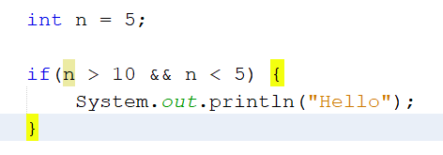

**ANSWER:**

**Nothing. At least from this snippet only. Immediately, 5 is not greater than 10, but it’s also not less than 5. Neither condition of this AND statement is met, the loop gets skipped.**

1. In order to loop through the following array what code would you replace with the “TODO” text in the below code snippet?

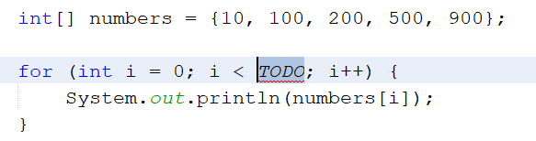

**ANSWER:**

**I would replace the TODO with the number 4, or you could also use numbers.length.**

**(Would it be numbers.length -1? I’d end up figuring it out)**

1. 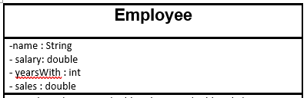Below is a part of a UML diagram for an Employee class. Are the variables listed in this UML private or public?

**ANSWER:**

**I honestly don’t know. My only thoughts are I hope it’s not open information, but I don’t know.**

1. **Is the below constructor default or overloaded? Why?**

**ANSWER:**

**It looks like the default constructor to me. Based on the UML above, it’s the correct information with the correct datatypes and in the correct order. Is something like a set method considered overloaded?**

1. **True or False, In Java, you can create an object of an abstract class:**

**Answer:**

**True.**

1. **True of False, In Java you can inherit from multiple classes**

**Answer:**

**True.**

1. **True or False, In Java you can Inherit and Implement in the same class**

**Answer:**

**True.**

1. **What is the range of possible numbers the below line of code would produce?**

**  
  
Answer:**

**Without using Google, I don’t know.**

1. **True or False, an Object o can be passed as an argument to a method?**

**Answer:**

**True.**

1. 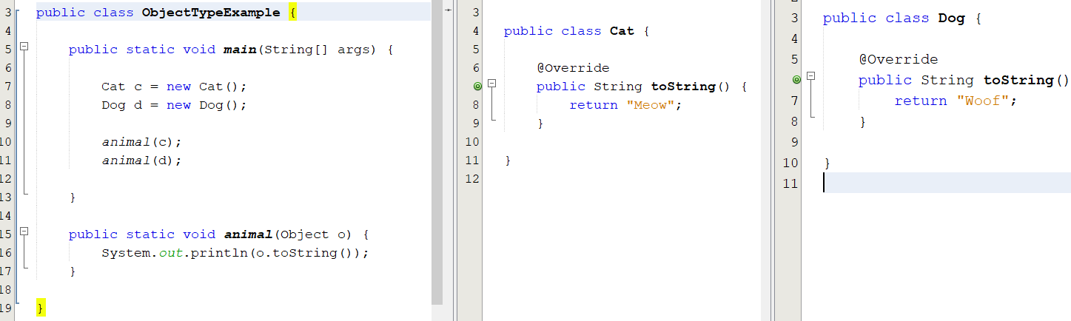**What would the below codes output be?**

**Answer:**

**Meow. Woof.**

1. **BONUS QUESTION: What does the below method do? (If you are unsure you may answer N/A) – This is something we will cover later in the semester.**

**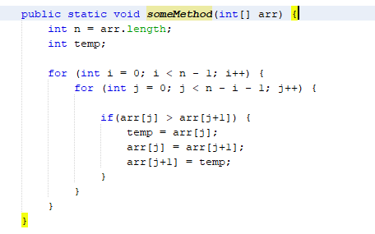  
Answer: I think it’s iterating through each position of more than one array and maybe reassigning things? I’m not fully sure what it’s doing here.**