**Lab Assignment 1  
Due: 02 / 06 (Monday) By 11:59 PM**Please submit this Lab assignment via blackboard under the “Assignments” section. Be sure to include an honest answer each question completely (2-5 sentences). For coding questions, you will **not** be penalized for incorrect answers, these are just to gauge where you at and what to cover during review.  
 ***(If required use the scale 1 (Extremely Comfortable) – 10 (Very uncomfortable)***

***Short Answers & Scales***

1. **How long ago did you take CIT-130?**

**Last semester. I had Professor Moore in a Zoom class and I received an A for a final grade.**

1. **On a scale of 1 – 10 how what is your comfort level / knowledge of: Arrays:**

**On a scale of one to ten, I would rate myself at a 5-6 when it comes to arrays. I’m comfortable with them, know when to use them (for the most part) and if I hit snags, I can figure it out relatively quickly. I say a five or a six because it’s not like I have a decade of experience using them and I know there’s more I can learn about them.**

1. **On a scale of 1 – 10 how what is your comfort level / knowledge of: Multi-Dimensional Arrays:**

**This one I’m not quite as familiar with as I am with basic arrays. I would probably rate myself closer to 4-5 for this one, learning towards four, because I do understand the concept and why it would be beneficial, I just don’t have much experience implementing them.**

1. **On a scale of 1 – 10 how what is your comfort level / knowledge of: Object Oriented programming (Creating classes, using constructors):**

**For this one I would give myself a 6-7. Again, there’s always room for improvement and I’ve only really been learning Java since my first semester, this is my fourth, but I have a strong understanding of the concept and mostly how to execute these. I’ve began learning multiple languages now, both in CCAC and my own, and classes seem to be a common theme in a lot of them. Except C.**

1. **Have you heard of / are you comfortable using a UML (Unified Modeling Language) Diagram?**

**I have used a UML in one of my other classes. However, I don’t remember being good at it in that course, or good at making them, I should say, but I do see why they’re beneficial for a project. Even if I don’t understand it, Google will help me figure it out.**

1. **On a scale of 1 – 10 how what is your comfort level / knowledge of: Inheritance & Interfaces:**

**This is another one I don’t think I’m very strong with. I would give myself a 4-5 with this one, too. I don’t fully understand the ideas behind this one, but it’s not totally foreign and I’m sure I could cobble something together with time and Google.**

**PAUSE: A quick note, if you are not confident in any of the above subject matters, are first few weeks will be a review of CIT-130. As well as this I have listed playlists to EVERY video from my CIT-111 & CIT-130 course so you have access to all of this & more in detail if needed. You may find this links on our blackboard site under “Week 0” at the bottom.**

1. **After reading the syllabus and / or reviewing the course site what week / topic are you looking forward to the most and why?**
2. **After having a chance to look around our blackboard course site. Do you feel comfortable / confident with the layout and have a general understanding of what is expected of you each week? If no, please state any questions or concerns you may have.**
3. **Give a brief description of what you would deem your most challenging and/or rewarding programming project (inside or outside of school):**
4. **Are there any concepts you learned in CIT-111 AND / OR CIT-130 that you are still not too sure of or comfortable with? If so, what is that concept? If not, you may answer N/A:**

***Programming Questions* (You will NOT be graded on incorrect answers, as long as you answer! This is just to gauge how the review section will go) - If you do not know the answer, that is fine, but when possible please state your thought-process.**

1. **What would the below code output?**

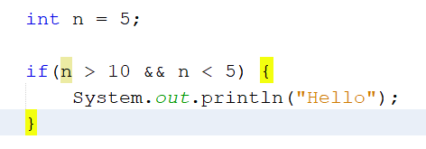

**ANSWER:**

1. In order to loop through the following array what code would you replace with the “TODO” text in the below code snippet?

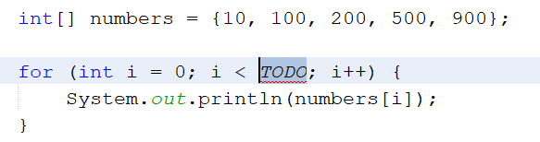

**ANSWER:**

1. 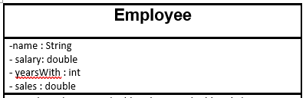Below is a part of a UML diagram for an Employee class. Are the variables listed in this UML private or public?

**ANSWER:**

1. **Is the below constructor default or overloaded? Why?**

**ANSWER:**

1. **True or False, In Java, you can create an object of an abstract class:**

**Answer:**

1. **True of False, In Java you can inherit from multiple classes**

**Answer:**

1. **True or False, In Java you can Inherit and Implement in the same class**

**Answer:**

1. **What is the range of possible numbers the below line of code would produce?**

**  
  
Answer:**

1. **True or False, an Object o can be passed as an argument to a method?**

**Answer:**

1. 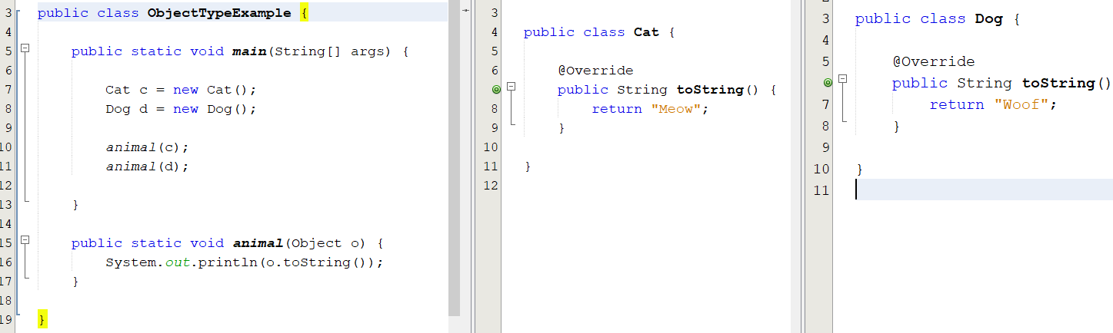**What would the below codes output be?**

**Answer:**

1. **BONUS QUESTION: What does the below method do? (If you are unsure you may answer N/A) – This is something we will cover later in the semester.**

**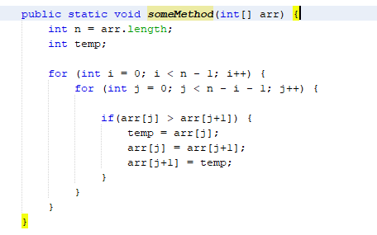  
Answer:**