USB Doodad
Thanks for purchasing a USB Doodad kit. With this kit, you can learn about surface mount technology (SMT), learn the basics of how to solder surface mount devices (SMD), and build a fun and useful USB-capable microprocessor board.

Before you start
This kit assumes you know how to solder, and have soldered before. If you haven't soldered before, it's probably a good idea to practice on something else before you start this kit. If you'd like help learning to solder, there are groups where you can learn. Most cities have a radio club or a hackerspace:

http://hackerspaces.org/wiki/List_of_Hacker_Spaces

If you have successfully done the soldering for any sort of electronic kit, you shouldn't have any problem soldering the USB Doodad.

TIP: Please take the time to read these instructions through completely, from one end to the other, before you start construction. Study the components in the kit (but leave them in their carrier tapes), compare them to the instructions, and develop a feeling for what goes where. Ten minutes of patient work here can save you hours of frustration later.

Getting Help
If you have trouble constructing this kit, or it doesn't work, please visit the USB Doodad forum:

http://groups.google.com/group/usb-doodad/about

What you need
Must have:
- Soldering iron
- Solder or solder paste (see below)
- The components in this kit!
Good to have:
- Magnifying glass
- Multimeter

Licence
CC BY-SA 3.0 AU

What is “surface mount technology (SMT)”?
There are two main ways of putting components onto circuit boards:


Here's a cut-away diagram showing a circuit board from the side. Traditionally, the wire leads of components were threaded through a small hole from the top side of the circuit board to the bottom, then the lead was soldered to the copper traces on the bottom of the board. This is called the “through-hole” style, and is quite labour intensive to manufacture.

Nowadays, all manufacturing is done using SMT. Components are placed and soldered directly onto tracks on the top of the board. Because this can be done by machine, commercial manufacturing using SMT is much cheaper, quicker and reliable than through-hole.

Because of this, the majority of components sold today are in the surface mount device (SMD) style. It's become harder and harder to buy through-hole components, and some chips and components are now only available as SMD.

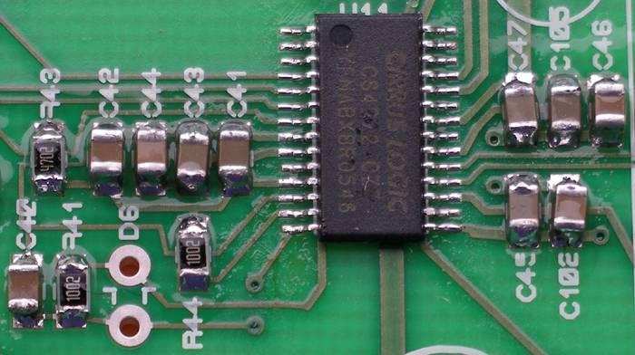
(Image CC BY-SA from)

The USB Doodad kit uses “surface mount devices (SMD)”.

http://en.wikipedia.org/wiki/Surface-mount_technology

Your kit
Most of the components in this kit are supplied in the “1206” size. In metric, that's 3.2mm x 1.6mm.
You can solder 1206-sized parts without special skills, using just an ordinary soldering iron and electronics solder. However soldering the microprocessor needs special techniques, so it has been pre-soldered onto your kit's circuit board.

Solder
Solder is available as wire and as a paste. The wire form comes on a reel. The paste form may come in a small tub, or in a syringe. The techniques for each are different.

It is easier to use solder paste than solder in the wire form. If you have a choice, use solder paste.

Health warning
Hobbyist solder contains lead. Lead is a toxic metal which is easily absorbed through the skin and by inhaling soldering smoke.

The risk is minimal if you follow these precautions:

- Avoid eating or smoking while soldering and handling solder.
- Keep your fingers away from your mouth.
- Solder in a well-ventilated place, and try not to breathe the smoke.
- If you get solder paste on your fingers or skin, wash it off immediately.
- Wash your hands thoroughly with soap and water when you've finished.
Lead is also an environmental poison, so unused solder should not be thrown out in the ordinary rubbish. If the amount is more than a few blobs, please contact your local council for advice on how to dispose of it properly.

Soldering with solder wire
Since SMD components have no leads, there's nothing to hold them in place on the board when you're soldering them. It's quite annoying when a component jumps out of place just as you solder it!

To prevent parts from wandering, use something to hold each component in place as you solder it. Jon Oxer uses one point of a hand-held gardening fork:

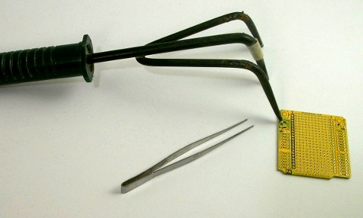
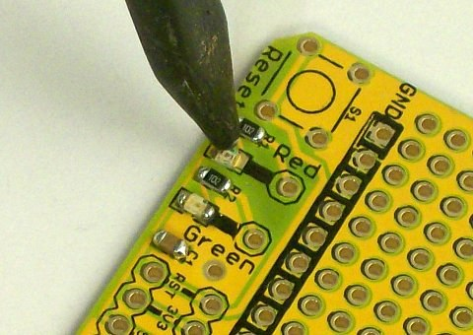
http://jon.oxer.com.au/blog/id/349 (Image courtesy of Jon Oxer of Freetronics).

To solder using this technique:

- Place a component in the correct position
- Rest the tine of the fork on the component.
- Solder one pad as follows: Apply the tip of the heated soldering iron simultaneously to the pad and the metal end of the component. Wait a moment for heat transfer, then apply the solder wire to the exact point where the iron, the component end and the pad meet. Apply enough so the molten solder coats most of the pad and component end, but not so much that the solder forms a convex blob. When the solder has flowed properly, take the tip away. See the diagram on page one for the correct solder shape.
- Turn the board around, reposition the tine, and solder the other end.
- Repeat this for all the pads.

Solder paste
Solder paste is uncountable millions of perfectly spherical, silvery solder balls suspended in a gel. (If you have a microscope, do check them out!)

If you're on a budget and don't mind waiting a few weeks, you can get solder paste here:

http://www.dealextreme.com/details.dx/sku.7952

If you're in Australia, you can get high quality solder paste in a syringe here, with next-day delivery:

http://ultrakeet.com.au/index.php?id=1&cID=5805 (choose Syntech LF solder paste, code AC305-10CC)
http://ultrakeet.com.au/index.php?id=1&cID=5827 (choose a 22-gauge 45º dispensing needle, code DN-BLANA)

The syringe plus the 45º dispensing needle is the easiest option, as it allows you complete control over where the solder ends up.

The metal parts of each component will sit on and be soldered to “pads” on the circuit board.

To solder a component with solder paste:

- Use the syringe and dispensing needle (or a sharpened match head or similar, if you're using paste in a tub) to place a small amount of solder paste on all the pads for that component. As a good guide, aim to cover about 50-70% of the area of each pad.
- Use tweezers to partly place, partly drop components onto the pads. The surface tension of the solder paste will hold the component in place. To prevent lead contamination, be careful that you don't get solder paste on the tweezers. If you do, wipe it off the tweezers with paper tissue.
- Gently align the component if it is badly misaligned. (Slight misalignment will fix itself when you solder the component).
- If necessary, you can give the component a little pat with the tweezers to help the paste adhere to the component surface, but do not squish the component right down to the board.
- Apply the tip of the heated soldering iron to a pad, wait for the solder to melt and flow, then take the tip away. (This step is much easier than through-hole soldering!)
- Repeat this for all the pads.

TIP: Once you have experience at soldering components and you know what you're doing, you can save a lot of time by applying the solder paste for several components, then placing the components, then soldering the components. Don't do too much at a time, as solder paste dries out after about 20 minutes, and it is very easy to accidentally smudge the solder paste with your hand.

The fluxes in solder paste don't last forever. You can extend the life of solder paste by keeping it in the fridge. Pay attention to avoiding lead contamination: Make sure there is no possibility that the solder from the syringe, needle or tub can ever touch anything else in your fridge (zip lock bag?). Securely seal it and mark it well so that everyone, especially youngsters, won't open it. You might consider cutting out and reusing the red health warning from these instructions.

Since there's enough solder in a syringe or tub to solder hundreds of boards, it's unlikely you'll finish it before the solder reaches end-of-life. You can reduce waste and help others by sharing a syringe or tub at your local hackerspace, school or other electronics club.

Know your components

Component identification
An electronic circuit typically uses many different kinds of component, and there'll be several different values of each kind. With through-hole components, the value of the component is always marked on the body with numbers or a colour code. Since SMT manufacturing is done by machine, many component manufacturers don't bother to mark the bodies of SMDs, so we have to use other ways of identifying component types and values.

SMDs are usually supplied to manufacturers in long strips, wound on reels by the thousand. Machines pull the components out of the carrier tape and place them on the circuit board.

For this kit, we will use the quantity of each component, and the colour of the carrier tape, to identify which component is which. No two components in this kit have the same quantity and same coloured carrier tape.

For example, there are three colours of LEDs, red, green and amber. The LEDs are the only components which come in a black carrier, and the quantities of 5, 10 and 1 respectively tell you which colour is which.

TIP: Don't remove components from the carrier tape until it's time to place them on the board. Without the quantity and the colour of the carrier tape to guide you, it can be nearly impossible to visually identify them.

Component polarity
Some components can be installed in any direction. Other components will only work when oriented properly. Most of the components in this kit are non-polarised, and can be mounted either way.

Some components however, are polarised, and must be mounted the right way around for the circuit to work:

- Push-button switch (S1)
The switch is nearly square-shaped, and has four legs. Looking from above, one edge of the switch is longer than the other. The legs of the switch come out from the shorter side.
ERRATA: See note at side
If the legs of the switch don't line up with the pads, try turning the switch by 90 degrees.
- Light emitting diodes (LEDs) (LED1-LED16)
Under each LED there is a green “T” shape. Consider the letter “T” for a moment: there's a horizontal stroke and a vertical stroke. Regarding the “T” on the bottom of each LED, the horizontal stroke should be closer to the centre of the board.
You should be able to see the tiny cube of light emitting material in the middle, sitting on a pad of metal. The metal of that pad will extend to one end of the LED. That end should be closest to the edge of the board. There will also be a tiny whisker-like wire that runs from the cube to another wire pad, which then runs to the other end. That end should be closest to the centre of the board.
- Zener diodes (D1, D2)
These components are glass cylinders with metal end caps. There's a band on one end of the diode. The diodes go on the board right next to the USB connector. If you're looking at the board with the USB connector on the right, the diodes should be mounted with the band in the up position.
- Capacitors
In many circuits, larger capacitors such as the 4.7µF (C7) are polarised. The capacitors in this kit are not polarised, so you can put them on either way.

This table shows the components in this kit, along with the quantity of that component and the colour of the carrier tape. The web link can be used to look at the data sheet for that component, or to help you buy more components if you want to assemble the components for making another kit.

Please note: The colours on the placement chart do not match the colours of the actual components. The only way to determine which component goes where is to use the component designators.

Component placement guide
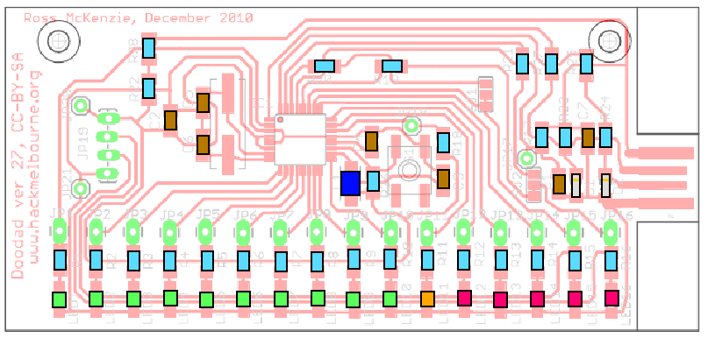
This diagram shows which component goes where. The important thing to note is that next to each component is a designator, such as R12, C7, and LED11.

Assembly
There are two useful strategies for systematically soldering components on the board:

Strategy one
For a given position on the circuit board and placement diagram:

- Find the designator of the component at that position.
- Look up that designator in the component table.
- For that component, note the quantity and appearance (for example, carrier tape colour).
- Find that component amongst your unplaced components. Remove one from the carrier tape.
- Solder the component to the board in the right position.
- Repeat until done.

Strategy two
For each component type in the component table:

- Note the quantity and appearance (for example, carrier tape colour).
- Find that kind of component amongst your unplaced components.
- Put the other components aside.
- Note the range of designators for this component.
- For each designator, find it on the circuit board and solder the component in at that position.
- Repeat until done.

Both methods work well, so choose the one you're most comfortable with.

After reading the material above about techniques, and how to work out what components go where, you're almost ready to start. Get the circuit board, the parts, the charts, and the tools you'll need assembled in your work area.

Using one (or both) of the placement strategies, mount all the components on the circuit board.

Mount the components around switch S1 before mounting S1.

Things to note:

- If you burn yourself, run the burn under slow-running cold tap water for 10-15 minutes.
- If you have a temperature controlled iron, adjust the temperature to somewhere between 290º and 350ºC. If you're just starting out, use a temperature at the lower range, as this will give you more time to follow the correct procedure for a good joint. If you are more experienced, you can use a higher temperature.
- Lead-free solders will need to be soldered about 30ºC hotter than for solders that contain lead.
- Surface mount components heat up extremely fast, so try to keep soldering time down. Any more than three seconds per joint is probably too much. If you need more time to get a joint right, let the joint cool completely before trying again.
- Some of the circuit board traces run underneath components. When positioning and soldering these components, try to place the component so the metal ends of the components, and the solder, don't touch the traces underneath the components. This is especially important for the LEDs, most of which have two traces running underneath.

Troubleshooting
- Set your multimeter to measure resistance, and measure the resistance between the two outer fingers of the USB connector. (The two outer fingers are the ground and power for the circuit, so this tests for power suppy shorts). The resistance should be at least X ohms.

Feedback

Tell us how you went!

Website for more software and to talk about the Doodad

Advanced

How to solder fine pitch chips

TODO: Software! Big enough to fill a whole book, not sure what to do...

TODO: Image credits

Firmware loading

“Hello World”
Components you need to load in order to get the chip to the point where firmware can be loaded:

- MCU (If you're hand-soldering it, put it on first then buzz out for shorts between pins)
- LEDs 11-16
- LED 16 (red) says you're in you've gone through the bootloader.
- LED 15 (red) says you've left the bootloader and you're into app space.
- LED 11 (amber), LED 12-14 (red). A 4-bit binary count when in the bootloader. Set to all on when bootloader jumps to the application space. You can get away with loading just one, say LED 11.
- R11 180R
- R12-16 360R
- R19 0R (wire link will do)
- C7 4u7
- R17 10k
- C1,C2 100n

Solder your 6-pin ISP header as follows (assuming looking at Doodad board w/ USB conn on right):

JP9 | MISO | ○ | ○ | Vcc | Top pin of JP19
JP10 | SCK | ○ | ○ | MOSI | JP8
JP17 | RST | ○ | ○ | GND | Bottom pin of JP19

Source: USBTiny Mkii User Manual

Measure the pins on your programmer to determine which one is GND and which is Vcc. Buzz the cable out to confirm that this will go to the right places on the USB Doodad.

Take the software archive and untar it.

Connect up the programmer and try to id the processor (you'll need to run as root, and adjust the programming command to suit your programmer):

[root@xiaomao bins-doodad-27-1]# avrdude -c avrisp2 -P usb -p atmega168 -q

avrdude: AVR device initialized and ready to accept instructions
avrdude: Device signature = 0x1e940b
avrdude: Expected signature for ATMEGA168 is 1E 94 06
Double check chip, or use -F to override this check.

avrdude done. Thank you.

[root@xiaomao bins-doodad-27-1]#

Despite the error message, it's a really good sign. It means the programmer can talk to the chip. The error message is generated because the chip signature for the ATmega168p is different to the signature for the ATmega168. Sadly, the most recent version of avrdude has not yet been modified to recognise the ATmega168p. If you use the -F option, you can force avrdude to ignore the signature:

[root@xiaomao bins-doodad-27-1]# avrdude -c avrisp2 -P usb -p atmega168 -q -F

avrdude: AVR device initialized and ready to accept instructions
avrdude: Device signature = 0x1e940b
avrdude: Expected signature for ATMEGA168 is 1E 94 06

avrdude: safemode: Fuses OK

avrdude done. Thank you.

[root@xiaomao bins-doodad-27-1]#

Let's load in the “hello world” program. This program flashes the 6 LEDs closest to the USB connector in a once-per-second odd-even pattern:

[root@xiaomao bins-doodad-27-1]# avrdude -c avrisp2 -P usb -p atmega168 -F -q -U flash:w:hello-internal.hex

avrdude: AVR device initialized and ready to accept instructions
avrdude: Device signature = 0x1e940b
avrdude: Expected signature for ATMEGA168 is 1E 94 06
avrdude: NOTE: FLASH memory has been specified, an erase cycle will be performed
To disable this feature, specify the -D option.
avrdude: erasing chip
avrdude: reading input file "hello-internal.hex"
avrdude: input file hello-internal.hex auto detected as Intel Hex
avrdude: writing flash (216 bytes):
avrdude: 216 bytes of flash written
avrdude: verifying flash memory against hello-internal.hex:
avrdude: load data flash data from input file hello-internal.hex:
avrdude: input file hello-internal.hex auto detected as Intel Hex
avrdude: input file hello-internal.hex contains 216 bytes
avrdude: reading on-chip flash data:
avrdude: verifying ...
avrdude: 216 bytes of flash verified

avrdude: safemode: Fuses OK

avrdude done. Thank you.

[root@xiaomao bins-doodad-27-1]#

You should now see some of the LEDs flashing. Seek help if they don't.

When the ATmega168P is shipped from the factory, the internal “fuses” are set so that the CPU takes the signal from the internal 8MHz oscillator, then divides it by eight. Let's turn off the divide-by-eight:

[root@xiaomao bins-doodad-27-1]# avrdude -c avrisp2 -P usb -p atmega168 -F -q -U lfuse:w:0xE2:m

⋮
⋮
⋮

avrdude done. Thank you.

[root@xiaomao bins-doodad-27-1]#

The LEDs should now be blinking very rapidly.

Loading the crystal
Solder these components in order to run off the external crystal:

- Q1 16MHz crystal
- C5, C6 18p

When you first power up the board, the LEDs should flash fast as before. Now modify the fuses to use the external crystal:

[root@xiaomao bins-doodad-27-1]# avrdude -c avrisp2 -P usb -p atmega168 -F -q -U lfuse:w:0xFF:m

⋮
⋮
⋮

[root@xiaomao bins-doodad-27-1]#

The fuses should now be flashing frantically.

Next, swap the program for one that's been written to run at 16MHz:

[root@xiaomao bins-doodad-27-1]# avrdude -c avrisp2 -P usb -p atmega168 -F -q -U flash:w:hello-external.hex

⋮
⋮
⋮

[root@xiaomao bins-doodad-27-1]#

The LEDs should be back to flashing the 1-per-second pattern.

Bootloader
To get the bootloader running, install these components:

- R26 10k
- S1 (note page 5 for necessary mods to switch in rev 27)

The binary firmware for the bootloader is in bootloaderHID.hex:

[root@xiaomao bins-doodad-27-1]# avrdude -c avrisp2 -P usb -p atmega168 -F -q -U flash:w:bootloaderHID.hex

avrdude: AVR device initialized and ready to accept instructions
avrdude: Device signature = 0x1e940b
avrdude: Expected signature for ATMEGA168 is 1E 94 06
avrdude: NOTE: FLASH memory has been specified, an erase cycle will be performed
To disable this feature, specify the -D option.
avrdude: erasing chip
avrdude: reading input file "bootloaderHID.hex"
avrdude: input file bootloaderHID.hex auto detected as Intel Hex
avrdude: writing flash (16252 bytes):
avrdude: 16252 bytes of flash written
avrdude: verifying flash memory against bootloaderHID.hex:
avrdude: load data flash data from input file bootloaderHID.hex:
avrdude: input file bootloaderHID.hex auto detected as Intel Hex
avrdude: input file bootloaderHID.hex contains 16252 bytes
avrdude: reading on-chip flash data:
avrdude: verifying ...
avrdude: 16252 bytes of flash verified

avrdude: safemode: Fuses OK

avrdude done. Thank you.

[root@xiaomao bins-doodad-27-1]#

Now, if you power-cycle the Doodad, you should see these LEDs:
- LED 16 should be on: It went into the bootloader.
- LED 15 should be off: There was no application in flash to set it.
- LEDs 11-14 should be on: The bootloader sets them before jumping to an application.

Now power-cycle the Doodad with the switch held down. You should see these LEDs:

- LED 16 should be on: It went into the bootloader.
- LED 15 should be off: There was no application in flash to set it.
- LEDs 11-14 should be running a binary count: The bootloader is running and waiting for an application via USB.

You won't be able to load software over USB yet, because the USB interface components haven't been loaded. But you can remove the 6-pin ISP header and turn it over to someone else for the assembly of the remainder of the components. You could also consider removing all the components except for the chip, and let someone else re-add them later.

