MR.CREAMS

Investor Documentation & NDA
Date: 2025-11-01
Prepared by: ENUM TECHNOLOGIES | Addis Ababa, Ethiopia

Confidentiality Agreement (NDA)
This document is confidential and intended solely for potential investors of MR.CREAMS. By reviewing this material, the recipient agrees not to disclose, copy, or distribute any of the contained information without written permission from ENUM TECHNOLOGIES

Business Overview

🧠 MR.CREAMS (Modern Relationship Conflict Resolution & Emotion Analysis Management System) is a digital emotional wellness platform developed by ENUM TECHNOLOGIES. It aims to revolutionize mental health access in Ethiopia by combining technology, therapy, and community support.

Market Opportunity
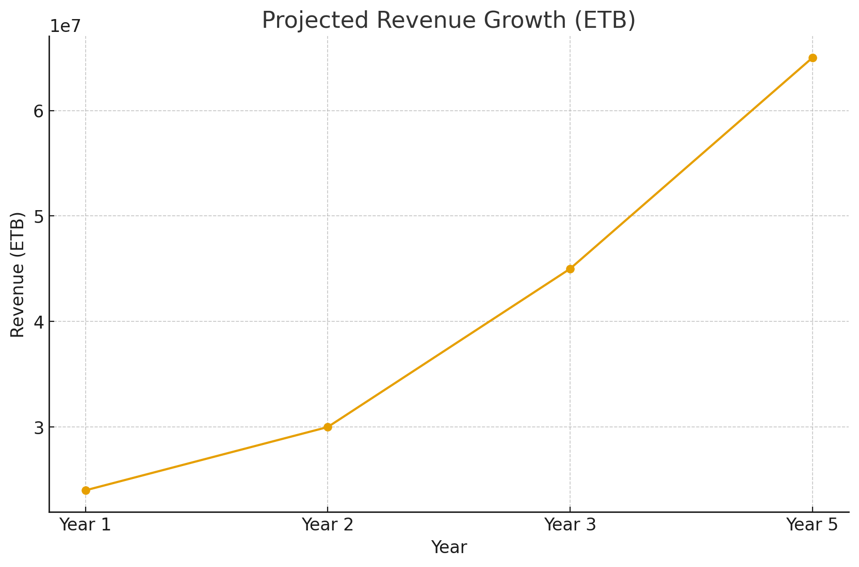
Ethiopia’s digital health market is growing rapidly, supported by increasing smartphone adoption and awareness. Our projections estimate 20–25% market expansion annually for digital wellness services.

Revenue & Financial Outlook
Based on realistic 2% market penetration, MR.CREAMS is expected to generate approximately 24M ETB in Year 1, reaching 65M ETB by Year 5. Estimated operating costs are 9M ETB annually, ensuring profitability by Year 2.

Competitor Analysis
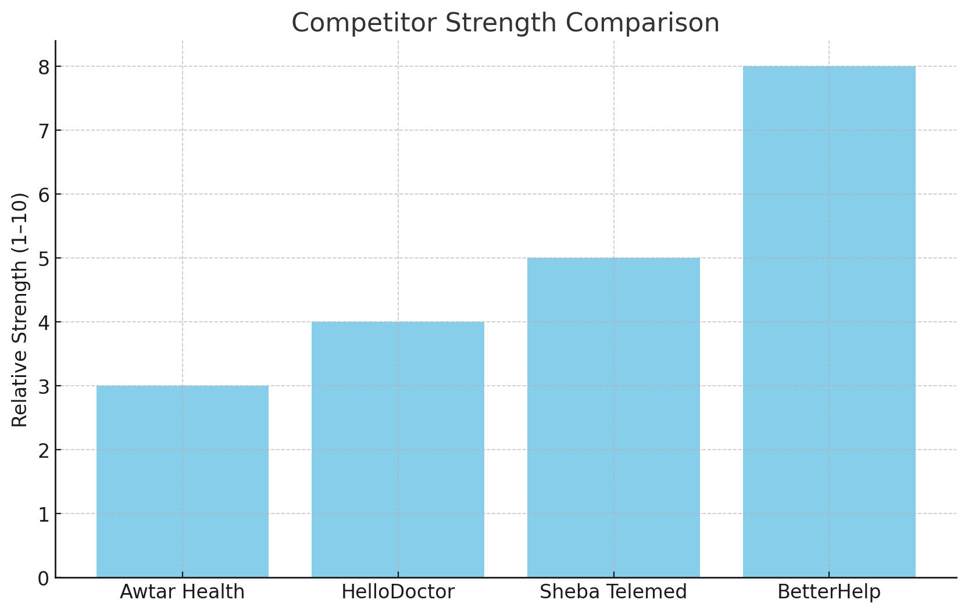
MR.CREAMS differentiates through cultural fit, Amharic support, and affordability. Current competitors like HelloDoctor or Sheba Telemed focus on general telemedicine, not mental health.

Investment Proposal
We are seeking an investment of 12–15 million ETB to finalize national rollout, improve app features, and expand therapist partnerships. Projected ROI is 3–4x within 5 years.

Signatures
Investor Name: ___________________________
Signature: _______________________________
Date: ____________________
Prepared by:
ENUM Technologies
Founder: Fitsum Mulugeta
Email: Founder@enumtechnologies.com

