VLSM Exercise # 1

Student Name: Caprice Godinez

Design an appropriate VLSM addressing scheme for the topology. Maximize the number of host addresses at each level of subnetting.

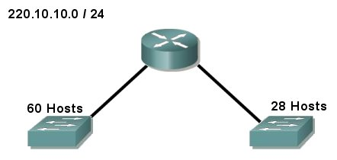

VLSM Exercise # 2

220.10.10.0/26

220.10.10.64/27

Student Name: Caprice Godinez

Design an appropriate VLSM addressing scheme for the topology. Maximize the number of host addresses at each level of subnetting.

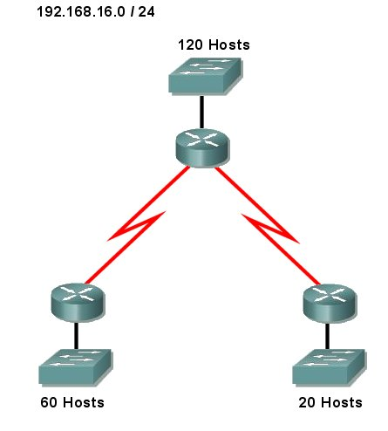

192.168.16.192/27

192.168.16.128/26

WAN1

192.168.16.224/30

WAN2

192.168.16.228/30

192.168.16.0/25

VLSM Exercise # 3

Student Name: Caprice Godinez

Design an appropriate VLSM addressing scheme for the topology. Maximize the number of host addresses at each level of subnetting.

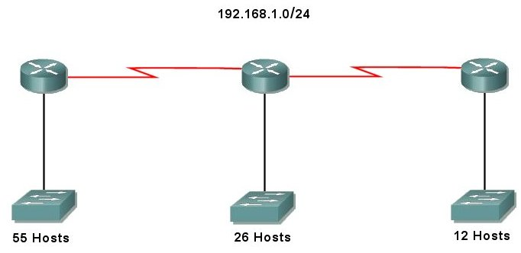

WAN2

192.168.1.116/30

WAN1

192.168.1.112/30

192.168.1.96/28

192.168.1.64/27

192.168.1.0/26

VLSM Exercise # 4

Student Name: Caprice Godinez

Design an appropriate VLSM addressing scheme for the topology. Maximize the number of host addresses at each level of subnetting.

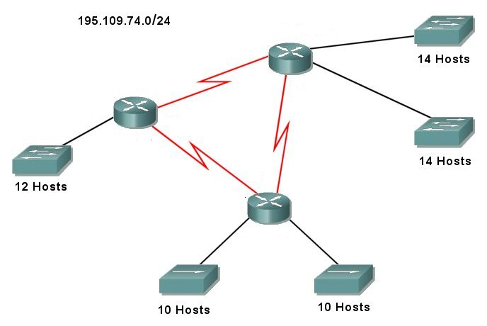

10h#1

195.109.74.48/28

195.109.74.32/28

10h#2

195.109.74.64/28

WAN2

195.109.74.84/30

WAN3

195.109.74.88/30

14h#2

195.109.74.16/28

14h#1

195.109.74.0/28

WAN1

195.109.74.80/30

VLSM Exercise # 5

Student Name: Caprice Godinez

Design an appropriate VLSM addressing scheme for the topology. Maximize the number of host addresses at each level of subnetting.

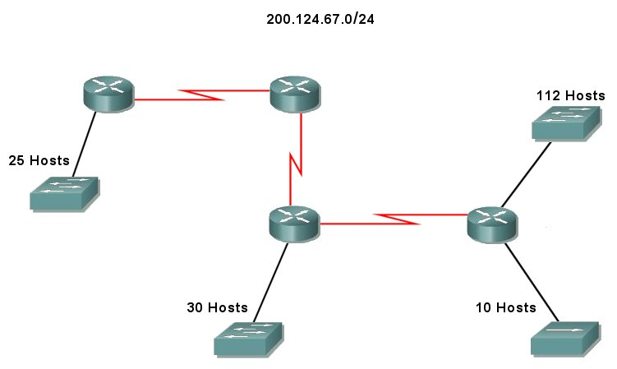

200.124.67.128/27

200.124.67.192/28

WAN3

200.124.67.216/30

200.124.67.160/27

WAN2

200.124.67.216/30

WAN1

200.124.67.208/30

200.124.67.0/25

VLSM Exercise # 6

Student Name: Caprice Godinez

Design an appropriate VLSM addressing scheme for the topology. Maximize the number of host addresses at each level of subnetting.

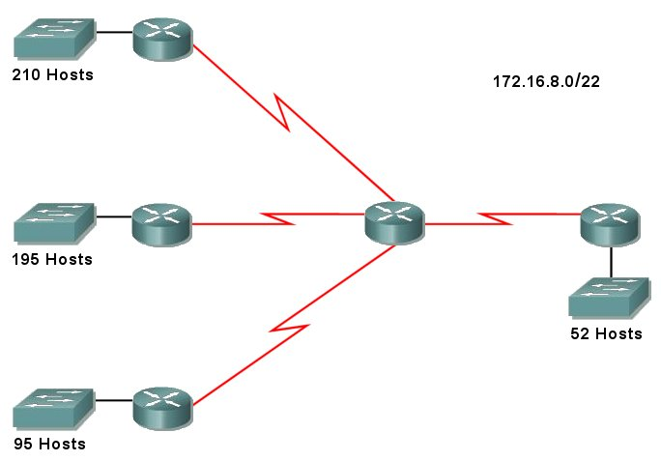

WAN1

172.16.10.192/30

172.16.10.0/25

WAN3

172.16.10.200/30

172.16.9.0/24

172.16.8.0/24

WAN2

172.16.10.196/30

WAN4

172.16.10.204/30

172.16.10.128/26

VLSM Exercise # 7

Student Name: Caprice Godinez

Design an appropriate VLSM addressing scheme for the topology. Maximize the number of host addresses at each level of subnetting.

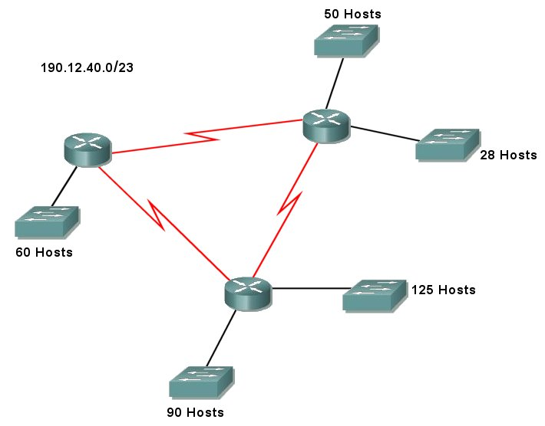

WAN3

190.12.41.168/30

190.12.41.0/26

WAN2

190.12.41.164/30

190.12.40.128/25

190.12.40.0/25

190.12.41.128/27

WAN1

190.12.41.160/30

190.12.41.64/26

VLSM Exercise # 8

Student Name: Caprice Godinez

Design an appropriate VLSM addressing scheme for the topology. Maximize the number of host addresses at each level of subnetting.

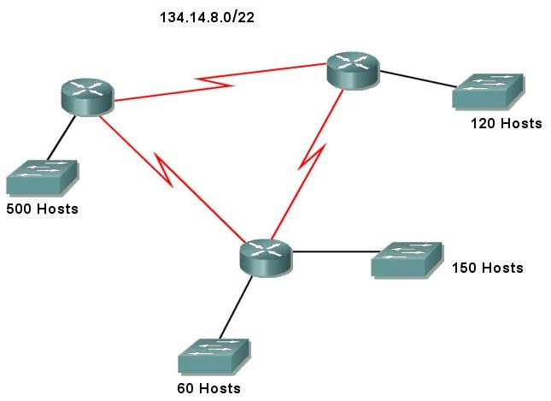

134.14.8.0/23

134.14.11.128/26

134.14.10.0/24

134.14.11.0/25

WAN3

134.14.11.200/30

WAN2

134.14.11.196/30

WAN1

134.14.11.192/30

VLSM Exercise # 9

Student Name: Caprice Godinez

Design an appropriate VLSM addressing scheme for the topology. Maximize the number of host addresses at each level of subnetting.

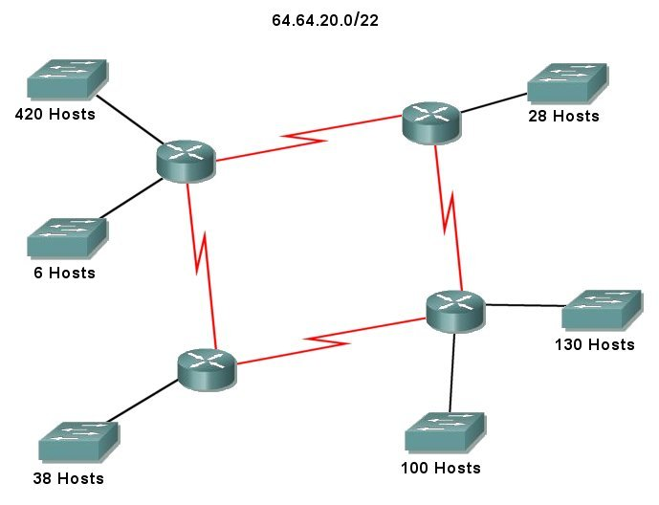

WAN2

64.64.23.236/30

WAN4

64.64.23.244/30

WAN3

64.64.23.240/30

WAN1

64.64.23.232/30

64.64.20.0/23

64.64.23.224/29

64.64.23.128/26

64.64.23.0/25

64.64.22.0/24

64.64.23.192/27

VLSM Exercise # 10

Student Name: Caprice Godinez

Design an appropriate VLSM addressing scheme for the topology. Maximize the number of host addresses at each level of subnetting.

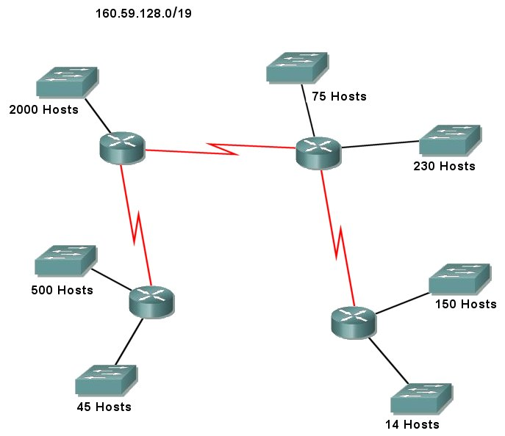

160.59.136.0/23

160.59.140.128/26

WAN2

160.59.140.212/30

160.59.128.0/21

WAN1

160.59.140.208/30

WAN3

160.59.140.216/30

160.59.140.192/28

160.59.139.0/24

160.59.138.0/24

160.59.140.0/25

VLSM Exercise # 11

Student Name: Caprice Godinez

Design an appropriate VLSM addressing scheme for the topology. Maximize the number of host addresses at each level of subnetting.

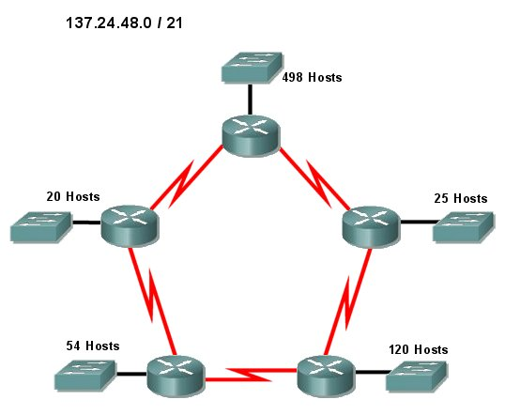

WAN1

137.24.51.16/30

137.24.50.224/27

WAN3

137.24.51.12/30

137.24.50.128/26

WAN5

137.24.51.8/30

137.24.48.0/23

137.24.50.192/27

WAN4

137.24.51.4/30

137.24.50.0/24

WAN2

137.24.51.0/30