# 21A – Charge and Polarization

Reading: Lecture Notes 1. Young and Freedman Section 21.02.

Recommended Viewing: <https://www.khanacademy.org/science/physics/electric-charge-electric-force-and-voltage> (Click on “Conductors and Insulators”)

Basic facts:

* All materials have a nearly equal balance between positive (proton) and negative (electron) charge. Protons and electrons have equal and opposite charge. The electron has a charge of   
  -1.6x10-19 Coulombs. A typical solid has about 1028 electrons and protons per cubic meter.
* Charge can move rapidly (< microseconds) over large distances (meters) in a conductor. Charge cannot move rapidly over large distances in insulators. Typical motion in insulators is just over atomic scale distances.
* Coulomb’s Law applies. ($F=kqQ/r^{2}$)
* When you “ground” an object you are connecting it to a pipe in the ground via a conducting wire. Charge can flow to and from “ground”.
* When two dissimilar materials are rubbed against one another, charge is exchanged and usually one material becomes positive and the other becomes negative.  
  (When a glass rod is rubbed with silk, the rod becomes positive.)

Thinking and calculating:

1. 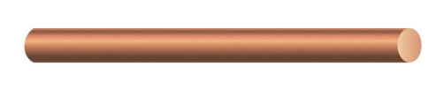If two excess electrons are placed on a long straight copper wire, where are they most likely to be found?

(Anywhere? On one end? On opposite ends?) Explain your answer.

They are both of like charges, so they repel each other

Ans: Opposite ends

1. If 106 electrons are placed on a long straight copper wire, how will they be distributed?

(Anywhere? On one end? On opposite ends? Evenly throughout the volume? Over the outside surface?) Explain your answer.

They all want to be equidistant from each other. Since the repelling motion would be constant, entropy dictates that it would naturally spread out.

Ans: Even throughout the volume

1. The conducting rod to the right has no net charge. A negatively charged object is brought near the right end of the rod. What happens to electrons in the conducting rod?

The electrons in the rod would be pushed to the left. Since electrons are negatively

1. Would the charged object exert a force on the neutral rod? Ans. (Yes/No): Yes

If yes, in what direction is the force on the rod? (Attract or Repel?) Ans. (Attract/Repel): Attracted

Explain.

The direction of the force would be towards the electron, since all the negative electrons are at the left side and the positive charge of the right side would attract the rod towards the negatively charged electron.

**Doing Science – Simulation**:

An electroscope has thin conducting foil leaves hung from a conducting rod. If the leaves are similarly charged they repel one another, indicating the presence of net charge on the leaves.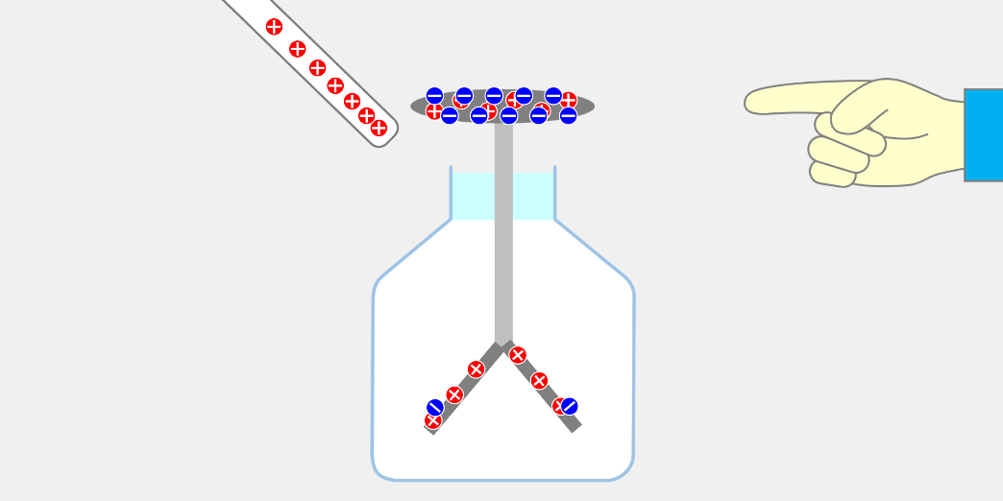

You will explore the behavior of an electroscope using the simulation: <https://javalab.org/en/electroscope_en/>

The conceptual focus is on how charge moves on a conductor when charge is brought near it.

In this simulation the hand acts as a grounded conductor. Charge can flow from the hand to and from ground. The rod can be charged with positive or negative charge.

1. Perform the operations in the table below in the sequence instructed and record i) the number of positive and negative charges and the net charge on the knob of the electroscope; ii) the number of positive and negative charges and the net charge on the leaves of the electroscope; iii) the net charge on the whole electroscope; iv) whether the leaves are separated or together.

|  |  |
| --- | --- |
| **Situation** | **Observations**  **i) Charges and net charge on knob**  **ii) Charges and net charge on leaves**  **iii) Net charge on whole electroscope.**  **iv) Position of leaves.** |
| Example: (not correct)  Initial condition with rod negative and far, and hand far from knob. | i) 100 positive, 100 negative; net charge=0  ii) 200 positive, 200 negative; net charge=0  iii) net charge=0  iv) leaves together |
| 1. Rod negative; Rod near; Hand far away. | i) 100 positive, 40 negative; net charge=60  ii) 200 positive, 260 negative; net charge=-60  iii) net charge=0  iv) leaves separated |
| 1. Rod negative; Rod far; Hand touching. | i) 100 positive, 100 negative; net charge=0  ii) 200 positive, 200 negative; net charge=0  iii) net charge=0  iv) leaves together |
| 1. Rod negative; Rod near; Hand still touching. | i) 100 positive, 0 negative; net charge=-100  ii) 200 positive, 200 negative; net charge=0  iii) net charge=-100  iv) leaves together |
| 1. Rod negative; Rod near; Hand moved away. | i) 100 positive, 0 negative; net charge=-100  ii) 200 positive, 200 negative; net charge=0  iii) net charge=-100  iv) leaves together |
| 1. Rod negative; Rod far; Hand still moved away. | i) 100 positive, 60 negative; net charge=-40  ii) 200 negative, 140 negative; net charge=-60  iii) net charge=-20  iv) leaves separated |
| 1. Rod negative; Rod still far; Hand touching | i) 100 positive, 100 negative; net charge=0  ii) 200 positive, 200 negative; net charge=0  iii) net charge=0  iv) leaves together |
| 1. Rod negative; Rod still far; Hand moved away. | i) 100 positive, 100 negative; net charge=0  ii) 200 positive, 200 negative; net charge=0  iii) net charge=0  iv) leaves together |
| 1. Rod negative; Rod near; Hand still far. | i) 100 positive, 40 negative; net charge=60  ii) 200 positive, 260 negative; net charge=-60  iii) net charge=0  iv) leaves separated |

Initial situation: Start with the rod **negatively charged** and far from the electroscope.( “Rod far” means as far from the electroscope as possible, while “rod near” means as close to the rod as possible.) Touch the hand to the electroscope. Move the hand back away from the electroscope. (Note: in the table below, each row follows sequentially from the row above it. That is, step (b) follows from step (a), and so on …)

i) Explain your observations for situation “h” in the table above using the concepts of charge carriers in conductors, the sequence of situations, and Coulomb’s Law as discussed in Chapter 21.02 of your textbook.

When the negatively charged rod is moved near the neutrally charged knob, the negatively charged electrons are shifted to the leaves below. Down there, the leaves would be more negatively charged than the previously neutrally charged leaves, causing the laves to move apart.

**Doing Science – Hands-on Experiment**

1. Place a metal beverage container, on its side, on the tabletop. Charge one of the insulating rods by rubbing it. Bring the rod near the can. Is the can attracted to, repelled by, or unmoved by, the charged rod? Repeat the experiment with other different rod materials and other cloth types. Write down your observations.

|  |  |  |
| --- | --- | --- |
| Rod Material | Rubbing Material | Attraction/Repulsion/No Force |
| 1. PVC | Fur (or your hair, or a piece of paper…) | Attraction |
| 1. PVC | Rayon (or whatever the pastel green fabric is in the lab) | Attraction |

1. Explain your observations above using the concepts of charge carriers in conductors and Coulomb’s Law. (A free-body sketch would be great!)

When the neutral rod is rubbed by another material like fur or rayon, it charges the rod, since force is generated when rubbing two objects together, so that would cause the can, a conductor, to be attracted towards the rod.

1. A picture containing text, night sky

   Description automatically generated**Optional**: Get an electroscope from the cart at the front of your lab classroom; it is like the one used in the simulation in part 5 above, although instead of a round knob at the top it has a flat conducting plate. Use the rayon fabric (or, pieces of paper) to charge the PVC rod, like you did in part 6 above. To ground the electroscope, instead of using your hand (as in the simulation), use one of the wires stored at the front of your lab room and connect it to the grounding pin of a power outlet at your lab station (see the figure at right); touching the grounding wire to any metal part of the electroscope will provide a path for charge to ground. Write your observations of the behavior of the electroscope needle/leaves in the right column for each situation. **Note that each item is a part of a sequence – that is, for example, (d) follows after having done (c), which comes after doing (b), etc.**

|  |  |
| --- | --- |
| 1. Rod charged & near; Grounding wire far away. |  |
| 1. Rod charged & far away; Grounding wire touching. |  |
| 1. Rod charged & near; Grounding wire touching. |  |
| 1. Rod near; Grounding wire now moved away. |  |
| 1. Rod moved far away; Grounding wire far away. |  |
| 1. Rod near; Grounding wire far; then move rod away |  |
| 1. Rod far; Grounding wire now touching |  |
| 1. Rod far; Grounding wire moved away |  |
| 1. Rod near; Grounding wire far. |  |
| 1. Rod touching upper plate; Grounding wire far away. |  |
| 1. Rod moved far away; Grounding wire still far away. |  |

# 21B – Quantitative Practice Applying Coulomb’s Law

Reference and Reading: Young and Freedman Chapter Section 21.03

Coulomb’s Law describes the force between charged particles. In symbolic form the force exerted on particle 0 by particle 1 is given by

${\overset{⃑}{F}}_{1 on 0}=k\frac{q_{0}q_{1}}{r_{10}^{2}}\frac{{\overset{⃑}{r}}_{10}}{\left|{\overset{⃑}{r}}_{10}\right|}$**Equation 21a**.

where ${\overset{⃑}{r}}_{10}$ is the vector pointing from particle 1 to particle 0, *q*0 and *q*1 are the charge values for the two charges (including sign), and *k* is a constant.

1. Complete the sketch below of the physical situation represented by equation 21a when both charges are positive. Draw a Free Body Diagram for particle 0 (which we will designate as the left-hand particle). Add and label the vector ${\vec{r}}_{10}$ to your sketch.



1

0

1. What is the relationship between *k* and the electric permittivity given in your lecture notes and the front of your textbook? What is the numerical value of *k* and its units in the SI system?

The electric permittivity is C, and k is distance squared over C squared. The numerical value of k is 9.0 x 10^9 and the units is in m^2/C^2

1. How does equation 21a change if you want to find the force exerted on particle 1 by particle 0? (Rewrite it and explain the change.)

$$k\frac{q_{0}q_{1}}{r_{01}^{2}}\frac{\vec{r_{01}}}{\left|\vec{r_{01}}\right|}$$

The change is from the direction of r, going from particle 1 to 0 to particle 0 to 1.

1. A blue and black circles

   Description automatically generatedIn the figure to the right, particle 1 has a positive charge *q*1 = +9.00 nC and lies at the position *P*(0, 10.00, 0) with units in millimeters. Particle 0 has charge magnitude  = 3.00 nC, but the sign is unknown. The direction of the force on particle 1 is to the right.
2. What is the sign of charge *q*0? Explain.

Positive, since the charge is positive

1. Rewrite equation 21a, putting numbers in the place of variables and including sign and vector direction for the force on particle 0.
$$k\frac{3E-9 * 9 E-9}{{10}^{2}}$$

2. What is the magnitude of the force on charge 0? *F* = 0.00324N

1. Consider the same case, but with the addition of particle 2 at some point *P*(0, *y’*, 0) between particles 0 and 1. Particle 0 experiences a repulsion from particle 1 and an attraction to particle 2. Particle 2 has charge = 4.00 nC.
2. What is the sign of charge *q*2?

Negative

1. For what value of *y’* does particle 0 experience a net force of zero?

$$k\frac{3E-9*-4E-9}{y^{2}}=2.43E-9$$

y = 4.7mm

1. For this position, find the *x* and *y* components of the total force on particle 2.

*x*-component: 0 *y*-component: 0.0273N

1

point *P*(0, 0, -3.30) on the *z*-axis.

1. Draw two vectors representing the forces on particle 2 due to each of the two charges 0 and 1.
2. What is the magnitude of *F*0on2?

Fy =



Fx =

*F* =0.009917N

1. What is the magnitude of *F*1on2?

*F* =0.0299N

1. What angle *θ* does ${\overset{⃑}{F}}_{1on2}$ make with the +*y*-axis?

*θ* =6.21 degrees