Business Template

Recruitment agency

Contents
1 Business Description 3
1.1 Business background 3
1.2 Problems. Current Situation 3
1.3 The benefits of implementing a database. Project Vision 3
2 Model description 3
2.1 Definitions & Acronyms 3
2.2 Logical Scheme 3
2.3 Objects 3

Business Description

Business background
The Recruitment Agency acts as an intermediary between employers and job seekers.
It helps companies find experienced employers for open vacancies and help job seekers in finding jobs.
The agency also provides career services such as resume writing, interview preparation, etc.

Problems. Current Situation
Currently, most recruitment processes are handled manually through emails and spreadsheets, which leads to data redundancy, difficulty in filtering applications, and inefficiency in communication between candidates and employers.
This lack of centralization causes problems such as lost candidate data, inconsistent interview scheduling, and inaccurate reports on job placements.

the Benefits of implementing a database. Project Vision
Improve the efficiency of candidate tracking and job management.
Provide real-time visibility into applications, interviews, and placements.
Reduce data duplication and human error.
Offer analytics on job market demand, candidate performance, and agency services.
The vision is to create an integrated system that connects all stages — from job posting to candidate placement.

Model description

Definitions & Acronyms
Term Definition
PK Primary Key
FK Foreign Key

Logical Scheme
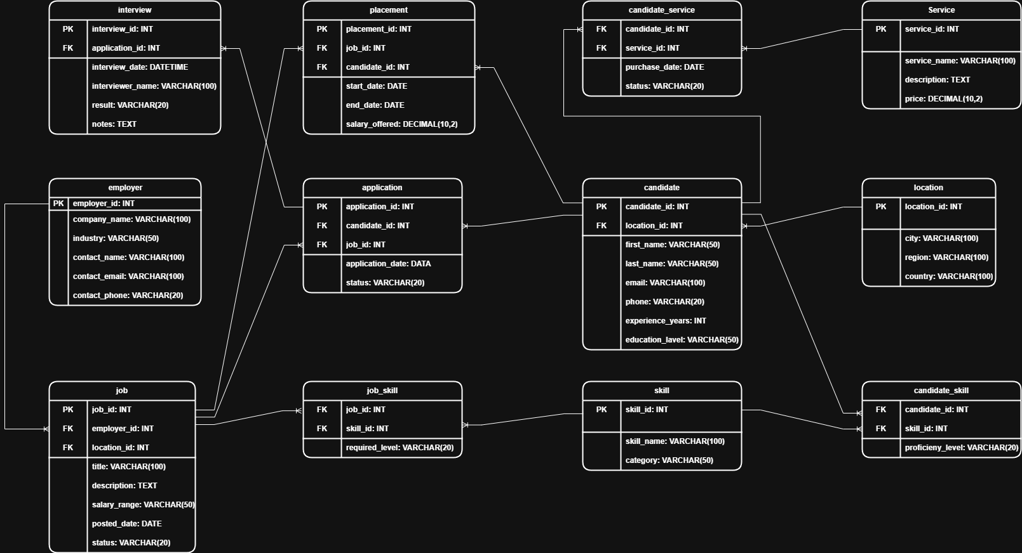

Objects
employer Stores company information for job postings.
job Contains job information posted by employers.
candidate Stores candidate profiles and information.
application Links candidates to the jobs they apply for.
interview Tracks interviews scheduled for applications.
placement Records successful job placements.
skill Stores available skills.
candidate_skill Links candidates and their skills.
job_skill Links jobs and required skills.
location Stores geographical locations of jobs and candidates.
service Contains information about agency services.
candidate_service Links candidates to purchased services.
Table Description
Table Name | Field name | Field Description | Data Type
employer | employer_id | Unique employer identifier (PK) | INT
 | company_name | Company name | VARCHAR(100)
 | industry | Industry type | VARCHAR(50)
 | contact_name | Contact person | VARCHAR(100)
 | contact_email | Email address | VARCHAR(100)
 | contact_phone | Phone number | VARCHAR(20)
job | job_id | Unique job identifier (PK) | INT
 | employer_id | Reference to employer (FK) | INT
 | location_id | Reference to location (FK) | INT
 | title | Job title | VARCHAR(100)
 | description | Job description | TEXT
 | salary_range | Offered salary range | VARCHAR(50)
 | posted_date | Date of posting | DATE
 | status | Job status (Open/Closed) | VARCHAR(20)
candidate | candidate_id | Unique candidate identifier (PK) | INT
 | location_id | Reference to candidate’s location (FK) | INT
 | first_name | Candidate’s first name | VARCHAR(50)
 | last_name | Candidate’s last name | VARCHAR(50)
 | email | Candidate’s email | VARCHAR(100)
 | phone | Phone number | VARCHAR(20)
 | experience_years | Total years of experience | INT
 | education_level | Education level | VARCHAR(50)
application | application_id | Unique application identifier (PK) | INT
 | candidate_id | Reference to candidate (FK) | INT
 | job_id | Reference to job (FK) | INT
 | application_date | Date of application | DATE
 | status | Application status | VARCHAR(20)
interview | interview_id | Unique interview identifier (PK) | INT
 | application_id | Reference to related application (FK) | INT
 | interview_date | Date and time of interview | DATETIME
 | interviewer_name | Name of interviewer | VARCHAR(100)
 | result | Interview result (Pass/Fail/Pending) | VARCHAR(20)
 | notes | Additional comments | TEXT
placement | placement_id | Unique placement ID (PK) | INT
 | job_id | Reference to job (FK) | INT
 | candidate_id | Reference to candidate (FK) | INT
 | start_date | Start date of employment | DATE
 | end_date | End date of employment | DATE
 | salary_offered | Final agreed salary | DECIMAL(10,2)
skill | skill_id | Unique skill ID (PK) | INT
 | skill_name | Name of skill | VARCHAR(100)
 | category | Skill category | VARCHAR(50)
candidate_skill | candidate_id | Reference to candidate (FK) | INT
 | skill_id | Reference to skill (FK) | INT
 | proficiency_level | Candidate’s proficiency level | VARCHAR(20)
job_skill | job_id | Reference to job (FK) | INT
 | skill_id | Reference to skill (FK) | INT
 | required_level | Required skill level | VARCHAR(20)
location | location_id | Unique ID (PK) | INT
 | city | City name | VARCHAR(100)
 | region | Region | VARCHAR(100)
 | country | Country | VARCHAR(100)
service | service_id | Unique service ID (PK) | INT
 | service_name | Service name | VARCHAR(100)
 | description | Service description | TEXT
 | price | Price of service | DECIMAL(10,2)
candidate_service | candidate_id | Reference to candidate (FK) | INT
 | service_id | Reference to service (FK) | INT
 | purchase_date | Date of purchase | DATE
 | status | Service status (Active/Completed) | VARCHAR(20)

Comments on table relationships
employer → job: One employer can post many jobs.
job → application: One job can have many applications.
candidate → application: One candidate can apply for many jobs.
application → interview: Each application can have one or more interviews.
candidate → placement: Candidate can be hired multiple times for different jobs.
job → placement: One job can lead to one or multiple placements.
candidate ↔ skill: Many-to-many via candidate_skill.
job ↔ skill: Many-to-many via job_skill.
candidate ↔ service: Many-to-many via candidate_service.
location → candidate / Job: One location can belong to many candidates and jobs.
Example with dat

employer_id | company_name | industry | contact_name | contact_email | contact_phone
1 | Uni trans | Logistics | Jhon Smith | unitrans@gmail.com | +998997654321
2 | Onesec | Cybersecurity | Ivan Donk | cyber@gmail.com | +998991231212
3 | Apex Insurance | Insurance | Sergey Lazarev | apex@gmail.com | +998991234567

