

基于Erlang 等待公式、元胞自动机的机场出租车排队问题

Airport taxi queuing problem based on Erlang waiting formula and cellular automata

**小组学生姓名** **隋春雨** **(黑体三号)**

**刘春燕 (黑体三号)**

**赵子辰 (黑体三号****)**

**王玥雯 (黑体三号)**

**李佳怡 (黑体三号)**

**刘计羽 (黑体三号)**

**朱常怡 (黑体三号)**

**赵深深 (黑体三号)**

**院、系、中心 计算机科学与技术 (黑体三号)**

**专业年级 计算机科学与技术 (黑体三号)**

**完成日期 2021-11-20 (黑体三号)**

catalogue

**1. Team-member commitment 2**

**2. Background: 3**

**3. Literature Review 4**

**4. Research question (Hypothesis)： 5**

**4.1 Question 5**

**4.2 Method 6**

**4.3 Expected results 7**

**4.4 Time management 8**

**5. reference documents 9**

1. **Team-member commitment**

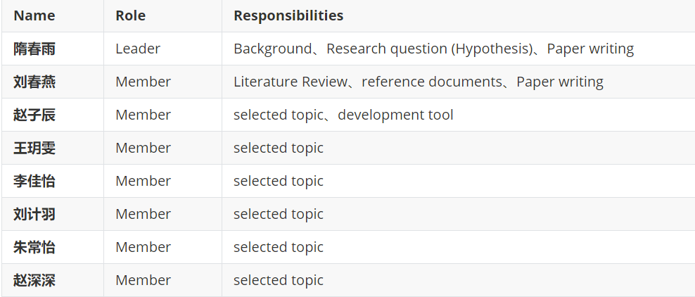

1. **Background:**

Most airports are built far away from the city center, so many passengers need to take transportation to their destinations in the city (or around) after getting off the plane. As one of the main means of transportation in the city, taxi is also the choice of many passengers. In order to facilitate and quickly see off (departure) and pick-up (arrival), many domestic airports separate the channels used in these two processes. Therefore, taxi drivers seeing off passengers to the airport may face the following two choices:

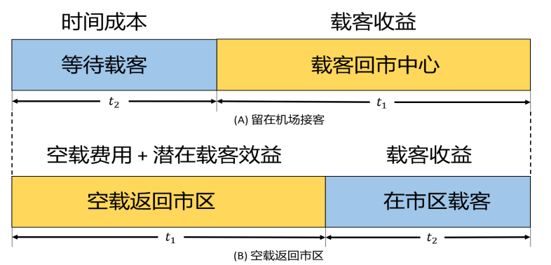

(A) Go to the arrival area and wait in line for passengers to return to the urban area. Taxis go to the "storage pool" to wait in line, and pay the corresponding time cost according to the number of taxis and passengers.

(B) Empty return to the urban area to solicit customers. Taxi drivers will pay no-load costs and may lose potential passenger carrying benefits because of no-load. At the same time, the number of taxis in the "storage pool" and the number of flights in a certain period of time can be known through the observation of drivers. The demand of season and time period factors for taxis can also be judged by the experience of drivers. If passengers want to "take a taxi" after getting off the plane, they need to go to the designated "loading area" and get on the bus in order. The airport taxi management personnel will also properly arrange the release of taxis.

1. **Literature Review:**

Monte Carlo method has strong adaptability, and the complexity of problem geometry has little effect on it. The convergence of this method refers to the convergence in the sense of probability, so the increase of the problem dimension will not affect its convergence speed, and the storage unit is also very saving, which are the advantages of this method in dealing with large-scale and complex problems[1]. Therefore, with the development of computer and the increasing complexity of scientific and technological problems, Monte Carlo method is more and more widely used. It not only solves difficult and complex mathematical calculation problems such as multiple integral calculation, differential equation solution, integral equation solution, eigenvalue calculation and nonlinear equation group solution[2], but also in statistical physics, nuclear physics, vacuum technology, system science, information science[3], public utilities, geology and medicine, Reliability and computer science have been successfully applied in a wide range of fields.

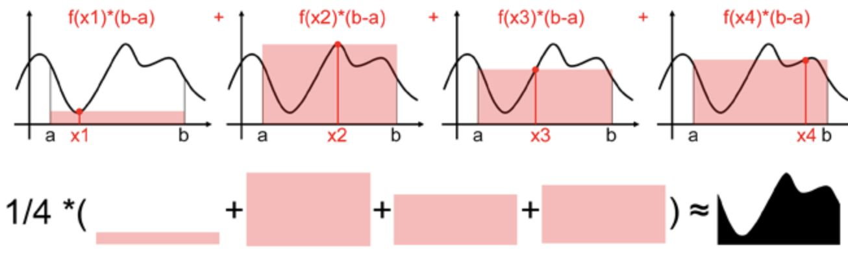

1. **Research question (Hypothesis)**：

4.1 Question

(1) Based on the analysis of the influencing mechanism of the factors related to the taxi driver's decision-making, considering the change law of the number of airport passengers and the income of taxi drivers, the taxi driver selection decision-making model is established, and the driver selection strategy is given.

(2) According to the basic situation of an airport in China, combined with the relevant data of taxis in its city, this paper gives the selection scheme of taxi drivers, and analyzes the rationality of the established model and its dependence on relevant factors.

(3) In some cases, the supply of taxis often exceeds the demand or the supply exceeds the demand. There are two parallel lanes. On the premise of ensuring the safety of vehicles and passengers, set up "boarding points" and reasonably arrange taxis and passengers, so as to maximize the overall riding efficiency.

(4) On the premise that taxi drivers cannot choose passengers and refuse to carry passengers, but allow taxis to carry passengers back and forth for many times, try to put forward a feasible short-distance passenger "priority" arrangement scheme to the management department to make the income of these taxis as balanced as possible.

4.2 Method

Firstly, from the perspective of taxi drivers, this paper establishes a mathematical model based on 0 - 1 programming[5], Monte Carlo method and queuing theory, gives the decision-making with the goal of profit maximization, and also provides the best decision-making scheme for taxi drivers in different time periods; Then, from the perspective of "airport manager", we also use Erlang waiting formula[6], big data simulation[7], cellular automata and normal distribution knowledge to give the arrangement scheme of "best riding point" and a taxi arrangement scheme based on "short-distance ticket".

To solve problem 1, we first put forward the direct factors affecting the driver's decision-making based on the two decisions of "no-load return to the urban area to carry passengers" and "stay at the airport to carry passengers": manned return fuel consumption, waiting time, manned profit, no-load fuel consumption and urban passenger profit. Then, aiming at maximizing the profit of drivers, we use 0 - 1 variable Q to characterize the choice of these two schemes, and establish a 0 - 1 integer programming model. Through the model solution, if q = 1, select "stay at the airport to carry passengers"; If q = 0, select "empty return to urban area to carry passengers".

In response to question 2, we chose Shanghai Pudong International Airport as the research object and collected the data of taxis and arrivals in the airport. Based on the collected data, we use Monte Carlo method and queuing theory model for analysis, combined with the relevant knowledge of normal distribution, we will give the driver decision-making scheme in three time periods. To ensure the robustness and credibility of the model, we use the sensitivity analysis method to explore the rationality of the model, and calculate the Spearman correlation coefficient between the data.

For question 3, referring to four taxi boarding systems in domestic airports, we finally chose the matrix (two lane) boarding system[9]. Then we abstract taxis and passengers based on the queue simulation model, and creatively use Erlang waiting formula to establish the model. The data obtained through the investigation are programmed and solved in MATLAB to obtain the number of the best boarding points

In view of problem 4, with the relative balance of drivers' income between "short-distance passenger carrying" and "long-distance passenger carrying", and referring to the practices of relevant domestic airports, we put forward a scheme of "short-distance ticket" for drivers with short passenger carrying distance. Taking Xuanqiao Town, 17 km away from Shanghai Pudong International Airport, as the upper boundary, we look for the critical point of short-distance and long-distance, so as to make the income of "short-distance passenger carrying" and "long-distance passenger carrying" drivers relatively balanced. [10]

4.3 Expected results

combined with Spearman correlation coefficient[12], on the basis of considering the change law of the number of airport passengers and the income of taxi drivers, the taxi driver selection decision model is established, and the driver selection strategy is given. On the basis of considering the change law of the number of airport passengers and the income of taxi drivers, A taxi driver selection decision model is established, and the driver selection strategy is given. In some cases, the supply of taxis often exceeds the demand or the supply exceeds the demand. There are two parallel lanes. On the premise of ensuring the safety of vehicles and passengers, set up "boarding points" and reasonably arrange taxis and passengers, so as to maximize the overall riding efficiency. On the premise that taxi drivers cannot choose passengers and refuse to carry passengers, but allow taxis to carry passengers back and forth for many times, try to put forward a feasible short-distance passenger "priority" arrangement scheme to the management department to make the income of these taxis as balanced as possible

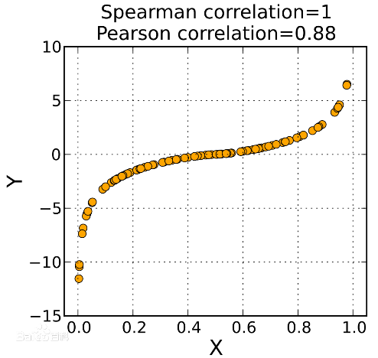

* 1. Time management

1. 11-12 – 11-14 : topic selection and feasibility analysis
2. 11-14 – 11-15： think of solutions and development tools
3. 11-15 – 11-17：collect literature, read domestic and foreign literature and write literature review
4. 11-18 – 11-20：report writing

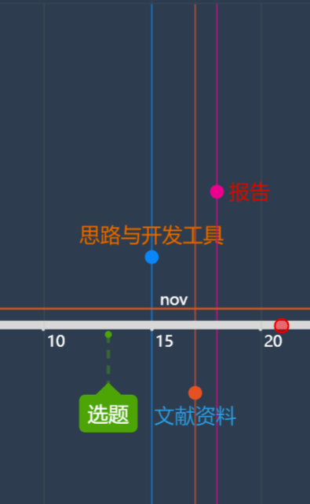

1. **reference documents**

[1]Hao X , Zhang G , Ma S . Deep Learning[J]. International Journal of Semantic Computing, 2016, 10(03):417-439.  
[2] Kehl W , Milletari F , Tombari F , et al. Deep Learning of Local RGB-D Patches for 3D Object Detection and 6D Pose Estimation[C]// Springer International Publishing. Springer International Publishing, 2016.  
[3] Wolf-Gladrow D A . Lattice-Gas Cellular Automata and Lattice Boltzmann Models - An Introduction[J]. Lecture Notes in Mathematics, 2000, 1725.  
[4] Chopard B . Cellular Automata Modeling of Physical Systems[J]. Springer New York, 2009.  
[5] White R , Engelen G . Cellular automata and fractal urban form: a cellular modelling approach to the evolution of urban land-use patterns[J]. Environment & Planning A, 1993, 25(8):1175-1199.  
[6] Wolfram S . Universality and complexity in cellular automata[J]. Physica D Nonlinear Phenomena, 1984, 10(1-2):1-35.  
[7] Gonek S M , Hughes C P , Keating J P . A Hybrid Euler-Hadamard product formula for the Riemann zeta function[J]. Duke Mathematical Journal, 2007, 136(3):507-549.  
[8] Kim T . q -Extension of the Euler formula and trigonometric functions[J]. Russian Journal of Mathematical Physics, 2007, 14(3):275-278.  
[9] Glasserman P . Monte Carlo Methods in Financial Engineering[M]. Springer, 2003.  
[10] Nylund K L , Asparouhov T , BO Muthén. Deciding on the Number of Classes in Latent Class Analysis and Growth Mixture Modeling: A Monte Carlo Simulation Study[J]. Structural Equation Modeling A Multidisciplinary Journal, 2007, 14(4):535-569.  
[11] Hastings W K . Monte Carlo sampling methods using Markov chains and their applications[J]. Biometrika, 1970(1):97-109.  
[12] Arellano M , Bond S . Some Tests of Specification for Panel Data: Monte Carlo Evidence and an Application to Employment Equations[J]. Review of Economic Studies, 1991, 58.