LLM Model Recommendation System
Architecture & Design Overview
Internal Team Document • v1.0

What this document covers
How we generate the training dataset • What data we collect • How the recommendation engine works

1. What Are We Building?
We are building a recommendation system that watches which AI model a user selects for a given prompt, evaluates whether that was the best choice, and suggests a better model with concrete, quantified benefits.

Example output the system produces
User typed: "Summarise this legal contract for key risks"
User chose: GPT-4o

Recommendation: Switching to Gemini 2.5 Pro gives you:
+12% accuracy • -8% cost • -180ms latency

To make this recommendation, the system needs to know how every major model performs across different types of prompts and levels of complexity. That is why we are building a large, structured benchmark dataset first.

2. How We Generate the Dataset
We will collect 10,000 rows of benchmark data by sending the same prompts to multiple models across all major providers, then evaluating each response with a single evaluator model call.

2.1 The Data Generation Pipeline

Prompt Pool  Curated prompts across use cases | → | Multi-Model Send  Same prompt → all 14 models | → | Evaluator Model  One call scores everything | → | Dataset Row  Stored with all metrics

For each prompt, the same input is sent to every model in scope. Each model returns a response. The evaluator model then receives both the original prompt and the response together, and in a single call returns three values:

- Prompt quality score: How clear and well-formed the prompt itself was
- Prompt complexity: Whether the prompt is low, mid, or high complexity
- Accuracy score: How correct and useful the response was for that prompt

2.2 Models in Scope
We benchmark across 6 providers covering 14 models at launch:

Provider | Models
OpenAI | gpt-4o, gpt-4o-mini
Google | gemini-2.5-pro, gemini-2.5-flash, gemini-2.5-flash-lite
Anthropic | claude-sonnet-4-6, claude-haiku (to be added)
DeepSeek | deepseek-r1, deepseek-v3
Meta | llama-3.3-70b, llama-4-scout
Mistral | mistral-large, mistral-small, pixtral-large
Amazon | nova-pro, nova-lite

2.3 Use Cases Covered
Users will select their use case manually when using the system. We collect data across 9 use cases:

Chat | Code | Reasoning | RAG | Summarization

Structured Output | Tool Calling | Vision | Multimodality

Since users explicitly select the use case at inference time, we do not need to train a classifier for it. This eliminates one source of classification error entirely.

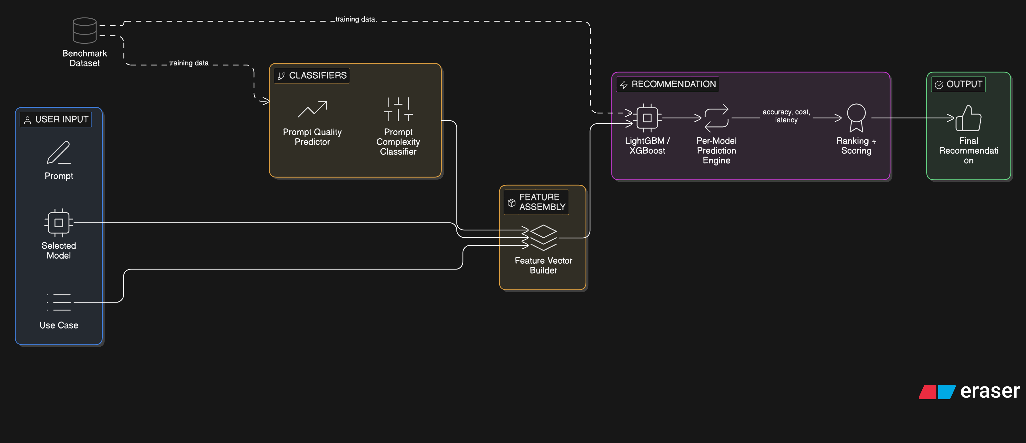

3. Dataset Schema
After evaluation, every row in the dataset contains the following columns. The response text itself is not stored — only the derived quality scores matter for the model.

Column | Type | Description
provider | string | Model provider name (e.g. OpenAI, Google, Anthropic)
model_id | string | Exact model identifier (e.g. gpt-4o, gemini-2.5-pro)
use_case | string | Task category selected by user (chat, code, rag, etc.)
prompt | text | The input prompt sent to the model
prompt_quality_score | int 0-100 | How clear and well-formed the prompt is (evaluator-scored)
prompt_complexity | enum | Complexity level: low / mid / high (evaluator-labelled)
cost | float | Total API cost in USD for this call
latency_ms | int | End-to-end response time in milliseconds
accuracy_score | int 0-100 | How correct and useful the response was (evaluator-scored)

Why we dropped these columns
response (raw text) — the accuracy score already captures response quality; raw text is noise for ML
input_tokens / output_tokens — cost already encodes this indirectly
id / created_at — metadata only, not predictive features

4. Inference-Time Classifiers
At inference time, the user has only typed a prompt — no response exists yet. We need two lightweight classifiers, both trained on our dataset, to predict what the evaluator would have said about this prompt.

4.1 Prompt Complexity Classifier
Predicts whether an unseen prompt is low, mid, or high complexity. This is a standard 3-class text classification problem.

User's prompt | Text embedding  sentence-transformers | Classifier  trained on labeled prompts | low / mid / high

4.2 Prompt Quality Classifier
Predicts a quality score (0-100) for an unseen prompt — how clear and well-formed it is. This is a regression problem on the same input features.

User's prompt | Text embedding  sentence-transformers | Regressor  trained on quality scores | 0 – 100 score

Data requirement for classifiers
Both classifiers are trained entirely on prompts from our benchmark dataset.
Target: 2,000+ labeled examples with good class balance across low / mid / high.
The evaluator model that labels our dataset is the same ground truth these classifiers learn from.

5. The Recommendation Model
Once we have the two classifiers running at inference time, we have everything we need to feed into the recommendation model and generate a model comparison.

5.1 Full Inference Flow

User types prompt + selects use case
▼
Complexity Classifier  → low / mid / high | Quality Classifier  → 0-100 score
▼ Features assembled
use_case  user selected | complexity  classifier output | quality score  classifier output | user's model  user selected
▼
Recommendation Model (XGBoost / LightGBM)
Predicts accuracy score per model for this context
▼
Ranked model list + delta calculation
▼
"Switch to Gemini 2.5 Pro → +12% accuracy, -8% cost, -180ms latency"

5.2 What the ML Model Actually Learns
The recommendation model is an XGBoost or LightGBM model trained on our benchmark dataset. It takes the features listed above and predicts the accuracy score any given model would achieve in that context.

At inference time, we run this prediction for every model in scope. Then we rank by a weighted composite score:

Metric | Weight | Reason
Accuracy / correctness | 60% | Primary goal — user needs the right answer
Cost | 30% | Secondary goal — cheaper is better when accuracy is equal
Latency | 10% | Tiebreaker — faster is nicer but rarely decisive

5.3 ML Model Candidates

Model | Best For | Complexity | Why Use
XGBoost / LightGBM | Tabular benchmark data | Medium | Best fit — handles tabular data well, interpretable, fast
Random Forest | Simpler baseline | Low | Good starting point for validation
Neural Network | Very large datasets | High | Overkill at 2K–10K rows; revisit at 50K+

Recommendation: Start with LightGBM. It handles the mix of categorical features (provider, use_case, complexity) and continuous features (cost, latency, quality score) naturally, and trains fast enough to iterate on quickly.

6. Data Requirements & Targets

6.1 Target Volume

Component | Minimum (v1) | Target
Total dataset rows | 2,000 | 10,000
Rows per model per use case | 5–10 | 20–30
Complexity balance (low/mid/high) | Roughly equal thirds | Roughly equal thirds
Use cases in focus | Top 5 | All 9

6.2 Key Bottlenecks
The ML algorithm is not the hard part. The real challenges are:

- Data volume: Not enough rows per model per use case combination — sparse cells mean the model cannot learn
- Label consistency: If the evaluator scores prompts inconsistently, classifiers learn noise instead of signal
- Class imbalance: If 80% of prompts are mid-complexity, classifiers will be biased toward mid
- Evaluator prompt design: The evaluator prompt must be specific enough to produce consistent JSON output every time

7. Summary
Here is the full picture from data collection through to recommendation output:

STEP 1 — Build the dataset
Send prompts to all models, evaluate with one LLM call per response
▼
STEP 2 — Train complexity + quality classifiers
Two lightweight models trained on labeled prompts from dataset
▼
STEP 3 — Train recommendation model (LightGBM)
Learns which model performs best for each context
▼
STEP 4 — Deploy inference pipeline
User types prompt + selects use case → classifiers run → recommendation generated
▼
STEP 5 — Output recommendation with deltas
+X% accuracy • -Y% cost • -Z ms latency

Design principles
Accuracy is primary — weighted at 60% in the scoring function
Use case is user-selected — eliminates one classifier and one source of error
No LLM at inference — only trained classifiers, fast and cheap
Dataset is the moat — the more benchmark rows we have, the better the recommendations get

