­

Team Member

EC1 - Inception

Capstone Project

Residents Connect

2020CFSE007 – Suhail Haroon

2020CFSE020 – Ramesh T

2020CFSE017 - Rajeswari Subramanian

Contents

**1.** **Problem** 4

**2.** **Proposed Solution** 4

**3.** **Targeted Customers** 4

**4.** **Literature Review** 4

**5.** **Requirements** 4

5.1. Functional Requirements 4

5.1.1. Registration & Login 4

5.1.2. Property Details 5

5.1.3. Dashboard 5

5.1.3.1. Admin-Dashboard 5

5.1.3.2. Residents-Dashboard 6

5.1.4. Events Management (Paid Service) 6

5.1.5. Buy and Sell 7

5.1.6. Car polling 7

5.1.7. Contacts Management 7

5.1.8. Maintenance Service (Paid Service) 8

5.1.9. Chat Room 8

5.1.10. Fee/Rent Payment 9

5.1.11. Announcements 10

6.1.12 Classifieds 10

6.1.13 Poll Service 10

6.1.14 Facility Booking (Paid service) 11

6.1.15 Visitor Management (Paid Service - Mobile Only) 11

6.2 Non-Functional Requirements 12

**7** **Constraints and Challenges** 12

**8** **System Architecture** 12

**9** **Deliverables** 14

# **Problem**

In the digital age we live in there are a plethora of options services and features that are offered through several applications and services. The selective integration of required features and services required by people within a select subgroup of society is lacking and it would feel great to have a one stop shop for all the necessary features required by the people within different communities. The idea behind this project is to bring together these services and provide this one stop shops of a vast majority of these services in one place where they can be accessed by the intended audience. With the above considerations in mind, we assessed that there is a requirement for the segregation of these features to present them to a subgroup audience here the audience we have chosen to provide this feature for are the residents of the apartments that we enrol within the application.

# **Proposed Solution**

The objective here is to create a super app for apartment residents with all the features that are required by them to immediately tend to a crisis or solving simple problem in their apartment as well as getting in touch with the right people within the apartment.

# **Targeted Customers**

The target customers using the application would be the apartment residents that can use our app so that they can cater to all of their immediate needs and requirements relevant to them within one place and also keep up to date with the changes, events and all that is trending around them in their immediate surroundings.

# **Literature Review**

# **Requirements**

## Functional Requirements

### Registration & Login

|  |  |  |  |  |
| --- | --- | --- | --- | --- |
| Requirement Number | Requirement Details | Any dependent requirement? | Priority | Planned Release |
| 1.1 | Admin should able to register the application using email & password/google/facebook |  | 1 | R1 |
| 1.2 | Resident should able to register the application using email & password/google/facebook |  |  |  |
| 1.3 | Admin/Resident should able to login into application using email/google/facebook credentials |  |  |  |
| 1.4 | Admin/Resident provides details like email, phone number, emergency contact details & blood group during first time login |  |  |  |
| 1.5 | Admin provides community details |  |  |  |
| 1.6 | Upon first time login, admin should able to free and paid service details. He can able to select required paid services |  |  |  |
| 1.7 | Maintenance, Events Management, Buy & Sell are paid services |  |  |  |
| 1.8 | Multiple login record (user) can be linked with one apartment (maximum upto 5 login user allowed per flat) |  |  |  |

### Property Details

|  |  |  |  |  |
| --- | --- | --- | --- | --- |
| Requirement Number | Requirement Details | Any dependent requirement? | Priority | Planned Release |
| 2.1 | Admin provides community details like community name, builders, location of community upon first time login |  | 1 | R1 |
| 2.2 | Admin registers details like Apartment modal, blocks, flats details upon first time login |  |  |  |
| 2.3 | Admin had ability to send email/mobile notification to residents to register application with unique token id (per flat) |  |  |  |
| 2.4 | Admin has ability to edit/delete the property details |  |  |  |
|  |  |  |  |  |

### Dashboard

### Admin-Dashboard

|  |  |  |  |  |
| --- | --- | --- | --- | --- |
| Requirement Number | Requirement Details | Any dependent requirement? | Priority | Planned Release |
| 3.1 | Admin can view occupied/un-occupied flat details in dashboard |  |  |  |
| 3.2 | Overview of payment details would be displayed as graph in admin’s dashboard |  |  |  |
| 3.3 | Admin who moderator access can view overview of items flagged for moderations |  |  |  |
| 3.4 | Overview of announcement details displayed |  |  |  |
| 3.5 | Overview of upcoming events would be displayed |  |  |  |

### Residents-Dashboard

|  |  |  |  |  |
| --- | --- | --- | --- | --- |
| Requirement Number | Requirement Details | Any dependent requirement? | Priority | Planned Release |
| 4.1 | Resident can view announcement details in dashboard |  |  |  |
| 4.2 | He can view un-viewed chat details in dashboard |  |  |  |
| 4.3 | Any upcoming payment due (or) ‘over due’ would be displayed in dashboard |  |  |  |
| 4.4 | Upcoming events would be displayed in their dashboard |  |  |  |
| 4.5 | Active poll displays in dashboard |  |  |  |
| 4.6 | Response to their Buy & sell would be displayed in notification area |  |  |  |

### Events Management (Paid Service)

|  |  |  |  |  |
| --- | --- | --- | --- | --- |
| Requirement Number | Requirement Details | Any dependent requirement? | Priority | Planned Release |
| 5.1 | Resident/admin can create event and have option to make event accessible to nearby communities. |  |  |  |
| 5.2 | Resident/admin can able to see events posted by them |  |  |  |
| 5.3 | Resident/admin can edit the events posted by them |  |  |  |
| 5.4 | Resident/admin can able to see the events enrolled by them in their timeline |  |  |  |
| 5.5 | Resident/admin able to see & enrol upcoming events in their community, nearby communities or their cities |  |  |  |
| 5.6 | Resident/admin have option to search events by type, name, timeline, locations |  |  |  |

### Buy and Sell

|  |  |  |  |  |
| --- | --- | --- | --- | --- |
| Requirement Number | Requirement Details | Any dependent requirement? | Priority | Planned Release |
| 6.1 | Resident can post ‘sell advertisement’ and have option to make advertisement visible to nearby communities in app. |  |  |  |
| 6.2 | Residents can able to see all ads in Buy& sell page |  |  |  |
| 6.3 | Resident has option to search ads by type, category, location |  |  |  |
| 6.4 | Seller and buyer can chat in application |  |  |  |
| 6.5 | Buyer & seller can negotiate price through app |  |  |  |
| 6.6 | Resident can view their ads posted in past |  |  |  |
| 6.7 | Seller can update/delete their active ads |  |  |  |

### Car polling

|  |  |  |  |  |
| --- | --- | --- | --- | --- |
| Requirement Number | Requirement Details | Any dependent requirement? | Priority | Planned Release |
| 7.1 | Resident can view the list of car polling ads |  |  |  |
| 7.2 | Resident can post the car pooling with the details like start & end data with timing, source & destination location , any stop points in between, how many passengers can taken and any amount involved |  |  |  |
| 7.3 | Resident interested in car polling, they can contact car driver/owner by using phone number. If both are agreed, car polling request would be closed (or) seats would be reduced by owner in the request |  |  |  |

### Contacts Management

|  |  |  |  |  |
| --- | --- | --- | --- | --- |
| Requirement Number | Requirement Details | Any dependent requirement? | Priority | Planned Release |
| 8.1 | Admins can create/edit contacts details like nearby police station, fire station, hospital, clinics;  Contact details of community secretary, presidents and security extension numbers. Etc |  |  |  |
| 8.2 | Resident able to view the contact details in their app under ‘contacts’ menu |  |  |  |

### Maintenance Service (Paid Service)

|  |  |  |  |  |
| --- | --- | --- | --- | --- |
| Requirement Number | Requirement Details | Any dependent requirement? | Priority | Planned Release |
| 9.1 | Resident can raise the maintenance request. Initial status of request should be ‘Open’ |  |  |  |
| 9.2 | Resident can able to see list of maintenance requests raised by him and their current status |  |  |  |
| 9.3 | After maintenance worker completes the work, status of the request should be changed to ‘completed’. |  |  |  |
| 9.4 | Any charges related to ‘maintenance request’ should be calculated and paid by resident on monthly basis though application |  |  |  |
| 9.5 | ‘Monthly Maintenance Fee’ receipt should be generated and should be visible in payments tab of application for resident. |  |  |  |

### Chat Room

|  |  |  |  |  |
| --- | --- | --- | --- | --- |
| Requirement Number | Requirement Details | Any dependent requirement? | Priority | Planned Release |
| 10.1 | Resident can create chat room and invite other residents in the chat room |  |  |  |
| 10.2 | Creator of chat room should be marked as ‘Admin’ of the chat room |  |  |  |
| 10.3 | ‘Admin’ in the chat room can promote other people in the chat room as ‘Admin’ |  |  |  |
| 10.4 | Members in the chat room can send the messages, documents, audio and video files in the chat room |  |  |  |
| 10.5 | Residents can see the list of all chat rooms |  |  |  |
| 10.6 | Resident can able to access the chat room where he is the member |  |  |  |
| 10.7 | Resident can raise the request to include him in a chat room. |  |  |  |
| 10.8 | Admin of the chat room can approve/decline ‘Add member request’ |  |  |  |
| 10.9 | Member can like other member’s messages |  |  |  |
| 10.10 | Chat room details (like name) can be changed by admin of the chat room only. |  |  |  |
| 10.11 | Any chat room which is inactive more than 35 days would be deleted |  |  |  |
| 10.12 | Notification would be sent to admins of the chat room 5 days prior to deletion of the chat room |  |  |  |
| 10.13 | All the messages in the chat room should be timestamped |  |  |  |
| 10.14 | Message would be deleted/edited by the member who created the message. Others can only view the messages |  |  |  |
| 10.15 | Any inappropriate content would be marked with flag and notification would be send to admins of the chat room and moderator assigned by community |  |  |  |
| 10.16 | Admin can take appropriate action on flagged messages. If he didn’t take action, assigned moderator should take action. SLA would be 7 days |  |  |  |
| 10.17 | Flagged message should be invisible until further action taken on that message |  |  |  |

### Fee/Rent Payment

|  |  |  |  |  |
| --- | --- | --- | --- | --- |
| Requirement Number | Requirement Details | Any dependent requirement? | Priority | Planned Release |
| 11.1 | Admin can generate Monthly (or) quarterly (or) annual maintenance fee receipts |  |  |  |
| 11.2 | When receipt is generated, mail notification would be sent to all residents |  |  |  |
| 11.3 | Admin can view payment details per apartment wise |  |  |  |
| 11.4 | Admin can send notification to residents separately, when there is a payment due |  |  |  |
| 11.5 | Fee incurred as part of maintenance and facility booking would be auto generated on monthly basis. Resident can pay them on monthly basis |  |  |  |

### Announcements

|  |  |  |  |  |
| --- | --- | --- | --- | --- |
| Requirement Number | Requirement Details | Any dependent requirement? | Priority | Planned Release |
| 12.1 | Admin can create announcement related to ‘community meeting’, ‘Electricity outage’ etc.. |  |  |  |
| 12.2 | Resident can see this announcement in their dashboard page. |  |  |  |
| 12.3 | Only future, present-dated announcement should be visible in resident dashboard |  |  |  |
| 12.4 | Resident can view complete details of the announcement in pop-up on clicking announcement in their dashboard |  |  |  |

### Classifieds

|  |  |  |  |  |
| --- | --- | --- | --- | --- |
| Requirement Number | Requirement Details | Any dependent requirement? | Priority | Planned Release |
| 13.1 | Trusted vendors for household related services would be listed under classifieds menu  (Example services: Electrician, plumber, vegetable/fruit shop, home food delivery, day care centre, pet care centre etc..) |  |  |  |
| 13.2 | Resident can add vendors details who offer household service details |  |  |  |
| 13.3 | Resident member can rate service of the vendor and add comments for each vendor |  |  |  |

### Poll Service

|  |  |  |  |  |
| --- | --- | --- | --- | --- |
| Requirement Number | Requirement Details | Any dependent requirement? | Priority | Planned Release |
| 14.1 | Resident can create poll and gather opinions/options of other apartments residents on any issue or event |  |  |  |
| 14.2 | Created poll should have expired date & time |  |  |  |
| 14.3 | Result of poll can be shared with all the members of the community along with authority of the community |  |  |  |
| 14.4 | Active poll should be shown in resident/admin dashboard |  |  |  |
| 14.5 | Resident can participate in poll. Any user can participate only one time. |  |  |  |

### Facility Booking (Paid service)

|  |  |  |  |  |
| --- | --- | --- | --- | --- |
| Requirement Number | Requirement Details | Any dependent requirement? | Priority | Planned Release |
| 15.1 | Resident can book community facility for the particular day and time. Facilities like swimming poll, club house, Banquet Hall. etc |  |  |  |
| 15.2 | Resident can able to see list of free slots on any particular day |  |  |  |
| 15.3 | Booking can be cancelled 24 hrs prior to booked time |  |  |  |
| 15.4 | While booking, resident can see the fee involved in booking. |  |  |  |
| 15.5 | Any fee incurred due to using facility would be calculated and added as part of monthly maintenance Fee. |  |  |  |

### Visitor Management (Paid Service - Mobile Only)

|  |  |  |  |  |
| --- | --- | --- | --- | --- |
| Requirement Number | Requirement Details | Any dependent requirement? | Priority | Planned Release |
| 16.1 | Resident can approve visitor to enter community |  |  |  |
| 16.2 | Resident can pre-approve visitor |  |  |  |
| 16.3 | Resident can see the list of approved visitors in past (maximum upto last 6 months) |  |  |  |
| 16.4 | Admin can view complete visitors list and can view visitors based on day (or) flat they visited |  |  |  |

## Non-Functional Requirements

|  |  |  |  |  |
| --- | --- | --- | --- | --- |
| Requirement Number | Requirement Details | Any dependent requirement? | Priority | Planned Release |
| 17.1 | At any point of time maximum 1000 users can connect into application |  |  |  |
| 17.2 | Application should take less than 10 MB memory size while running |  |  |  |
| 17.3 | Response time to load any page should be less than 5 seconds |  |  |  |
| 17.4 | Maximum CPU allocation for this application should not exceed 5% |  |  |  |

# **Constraints and Challenges**

The challenges of the application are that they need to always be up to date with the relevant contacts of the apartments that are near the residents using them keeping all the information fresh and relevant so that all transactions within the application remains smooth and the user experience is always at its best catering to their immediate needs and requirements.

# **System Architecture**

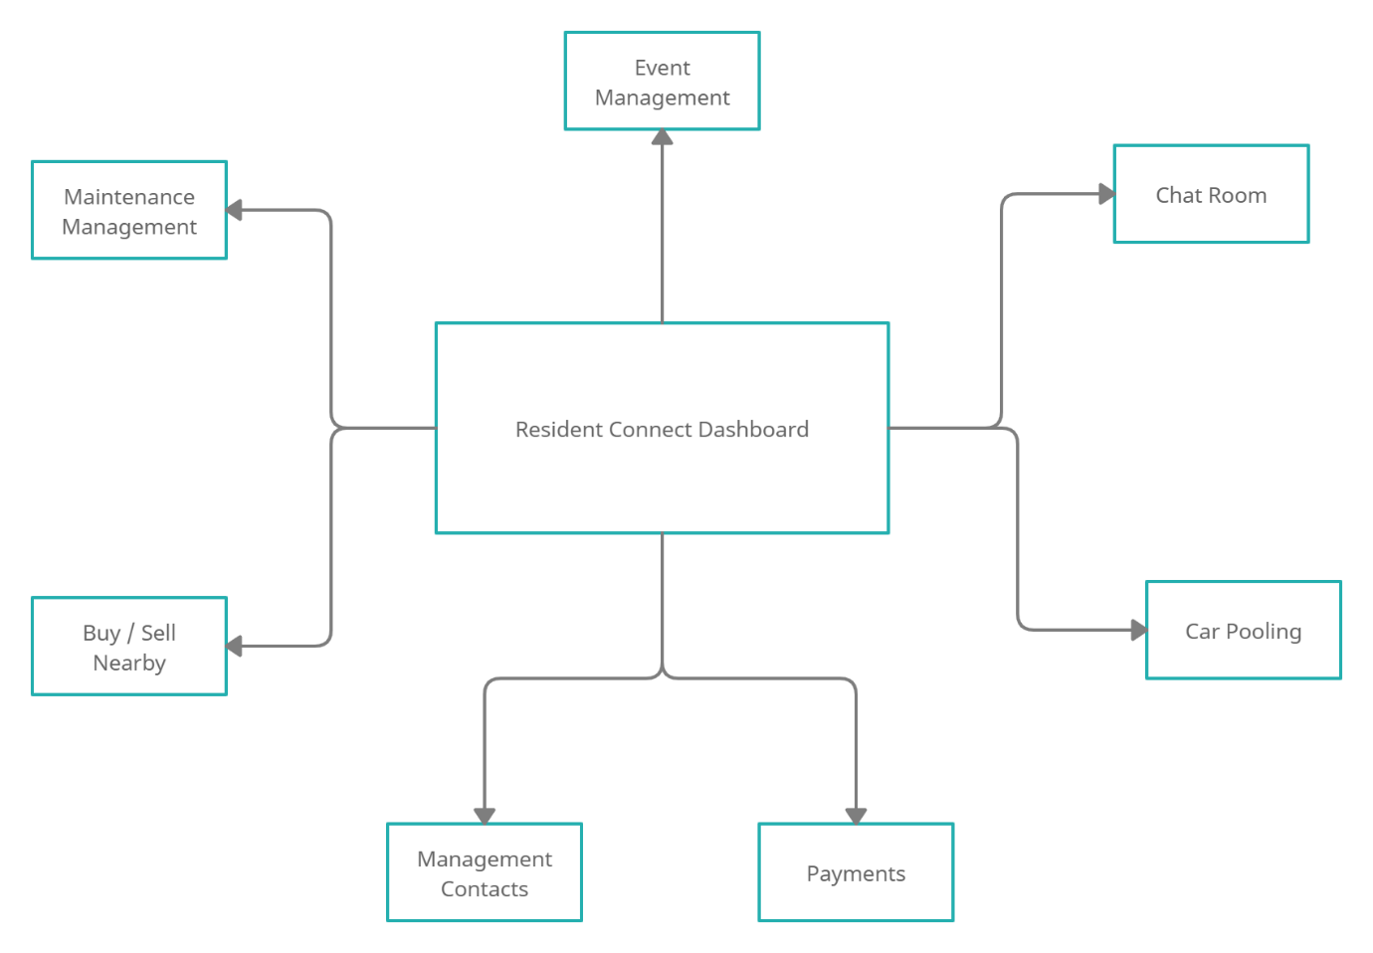

Use Case Diagram for Resident Connect

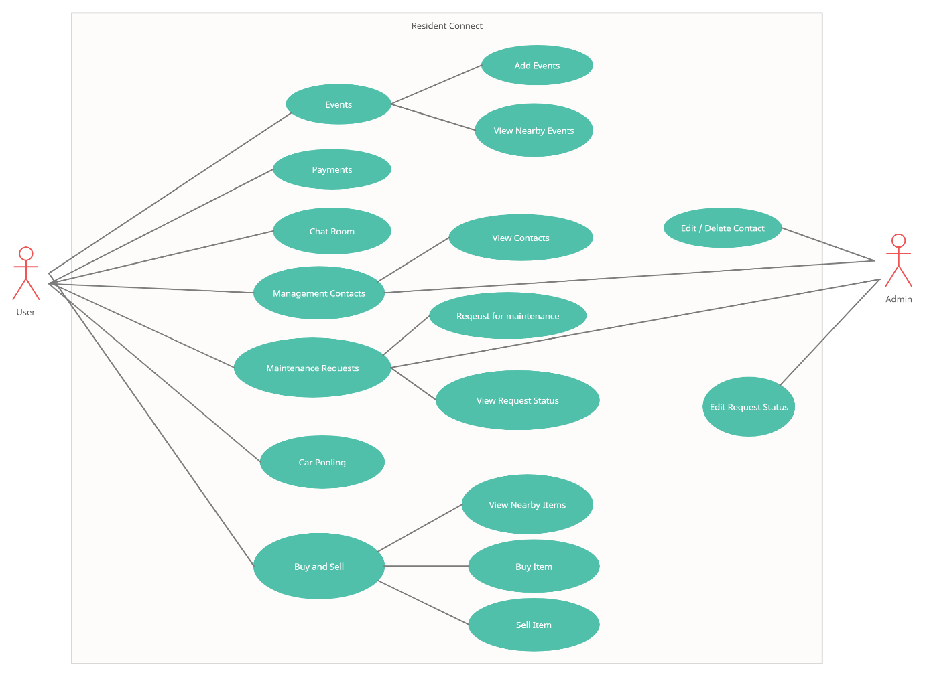

This System Architecture and Use Case Diagram is only a high level Overview of the functionality of the application and there would be a significantly more elaborate and low level design document that would be included in the later documents.

# **Deliverables**

The Deliverable application would be a super app that is capable of serving all the requirements of the residents living in Apartments with all the features that are required by them and relevant to them within their day to day lives.